
FOR IMMEDIATE RELEASE: July 1, 2025
CONTACT: pressoffice@cityhall.nyc.gov, (212) 788-2958

MAYOR ADAMS CONTINUES “WE OUTSIDE SUMMER”
BY ANNOUNCING LARGEST EVER SUMMER STREETS,
UNVEILS MORE THAN 22 MILES OF CAR-FREE STREETS THIS SUMMER

Record Route with More Than 22 Miles of Car-Free Streets
Across All Five Boroughs in July and August

For First Time, New Yorkers Can Travel Length of
Manhattan from Brooklyn Bridge to Inwood on a Car-Free Route

Free, Local Running and Walking Events Debuting at Summer Streets

NEW YORK – New York City Mayor Eric Adams and New York City Department of Transportation (DOT) Commissioner Ydanis Rodriguez today continued “We Outside Summer” by announcing the city’s largest-ever Summer Streets, featuring more than 22 miles of car-free streets and two free community races in partnership with the nonprofit New York Road Runners (NYRR). For the first time ever, New Yorkers will also be able to travel the length of Manhattan, from the Brooklyn Bridge to Inwood, on a car-free route.

“This summer, ‘We Outside,’ and we’re bringing everyone with us,” said Mayor Adams. “From the Brooklyn Bridge to Inwood — and across all five boroughs — New Yorkers will have more space than ever to walk, bike, run, and connect with their neighbors in their communities at our Summer Streets events. Our administration is working every day to improve quality of life in the city, expand access to public spaces, and to give New Yorkers the safe and enjoyable summer they want and deserve. We’re not just opening streets this summer, we’re opening opportunities for a more vibrant, inclusive, and active city on 22 miles of car-free streets.”

“New York is an unbeatable city no matter how you experience it — but there's something genuinely magical about biking or walking down the avenues, unencumbered by car traffic,” said Deputy Mayor for Operations Jeff Roth. “Summer Streets is coming back bigger and better than ever this year to support the pure joy of the urban experience. We'll see you out there!”

“New York City’s largest public space is our streets, and when summer finally arrives, we want New Yorkers to be out in the streets — walking, biking, dancing, and connecting with our neighbors,” said DOT Commissioner Rodriguez. “Summer Streets captures that excitement by activating our streets and transforming them into public spaces that reflect the energy and diversity of our communities. The Adams administration continues to deliver Summer Streets each year because accessible public spaces are essential for everyone.”

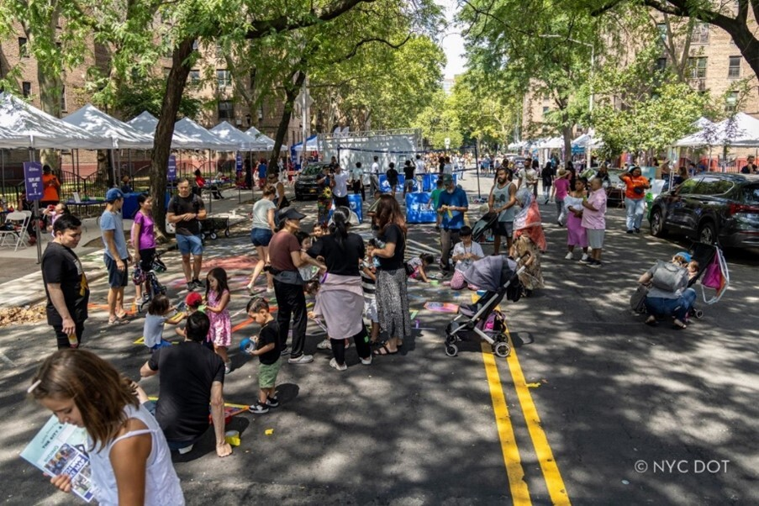

Summer Streets on Vernon Boulevard in Queens last summer. Credit: NYC DOT

With the largest ever expansion, Summer Streets will also return to the Bronx, Brooklyn, Queens, and Staten Island, including a brand-new route along Forest Avenue on Staten Island. This year, over 22 miles of Summer Streets corridors will be open to pedestrians and cyclists, from 7:00 AM to 3:00 PM for five consecutive Saturdays, from July 26 through August 23.

As part of this year’s expanded programming, DOT is partnering with NYRR to launch the NYRR Start Line Series, a new initiative bringing free, community-based run and walk events to Summer Streets. Geared toward beginner athletes, the pilot series will debut with events in Queens and Brooklyn on Saturday, July 26 and on Saturday, August 23. Registration for the NYRR Start Line Series will open later this month. “We’re thrilled to launch the New York Road Runners Start Line Series as part of DOT’s Summer Streets — creating even more opportunities for New Yorkers of all ages and experience levels, especially new athletes, to discover the joy of running,” said Rob Simmelkjaer, CEO, NYRR. “By bringing these accessible, community-focused, beginner-friendly events to car-free streets, we’re proud to help reimagine how public space can inspire movement, health, and connection.”

“Summer Streets is all about serving our communities and connecting New Yorkers to their city in the most joyful way possible, by bike,” said Patrick Knoth, general manager, Lyft Urban Solution’s Citi Bike. “Lyft is excited to offer riders the code LYFTSUMMER25 for free Citi Bike day passes during Summer Streets. We’re proud to help connect people to new neighborhoods and experiences they might never have discovered otherwise.”

In addition to the new races, Summer Streets will showcase a range of engaging public art installations that activate the corridors and celebrate the city’s creative spirit. DOT Art released an open call earlier this year and selected two installations to be presented as one-day activations at rest stops along the Summer Streets routes: Mookntaka’s Friends and Follies inflatable sculptures will inspire spontaneous play in the Bronx, Brooklyn, Queens, and on Staten Island, and Acrylicize’s new interactive sculpture, Collective Bloom, will harness human energy to initiate change in Manhattan. Two illustrators, Yuke Li and Tou Yia Xiong, from a separate open call, were commissioned to design this year’s NYC Art Stop Letters , which celebrate the vibrant activations and fun of Summer Streets, on display at rest stops in all boroughs. Through the support of Lyft and Citi, Citi Bike will offer free day passes for all riders on a classic Citi Bike for 24 hours. Riders can take advantage of the offer by using the promo code LYFTSUMMER25 on the Daypass tab of the Citi Bike App.

Saturday, July 26: Queens and Staten Island
- Queens: Summer Streets will run along Vernon Boulevard, from 44th Drive to 30th Drive. The program will allow users to enjoy the entire Queens waterfront in Long Island City and Astoria.
- Staten Island: Summer Streets will run along Forest Avenue, from Broadway to Bard Avenue, marking a brand-new route on Staten Island.

Saturday, August 2, August 9, and August 16: Manhattan
- Manhattan: Summer Streets will run from the Brooklyn Bridge all the way to Dyckman Street in Inwood, marking the longest Manhattan route in the program’s history. The route will travel along Lafayette Street and Park Avenue up to 110th Street, continue west on 110th Street to Broadway, and head north to Dyckman Street. A special Harlem rest stop will activate Adam Clayton Powell Jr. Boulevard from 110th Street to 125th Street, offering programming and community engagement in the heart of Harlem.

Saturday, August 23: Bronx and Brooklyn
- Bronx: Summer Streets will run along Grand Concourse, from East Tremont Avenue to Mosholu Parkway. This program will open a major car-free corridor to people from the west Bronx to the north Bronx.
- Brooklyn: Summer Streets will run along Eastern Parkway, from Grand Army Plaza to Buffalo Avenue. It will connect Prospect Heights and Brownsville along the same route as the Labor Day Caribbean Day Parade — one of the city’s most popular annual events.

WABC-TV will serve as the official media sponsor of Summer Streets, along with sponsors ALOHA Protein Bars, Brooklyn FC, C4 Performance Energy®, Chamber of Mothers, Coca-Cola, Grand Central Terminal®, MUSH, Remitly, RYZE, siggis, Stonyfield, and Yerba Madre.

“This year Summer Streets is accessible to even more people, stretching the length of Manhattan,” said U.S. Representative Jerrold Nadler. “Summer Streets is a perfect example of what happens when we create public spaces for everyone, not just those in cars. Kids have room to ride their bikes without worrying about traffic, families can enjoy walks while discovering local restaurants and businesses, and it creates chances for neighbors to connect in meaningful ways. Summer Streets means workers, families, and neighbors will have more opportunities to enjoy recreating on car-free streets, explore neighborhoods, and enjoy the summer weather. More than half a million people participated in 2024, an increase of 300,000 from the year before. It's obvious this program has captured the hearts of New Yorkers.”

“Summer Streets isn’t just recreation — it’s equity in action,” said New York State Senator Robert Jackson. “As a bike rider myself, I’m thrilled to see this initiative finally reach uptown, bringing safe, open streets to the people of Washington Heights, Inwood, and the Bronx. I commend the City and DOT for expanding access and delivering joy, health, and community to working-class New Yorkers — where it’s needed most.”

“I can’t wait! I love the entire premise behind Summer Streets, and I couldn’t be more excited that the program is expanding,” said New York State Assemblywoman Latrice Walker. “This year, people will be able to bike, walk and enjoy free activities along Eastern Parkway in Brooklyn — a vibrant stretch that connects Brownsville to Prospect Heights. While New Yorkers are enjoying the car-free experience, it should remind everyone of the value of public space and safe recreation. Where Brooklyn at? We’ll be on Eastern Parkway on Saturday, Aug. 23.”

“Summer Streets is exceptionally popular, with New Yorkers coming from all across the city to make use of the extra public space and access to our streetscape,” said Manhattan Borough President Mark Levine. “I am especially glad to see this year's Summer Streets in Manhattan expanded to cover almost the entire length of the borough, from the Brooklyn Bridge to Inwood. I encourage Manhattanites to check out the fantastic programming scheduled in our borough and to be inspired to think about how our streets can be designed to better support New Yorkers' needs and improve our environment.”

“I'm so glad to welcome back Summer Streets to Queens and the rest of the city. This program brings so much joy to people of all ages and backgrounds, and brings with it great cultural, artistic and public health activities for all,” said Queens Borough President Donovan Richards Jr. “It's great to see the expansion of this program this year. We must continue to expand upon Summer Streets and Open Streets, so that our community members can enjoy our streets safely.”

“Summer Streets offers visitors a fun and unique way to experience New York City — inviting them into neighborhoods across all five boroughs and showcasing what makes NYC such a special destination,” said Julie Coker, president and CEO, New York City Tourism + Conventions. “We’re thrilled to see the continued expansion of this program, celebrating the City’s unmatched energy and walkability, supporting local businesses, and activating our vibrant public spaces.”

“The Summer Streets program makes New York accessible for all, providing 22 miles of safe, scenic, traffic-free public spaces where locals and visitors in all five boroughs can enjoy a summer Saturday outdoors,” said MTA Chief Administrative Officer Lisette Camilo. “We are pleased to partner with NYCDOT and the Mayor’s Office once again for this fun and unique way to explore the city.”

“RPA’s research in the 1920s highlighted the threat that automobility posed to the welfare of New York’s children, families, and everyday commuters,” said Dr. Sam Bowden Akbari, director of communications, Regional Plan Association (RPA). “As we told the New York Times at the time, motorists “should be prepared to concede that the closing of certain streets in New York to traffic, so that they could be used as children’s playgrounds, is merely a grant to the children of the user of certain streets for loss of partial use of all streets, in the interests of fast traffic. More than 90 years later, we continue to call for car-free streets which can deliver New Yorkers of all ages the safety and improved quality of life we deserve. Here’s to expanded open streets for all!”

“We’re thrilled that our Skyline to Shoreline Road Tour will be featured in NYC Summer Streets, bringing the energy of the World Cup directly into the heart of communities,” said Alex Lasry, CEO, NYNJ Host Committee. “From festivals to neighborhood events, each stop on the tour is designed to reflect the unique spirit of our region and engage fans of all ages. This is just the beginning of a summer-long celebration leading up to the world’s biggest sporting event.”

“What a thrill to see Summer Streets grow into the most ambitious and inclusive open streets celebration yet, with more than 22 miles of car-free streets across all five boroughs,” said Ken Podziba, CEO, Bike New York. “We’re proud to support this incredible transformation by offering Learn to Ride classes for kids and providing free bike maintenance through our Recycle-A-Bicycle mechanics in every borough. These opportunities empower New Yorkers of all ages to embrace biking with safety, confidence, and joy. We applaud Mayor Adams, Commissioner Rodriguez, and NYC DOT for their bold vision and unwavering commitment to equity, health, and community.”

###

