
THE CITY OF NEW YORK
OFFICE OF THE MAYOR
NEW YORK, NY 10007

FOR IMMEDIATE RELEASE: November 17, 2016
pressoffice@cityhall.nyc.gov, (212) 788-2958

MAYOR DE BLASIO ANNOUNCES WINNERS OF 34TH ANNUAL AWARDS FOR EXCELLENCE IN DESIGN

NEW YORK—Mayor Bill de Blasio, the Public Design Commission President Signe Nielsen and Executive Director of the Commission Justin Moore today announced the winners of the Annual Awards for Excellence in Design. Every year, the City’s Design Commission selects and honors public projects across the five boroughs that exemplify how innovative and thoughtful design can provide New Yorkers with the best possible public spaces and services and engender a sense of civic pride.

This year’s honorees span diverse fields and range from small-scale to large, including the opening of Dock 72 in Brooklyn to the citywide, technological milestone LinkNYC. Additionally, projects such as the Snug Harbor Cultural Center Music Hall Addition and The High Line Park Passage and Spur will allow for more cultural exchange and recreational opportunities for residents. This year’s honorees help prepare New York City to thrive in the 21st century, from technological connectivity to business development to expanded areas for exercise and improved health.

“The winners of this year’s Excellence in Design Awards highlight NYC’s dedication to providing a wide range of design and public spaces that speak to the modern day New Yorker and meet the needs of a large, active and diverse city,” said Mayor Bill de Blasio. “Today, we are here to honor and to celebrate the work of these innovators, who have invested in creating inclusive public projects across the five boroughs.”

“These thoughtful and innovative designs support the de Blasio Administration’s commitment to providing quality, equitable, and resilient public spaces to all New Yorkers. By utilizing good design principles, these projects will provide the public with increased access to the waterfront, open spaces and parks; improved places for play and community gatherings; and inspiring artworks,” said Public Design Commission President Signe Nielsen.

"Part of what makes our city great is the quality of our public realm and the creativity and ingenuity found in our design community and city agencies. These award-winning projects range from new technologies to improved neighborhood parks and public artwork. They show that design excellence is an important part of New York's leadership in promoting innovation, sustainability, and equity in cities," said Public Design Commission Executive Director Justin Moore.

The Public Design Commission

The Public Design Commission reviews permanent works of architecture, landscape architecture, and art proposed on or over City-owned property. The Commission comprises 11 members, including an architect, landscape architect, painter, sculptor, and three lay members, as well as representatives of the Brooklyn Museum, Metropolitan Museum of Art, New York Public Library, and the Mayor.

Members of the Commission serve pro bono and meet once per month. Projects are submitted by City agencies and include the construction, renovation, or restoration of buildings and other structures; the creation or rehabilitation of parks, playgrounds, and plazas; installation of lighting and other streetscape elements; signage; and the installation and conservation of artwork and memorials. The Commission has been honoring these projects annually since 1983.

The winning projects for 2016 include:

40th Police Precinct
East 149th Street and St. Ann’s Avenue, Bronx
A project by the Department of Design and Construction, the New York Police Department
Bjarke Ingels Group and Starr Whitehouse

Aligned with OneNYC objectives and the City’s commitment to equity, the 40th Precinct includes the very first community meeting room within a police facility. With a porous façade and an artwork component, this flexible multipurpose room will provide space for classes and events.

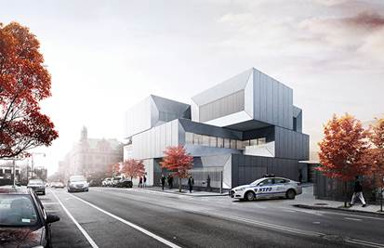

Waterfront Nature Walk by George Trakas
Newtown Creek Water Pollution Control Plant, 329 Greenpoint Avenue, Brooklyn
A project by the Department of Cultural Affairs’ Percent for Art Program, the Department of Design and Construction and the Department of Environmental Protection
George Trakas; Quennell Rothschild & Partners

The Waterfront Nature Walk revives a long-inaccessible industrial shoreline for public use as a waterfront promenade and kayak launch. This project expands the artist’s conceptual focus from the local histories to ruminations on a broader history of ecology and human existence.

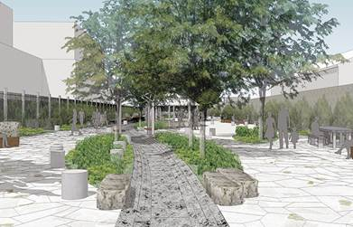

Van Name Van Pelt Plaza/Richmond Terrace Wetlands
Richmond Terrace between Van Pelt Street and Van Name Street, Staten Island
A project by the Department of Parks & Recreation and the Department of Transportation
Department of Parks & Recreation In-House Design

The Van Name Van Pelt Plaza/Richmond Terrace Wetlands is a gathering space that can be programmed for educational use and features engraved maps that describe the evolution of the island in relation to the waterway. Woody understory and herbaceous planting in the wetland park increase shoreline resilience. The design prioritizes public access to the waterfront while preserving the wetlands and enhancing avian habitat.

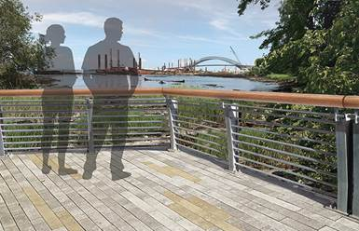

Luminescence by Nobuho Nagasawa
The Peninsula, Hunter’s Point South Waterfront Park, 54th Avenue, Center Boulevard, 55th Avenue, and the East River, Queens
A project by the Economic Development Corporation and the Department of Parks & Recreation
Nobuho Nagasawa; Thomas Balsley Associates; Weiss/Manfredi Architects

Luminescence consists of seven sculptures, all of which are both beautiful and educational. A phosphorescent material integrated into the surface of each domed shape absorbs sunlight during the day and illuminates the phases of the moon at night with a soft blue glow. Additionally, the concrete and aggregate sculptures are etched with the moon’s pattern of craters, mountains and valleys.

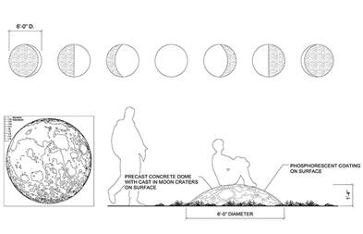

Dock 72
Brooklyn Navy Yard, Brooklyn
A project by the Brooklyn Navy Yard Development Corporation, the Boston Properties, Rudin Development, and WeWork
S9 Architecture; MPFP

Dock 72 embraces rapidly emerging technological and creative industries in Brooklyn with a work environment that encourages and enables hundreds of new and maturing creative startups to flourish. The building’s open and flexible work environments encourage the interaction of people and foster the sharing of ideas, both of which are critical to development of innovative creative communities.

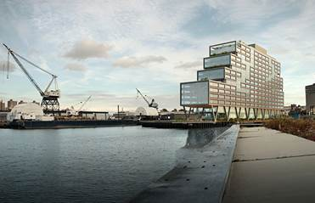

The High Line Park Passage and Spur
West 30th Street between 10th Avenue and 11th Avenue, Manhattan
A project by the Department of Parks & Recreation, the Economic Development Corporation, and Friends of the High Line
James Corner Field Operations; Diller Scofidio + Renfro; Piet Oudolf

The Spur is envisioned as a piazza with amphitheater-like seating steps that surround a central plinth for a rotating art program. The Passage and Spur will offer expansive views, dense woodland plantings, ample public seating, and a large open space for public programming, as well as public bathrooms for High Line visitors.

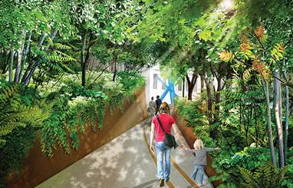

Snug Harbor Cultural Center Music Hall Addition
1000 Richmond Terrace, Staten Island
A project by the Department of Design and Construction, the Department of Parks & Recreation, the Department of Cultural Affairs, and Snug Harbor Cultural Center
Studio Joseph;SCAPE/Landscape Architecture

Outside the public entrance of the Snug Harbor Cultural Center Music Hall addition, a landscaped courtyard and lawn provides flexible space for the Music Hall and Snug Harbor campus. This project will reinvigorate the historic theater, enhancing programmatic opportunities and operational efficiency that enable this cultural gem to put on its distinctive performances.

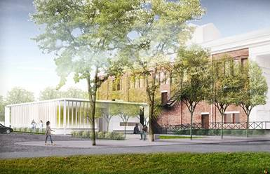

SoHo Square
Sixth Avenue between Spring Street and Broome Street, Manhattan
A project by the Department of Transportation, the Department of Parks & Recreation, and the Hudson Square Connection Business Improvement District
Mathews Nielsen Landscape Architects

The renovation of SoHo Square, an under-utilized open space, will establish a distinct gateway to the thriving hub of Hudson Square. A central focal point at the mid-block crossing will be anchored by the relocated statue of General José Artigas (1987) by José Luis Zorrilla de San Martín, which will be conserved as part of the project.

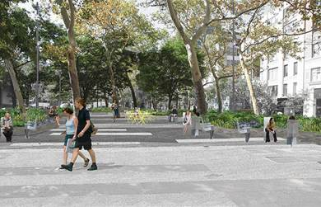

Anti-idling Ambulance Pedestals
Citywide
A project by the Fire Department of the City of New York
Ignacio Ciocchini; MOVE Systems

The anti-idling ambulance pedestals will reduce ambulance vehicle emissions without disrupting the Fire Department’s critical emergency operations. By plugging in to these curbside pedestals, EMTs can safely shut off their engines while keeping their communication systems live and temperature-sensitive medicines refrigerated. This smart industrial design improves neighborhood air quality and ensures that the City’s ambulances are ready to respond to emergencies at a moment’s notice.

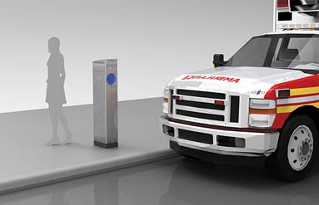

LinkNYC
Citywide
A project by the Department of Information Technology & Telecommunications
CityBridge (Antenna Design, Intersection, Qualcomm, and CIVIQ Smartscapes)

LinkNYC is a new telecommunications network replacing old payphones with “Links” that benefit New Yorkers by offering free services such as high-speed Wi-Fi, mobile device charging, and a custom-built tablet for Internet-access and telephone calls within the United States. The resulting design is user-friendly and strong enough to stand up to life in New York City.

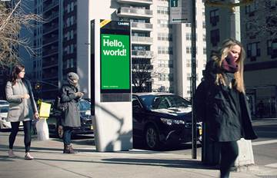

SPECIAL RECOGNITION FOR COMPLETED PROJECTS

Parks Without Borders
Citywide
A project by the Department of Parks & Recreation
Department of Parks & Recreation In-House

Parks Without Borders aims to improve the interface between New York City parks and their surrounding neighborhoods. As part of OneNYC, this initiative aims to make parks more welcoming, accessible, and active. Each design concept will begin at the park edge, with lowered fences and gates, wider and more porous entrances, and improved sightlines into the park.

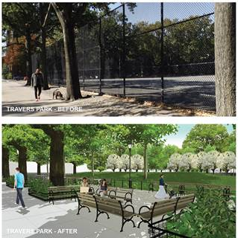

Community Parks Initiative
Citywide
A project by the Department of Parks & Recreation
Department of Parks & Recreation In-House; dlandstudio architecture & landscape architecture; Hargreaves Associates; Mathews Nielsen Landscape Architects; MKW Landscape Architecture; Nancy Owens Studio; Prospect Park Alliance; Quennell Rothschild & Partners; Sage and Coombe Architects

Many bleak, paved yards surrounded by high chain-link fences will be transformed into vibrant green parks with playgrounds for children, animated water play, multi-use courts and fields, sitting areas, and multi-generational community gathering places. The initiative also includes five new and 15 reconstructed comfort stations and incorporates green infrastructure to manage on-site and street storm water runoff.





