
FOR IMMEDIATE RELEASE: November 2, 2023
CONTACT: pressoffice@cityhall.nyc.gov, (212) 788-2958

MAYOR ADAMS KICKS OFF ANNUAL “DUSK AND DARKNESS” CAMPAIGN TO PROMOTE STREET SAFETY DURING DANGEROUS TIME OF YEAR

As Daylight Saving Ends, Streets Become More Dangerous in Evenings and at Night, Especially for Pedestrians and Cyclists

Elementary and Middle Schools Students from Queens and Bronx Named Winners of “We’re Walking Here!” Contest for “Hip Hop 50” Safety-Themed PSA Videos

NEW YORK – New York City Mayor Eric Adams today kicked off the 2023 edition of the annual “Dusk and Darkness” public safety campaign to keep New Yorkers safe on city streets, ahead of the end of daylight-saving time this Sunday, November 5. With the city on track for a lowest number of pedestrian deaths in recorded history in 2023, the campaign this year focuses on the scourge of reckless driving, with expanded New York City Police Department (NYPD) enforcement of dangerous moving violations during the evening and overnight hours that have traditionally proven most dangerous to pedestrians. Returning for its third consecutive year, after a one-year pause and its seventh year overall, Dusk and Darkness focuses the city’s suite of street safety tools and resources during this time of year, and during particular times of day, when the risk of a traffic crash is heightened.

Mayor Adams also congratulated students from I.S. 59Q in Springfield Gardens, Queens and an afterschool program at the Jamaica YMCA, as well as Elm Tree School in Corona, Queens and P.S. 396X and P.S. 723X in the Bronx, for creating the winning public service announcement (PSA) videos in the city’s “We’re Walking Here” contest. The contest challenged New York City school students, in celebration of the 50th anniversary of hip hop, to create hip hop-themed public service announcement videos to warn of the perils of traffic violence. The winning videos are available online and will be incorporated into a new Vision Zero traffic safety curriculum to be used this academic year.

“We’re taking action across our city to prevent traffic violence, and that’s why we’re on track to hit a historic low for pedestrian fatalities on our streets,” said Mayor Adams. “But one death on our streets is still one too many — and the data shows us that when the clocks fall back, crashes go up. Our targeted ‘Dusk to Darkness’ campaign will help keep our streets safe during rush hour. And because so many of our crashes involve young people, we know that our best messengers to prevent dangerous driving are young people themselves. As we head into a more dangerous season on our city’s streets, the hard-hitting and accessible messaging produced by the students in our ‘We’re Walking Here’ contest will educate more drivers as well as fellow young people in classrooms on the life-or-death consequences of dangerous behavior on the street.”

“The end of daylight saving is the most dangerous time for pedestrians and drivers,” said Deputy Mayor for Operations Meera Joshi. “Through our proactive ‘Dusk and Darkness’ public outreach and through increased enforcement, we’re reminding drivers to slow down and pedestrians to be vigilant. Everyone deserves to feel safe on our streets.”

“As daylight saving time ends this weekend, all New Yorkers should remain alert on our local streets and highways,” said NYPD Chief of Transportation Philip P. Rivera. “Because this is historically the most dangerous time of the year for pedestrians and cyclists, NYPD officers and traffic agents will be focusing on precautionary measures designed to keep all road users safe — including increased education and enforcement. At the forefront of our public safety mission is prevention and reminding motorists that the decisions they make can save lives.”

“When the sun goes down, risks for pedestrians go up. Through the ‘Dusk and Darkness’ campaign, we want to remind drivers to slow down and remain vigilant as daylight saving time ends,” said New York City Department of Transportation Commissioner Ydanis Rodriguez. “With NYPD officers going after distracted driving and our automated cameras getting drivers to stop at red lights and slow down, we need drivers to do their part as well as the sun sets earlier. As we continue our work to make streets safer, I want to offer special thanks to the teams at schools around New York City, who are teaching students about road safety. The ‘We’re Walking Here’ contest allowed students to combine their creativity with a life-saving public service message.”

“Our young people deserve the freedom to move about their communities without fear, and our drivers have a responsibility to obey traffic laws and watch out for pedestrians and cyclists on our city streets,” said New York City Department of Education Chancellor David C. Banks. “I want to congratulate the winners of this year’s ‘We’re Walking Here’ contest and recognize every school who submitted an entry. You are doing the important work of bringing awareness to the dangers of moving violations during the evening and overnight hours to your families and communities. I know I speak on behalf of our entire city when I thank you for your public service.”

“When daylight saving ends, the time to be extra vigilant when it comes to saving lives begins,” New York City Taxi & Limousine Commissioner David Do. “The odds of crashes rise as our light and visibility diminishes, but we know what to do to protect ourselves and each other when behind the wheel: Slow down, take extra precautions when you’re making turns, and be mindful that it will be harder to see pedestrians and cyclists. We’ve made tremendous progress reducing pedestrian deaths and injuries, but the goal of Vision Zero isn’t about one or two or five deaths a year. The goal is zero.”
“The end of daylight saving time brings more hours of darkness and can make us feel drowsy or less alert,” said New York City Department of Health and Mental Hygiene Commissioner Dr. Ashwin Vasan. “Whether you drive, walk, or ride, nighttime — and lower-visibility hours — will come earlier for all of us. Follow the safety tips in the catchy new ‘We’re Walking Here’ videos: Drive the speed limit, drop the distractions, and turn slowly. Your attention can save a life.”

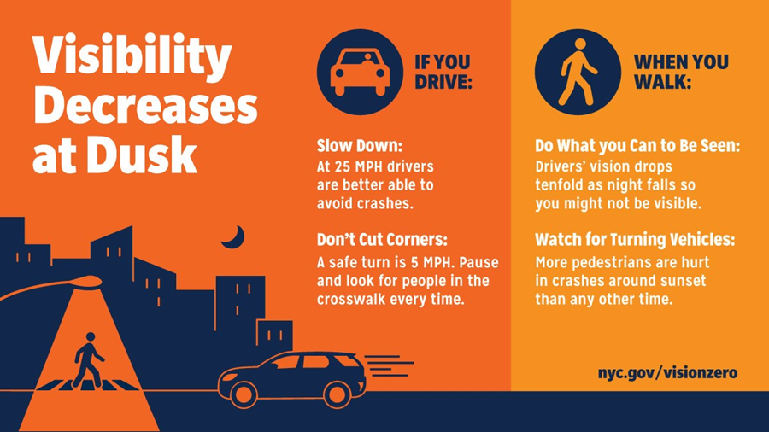
Dusk and Darkness tips for drivers and pedestrians. Credit: New York City Department of Transportation

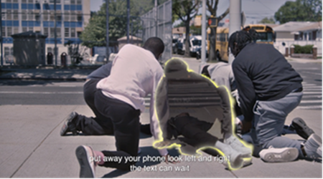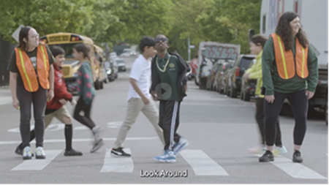

The first- (left) and second-place (right) videos in the “We’re Walking Here” Hip Hop 50 contest, submitted by students from I.S. 59Q and P.S. 211Q, respectively.

The Dusk and Darkness campaign combines proven tactics to combat elevated rates of fatal crashes. During fall evenings, rush hour occurs at a time when sunlight and visibility are dramatically and suddenly reduced, leading to some of the highest fatal crash rates of the calendar year. In the past, this campaign has improved safety on city streets — reducing the average number of evening and overnight fatalities each year by 13.5 percent over the years it has been in place as compared to the five years prior. During this period, the average number of pedestrian fatalities declined 21.7 percent, and the average number of motor vehicle occupant fatalities dropped by 25.8 percent.

The Dusk and Darkness campaign this year includes the following initiatives:

Day of Awareness: Prior to clocks “falling back” early Sunday morning, November 5, DOT and NYPD Vision Zero Street Teams will undertake community engagement efforts this Saturday at high-visibility locations across the five boroughs to remind commuters of the increased dangers of traffic crashes during the fall evening and overnight hours.

Increased Evening and Overnight Enforcement: Starting in late October, the NYPD increased enforcement in preparation for the Dusk and Darkness campaign. Focused on the late afternoon and evening shift, NYPD officers are deployed on highways and local streets, focusing on driving behavior that endangers vulnerable road users. Officers will enforce hazardous driving violations — with a focus on drivers who speed, disobey traffic signals, fail to yield to pedestrians, and drive distracted — to keep pedestrians and cyclists, especially older adults and children, safer in neighborhoods throughout the city. NYPD traffic enforcement agents will also improve lines of sight by focusing enforcement on vehicles that are double-parked, obstructing crosswalks, and blocking bike and bus lanes.

Addressing Reduced Driver Perception: As the end of daylight saving time approaches on Sunday, city agencies and other partners will use social media channels to alert drivers to the dangers of lower visibility, while encouraging them to follow the 25-mile-per-hour citywide speed limit and to yield to pedestrians and cyclists throughout the season.

For-Hire Vehicle Driver Safety: TLC will visit areas frequented by for-hire vehicle drivers to remind them of the importance of using extra caution during low-visibility periods, including by driving 25 miles per hour unless otherwise posted. TLC will also reiterate this message to drivers and passengers via social media.

The Dusk and Darkness campaign is a part of New York City’s multi-pronged Vision Zero approach to enforcement, education, and street redesign. At this point in 2023, pedestrian fatalities are at the fewest ever seen in New York City’s 114-year recorded history, while pedestrian deaths nationwide have increased to a 40-year high.

“We’re Walking Here!”: DOT hosts an annual “We’re Walking Here” competition, in which schools compete to develop creative PSAs that encourage walking and give young New Yorkers the platform to communicate with New York drivers. The competition builds on the city’s Vision Zero efforts that aim to educate New Yorkers about shared responsibilities for street safety. The program returned in 2022 after a three-year hiatus caused by the COVID-19 pandemic. As part of the citywide “Hip Hop 50” effort to celebrate New York City’s status as the birthplace of hip hop music 50 years ago, students submitted rap lyrics, informal videos, and dances they created to promote traffic safety. In total, 107 schools registered for the “We’re Walking Here” competition. A final group of 35 elementary and middle schools, representing each of the five boroughs, submitted PSA entries that were evaluated by DOT’s safety education unit for their creativity and messaging.

This year’s “We’re Walking Here” winners are:
- First Place:S. 59Q, Springfield Gardens, Queens, in coordination with the Jamaica YMCA afterschool program
- Second Place (tie): Elm Tree School, Corona, Queens
- Second Place (tie): PS 396X, University Heights, Bronx
- Third Place:S. 723X, Claremont Village, Bronx

“I commend New York City Mayor Eric Adams for prioritizing the safety of pedestrians, cyclists, and residents with this year's installation of the Dusk and Darkness educational campaign,” said U.S. Congressman Adriano Espaillat. “This multi-agency engagement has been proven to increase street safety and reduce traffic crashes and fatalities around our city and makes New York City safer for residents and visitors ahead of the busy holiday season.”
“As daylight saving time ends and our days get shorter, we need to ensure that pedestrians are safe at all hours,” said Brooklyn Borough President Antonio Reynoso. “In New York City, reckless driving has cost far too many lives. Throughout my career in public office, I have called for an increase in preventative programs that will improve street safety and keep all road users – especially those who are most vulnerable — safe. I am glad to see the NYC Department of Transportation and New York City Police Department utilize the “Dusk and Darkness” campaign to help curb reckless drivers. I look forward to continuing to work with government partners on proactive measures to end traffic violence.”
“All those who use our city’s roadways need to be aware of the increased dangers of driving in the early evening following the end of daylight saving time, as we adjust to the earlier onset of darkness,” said Queens Borough President Donovan Richards Jr.. “The Dusk and Darkness campaign reminds us we must all be careful and look out for each other on the roads. Thank you to Mayor Adams, the New York City Department of Transportation, and the NYPD for their efforts to keep motorists, pedestrians and cyclists safe, and congratulations to the students who created the winning PSAs that use hip-hop to promote traffic safety.”
“After daylight saving time ends, the PM commute becomes much more dangerous – especially for pedestrians. This trend is true across the country, and we’re thankful that New York City is taking action to prioritize safety during this period,” said Alec Slatky, managing director, Public and Government Affairs, AAA Northeast. “When the evenings are darker, visibility and alertness are key. Drivers should make sure their lights are in good working order, stay off their phones, and turn slowly so they can spot pedestrians and cyclists on the road.”
###

