
FOR IMMEDIATE RELEASE: May 27, 2025
CONTACT: pressoffice@cityhall.nyc.gov, (212) 788-2958
MAYOR ADAMS KICKS OFF “WE OUTSIDE SUMMER” BY ANNOUNCING NEW EFFORT TO TRANSFORM VACANT, ABANDONED LOTS INTO GREENSPACE ACROSS NEW YORK CITY
Adams Administration Has Committed $80 Million to Acquire New Parkland Since Taking Office
Targeted Acquisitions in Neighborhoods Without Parks Access Will Bring New Greenspaces to Communities That Need Them Most
City Has Added Over 86 Acres of Parkland During Adams Administration, Bringing Greenspace to an Additional 37,000 More New Yorkers
“We Outside Summer” Kicks Off, Will Include Range of Announcements, Investments, and Programs Across Five Boroughs
NEW YORK – New York City Mayor Eric Adams and New York City Departments of Parks and Recreation (NYC Parks) Commissioner Sue Donoghue today announced a new effort to transform vacant, abandoned lots into green space for New Yorkers and put more residents of the five boroughs within walking distance of a park. Since taking office, the Adams administration has committed a total of $80 million to expand New Yorkers’ access to the citywide greenspace network — $50 million has already been spent over the past three years to acquire new parkland in all five boroughs, adding over 86 acres of parkland and bringing greenspace within a 10-minute walk of an additional 37,000 New Yorkers.
As part of the “Vital Parks for All” initiative, Mayor Adams announced that an additional $30 million was being allocated to transform vacant, underutilized, and abandoned lots into parkland, playgrounds, and open green space in neighborhoods that do not currently have access to such space. By transferring land from other city agencies and using neighborhood-wide Uniform Land Use Review Procedure (ULURP) applications, this initiative furthers the Adams administration’s work to ensure that more New Yorkers live within a 10-minute walk of a park. Mayor Adams announced the start of this effort with the submission of the first two neighborhood-wide ULURP applications in Brooklyn and Queens earlier this month.
Mayor Adams used today’s announcement to also kick off “We Outside Summer,” a new initiative that will include a series of announcements, events, investments, and new programming across the five boroughs to ensure New Yorkers have a safe, enjoyable summer.
“As we kick off the 'We Outside Summer,' we know New Yorkers across the five boroughs are looking for more places to enjoy the warmer weather with friends and loved ones,” said Mayor Adams. “Today, we're announcing a new effort to turn vacant, abandoned lots into parks — bringing more green spaces to neighborhoods across New York City that don’t currently have access to them. This initiative builds on our administration's commitment to put a park within walking distance of a park because access to parks is critical, and as summer arrives, we're working hard to deliver green spaces to the areas most in need across the five boroughs.”
“Parks aren’t just a nice to have — they’re a need-to-have. New Yorkers find respite in the public realm, a place to connect and recharge outside,” said Deputy Mayor for Operations Jeff Roth. “There’s no better way to celebrate the summer than by creating new outdoor spaces in busy neighborhoods, like Jackson Heights and East New York, within walking distance of tens of thousands of New Yorkers who went without these space for too long. We look forward to continuing this process with local communities.”
“Access to high-quality parks is not a luxury, it is a necessity for the health and wellness of our communities. Expanding our green spaces is just one of the ways we’re making New York City the best place to raise a family,” said NYC Parks Commissioner Donoghue. “We’re committed to supporting creative efforts to add more open space in the city so that every New Yorker — regardless of your zip code — has room to play, grow, and gather outside.”
“In just three and a half years, we’ve added the equivalent of over 86 football fields of new public space — and NYC Parks has been a critical partner in that transformation” said Chief Public Realm Officer Ya-Ting Liu. “By turning vacant, underutilized lots into parks, we are working towards making sure as many New Yorkers have easy, local access to the public realm. These are the kinds of investments that bring neighborhoods together and spark joy and connection in our shared public spaces.”
The acquisition plan includes multiple strategies, including pursuing neighborhood-wide ULURP applications in communities that lack access to parkland. In collaboration with the New York City Department of City Planning (DCP), NYC Parks has identified 19 community districts that are underserved by the existing parks network and has begun submitting one ULURP application per community district, encompassing many smaller sites within the district. While not every site included in the applications will be acquired, the successful ULURP applications will allow NYC Parks to purchase the sites, pending a willing private seller.
Mayor Adams’ Get Stuff Build initiative made this new strategy possible – neighborhood-scale ULURPs – which allow multiple locations to go through the ULURP process in one application, thus cutting red tape and bureaucracy throughout city government. NYC Parks recently submitted ULURP applications for 44 sites in the first two communities identified through this initiative: Brooklyn Community District 5, which includes East New York and Cypress Hills, and Queens Community District 3, which includes Jackson Heights, East Elmhurst, and Corona. Not all of the sites will be turned into parkland, and additional community districts and sites will be shared in the coming months.
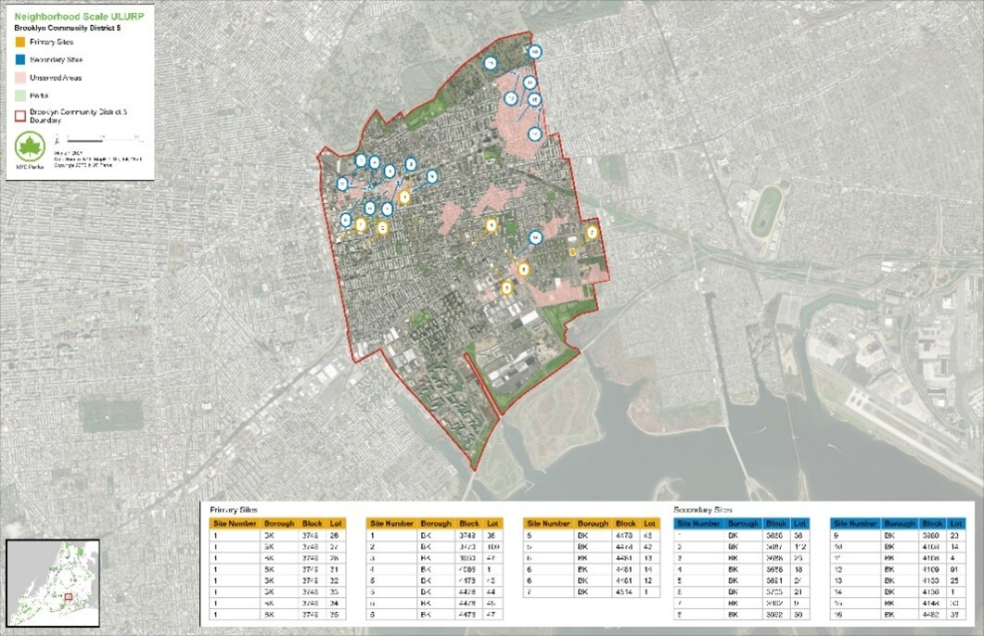
Brooklyn Community District 5 sites. Credit: NYC Parks
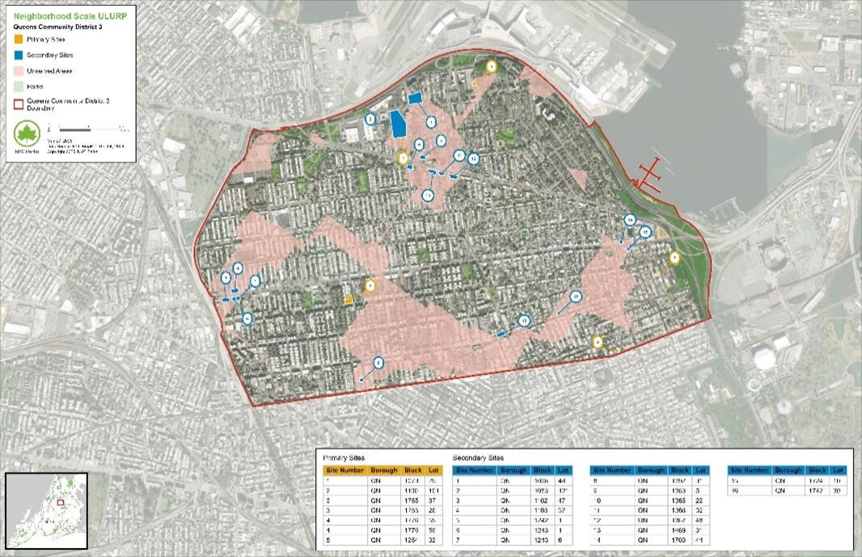
Queens Community District 3 sites. Credit: NYC Parks
In addition to acquisitions from private property owners, NYC Parks also plans to acquire new parkland through transfers from other city agencies. The majority of new acquisitions by NYC Parks over the past three years have been property transfers from other agencies at no cost. To advance the Adams administration’s priority of building more affordable housing, NYC Parks collaborated with DCP and the New York City Department of Housing Preservation and Development to determine which sites were better suited for housing development or parkland, depending on factors like size, location, and status of adjacent properties.
Since the beginning of his administration, Mayor Adams has made transforming the city’s public spaces for families to enjoy a central focus, creating over 85 football fields of new public spaces and adding 86.5 acres of parkland, from smaller additions like a new overlook at Starlight Park in the Bronx to major public space projects like the new Freshkills Park in Staten Island on the site of a former landfill. In his 2025 State of the City address, Mayor Adams announced that New York City will open more schoolyards in underserved neighborhoods for use during the summer, after school, and on the weekends, and put another 20,000 individuals within a 10-minute walk of a park. By transforming these vacant, abandoned lots into green space for New Yorkers, this announcement builds on Mayor Adams’ State of the City commitment to give even more New Yorkers in under-resourced areas access to valuable public spaces as his administration continues its efforts to make New York City the best place to raise a family.
###

