From: Eileen Sullivan [mailto:esullivan@rubenstein.com]
Sent: Wednesday, March 16, 2016 11:07 AM
To: Negash, Dabash
Subject: More than 150 CEO’s, Presidents, Executive Directors, and Founders of New York Nonprofits Attend Summit to Strategize Utilizing Volunteers
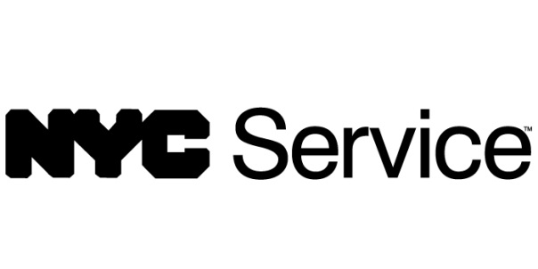
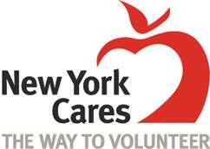

Contact: Eileen Sullivan (Rubenstein Communications, Inc.) – 212-843-8016, esullivan@rubenstein.com

***Photos Available Upon Request***

MORE THAN 150 CEO’s, PRESIDENTS, EXECUTIVE DIRECTORS, AND FOUNDERS ATTENDED SUMMIT ON STRATEGICALLY UTILIZING VOLUNTEERS TO BUILD CAPACITY AND SERVE MORE NEW YORKERS

Attendees Explored How Volunteers Can Help NYC’s 30,000 Nonprofits Maximize
Their Resources

(New York, NY, March 16, 2016) – New York City nonprofit organizations operate in a city where 47% of the population falls within the poverty line and the need in the community is outpacing many sources of funding. The strategic engagement of volunteers to grow services is critical to supporting more New Yorkers and offers a powerful way for agencies to get the most out of their current assets.

To explore this important issue in depth, more than 150 CEO’s, presidents, executive directors, and founders of New York nonprofits attended a volunteer summit on Wednesday, March 16, 2016 to share success stories, tools, and opportunities to grow volunteerism in NYC, and to discuss effective volunteer management as a bottom-line strategy.

Co-sponsored by NYC Service and New York Cares, nonprofits shared how organizations that think strategically about engaging their volunteers are able to accomplish more for New Yorkers and do so in a cost-effective manner. The summit was hosted at the office of UJA-Federation of New York in Manhattan.

Paula Gavin, NYC Chief Service Officer, kicked off the summit by outlining the important role nonprofits play in New York City, and discussed the need to increase the city’s 18% volunteer rate, which falls behind the 25% volunteer rate nationally.

“Making the Most of Your Resources: A Strategic Look at How Volunteers Can Add Real Value to your Nonprofit” also included remarks from Gary Bagley, Executive Director of New York Cares, and Eric S. Goldstein, CEO of UJA-Federation of New York.

“Volunteerism is essential to building stronger communities,” said Mayor Bill de Blasio. “Those who serve help mold our city into safer, cleaner, equitable and more inclusive spaces. I applaud the efforts of NYC Service and New York Cares in garnering more volunteers to continue to strengthen communities across the five boroughs.”

“Volunteerism is a catalyst for civic engagement,” said NYC Chief Service Officer Paula Gavin. “Strategically engaging more New Yorkers as volunteers will allow you to better support, improve, and expand your services, and also help shape the future of individuals and our communities.”

“Volunteers increase our ability to achieve our objectives and more effectively fulfill the mission of our organizations,” said Gary Bagley, Executive Director of New York Cares. “By making volunteers a core function of your operations, your nonprofit will become more adaptable, sustainable, and capable of going to scale.”

The summit included a raffle of free, customized mentoring and training by New York Cares for five New York nonprofits.

About New York Cares
New York Cares is the largest volunteer network in the city. Last year, 63,000 New Yorkers made the city a better place by volunteering in New York Cares programs at 1,350 nonprofits and schools – improving education, meeting immediate needs, and revitalizing public spaces. For more information, visit newyorkcares.org.

About NYC Service
NYC Service, a division of the Office of the Mayor, promotes volunteerism, engages New Yorkers in service, and mobilizes the power of volunteers and service year members to impact New York City's greatest needs. To learn more about NYC Service and volunteer opportunities in New York City, visit nyc.gov/service.
###

