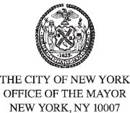
FOR PLANNING PURPOSES
CONTACT: pressoffice@cityhall.nyc.gov, (212) 788-2958
UPDATED PUBLIC SCHEDULE FOR MAYOR ERIC ADAMS
FOR THURSDAY, JANUARY 16, 2025
***Updated Schedule***
On Thursday, New York City Mayor Eric Adams will travel to Palm Beach, Florida for a meeting with U.S. President-elect Donald Trump tomorrow.
###

