
FOR IMMEDIATE RELEASE: May 21, 2025
CONTACT: pressoffice@cityhall.nyc.gov, (212) 788-2958

MAYOR ADAMS ANNOUNCES NEW INVESTMENTS,
TOTALING OVER $400 MILLION, TO FULLY FUND
TRANSFORMATION OF FIFTH AVENUE INTO WORLD-CLASS,
PEDESTRIAN CENTERED BOULEVARD AS PART OF “BEST BUDGET EVER”

$250 Million in New Investments for Future of Fifth Will Strengthen
Historic Corridor’s Economic Engine and Increase Job Creation, Making New York City
More Affordable by Providing Good-Paying Jobs for Working-Class New Yorkers

Plan Includes Widened, Greened Sidewalks, Prioritizing
Pedestrians, and Expanded Public Space

Since 2022 Project Launch, Corridor Has Seen Nearly $4 Billion in
Real Estate Sales, Showing Significant Enthusiasm in Future of Fifth

Announcement Follows Mayor Adams’ Unveiling of “Best Budget Ever,” Which Invests in
Affordability, Public Safety, and Quality-of-Life Issues New Yorkers Care Most About

NEW YORK – New York City Mayor Eric Adams today announced that total investments of over $400 million to fully fund the city and the Future of Fifth Partnership's plan to transform Fifth Avenue — between Bryant Park and Central Park — into a world-class, pedestrian-centered boulevard, cementing the iconic corridor's status as a catalyst for economic growth and job creation in New York City. Mayor Adams is providing an additional $250 million in new investments today to build on the $152.7 million initial investment he first announced in December 2024. Part of Mayor Adams’ Fiscal Year 2026 Executive Budget — referred to often as the city’s “Best Budget Ever” — the total $402 million project represents the first major redesign in the avenue's 200-year history and is projected to pay for itself in less than five years through increased property and sales tax revenue. The project is the culmination of years of support building through the administration’s remarkably successful Holiday Open Streets along Fifth Avenue. The event temporarily pedestrianized the avenue and nearby streets for the holiday season and boosted the sales of nearby businesses.

“Fifth Avenue is a bustling boulevard of shopping, restaurants, businesses, and tourism, with more people walking down the street every hour than fill Madison Square Garden during a sold-out Knicks game. Thanks to hundreds of millions of new dollars we are infusing into Fifth, we are finally making what has been called ‘America’s Street of Dreams’ a pedestrian paradise by making it more walkable, greener, and safer,” said Mayor Adams. “Thanks to our ‘Best Budget Ever,’ we are bringing total investments up to over $400 million as we reclaim space for New Yorkers, their families, and tourists, and cement Fifth Avenue’s status as an economic engine and job creator for all five boroughs. What’s more is that these investments will pay for themself within five years of completion, marking a huge win for New York City. Thank you to the Fifth Avenue Association, Grand Central Partnership, Central Park Conservancy, and the Bryant Park Corporation, as well as our local elected officials, for their partnership throughout this generational project.”

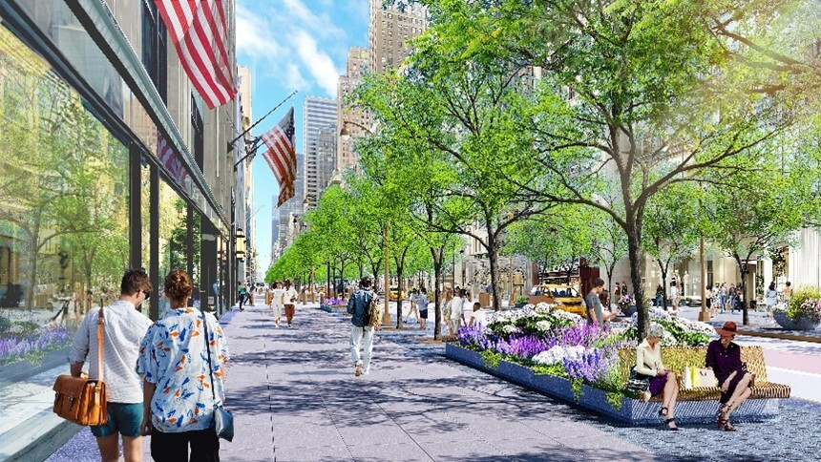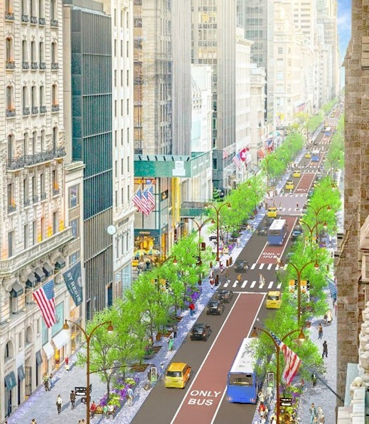
Courtesy of the New York City Economic Development Corporation

“Fifth Avenue has long been our ‘Street of Dreams,’ so it’s time to invest in its future,” said First Deputy Mayor Randy Mastro. “And when this project is done, from Midtown Manhattan to Central Park, we will have a tree-lined, pedestrian mecca that rivals the Champs Elysees thanks to Mayor Adams’ foresight and commitment to this transformational project. The greatest city in the world deserves to have the greatest boulevard in the world, and now, we will have it.”

“Strolling Fifth Avenue during the holidays and year-round should be a delight, not a contact sport,” said New York City Chief Public Realm Officer Ya-Ting Liu. “Thanks to $400 million in funding from the Adams administration, in partnership with Madelyn Wils and the Fifth Avenue Association, it will be. This iconic boulevard is getting the above- and below-ground upgrades it deserves, not only to deliver a great personal experience for the people who live, work, and visit the avenue, but support its outsized economic and social role in our city.”

“This historic investment is going to reinvigorate one of the world’s most important streets and set the stage for another triumphant 200 years on Fifth Avenue,” said Madelyn Wils, CEO, Fifth Avenue Association, and co-chair, Future of Fifth Steering Committee. “Hundreds of thousands of people come to Fifth Avenue every day — and most of them are pedestrians. This visionary plan will rebalance and reinvigorate Fifth Avenue to better serve both New Yorkers and tourists alike. I applaud Mayor Adams for his leadership in advancing this bold vision for Fifth Avenue and look forward to partnering with the city on turning it into a reality.”

Fifth Avenue is currently 100 feet wide, comprised of five lanes of vehicular traffic and two 23-foot sidewalks. Even though pedestrians make up 70 percent of all traffic on the corridor, sidewalks account for only 46 percent of the space. Each block serves approximately 5,500 pedestrians an hour on an average weekday and up to 23,000 people an hour during the holidays — the equivalent of a full Madison Square Garden plus 4,000 additional people. The current configuration can no longer accommodate this volume of foot traffic, especially given that only 15 feet on either side is unobstructed for walking; the rest is occupied by street infrastructure like signage, bus stops, lighting, and trash cans.

The redesign along this stretch of Fifth Avenue will expand sidewalks by 46 percent, shorten pedestrian crossings by a third, reduce the number of traffic lanes from five to three, and add plantings and lighting to make for a more walkable, greener, and safer avenue. The city will begin construction to update much-needed underground sewer and water main upgrades, which will enable underground and aboveground work to be done concurrently and efficiently.

The design nearly doubles the width of the sidewalks to 33.5 feet each, expanding clear pedestrian space to 25 feet on each side and adding another 8.5-foot-wide section for trees, planters, and an alternative pedestrian path. These changes will reduce crossing lengths by more than a third, boosting pedestrian safety along the avenue. Beyond rebalancing Fifth Avenue's space to reflect its usage, the new design also greens the corridor with more than 230 new trees and 20,000 square feet of planters, new seating and activation space, better lighting, and more.

Greening Fifth Avenue will create additional shade cover to protect against heat and innovative stormwater infrastructure to prevent flooding. The design draws inspiration from Fifth Avenue's historic landmarks and art deco influences, heightening the iconic architectural features integral to the avenue's visual identity. It is also inspired by other iconic shopping street redesigns, including the Champs Elysees in Paris; Calle Serrano in Madrid; Bond, Oxford, and Regent Streets in London; and Ginza in Tokyo. The effort builds on the core tenets of the "New" New York action plan, which identified public space as a key force for the city's economic recovery.

Fifth Avenue has long been a major driver of economic growth for New York City. The avenue is responsible for 313,000 direct and indirect jobs, which, in turn, generate $44.1 billion in total wages and $111.5 billion in total economic output each year. Moreover, since Mayor Adams announced this project in December 2022 , Fifth Avenue has experienced an unprecedented wave of investment in commercial renovations, record-breaking sales, and leasing activity. Since 2023, there have been more than 10 commercial real estate sales on Fifth Avenue, totaling $3.9 billion. And while the street has made huge strides in rebounding from the COVID-19 pandemic — with 80 percent of foot traffic having returned — this project will help propel this growth and attract more people back to this vital stretch of Fifth Avenue for decades to come.

In 2023, the Adams administration launched the Future of Fifth public-private partnership, which brings city agencies together with the Fifth Avenue Association, the Grand Central Partnership, the Central Park Conservancy, and the Bryant Park Corporation to further this project. The group selected firms Arcadis, Sam Schwartz, and Field Operations to lead the design and study, and schematic design is underway and slated for completion by the summer of 2025.

“The redesign of Fifth Avenue will help turn this iconic corridor into a world-class public space that’s safer, more vibrant, and welcoming for everyone who walks, shops, and works there,” said New York City Department of Transportation Commissioner Ydanis Rodriguez. “Thanks to critical funding from the Adams administration, we’re transforming this iconic street into a greener, more accessible space that reflects the needs of a thriving city. The Future of Fifth is a bold investment in our public realm — and a major step toward making this project a reality.”

“This investment in the transformation of Fifth Avenue is a major step forward for public space,” said New York City Parks Commissioner Sue Donoghue. “By expanding sidewalks, planting hundreds of shade-giving trees, and integrating green infrastructure, we’re not only making the corridor more beautiful — we’re creating a more sustainable, livable city. Our agency is proud to support a project that reflects a shared commitment to a greener, more pedestrian-friendly future for New York.”

“Transforming Fifth Avenue, from Bryant Park to Central Park, to better serve the flow of pedestrian traffic also means investing in the vital underground infrastructure that keeps our city flowing,” said New York City Department of Environmental Protection (DEP) Commissioner Rohit T. Aggarwala. “This redesign presents a unique opportunity for DEP to efficiently upgrade century-old water mains and sewer pipes along this iconic corridor, while our project partners carry out aboveground improvements. Thanks to Mayor Adams’ leadership, the creation of a world-class public space on this renowned stretch of Fifth Avenue is now within reach.”

“New York City’s Fifth Avenue is a global destination that has long been an engine for the city’s bustling economy” said New York City Economic Development Corporation President and CEO Andrew Kimball. “This historic investment will transform the iconic thoroughfare into a safer, greener, and more accessible pedestrian-centric area, poised to drive economic activity and job creation for the city. The Future of Fifth project symbolizes this administration’s commitment to leveraging public space as fuel to bolster our economy, and deliver 24/7 live, work, and play neighborhoods.”

“This transformative investment reaffirms Fifth Avenue’s status as one of the world’s most iconic destinations. said Hilary Spann, executive vice president, New York Region, BXP. “With the mayor’s support, we’re creating a more elegant, accessible, and pedestrian-focused corridor — one that will continue to attract global businesses and serve as a vibrant hub for generations to come.”

“Fifth Avenue is one of the world’s most famous and iconic commercial corridors and its significance and vitality will only multiply by the financial commitment being made by Mayor Adams and his administration,” said Fred Cerullo, president and CEO, Grand Central Partnership. “Implementing this new plan will strengthen the continued revitalization and envisioning of Midtown East and serve to establish a whole new Future of Fifth!”

“As a proud member of the Fifth Avenue community, Kering is enthusiastic in its support of this powerful investment in the city’s future,” said Ewa Abrams, president, Kering Americas. “The Future of Fifth is a visionary reimagining of this iconic corridor that will transform Fifth Avenue into a greener, more accessible, world-class promenade that meets the elevated expectations of discerning travelers from around the globe and New Yorkers alike.”

“The Future of Fifth Project is an ambitious initiative that will further cement Fifth Avenue's position as a global destination for luxury commerce,” said Melissa Xides, chief retail officer, Bergdorf Goodman. “This storied thoroughfare is central to the history of New York City and the Fifth Avenue Association's visionary plan lays the foundation for a flourishing future that residents and visitors alike will share.”

“We’re thrilled to see the Future of Fifth project moving forward,” said Dan Biederman, president, Bryant Park Corporation. “Fifth Avenue’s streetscape has long needed a thoughtful update, and we’re proud that Bryant Park anchors one end of this ambitious plan.”

“This project represents a new Fifth Avenue not only for shoppers and tourists, but for all New Yorkers who live and work in the neighborhood,” said Ed Hogan, board chair, Fifth Avenue Association; and executive vice president and head of retail leasing, Vornado Realty Trust. “The goal is to transform Fifth Avenue to become the most beautiful street in the city with a design that prioritizes pedestrians. This project will bring more customers to the stores and encourage them to stay longer. A renovated Fifth Avenue will enhance the desirability of the Plaza District and midtown office markets. Beautifying Fifth Avenue, the front door to New York City, will re-energize Midtown Manhattan at a critical moment. I thank Mayor Adams for his leadership and commitment to delivering the type of high street that's worthy of our great city.”

“The Future of Fifth plan is a bold initiative that will transform Fifth Avenue between Central Park and Bryant Park into a world-class, pedestrian-friendly boulevard,” said Betsy Smith, president and CEO, Central Park Conservancy. “I commend Mayor Adams for steering this public-private partnership and committing the necessary resources to get the job done. The Central Park Conservancy is proud to have partnered on a plan that will bring beautiful new trees, plantings, and more pedestrian space to every single block and restore a sense of refinement to one of the busiest thoroughfares in the world.”

###

