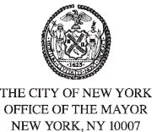
FOR PLANNING PURPOSES
CONTACT: pressoffice@cityhall.nyc.gov, (212) 788-2958
PUBLIC SCHEDULE FOR MAYOR ERIC ADAMS
FOR FRIDAY, JANUARY 17, 2025
On Friday, New York City Mayor Eric Adams will hold his daily meeting with senior administration officials. This event is closed press.
Later, the mayor will meet with U.S. President-elect Donald J. Trump to discuss New Yorkers’ priorities. This meeting is closed press.
Finally, the mayor will travel back from Palm Beach, Florida to New York City.
Press Schedule
Approximately 8:00 AM – Meets with Senior Administration Officials
Approximately 1:00 PM - Meets with President-Elect Trump
###

