From: Hoy, Seth (CCHR) [mailto:SHoy@cchr.nyc.gov]
Sent: Monday, September 26, 2016 12:58 PM
To: Hoy, Seth (CCHR)
Subject: DE BLASIO ADMINISTRATION ANNOUNCES COMMUNITY AND MEDIA OUTREACH EFFORTS ACROSS CITY TO COUNTER WAVE OF NEGATIVE RHETORIC TARGETING MUSLIM COMMUNITIES

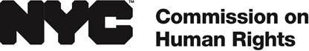

FOR IMMEDIATE RELEASE: September 26, 2016
CONTACT: Seth Hoy, shoy@cchr.nyc.gov, 212-416-0156

DE BLASIO ADMINISTRATION ANNOUNCES COMMUNITY AND MEDIA OUTREACH EFFORTS ACROSS CITY TO COUNTER WAVE OF NEGATIVE RHETORIC TARGETING MUSLIM COMMUNITIES

Across the country, hateful speech has made Muslim residents the target of misguided attacks and threats, especially in the aftermath of terrorist incidents.

City agencies, in conjunction with community groups, are announcing ongoing outreach events and a social media campaign that promote religious diversity and support for Muslim New Yorkers who make vital contributions to the economic, professional, and cultural life of our City

NEW YORK—The Mayor’s Community Affairs Unit and Office of Immigrant Affairs and the Commission on Human Rights announced today a series of ongoing events and a new social media ad campaign that promote respect, understanding, and support for the City’s diverse Muslim communities. There are roughly 3.3 million Muslims living across the United States, according to estimates, with thousands living in New York City.

“Now more than ever, it is important for every New Yorker to stand united as one city and reject hate and violence,” said Mayor Bill de Blasio. “In New York, everyone deserves to be treated with respect. Christian, Muslim, Jewish, Sikh, Hindu, Agnostic, and Atheist — it doesn’t matter. We are all New Yorkers and we all deserve to live safely and free from hatred or discrimination. We will not tolerate discrimination or violence of any kind and we will not rest until all New Yorkers, including our Muslim brothers and sisters, are treated with the dignity they deserve.”

“In New York City, our diversity is our strength,” said Commissioner and Chair of the NYC Commission on Human Rights Carmelyn P. Malalis. “We cannot and will not let xenophobia or violence against hard working Muslim families or any other group become the norm in New York City. Muslim New Yorkers are our police, our teachers, our small business owners, and our neighbors. The Commission is fighting discrimination in all its forms and continues to ramp up public education efforts to bridge cultural divides and foster respect among the City’s diverse communities. In New York City, we embrace our differences. They do not divide us.”

“To combat xenophobia and Islamophobia, we must come together in solidarity to develop strategies against it,” said Commissioner Nisha Agarwal of the Mayor’s Office of Immigrant Affairs. “Our recent convening with Muslim community leaders, immigrant advocates, and refugee rights advocates is leading to the creation of a shared action plan.”

“New York City’s Muslim communities are diverse, increasingly engaged in local political life, and deserve to be celebrated alongside other communities,” said Commissioner of the Mayor’s Community Affairs Unit Marco Carrión. “We are working diligently to engage this community on a range of issues, from affordable housing to education and public safety to deepening their civic engagement.”

According to researchers and law enforcement officials, reports of attacks and threats against Muslims have surged nationally, most likely fueled by national and international terrorist attacks and political vitriol. The NYC Commission on Human Rights, the City agency charged with fighting discrimination, has increased investigations into discrimination based on race, national origin, and religion in New York City by more than 60 percent over the last two years.

While City agencies, including the NYPD, continue to engage Muslim and immigrant leaders to better protect and respond to the needs of their communities, the City is ramping up its support for Muslim New Yorkers to respond to recent events.

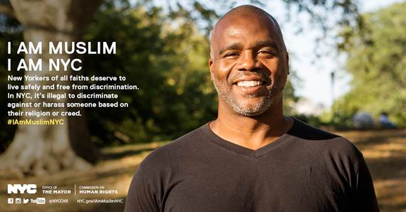

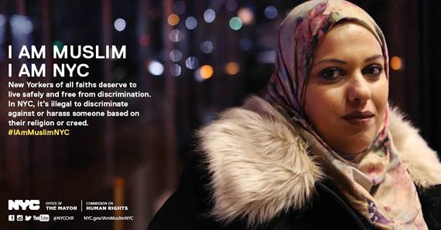

The City is hosting and participating in an ongoing series of events and public outreach efforts to support Muslim, refugee, and immigrant communities, including:

• Launching a digital ad campaign today led by the NYC Commission on Human Rights to promote respect and understanding of Muslim communities and underscore anti-discrimination protections under the NYC Human Rights Law. The ads will appear on Facebook, Instagram, and Twitter with the hashtag #IamMuslimNYC. The ads will direct traffic to NYC.gov/iammuslimnyc, which will list resources, events, and calls-to-actions in an effort to support and serve Muslim New Yorkers.

• Hosting Community Safety and Fair Treatment Forums with the NYPD, the Mayor’s Community Affairs Unit, NYC Commission on Human Rights, Department of Health and Mental Hygiene, and the Department of Education to discuss public safety concerns on the streets and in our schools, anti-discrimination protections under the law, and information on accessing City services.

• Developing a cultural competency workshop with the input of community leaders, including and the Islamic Center at NYU, called “Understanding Islam” to help City employees and public and private employers citywide better understand the Islamic faith and to dispel common myths. The NYC Commission on Human Rights will launch a pilot workshop in October 2016.

• Increasing public outreach and awareness efforts on religious protections under the NYC Human Rights Law, including issuing a new fact sheet explaining protections against religious discrimination with a focus on Muslim communities and a new brochure on protections against religious discrimination under NYC Human Rights Law with practical examples to identify discrimination in the workplace, housing, and public accommodations. These materials will soon be available in several languages.

• Hosted a “Building Inclusive and Progressive Cities” forum with Mayor de Blasio and the Mayor of London Sadiq Khan, along with Muslim leaders and community members, to discuss how New York City and other cities can better address Islamophobia and prevent hate crimes and other acts of discrimination.

• Convened Muslim, immigrant, and refugee groups to unite communities facing hate and violence and discuss shared actions the City and communities can take to combat xenophobic rhetoric, including a joint multi-sector action plan to join together and push back.

• Launching a citywide media campaign in late spring 2017 to educate New Yorkers on combatting xenophobia and embracing religious diversity, and create toolkits for government agencies and non-profits to improve cultural competency with faith-based communities.

Over the last two years, the de Blasio administration has been taking several steps to increase public awareness about NYC’s diverse religious communities and to serve the needs of Muslim communities, including:

• Recognizing Eid al Fitr and Eid al Adha as public school holidays for the first time in the 2015-16 school year.

• Hiring a senior advisor specifically focused on working with City agencies to ensure programs and services reach Muslim communities.

• Improving language access across the City. The Mayor’s Office of Immigrant Affairs develops policy and monitors and coordinates with 75 City agencies to ensure effective translation, interpretation, and "plain language" practices amongst City agencies. At the NYC Commission on Human Rights, 26 languages, including Arabic, French, Hindi, Bengali, Punjabi, Urdu, and Gujarati, are now spoken among law enforcement staff.

• Meeting regularly with Muslim community leaders and making mosque visits to discuss public safety concerns, social services, small business services, mental health, access to universal pre-K, and other issues facing communities.

• Furthering the inclusion of immigrant communities though IDNYC, a government-issued identification card that has over 900,000 unique cardholders and connects New Yorkers to libraries, museums, hospitals, and many City services.

• Convening roundtables and workshops with Muslim leaders and advocates to discuss religious protections under the NYC Human Rights Law and how to report acts of discrimination.

• Celebrating Muslim traditions and increasing cultural literacy through public events, such as Eid celebrations in every borough and iftars throughout the City, including the largest public iftar in City history, “Iftar in the City,” attended by hundreds of New Yorkers.

For additional information on these outreach efforts and digital media campaign, please visit NYC.gov/iammuslimnyc. If you believe you have been discriminated against based on your actual or perceived religion or creed, call 311 and ask for the NYC Commission on Human Rights.

###

“Hate is not a Brooklyn value, and it certainly is not a New York City value either,” said Brooklyn Borough President Eric L. Adams. “Our borough proudly seeks to embrace the rich diversity present within each of us, and fights against any ill-conceived effort to divide us on any measure. We are home to hundreds of churches, mosques, synagogues, and temples where the freedom to worship is exercised every day, and we will defend that right with every breath we have. Brooklynites will rally around our Muslim neighbors at a time when they are being inappropriately targeted with hatred and violence, and we will do the same for any community facing similar ill treatment.”

“The diversity of this great City has made it the best in the world, and in order to make sure we continue to grow, embracing those of all backgrounds and religions will raise everyone’s quality of life” said Councilman I. Daneek Miller. “The initiatives that this administration has taken to embrace the Muslim community have not only benefitted those who believe in our faith, but everyone who lives here as well. I look forward to continuing these efforts and thank Mayor Bill de Blasio for all his support.”

"I welcome the efforts of the de Blasio administration to send a strong message that Muslim New Yorkers are our residents and neighbors with deep ties to our city and nation and they deserve to live with dignity and in safety,” said Executive Director of the Arab American Association of New York Linda Sarsour. “We look forward to working with the different agencies to ensure the success of this city-wide initiative to combat Islamophobia and racism in all its forms.”

“These efforts by the Mayor's office to combat the rising anti-Muslim sentiment and overall xenophobia are essential at a time like this,” said Executive Director of the Islamic Center at NYU Imam Khalid Latif. “Bigotry and hatred against minorities of any kind will be deemed unacceptable only when each one of us does our part to speak out against it. We do not have to be women to stand up for women's rights, black to stand up for black rights, or Muslim to stand up for Muslim rights. An attack on any of us is an attack on all of us and we as New Yorkers should never let our diversity be something we compromise on.”

“We commend the De Blasio administration for organizing this much-needed campaign against xenophobia and hate,” said President of the Muslim Community Network Debbie Almontaser. “We recently mourned the loss of three Muslim New Yorkers who we continue to wonder why their lives were taken. One cannot but wonder that it may be connected to the climate of hate we live in. As more Muslim women experience hate crimes, people of goodwill and New York values must stand against xenophobia and bigotry. The diversity of New York City is what makes it one of the best cities in the world. Our diversity is our strength and we all must do our part in ensuring that hate and divisive politics of fear and ignorance do not divide us or hurt our fellow New Yorkers.”

“It is heartwarming to see the de Blasio administration combat Islamophobia and hate against Muslims in New York City,” said Executive Director for Turning Point for Women and Families Robina Niaz. “Turning Point for Women and Families has been working to address anti-Muslim bullying in public schools and Islamophobia since 2009, so I am very encouraged to see the de Blasio administration take action on this front. By doing so, New York City is sending a clear and strong message that xenophobia and Islamophobia are unacceptable and that people of all religions and backgrounds are valued and respected.”

"The beauty of New York is our differences,” said Executive Director of African Life Center Ramatu Ahmed. “I see our diversity like the rose flowers sprinkling in our city depicting love and unity. As Muslims, we embrace all spectrum of people and their cultures and we accept the common reality to live together in peace and harmony. It is unfortunate that some people live in constant fear of their lives. We should continue to open our doors to dialogue with others as true citizens of America. Peace is the answer.”

“The Southeast Queens Muslim Collective believes that all people should be treated with human decency, said President of the Southeast Queens Muslim Collective Abdus-Salaam Musa. “Everyone is entitled to equal protection under the law.”

