Mayor Adams, DOT Commissioner Rodriguez Take Major Steps To Advance "Dining Out NYC," Nation's Largest Outdoor Dining Program
October 19, 2023
Proposed Rules Offer Clear Guidance for Restaurant Owners, Prioritizing Equity and Expanding Access to Safe, Clean, Rat-Free Outdoor Dining in All Five Boroughs
With Launch of Outreach Plan, City Agencies Will Engage With Local Restaurants and Community Organizations
First Approved "Outdoor Dining NYC" Setups Expected on City Streets in Spring 2024
New York – New York City Mayor Eric Adams and New York City Department of Transportation (DOT) Commissioner Ydanis Rodriguez today took a major step forward to advance "Dining Out NYC" – the city's permanent outdoor dining program and the largest in the country. Beginning today, the Adams administration is launching a public outreach and engagement campaign to solicit feedback on new proposed rules that will give restaurant owners and community members the clear guidance they need for outdoor dining to become a permanent, rat-free staple of the city's streets. DOT – in partnership with the New York City Department of Small Business Services (SBS) – will engage with the local restaurants, business organizations, trade associations, and community groups to solicit feedback on proposed rules for the program. The first approved Dining Out NYC setups are expected to hit New York City streets in spring 2024.
Dining Out NYC represents one of the most significant efforts of the last decade to reimagine the city's streetscape to support all New Yorkers and small businesses, while creating vibrant public spaces that improve quality of life and continue to accelerate the city's economic recovery. The new program draws on lessons learned from the temporary outdoor dining program created during the COVID-19 pandemic, which saved 100,000 jobs across the city but led to quality-of-life issues, as a subset of restaurant owners were unable to maintain loosely regulated outdoor dining setups.
"Outdoor dining saved 100,000 jobs in New York City during the pandemic and gave the five boroughs something New Yorkers had been craving for a long time, and now, thanks to this program, it is here to stay," said Mayor Adams. "Our vision for the program will be developed in close partnership with restaurant owners, diners, and communities, and I am confident it will be a win for our entire city. We are taking the lessons of the temporary pandemic-era program – what worked, what didn't, and what we can improve – and assemble the ingredients for the nation's largest and best outdoor dining program. This public engagement period will allow us to refine the recipe and deliver a delicious final product."
"Outdoor dining is here to stay, and we look forward to getting New Yorkers' feedback on how to make the largest outdoor dining program in the country a success," said Deputy Mayor for Operations Meera Joshi. "Step by step, we are transforming what it feels like to be outside in New York City and making this city a better place to live, work, play, and eat."
"Outdoor dining has made our streets more vibrant public spaces, and Dining Out NYC will provide diners with an enjoyable experience while helping restaurants thrive," said DOT Commissioner Rodriguez. "Dining Out NYC will build upon what has worked and say goodbye to what has not. This public engagement period will help inform program rules and make sure the nation's biggest outdoor dining program is also the best."
"Outdoor dining helped save hundreds of restaurants and thousands of jobs during the pandemic while revolutionizing how New Yorkers experience their city," said SBS Commissioner Kevin D. Kim. "As we begin this next phase of Dining Out NYC, it is important to listen to community stakeholders, small business owners, and everyday citizens on how to make outdoor dining work for everyone. That's why SBS is proud to stand with Mayor Adams and Commissioner Rodriguez as we embark together on this ambitious outreach and education plan."
"I would like to congratulate Commissioner Rodriguez and the Department of Transportation, as well as our Chief Public Realm Officer Ya-Ting Liu, for creating a permanent, world-class outdoor dining program that will boost our small businesses, enhance our streetscapes, prioritize cleanliness, and give people – not rats – a quality dining experience," said New York City Department of Sanitation Commissioner Jessica Tisch.
"Outdoor dining has been a boon to New York City, saving thousands of restaurants and jobs during the worst of the pandemic and transforming our streets for the better," said New York City Department of City Planning Director Dan Garodnick. "As the city moves forward on permanent design rules for Dining Out NYC, it is critical that residents, patrons, and restaurant owners all have a voice. Your input will help the city create a more flexible outdoor dining experience that's cleaner, healthier, safer, and more welcoming."
"Today marks another step closer to the launch of the largest outdoor dining program in the country," said Chief Public Realm Officer Ya-Ting Liu. "Through these proposed rules, DOT and its partner agencies are envisioning a program that works for restaurant owners, patrons, pedestrians, and road users alike. These rules seek to ensure that outdoor dining setups are beautiful, safe, clean, and available to restaurants in all five boroughs."
"These Dining Out NYC proposed rules showcase the city's dedication to comprehensive rodent mitigation," said Director of Citywide Rodent Mitigation Kathy Corradi. "Tackling both the design and management elements of public realm dining spaces, these rules lay a strong foundation of a rat-free outdoor dining program."
"With the release of these Dining Out NYC rules, we are reaching yet another crucial milestone to make outdoor dining a permanent, safe, accessible, and rat-free reality," said "New" New York Executive Director B.J. Jones. "By actively engaging with restaurant owners, community members, and local organizations, the Adams administration is making every effort to balance stakeholder needs to create innovative and inviting ways to enliven neighborhoods across the city."
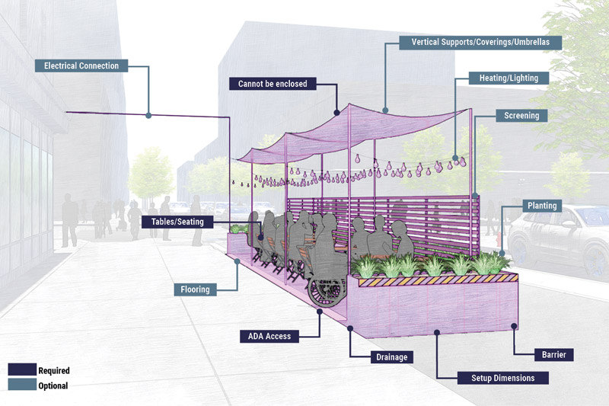
Visualization of Hypothetical Roadway Setup Under Proposed Rules for Dining Out NYC (Credit: New York City Department of Transportation)

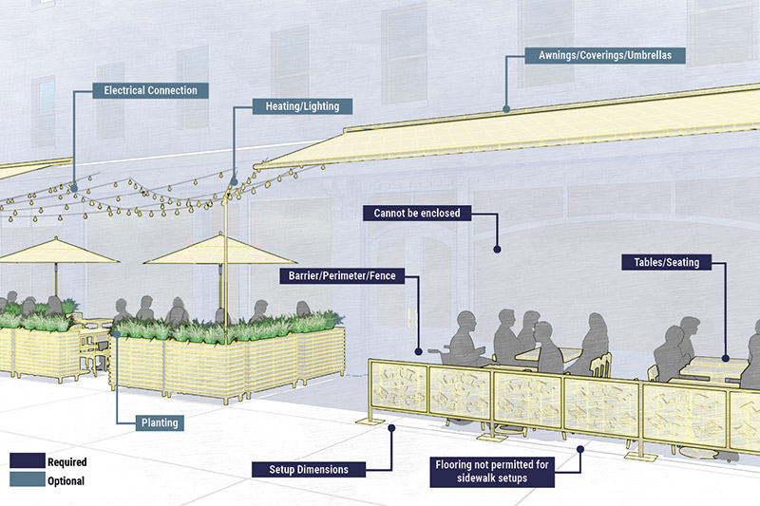
Visualization of Hypothetical Sidewalk Setup Under Proposed Rules for Dining Out NYC (Credit: New York City Department of Transportation)


Visualization of Hypothetical Streetscape Under Proposed Rules for Dining Out NYC (Credit: New York City Department of Transportation)
Before the COVID-19 pandemic, outdoor dining was permitted exclusively on the sidewalk, and almost only within Manhattan. Under Dining Out NYC, outdoor dining will be permitted year-round on the sidewalk and from April to November in the roadway. The new program creates an equitable, accessible fee structure for participating restaurants, with rates varying by location and setup size – and with significantly lower fees than existed under the previous sidewalk café program. For example, under the new program, a 100-square-foot sidewalk café in Lower Manhattan would cost about half as much on an annual basis than it did during the pre-pandemic sidewalk café program.
The proposed rules outline requirements for a safe, clean outdoor dining program, while providing restaurant owners with the flexibility to develop creative outdoor dining setups that are appropriate for their establishments. Proposed program rules include clear design requirements; siting criteria on where outdoor dining set-ups can be located in relation to other street features like subway entrances, fire hydrants, and more; and the types of materials that can be used in outdoor setups. They also require that the setups preserve clear sidewalk paths and emergency roadway lanes – include water-filled, rat-resistant protective barriers for roadway setups – and use easily moveable furniture and coverings. Ultimately, the proposed rules are designed to create a lighter-weight outdoor dining experience with lines of sight – as compared to the fully-enclosed shacks of the temporary, COVID-19-era program.
The proposed rules are subject to a 30-day public comment period and a public hearing before DOT publishes final adopted rules. DOT will review and consider all public feedback and expects to finalize and adopt program rules by the end of 2023. Once the new rules are adopted, DOT will launch an online application portal where restaurants can apply to participate in Dining Out NYC. A restaurant's outdoor dining setup will need to comply with the program's design requirements within 30 days of their application approval. On this timeline, the first approved Dining Out NYC setups will hit New York City and be on the street in spring 2024.
DOT, SBS, and other city agencies will conduct extensive public outreach to stakeholders to ensure that the city receives a wide range of feedback on the proposed rules. Members of the public can provide written comments on the proposed rules online or by attending a virtual public hearing online or by phone on Monday, November 20, 2023 at 10:00 AM. To sign up to speak at the hearing, email rules@dot.nyc.gov.
"Getting input from business owners and community members was essential to shaping this landmark legislation," said New York City Councilmember Marjorie Velázquez, chair, Committee on Consumer and Worker Protection. "We understood from the start that this historic piece of legislation would require a collaborative approach, as it implements the nation's largest outdoor dining program. I want to thank Department of Transportation Commissioner Ydanis Rodriguez and the New York City Department of Small Business Services for taking on this vital task, ensuring that everyone has a say in moving this law forward in an inclusive and equitable manner."
"New Yorkers love outdoor dining," said New York City Councilmember Oswald Feliz. "The outdoor dining program not only saved jobs and small business during the pandemic, but also enhanced the way we experience our restaurants, especially during the warmer weather. I applaud Mayor Adams on taking steps to ensure this program can continue, and of course, in a way that works for neighborhoods and communities."
"The NYS Latino Restaurant Bar & Lounge Association is excited for the city's permanent outdoor dining program and the expanded opportunities it will bring to the hospitality industry in all five boroughs," said Jeff García, president, New York State Latino Restaurant Bar & Lounge Association (NYSLRBLA). "We thank Mayor Adams and Department of Transportation Commissioner Ydanis Rodriguez for prioritizing business stakeholders' input in this rules process to ensure the city creates a beneficial program for businesses and New Yorkers alike."
"New York City's Open Restaurants program was a lifeline for NoHo restaurants during the COVID-19 Pandemic, and we are ecstatic to see Dining Out NYC build on that success with rules that work for us all," said Cordelia Persen, executive director, NoHo BID. "The NoHo BID looks forward to seeing many of outdoor dining's major challenges like rats, oversized sheds, and impeded sidewalks being rectified with a clear set of concise, enforceable rules. This is a huge step forward for the nation's largest outdoor dining program and will lead to a more vibrant NoHo and New York."
"For several years, RPA and its Alfresco NYC partners have supported the outdoor dining program to ensure we have more options to repurpose curb space for vibrant street life," said Maulin Mehta, New York director, Regional Plan Association. "With rules to govern the permanent program, we can finally focus on creating a more sustainable and equitable program to improve our streets and public spaces. We look forward to working with the city and our partners to get the details right so that all communities realize the benefits of outdoor dining."
"Earlier this year, Mayor Adams and the City Council enacted an historic permanent outdoor dining law that cuts the red tape and significantly reduces fees for restaurants to participate when compared to the overly restrictive pre-pandemic sidewalk café licenses, which excluded so many restaurants throughout the five boroughs from offering al fresco dining," said Andrew Rigie, executive director, and Rob Bookman, counsel, NYC Hospitality Alliance. "Now we look forward to building upon that success by working with Commissioner Ydanis Rodriguez and his team at the Department of Transportation, along with the Public Realm office during the rule making process to help ensure that the final outdoor dining requirements meet the needs of our local restaurants, the communities they serve, and the countless New Yorkers and visitors who love dining al fresco."
"The NYC BID Association applauds this next step in the process of finalizing rules for a permanent outdoor dining program which will provide much-needed regulatory clarity for restaurants across the city," said Robert J. Benfatto and Erin Piscopink, co-chairs, New York City Business Improvement District Association. "We look forward to closely reviewing the proposed rules and ensuring that our BIDs and the diverse neighborhoods they represent are able to provide comments and ensure that final rules find the right balance between supporting businesses and the communities they serve."
"The new Outdoor Dining Program is critical for helping our restaurants survive and thrive," said Dirk McCall de Palomá, executive director, Sunnyside Shines Business Improvement District. "We have many restaurants in Sunnyside that will be participating, and we will work to ensure a smooth transition to the new regulations and give feedback for future reforms. People love the ability to eat outdoors, and this program provides opportunities for our restaurants to serve more patrons and keep our economy strong."
"A sophisticated city deserves a sophisticated dining experience," said Rob Byrnes, president, East Midtown Partnership. "Dining Out NYC will take New York City dining to the next level, and we're looking forward to working with our restaurants and other stakeholders to provide an enjoyable, appealing outdoor Midtown Manhattan dining experience."
"Today, New Yorkers are getting a first look at the future of curbside dining," said Jackson Chabot, director of advocacy and organizing, Open Plans. These proposed rules address current concerns and capitalize on three years of experience to propose an outdoor dining program built to last. Clear guidelines and resources for business owners will help streamline participation; new rules and enforcement will ensure high quality. We're especially excited about the kit of parts, which will help restaurants build functional curbside cafes that seamlessly integrate into our reimagined streetscape."
"Morris Park BID applauds DOT and SBS for putting forward an ambitious, clean, green and innovative Dining Out NYC program that will allow our residents and visitors alike to have a positive outdoor experience at NYC restaurants, and will enhance the streetscape environment across all boroughs," said Dr. Camelia Tepelus, executive director, Morris Park Business Improvement District.
"Ever since the launch of the Outdoor Dining program this great initiative has been a life saver for many of our small mom-and-pop storekeepers as it provides breathing room and additional space to help minimize the effects of once in a century pandemic, this welcome relief has been attested by the subsequent study results of how helpful this initiative really is," said Wellington Chen, executive director, Chinatown Partnership.
"We are excited to see DOT and SBS lay a strong foundation with the public's input for the nation's largest outdoor dining program," said Darwin Keung, research and policy analyst, Tri-State Transportation Campaign. "The city has clearly heard and continues to listen to feedback from community groups, trade and business organizations, and advocates, addressing concerns such as clear lines of sight, clear sidewalk paths, and lanes for our emergency responders. This continued dynamic between the city and stakeholders will be instrumental in navigating a successful start and future of this program."
"AIA New York applauds the city of New York for taking bold steps to make outdoor dining permanent. As a founding member of the Design Corps and a member of the Alfresco NYC coalition, we have worked tirelessly with the city to ensure that good design thinking is applied to the program and offered equitably across the whole city," said Jesse Lazar, executive director, AIA New York. "The temporary outdoor dining program was a lifeline for thousands of businesses and tens of thousands of jobs during one of the most challenging periods for our city. The permanent program builds on the success of the temporary program, while addressing many of the challenges that arose. We are particularly pleased to see a focus on equity and accessibility, as well as a commitment to design. AIA New York will continue to work with the city to ensure that Dining Out NYC thrives as a vital new addition to New York City's streetscape. We are excited to see this vision come to life and to help create a more vibrant city for all."

