
FOR IMMEDIATE RELEASE: March 19, 2025
CONTACT: pressoffice@cityhall.nyc.gov, (212) 788-2958

MAYOR ADAMS CELEBRATES CITY PLANNING COMMISSION’S
APPROVAL OF ATLANTIC AVENUE MIXED USE-PLAN
TO CREATE 4,600 NEW HOMES, 2,800 PERMANENT JOBS

Plan to Include Significant Investments in New
Public Space and Infrastructure to Build Safer Streets

Plan Now Goes to New York City Council for Review and Final Vote

Announcement Comes as Adams Administration Continues to Advance
Bold, Transformational Housing Projects Across Five Boroughs

NEW YORK – New York City Mayor Eric Adams and New York City Department of City Planning (DCP) Director and City Planning Commission (CPC) Chair Dan Garodnick today celebrated the CPC’s vote in favor of the Atlantic Avenue Mixed-Use Plan, a community-led proposal that will deliver new housing, jobs, and investments in infrastructure in Brooklyn. The plan would create 4,600 new homes — including 1,440 permanently income-restricted, affordable homes — and 2,800 permanent jobs to a roughly 21-block stretch of Atlantic Avenue in Central Brooklyn, including neighboring blocks in Crown Heights and Bedford-Stuyvesant. Alongside new housing and jobs, the plan includes significant investments in local infrastructure and amenities, such as new and improved open space and traffic safety improvements. Today’s announcement comes as the Adams administration continues to address the city’s housing crisis by advancing bold, transformational housing projects across the five boroughs.

“With today’s vote, we come one step closer to turning the ambitious Atlantic Avenue Mixed-Use Plan from a proposal into reality,” said Mayor Adams. “The plan is a powerful reminder that government is still capable of delivering visionary and vital projects. This community-led proposal will build more affordable housing, create more jobs, and bring more public spaces for working-class families to live, play, and thrive. Across all the five boroughs, our administration is continuing to deliver bold, transformational housing projects that our city needs to build our way out of this generational affordable housing crisis.”

“Atlantic Avenue has been held back by outdated zoning for far too long. A central corridor like this should be a vibrant place for residents and workers alike, and that’s exactly what this plan will achieve,” said DCP Director and CPC Chair Garodnick. “With today’s vote, this Brooklyn community is one step closer to getting affordable homes, jobs, and infrastructure improvements it needs. Thanks to the City Planning Commissioners for their support.”

“Thank you to the entire team at the Department of City Planning for their outstanding work in reaching this important milestone. The Atlantic Avenue Mixed-Use Plan represents a bold vision that will transform this corridor in Central Brooklyn into a dynamic and vibrant community where families can thrive,” said Deputy Mayor for Housing, Economic Development, and Workforce Adolfo Carrión, Jr. “I look forward to collaborating with Councilmembers Hudson and Ossé, as well as the entire City Council, to bring this plan across the finish line and deliver 4,600 new homes, 2,800 jobs, and vital investments to this community.”

“Delivery of urgently-needed new housing must go hand-in-hand with investments in the surrounding neighborhood. Here, it's paired with a redesigned Atlantic Avenue that prioritizes safety for drivers, pedestrians, and cyclists, and enhances public space,” said Deputy Mayor for Operations Jeffrey Roth. “We look forward to engaging further with the City Council and community to see this important plan through.”

A New Vision for Atlantic Avenue

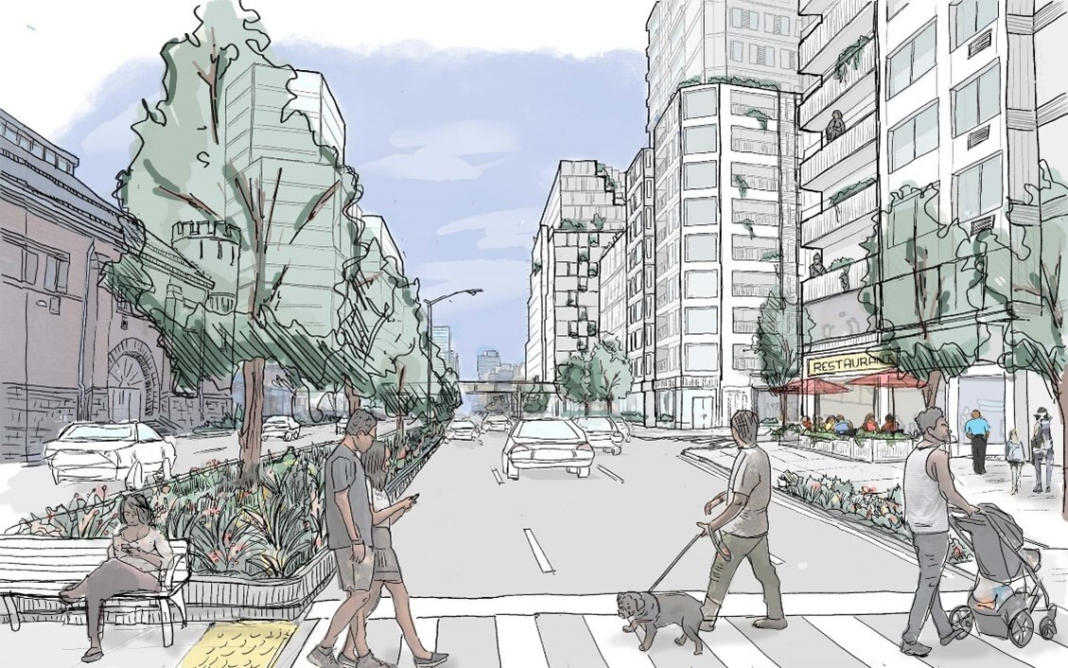
Illustrative rendering of a potential future of Atlantic Avenue.

The Atlantic Avenue Mixed-Use Plan focuses on a section of Atlantic Avenue and neighboring streets between Vanderbilt and Nostrand Avenues. Since the 1960s, this area of Atlantic Avenue has been zoned for one-to-two industrial buildings and storage, despite its proximity to a major commercial area and transit hub. Through this plan, Atlantic Avenue would be transformed into a vibrant, mixed-use neighborhood with new housing — including permanently income-restricted affordable homes through Mandatory Inclusionary Housing — alongside 800,000 square feet of new, active ground floor commercial uses and manufacturing businesses, and community facilities. Neighboring avenues and streets would see moderately-sized mixed-use buildings with income-restricted affordable housing and job-generating uses.

Building More Affordable Housing

Through programs run by the New York City Department of Housing Preservation and Development (HPD), the city will also develop an additional 380 permanently affordable homes on city and nonprofit-owned sites across the neighborhood, including 542 Dean Street, 516 Bergen Street, and 1134-1142 Pacific Street. These buildings will include homes reserved for older, low-income households, as well as formerly homeless New Yorkers. To preserve existing affordable housing, HPD's Partners in Preservation program will provide a nearly $3 million investment to community-based groups focused on anti-harassment and anti-displacement work to support local tenants. HPD will also hold a series of housing resources workshops this spring and summer to assist tenants and homeowners with their needs. In response to feedback from industrial business owners and other community members during the public review process, the City Planning Commission also modified the proposal to make it safer and easier to preserve and grow industrial businesses in mixed-use buildings within neighborhood.

Creating Safer Streets and Investing in Public Spaces

Alongside new housing and job opportunities, the Atlantic Avenue Mixed-Use Plan includes significant commitments to support and enhance the neighborhood’s infrastructure. To enhance the community’s open space, the plan has allocated $24.2 million in improvements to St. Andrew's Playground, including a new, synthetic turf multi-use field with a running track, upgraded basketball and handball courts, renovated playgrounds, a remodeled public restroom, new seating, plantings, and other green infrastructure. Lowry Triangle, located near Atlantic Avenue and Washington Avenue, will also be augmented to serve as a more vibrant community space. The plan also includes the first expansion of a zoning incentive to encourage the creation of publicly accessible open space outside of a central business district.

To make Atlantic Avenue safer for users of all ages, the plan includes several interim street safety improvements to be followed by future investments. These include painted "neckdowns," which are raised curb extensions that narrow the travel lane at intersections or midblock locations; daylighting to improve visibility at intersections; and bike corrals and a new bike lane on Bedford Avenue. Additionally, new buildings along Atlantic Avenue and Bedford Avenue would be required to be placed between five and 20 feet further away from the street, increasing sidewalk widths for pedestrians.

Alongside this plan, several storm water and sewer upgrades for Atlantic Avenue and Dean Street are already underway, as are the installation of subsurface stormwater detention systems and 140 rain gardens throughout the neighborhood. These investments will increase sewer capacity and help the neighborhood better handle storm events. New buildings would also be required to meet the New York City Department of Environmental Protection’s stormwater standards, further reducing flooding.

Engaging with the Community

Over the past decade, DCP has worked closely with Brooklyn Community Board 8 and local stakeholders to develop a vision for a more dynamic, mixed-use Atlantic Avenue. The official study for the Atlantic Avenue Mixed-Use Plan kicked off in early 2023 with New York City Councilmembers Crystal Hudson and Chi Ossé, engagement facilitator WXY Studio, Community Boards 2, 3, and 8, and agency partners. The process included over 20 meetings: three public community planning workshops, nine public working group meetings on three topic areas, and nine steering committee meetings to help shape the plan, which culminated in the release of the Community Vision and Priorities Report in 2023. CPC’s vote follows favorable recommendations with conditions from Brooklyn Community Boards 3 and 8, and Brooklyn Borough President Antonio Reynoso. The Atlantic Avenue Mixed-Use Plan now goes to the New York City Council for a public hearing and vote.

The Adams Administration’s Record on Housing

This year, Mayor Adams has doubled down on his commitment to build more affordable housing across the five boroughs. Last month, Mayor Adams and the New York City Economic Development Corporation announced the next phase of an ambitious, bold new vision for Coney Island in Brooklyn that will deliver 1,500 new homes and invest in the reconstruction of the historic Riegelmann Boardwalk. Additionally, Mayor Adams and HPD celebrated a $82 million investment to put homeownership within reach for more New Yorkers by expanding the HomeFirst Down Payment Assistance Program. Finally, the Adams administration has advanced several bold, forward-looking projects, including reimagining Gansevoort Square to build mixed-income housing, building 100 percent affordable housing at the Grand Concourse Library in the Bronx, advancing the 388 Hudson development in Manhattan to provide hundreds of critically-needed affordable housing units, and kicking off public review on the Midtown South Mixed-Use plan to create nearly 10,000 homes — all building on this year’s State of the City address.

Since entering office, Mayor Adams had made historic investments toward creating affordable housing and ensuring more New Yorkers have a place to call home. DCP is advancing several robust neighborhood plans that, if adopted, would deliver more than 50,000 units over the next 15 years in Midtown South in Manhattan and in Long Island City and Jamaica in Queens. Last year, the City Council approved the Bronx-Metro North Station Area Plan, which will create approximately 7,000 homes and 10,000 permanent jobs in the East Bronx.

Moreover, last December, Mayor Adams celebrated the passage of “City of Yes for Housing Opportunity,” the most pro-housing proposal in city history that will build 80,000 new homes over 15 years and invest $5 billion towards critical infrastructure updates and housing. In June 2024, City Hall and the New York City Council agreed to an on-time, balanced, and fiscally-responsible $112.4 billion Fiscal Year (FY) 2025 Adopted Budget that invested $2 billion in capital funds across FY25 and FY26 to HPD and the New York City Housing Authority’s capital budgets. In total, the Adams administration has committed $24.5 billion in housing capital in the current 10-year plan as the city faces a generational housing crisis. Mayor Adams celebrated both back-to-back record breaking fiscal years and calendar years in both creating and connecting New Yorkers to affordable housing. Last spring, the city celebrated the largest 100 percent affordable housing project in 40 years with the Willets Point transformation.

Further, the Adams administration is using every tool available to address the city's housing crisis. Mayor Adams announced multiple new tools, including a $4 million state grant, to help New York City homeowners create accessory dwelling units that will not only help older adults afford to remain in the communities they call home but also help build generational wealth.

Finally, Mayor Adams and members of his administration successfully advocated for new tools in the 2024 New York state budget that will spur the creation of urgently-needed housing. These tools include a new tax incentive for multifamily rental construction, a tax incentive program to encourage office conversions to create more affordable units, lifting the arbitrary "floor-to-area ratio" cap that held back affordable housing production in certain high-demand areas of the city, and the ability to create a pilot program to legalize and make safe basement apartments.

“The Atlantic Avenue Mixed Use Plan represents a significant milestone for land use policy that prioritizes equitable development of both affordable housing and industrial buildings. Today’s vote by the CPC demonstrates the city's commitment to creating inclusive, dynamic, and safe neighborhoods for both working families and the manufacturing sector to thrive as good neighbors,” said Brian T. Coleman, chief executive officer, Greenpoint Manufacturing and Design Center (GMDC). “GMDC appreciates DCP Chair Garodnick and the DCP team for stewarding the conversation towards a mixed-use neighborhood plan that incorporates opportunities to retain and grow good paying job creation and leverages public-private partnerships between non-profit developers and city agencies to build transformative mixed-use projects.”

“We at Community Board 8 support the AAMUP with expressed conditions. This is a plan that started over ten years ago with our M-1 Crown initiative,” said Irsa Weatherspoon, chairperson, Community Board 8. “I am pleased that we have been able to agree on a holistic plan that we believe supports some of the needs of our district. For example, rezoning to accommodate more affordable housing, HPD’s commitment to develop five identified sites for 100 percent affordable housing, a streetscape plan to increase safety for all users, tenant and landlord protections, a dedicated workforce development program, a green technology incubator, and measures to increase job employment with emphasis to M/WBE entrepreneurship. Just as important is the protection of our remaining open spaces to ensure that we are deliberate in not generating additional shadows and the loss of air.”

###

