
FOR IMMEDIATE RELEASE: May 13, 2025
CONTACT: pressoffice@cityhall.nyc.gov, (212) 788-2958

MAYOR ADAMS, DOT COMMISSIONER RODRIGUEZ ANNOUNCE DOUBLING OF
PEDESTRIAN AND CYCLING SPACE ON QUEENSBORO BRIDGE

City Will Convert Queensboro Bridge’s South Outer Roadway Into Pedestrian Walkway,
Make North Outer Roadway Dedicated Space for Cyclists

WATCH: Mayor Adams Announces Doubling of Pedestrian
and Cycling Space on Queensboro Bridge

NEW YORK – New York City Mayor Eric Adams and New York City Department of Transportation (DOT) Commissioner Ydanis Rodriguez today announced that the city will double the space available for pedestrians and cyclists on the Queensboro Bridge by repurposing one lane into a pedestrian walkway. Beginning this Sunday, the 11-foot-wide, north outer roadway of the Queensboro Bridge — currently used by both pedestrians and cyclists — will be used exclusively for cyclists, and the south outer roadway — currently a vehicle lane used during only limited hours — will become a dedicated space for pedestrians. The Queensboro Bridge is one of the city’s busiest bridges for pedestrian and cycling crossings, and the current, shared pedestrian and cyclist space has resulted in overcrowding as pedestrian and cyclist volumes have increased over time.

“For over 100 years, the Queensboro Bridge has safely connected New Yorkers driving, riding, and walking between Manhattan and Queens, all while offering breathtaking views of the greatest city in the world. Now, our administration will make it even easier and safer to do so,” said Mayor Adams. “The more we make it safe to walk and bike, the more people utilize their bikes, and thanks to new cycling infrastructure in communities near the bridge, more and more pedestrians and cyclists are utilizing the Queensboro Bridge. Today’s announcement will double the space available for pedestrians and cyclists by building off those upgrades and is a win-win for everyday New Yorkers.”

“We’ve seen record-high bicycle ridership in the city because we’ve provided safe, meaningful connections to riders commuting within and across the boroughs,” said DOT Commissioner Rodriguez. “By reclaiming the south outer roadway for pedestrians, we’re helping create comfortable connections for the growing number of pedestrians and cyclists on the bridge, as well as helping all New Yorkers get around more easily without a car. We look forward to delivering continued upgrades to each side of the bridge to improve cycling and pedestrian connections this summer.”

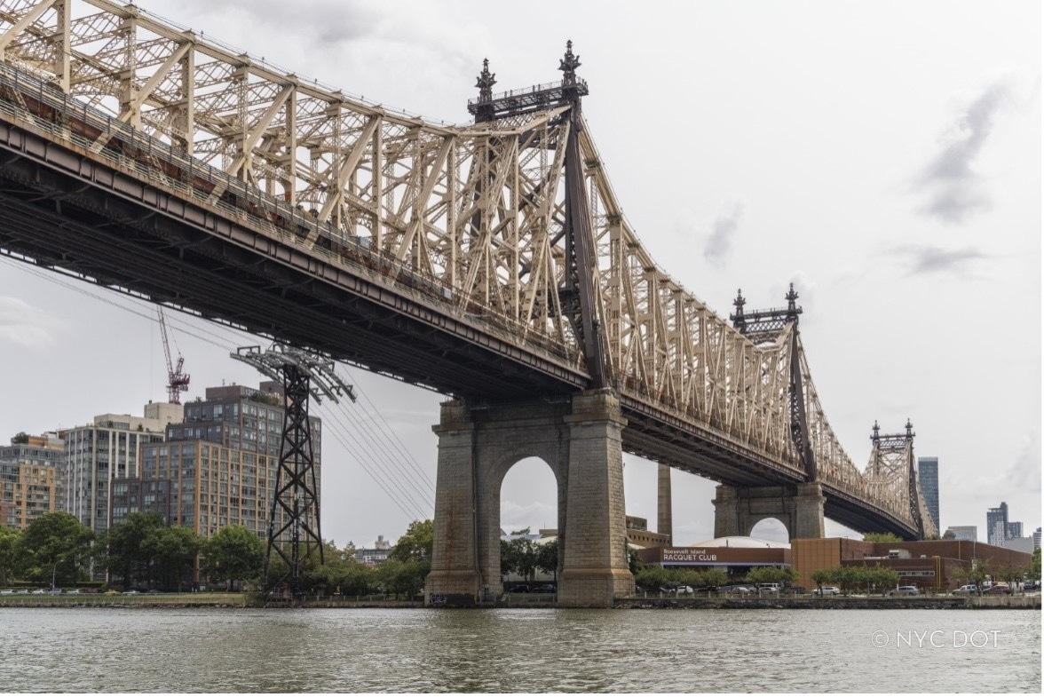

The Queensboro Bridge over the East River. Credit: NYC DOT

Since 2013, the south outer roadway of the Queensboro Bridge has been closed between 9:00 PM and 6:00 AM due to numerous overnight crashes. DOT’s analysis shows that the current traffic patterns — along with key signal timing changes — are sufficient to handle increased traffic volumes from the limited hours that the south outer roadway is currently open to cars.

The Queensboro Bridge is the third city bridge over the East and Harlem Rivers to receive expanded pedestrian and bike infrastructure in recent years, with improved and expanded space also added to both the Brooklyn Bridge in 2021 and the Washington Bridge in 2024. After the Brooklyn Bridge received its own dedicated bike lane, cycling over the bridge increased by 108 percent.

The opening of the south outer roadway for pedestrians is one of the 37 projects outlined in DOT’s “Connecting to the Core” report to help New Yorkers travel to and through Manhattan’s Central Business District without a car.

The Queensboro Bridge is the second busiest East River bridge for cyclists, having experienced steady increases in ridership year-over-year, as the city created major new cycling infrastructure in Jackson Heights, Woodside, Astoria, and Long Island City that eased cyclist passage around western Queens and created new demand for the city’s only bicycle crossing between Queens and Manhattan. More than 2,785 pedestrians, and another 7,568 cyclists, traverse the Queensboro Bridge each day. In 2024, bicycle ridership over the city’s four East River bridges reached an all-time high for the fourth-straight year.

In response to the COVID-19 pandemic, DOT included 34th Avenue in Jackson Heights among its inaugural car-free Open Streets, and the street has since thrived as the city’s longest Open Street (1.9 miles long), which includes dedicated bike lanes. The Adams administration allocated $89 million in capital funding in 2022 to permanently build out the 34thAvenue Open Street. These changes to the corridor have fed west-bound cyclists to Northern Boulevard in Woodside.

Farther north in Astoria, DOT completed a new protected lane to Crescent Street in 2020, where it also added barriers to further protect that lane in 2022. In 2023, DOT installed 2.5 miles of protected bike lanes on 11th Street, Jackson Avenue, and 44th Drive in Long Island City; and, in 2024, DOT completed the western section of the Queens Boulevard protected bike lane, connecting Sunnyside to Queens Plaza and the Queensboro Bridge. With over 16 miles of protected lanes created since 2020, coupled with the rising population of Long Island City, cycling in western Queens has boomed, fueling 20 percent growth in cycling over the Queensboro Bridge since 2020, as the bridge serves 6,267 daily riders.

###

