Local Law No. 109 Report – Fiscal Year 2023
(Pursuant to City Charter §1301(1)(b-2))

City Charter §1301(1)(b) requires New York City Economic Development Corporation (NYCEDC) to submit to the New York City Department of Small Business Services an annual report regarding the satisfaction of minority- and women-owned business enterprises goals by recipients of economic development benefits.
NYCEDC is the City's primary agent for economic development. Acting under annual contracts with the City, NYCEDC is a not-for-profit corporation that serves as the catalyst for promoting economic development and business growth in the City. Its principal mandate is to encourage investment and attract, retain, and create jobs in New York City.
The Mayor appoints NYCEDC’s president and chairman of the board, and NYCEDC’s unpaid board includes representatives of City agencies as well as appointees recommended by the Borough Presidents and the Speaker of the City Council. Partnering with City, State, Federal, and regional agencies, as well as businesses and residents, NYCEDC is a key driver of the City’s three-pronged economic development strategy to create jobs, diversify the City’s economy, and build affordable, attractive neighborhoods.
To fulfill its broad economic development mission, NYCEDC wears many hats—it is a business advocate and partner, a project manager, a policy analyst and a program administrator. The Initiatives Department at NYCEDC develops and implements initiatives to grow traditional and emerging industries in the city, as well as promote entrepreneurship generally across all industries. The Ports and Transportation Department advises on transportation and waterfront policy matters, and the Real Estate Transaction Services, Asset Management, and Capital Departments manage the sale of City-owned land, the management of City-owned property, and the management of capital construction projects, respectively. In addition, NYCEDC oversees industrial parks, wholesale and retail markets, cruise terminals, rail lines, and waterfront development. Other responsibilities include design, planning, and construction capabilities on various projects. NYCEDC also supports small businesses through a loan guarantee program for private lenders.
Furthermore, NYCEDC provides discretionary financial assistance under the authority of the New York City Industrial Development Agency (NYCIDA) and Build NYC Resource Corporation (Build NYC), contingent upon the realization of specified investment and/or job commitments.
NYCEDC is committed to strengthening and improving access to opportunities for Minority/Women/Disadvantaged Business Enterprises (M/W/DBEs). NYCEDC looks to ensure that all applicable and available projects are setting appropriate and realistic M/W/DBE participation goals and we work thoroughly to ensure that our policies and procedures are in place to meet and exceed M/W/DBE goals. NYCEDC continues to actively participate in city-wide M/WBE efforts. In Fiscal year 2023, NYCEDC awarded 29.2% of its publicly procured projects to MWBEs, and, of all payments made in fiscal year 2023, 31.7% went to MWBEs working on over 1,400 EDC projects.
In addition, NYCEDC is committed in ensuring that available M/W/DBEs will be competitive by providing programs and assistance aimed at increasing their capacity. In 2016, NYCEDC launched the ConstructNYC program to encourage growth of small M/W/DBE firms. The program provides in-depth training, individualized technical assistance, and opportunities to compete on NYCEDC construction projects to a pre- qualified list of small-to-medium M/W/DBE construction firms. NYCEDC also launched the Emerging Developer Loan Fund in 2016 to provide gap/mezzanine funding for small developers engaged in real estate development projects throughout the city. In 2022, NYCEDC also launched Waterfront Pathways, an program that builds capacity for M/W/DBEs on waterfront construction and offshore wind development projects.
NYCEDC continues to fine-tune and adjust our programs to ensure that M/W/DBE participation is maximized. We look for ways to expand the portfolio of projects for which M/W/DBE goals are applicable, to look beyond the procurement activities applicable under Local Law 1, and to include construction activities that are generated through NYCEDC’s land sales, leases, and by recipients of economic benefits.
To that end, in December 2014, NYCEDC adopted and put into practice a policy to require M/W/DBE participation on all construction activities on NYCEDC-sponsored land sales and leases. These RFPs required M/W/DBE commitments from the developers/respondents. The RFPs also detailed monitoring and compliance procedures that will govern the developers/respondents throughout the life of construction on these transactions.
The chart below reflects projects for which, as of June 30, 2023, developers have been selected and have committed to an M/W/DBE goal. Once these projects close and the real estate transaction is complete, we will monitor their M/W/DBE goal attainment throughout the duration of the project construction.
NYCEDC requires developers to submit a quarterly M/W/DBE Compliance report with backup documents substantiating M/W/DBE participation once a project is in the construction phase. The below chart lists projects currently in construction with their respective M/W/DBE goal attainment as of June 30, 2023:
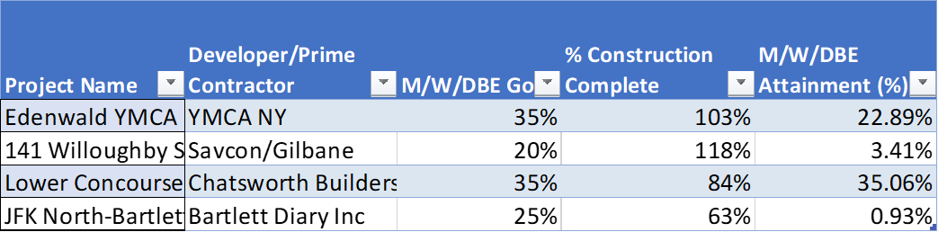

NCYCIDA began to implement goals on their projects in 2018. As additional projects close and reach construction phase, we will continue to monitor M/W/DBE attainment throughout the duration of the project’s construction.
The chart below reflects projects for which, as of June 30, 2023, developers have been selected and have committed to an M/W/DBE goal. Once these NYCIDA projects close and the real estate transaction is complete, we will monitor their M/W/DBE goal attainment throughout the duration of the project construction.
NYCIDA requires developers to submit a quarterly M/W/DBE Compliance report with backup documents substantiating M/W/DBE participation once a project is in the construction phase. The below chart lists projects currently in construction with their respective M/W/DBE goal attainment as of June 30, 2023:

NYCEDC is dedicated to ensuring that New York City’s M/W/DBEs are active and engaged in all aspects of New York City’s economic life, and that economic growth is shared fairly and equitably throughout the five boroughs.

