Mayor Adams Announces Holiday Season Open Streets Boosted Local Businesses by Millions of Dollars in 2022, Advances "Future of Fifth" Permanent Reimagining of Fifth Avenue
October 10, 2023
New Mastercard Study Finds Pedestrian-Focused Initiative Drove Spending $3 Million Higher, 6.6 Percent Increase in Spending at Midtown Businesses During Holiday Season
Design Team Identified to Permanently Reimagine Fifth Avenue as Safer, Pedestrian-Centered Boulevard
New York – New York City Mayor Eric Adams today announced that his administration's holiday season Open Streets initiative in Midtown Manhattan – which made Fifth Avenue vehicle-free for the first time in a half-century and brought back popular pedestrian-focused areas around Rockefeller Center – was a boon for local businesses in 2022. According to a new study conducted by Mastercard, in partnership with the New York City Office of Technology and Innovation (OTI) and Chief Public Realm Officer Ya-Ting Liu, the transformation of 11 city blocks into pedestrian-friendly public spaces as part of New York City's largest-ever holiday season-specific Open Streets drove an estimated $3 million in additional spending at businesses along pedestrianized streets, with merchants on Open Streets seeing a 6.6 percent increase in spending over similar blocks that were not opened to pedestrians.
The Open Streets initiative laid the groundwork for Mayor Adams' effort, announced last December in the "New" New York Panel's "Making New York Work for Everyone" action plan, to permanently reimagine Fifth Avenue from Bryant Park to Central Park. To realize this vision, Mayor Adams today established the "Future of Fifth" – a public-private partnership between New York City and four key business improvement districts and civic organizations: Fifth Avenue Association, Grand Central Partnership, Bryant Park Corporation, and Central Park Conservancy.
"Open Streets were an essential part of our city's economic recovery, and they will continue to be a core part of our city's future," said Mayor Adams. "The research is clear that Open Streets bring more people to our city's public spaces, more business to our city's stores, and more jobs to New Yorkers. That's why we are reimagining Fifth Avenue as a safer, less congested, pedestrian-centered boulevard that also prioritizes public space, mass transit, and cyclists. That's why we are excited to establish this public-private partnership and bring on this team of exceptional partners who will help us ensure that businesses and pedestrians can enjoy the benefits of a more open, accessible city – not just in December but all year round."
"Creating vibrant public spaces is an essential ingredient to New York City's continued success. The energy of our city is felt through our streets and providing more pedestrian friendly spaces is good for safety, good for local businesses, and good for the future of the city," said Deputy Mayor for Operations Meera Joshi. "We can't do this alone and are grateful to our partners in business and civic community who work hand in glove with us to realize a city filled with wonderful places to live, work, and play."
"Today's analysis affirms what we already know: New Yorkers and visitors alike are hungry for pedestrian-friendly spaces," said Chief Public Realm Officer Ya-Ting Liu. "Creating pedestrian-centered spaces attracts foot traffic that is a boon to local businesses and New York City's economy. People vote with their feet and wallets."
"The data is clear: When we give more space to people walking and biking, business thrives," said New York City Department of Transportation (DOT) Commissioner Ydanis Rodriguez. "That's because our streets can accommodate far more people on foot than in cars – a key reason why businesses had such great success during our car-free holiday Open Streets. As we've seen in our 'Streets for Recovery' report, creating safe, welcoming spaces for people is a vital part of supporting our economy and recovery throughout New York City. DOT looks forward to the continued progress toward delivering a permanent redesign of Fifth Avenue that builds on this success."
"Accessible and improved public realm helps drive New York City's economy and plays a central role in building neighborhoods across the five boroughs that are 24/7 live, work, play, and learn," said New York City Economic Development Corporation (NYCEDC) President and CEO Andrew Kimball. "NYCEDC is thrilled to be a driving force in this private-public partnership with City Hall, DOT, NYC Parks, and our business improvement district and civic association partners to create this historic redesign of Fifth Avenue and move forward an important recommendation of the 'New' New York Panel."
"Our city thrives when our public spaces are vibrant, accessible, and inviting," said New York City Department of Parks and Recreation (NYC Parks) Commissioner Sue Donoghue. "This report proves what so many of us felt intuitively when we visited Midtown's Open Streets last year: Bringing New Yorkers out of their cars and into our public realm is a win for businesses and for everyone who calls this city home. I look forward to working with our sister agencies and community partners on the future of the world-famous Fifth Avenue corridor, maintaining a dynamic and accessible connection from Bryant Park and Central Park, two iconic green spaces in the heart of our city."
"This data further demonstrates that Open Streets can provide a vital economic boost as part of the city's ongoing recovery," said "New" New York Executive Director B.J. Jones. "It's another example of how the Adams administration is adapting public spaces in innovative ways for New Yorkers and visitors alike to enjoy, and it shows exactly why we need to permanently reimagine Fifth Avenue."
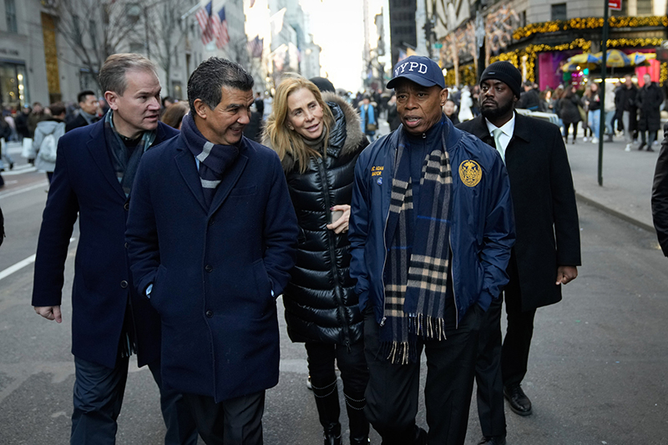
Mayor Adams, DOT Commissioner Ydanis Rodriguez, and representatives from the Fifth Avenue Association walk down Fifth Avenue during the 2022 holiday season Open Streets initiative.
Credit: Michael Appleton/Mayoral Photography Office
Mayor Adams' holiday season Open Streets initiative in 2022 brought together DOT, the New York City Police Department, and the Fifth Avenue Association to fully or partially pedestrianize stretches of Fifth Avenue, Sixth Avenue, West 49th Street, and West 50th Street between 12:00 PM and 6:00 PM on three Sundays in December. In conjunction with this major expansion of public space and access to local businesses, Mayor Adams launched two campaigns encouraging New Yorkers and visitors to support local small businesses – investing $200,000 at a critical time of year.
Mastercard's research found that in addition to increased spending at local businesses, the pedestrian-friendly initiative brought greater foot traffic and more purchases to businesses along the corridor – with businesses along Open Streets seeing 13.9 percent more in transactions than others. Overall, the merchants on pedestrianized streets saw an average of $90,000 in additional spending every day, with longer pedestrianization hours proving more effective at increasing foot traffic and driving spending.
Mastercard's findings build on the "Streets for Recovery" report developed by the DOT and Bloomberg Associates, which found that restaurants and bars on car-free Open Streets saw higher sales than those on closed streets and that the Open Streets program helped keep those local businesses and the city's economy afloat during the COVID-19 pandemic. It also builds on Mayor Adams' $375 million investment in public space outlined in his "Working People's Agenda," which has delivered vibrant, new public spaces along Broadway from Madison Square to Herald Square and under the Brooklyn Bridge in Manhattan, as well as is creating plans for major improvements at the Broadway Junction subway station and along Fulton Street in Brooklyn.
The new report also reaffirms the core tenets of the "New" New York panel's action plan, which identified public space as a key force for the city's economic recovery and helped drive Mayor Adams' initiative to permanently reimagine parts of Fifth Avenue as a safer, less congested, pedestrian-centered boulevard.
Advancing the effort to permanently reimagine Fifth Avenue, the "Future of Fifth" partnership has selected a core consultant team of four engineering, planning, and design firms, with 10 additional firms as supporting consultants, in the visioning and design process for the permanent redesign. These firms will collaborate to further assess Fifth Avenue's current layout and conditions along the corridor, engage with the community members and key stakeholders around the visioning and design process, and develop a comprehensive plan and design that will make Fifth Avenue more appealing to residents, workers, and visitors with world-class public space.
The consultant team selected today to support that visioning process is comprised of the following core team members:
- Arcadis, which will serve as the prime consultant and administrative manager as well as leading the implementation and construction phasing strategy;
- Sam Schwartz, which will manage the team's day-to-day operations and lead civil engineering, traffic engineering, and transportation planning;
- Field Operations, which will serve as the project's design lead, overseeing design vision, urban design, and landscape architecture, as well as co-lead the public engagement process; and
- Public Works Partners, which will lead the zoning analysis and co-lead the public engagement process.
The core team is supported by Gehl, BJH Advisors, SiteWorks, JKMuir, Tillotson Design, Toscano Clements Taylor, MFS Engineers and Surveyors, Gallas Survey Group, Introba, and TYLin/Silman. In keeping with the Adams administration's commitment to ensuring that city contracts are distributed equitably to all New Yorkers, seven of the 14 firms selected are minority- and women-owned business enterprises.
The "Future of Fifth" partnership and consultant team will begin collaborating the visioning and design process for the reimagined Fifth Avenue corridor this year and release a comprehensive plan – including a conceptual design – in mid-2024. An ultimate schematic design is anticipated to be completed in early 2025. Throughout the process, the team will conduct robust outreach efforts, including public events, meetings, surveys, and more.
"Mastercard's Test & Learn analysis illustrates how the Open Streets initiative drove real spending for small businesses," said Chiro Aikat, executive vice president, U.S. market development, North America, Mastercard. "Measuring the economic impact is just one way we can show up for small businesses, and we look forward to continuing to partner with Mayor Adams and the city to drive value to the community and its merchants."
"Today's announcement marks the beginning of a much-needed effort to reimagine one of the world's most famous and iconic avenues. We are excited to work with Mayor Adams and his administration to create a world-class promenade that is accessible and inviting to all," said Madelyn Wils, chief advisor, Fifth Avenue Association; and co-chair, "Future of Fifth" Steering Committee. "Our businesses continue to invest in this historic corridor and enliven the street every day, and the 'Future of Fifth' initiative will ensure that the avenue and its adjacent neighborhood remain a vital economic engine for the city well into the future. In the meantime, we encourage all New Yorkers to join us for an even more exciting Open Streets this holiday season and support the retailers, restaurants, and hotels that are an essential part of the fabric of New York City."
"We are looking forward to beginning this important visioning project for iconic Fifth Avenue – working with this talented team and incorporating our stakeholders in this public input process to ensure that this work results in a Fifth Avenue corridor that is deserving of Midtown East, our city, region, and beyond," said Fred Cerullo, president and CEO, Grand Central Partnership.
"We're happy to join the city and like-minded, privately funded entities who see the logic of a great streetscape linking Bryant Park and Central Park, to the benefit of Fifth Avenue retail and office buildings and the city as a whole," said Dan Biederman, founder and president, Bryant Park Corporation.
"We are excited to participate in the 'Future of Fifth,' working alongside the Adams administration and other major civic institutions to make Fifth Avenue more accessible and inviting for pedestrians," said Betsy Smith, president and CEO, Central Park Conservancy. "Fifth Avenue is an important entrance to Central Park and a vital boulevard for New Yorkers from Harlem to Grand Army Plaza and beyond. Through this work, we aim to continue making Central Park inviting, equitable, and accessible for millions of visitors."

