MAYOR ADAMS ANNOUNCES ARTIST AND UNVEILS DESIGNS FOR
NEW MEMORIAL HONORING FALLEN POST-9/11 SERVICE MEMBERS

Douwe Blumberg Chosen as Artist for “Flames of Honor,” Queens Memorial Recognizing at
Least 100 Service Members Who Sacrificed Their Lives in Wars in Iraq and Afghanistan

Full Designs for Memorial Available Online

Part of National Military Appreciation Month, New York City’s Fleet Week, and Lead up to
Memorial Day, Adams Administration Launches “Veterans and Service Members’ Week,”
Uplifting City’s Efforts to Serve those Who Have Served the United States

NEW YORK — New York City Mayor Eric Adams and New York City Department of Veterans’ Services (DVS) Commissioner James W. Hendon today continued “Veterans and Service Members’ Week,” as part of national Military Appreciation Month and the lead up to Memorial Day, by unveiling initial designs for a new memorial honoring the at least 100 fallen post-9/11 service members from New York City who made the ultimate sacrifice during their service in Iraq and Afghanistan. The memorial — titled “Flames of Honor” and which will be located in the Whitestone neighborhood of Queens — was first announced during last year’s Fleet Week reception and will be designed by artist Douwe Blumberg. During Veterans and Service Members’ Week, Mayor Adams is paying special tribute to the over 13,000 active service members who call New York City home, the 210,000 veterans who live in the five boroughs, and all those who lost their lives while serving their nation and who resided in New York.

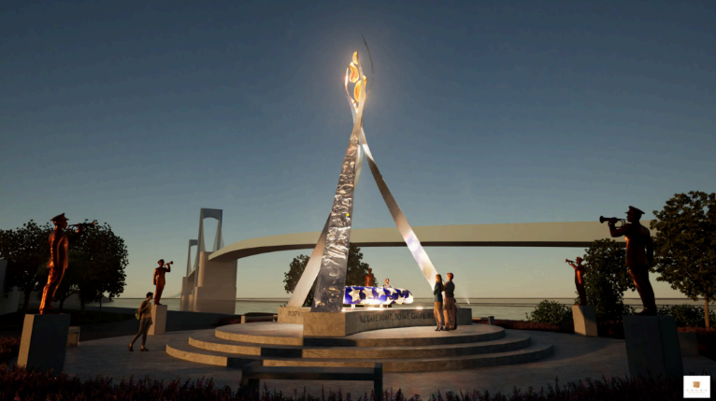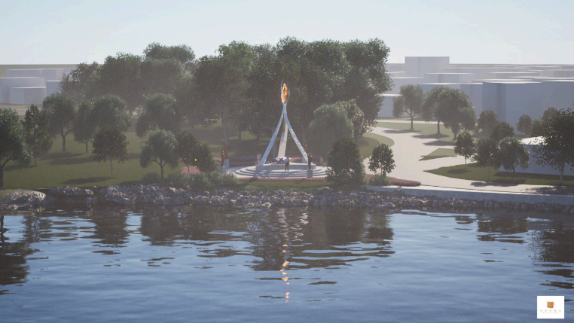

“Flames of Honor” — designed by nationally-recognized artist Douwe Blumberg — will pay tribute to the
100 service members who lost their lives in the post-9/11 wars in Iraq and Afghanistan. Credit: Douwe Blumberg.

“Our fallen soldiers gave their last measure of devotion defending the American Dream, and we could not call ourselves the greatest city on the globe if we did not give them the tribute they deserve,” said Mayor Adams. “With this memorial, we will honor a new generation of souls who gave their lives far too early in the wars in Iraq and Afghanistan and say ‘thank you’ to our service members and veterans every day of the year with a beautiful space for remembrance and reflection. Thank you to Douwe Blumberg for his thoughtful design and, above all, to our service members who put their lives on the line every day to protect our freedom, especially in this post-9/11 world.”

“This memorial will stand as a permanent reminder that the cost of war is not measured in years or deployments but in lives forever changed, birthdays missed, memories unshared, and time with loved ones that can never be reclaimed,” said DVS Commissioner Hendon. “‘Flames of Honor’ will give New Yorkers a sacred space to grieve, to reflect, and to remember those we’ve lost since 9/11 — not just as service members, but as sons, daughters, neighbors, and friends.”

“To the New Yorkers and all service members who gave their lives for our country, we owe a debt of gratitude that can never be repaid,” said New York City Department of Cultural Affairs (DCLA) Commissioner Laurie Cumbo. “We're delighted and honored to work with artist Douwe Blumberg to realize his vision of 'Flames of Honor,' which will pay tribute to our fallen soldiers while providing everyone with a contemplative space to reflect on their lives and honor their sacrifice.”

“I am humbled and honored to use my artistic gifts to help the City of New York pay tribute to those who have sacrificed everything for their nation. My hope is that this piece of fine art reminds us and future generations of their humanity and personhood,” said Douwe Blumberg. “This work is a unique fusion of artistic visions, which will impact and engage a diverse audience with the legacy of these fallen heroes for generations to come.”

Following an open call for submissions by DVS and DCLA, the city received dozens of submissions for the new memorial. A diverse advisory panel of individuals from New York City’s veteran community reviewed these submissions, ultimately choosing Blumberg’s design for its mixture of modern and traditional styles, its deep and meaningful symbolism, and its use of space to promote reflection and remembrance.

Flames of Honor will be built on the waterfront in the Whitestone neighborhood of Queens, the borough home to the largest number of post-9/11 service members who were killed in action. Queens is also the borough with the highest population of living veterans. The new memorial is part of the Utopia Parkway Seawall Replacement and Street Improvements project led by the New York City Department of Transportation and the New York City Economic Development Corporation that will incorporate a bike path, pedestrian walkway, and rebuilt bulkheads to revitalize the area and mitigate storm risk for the surrounding neighborhood.

In addition to commemorating the nearly 100 service members from New York City, as well as the total 7,064 service members, who lost their lives in the post-9/11 wars in Iraq and Afghanistan, Flames of Honor will also serve as a lasting "thank you" and "welcome home" to the post-9/11 veteran community. This site will provide a space for future commemorations, honoring both the fallen and the broader veteran community.

The son of a World War II veteran, Blumberg has been widely recognized for his work as a sculptor and artist. After attending the University of Southern California’s Idyllwild School of Music and the Arts, as well as four additional years of sculpture and metal working study, he shifted his career to focus on horse training before eventually returning to the arts. Douwe has since completed well over 200 private and public commissions across New York, California, Colorado, Kentucky, and other states. In addition to numerous awards, residencies, and shows to his credit, Blumberg has been hailed by former U.S. President Joseph Biden as being “America’s Greatest Sculptor.” He previously designed “America’s Response Monument” currently located at the World Trade Center site to pay tribute to U.S. Army Special Forces who responded to the 9/11 attacks.

“I welcome news that a memorial will be erected on our beautiful Northeast Queens waterfront to honor the 99 fallen post-9/11 service members from New York City,” said New York State Assemblymember Edward C. Braunstein. “With one-third of these service members having hailed from Queens, and with the largest population of living veterans in the city, Queens is a fitting future home to this tribute. The memorial will not only serve as a lasting reminder of these service members’ ultimate sacrifice, but it will also function to educate New Yorkers about all post-9/11 service members and their families. As our country prepares to commemorate Memorial Day, I thank New York City Department of Veterans’ Services Commissioner Hendon and Mayor Adams for announcing the next step in seeing this memorial become a reality.”

“The noble and heroic contributions of those who have served in the military after the devastating 9/11 attacks have helped keep our nation safe and secure,” said Queens Borough President Donovan Richards. “But that safety has come at a painful cost, as far too many of our post-9/11 service members have been killed in action. That’s why Queens is especially proud to be the site of the post-9/11 Fallen Service Member Memorial, and I am deeply honored to be allocating $3 million in capital funds toward its construction. Because the least we can do as Americans is given proper recognition to those service members who made the ultimate sacrifice in defense of our country.”

“Veterans have been overlooked by City Hall for far too long, so these announcements are a meaningful step in the right direction,” said New York City Councilmember Robert Holden. “I look forward to working with both sides of City Hall to deliver what our veterans have earned — including supportive housing, investment in our VSOs, relief from burdensome bureaucratic regulations and fines on our Posts and Halls, and real funding for groundbreaking PTSD treatments like Reconsolidation of Traumatic Memories.”

“This memorial is more than just stone and sculpture – it’s a lasting tribute to the 99 heroes from our city who answered the call after 9/11 and never came home,” said New York City Councilmember Vickie Paladino. “These men and women gave everything in defense of our country, and now, right here in Whitestone, we’re giving them a place of honor that will stand for generations. I’m proud that ‘Flames of Honor’ will be built in my district, and even prouder that our city is taking this moment to reflect, remember, and show unwavering gratitude.”

###

