
FOR IMMEDIATE RELEASE: April 7, 2025
CONTACT: pressoffice@cityhall.nyc.gov, (212) 788-2958
MAYOR ADAMS, CORPORATION COUNSEL GOODE-TRUFANT ANNOUNCE
LAWSUIT AGAINST NINE MAJOR NATIONAL DISTRIBUTORS FOR ILLEGALLY
SELLING DISPOSABLE FLAVORED E-CIGARETTES, CELEBRATE NEW PHASE
OF HIGHLY SUCCESSFUL “OPERATION PADLOCK TO PROTECT” INITIATIVE
Lawsuit Seeks to Block Distributors of Flavored Vapes from Further
Selling Products in New York City, Monetary Damages, and Penalties
As New York City Approaches One-Year Mark of “Operation Padlock to Protect,”
Adams Administration Unveils Plan for Un-Sealing Previously
Padlocked Businesses and Maintaining Enforcement
Since Launching in May 2024, Mayor Adams’ Successful “Operation Padlock to Protect”
Sealed Over 1,370 Illegal Cannabis Businesses, Seized Over $94 Million of Illegal Products
NEW YORK – New York City Mayor Eric Adams and New York City Corporation Counsel Muriel Goode-Trufant today announced that the City of New York has filed a federal lawsuit against nine of the largest nationwide distributors of disposable e-cigarettes, popularly known as “vapes” — the most popular devices for nicotine use among middle and high school youth. The defendants — all of whom have close relationships with e-cigarette manufacturers in China — are alleged to be distributing e-cigarettes with such youth-attracting flavors as pink lemonade, watermelon, banana ice, lychee ice, and cool mint to sub-distributors in the city that then supply them to retail stores or sell them directly to consumers in New York City and around the country through online sales, violating nearly every applicable federal, New York state, and New York City law governing the sale of e-cigarettes.
Today's lawsuit seeks to block these so-called “master distributors” from further sales of these illegal items into New York City, seeks both monetary damages and penalties, and marks the continuing effort by the Adams administration to curb illegal sales of flavored e-cigarettes, which are appealing and addictive, especially to teens.
“Nicotine addiction among middle and high school youth is exploding — fueled in large part to the targeting of our children. Today’s lawsuit not only builds on our previous two lawsuits against distributors and wholesalers, but makes clear that we will do whatever it takes to keep our children safe and enforce the law when it comes to illegal vape sales,” said Mayor Adams. “Building on the resounding success of ‘Operation Padlock to Protect’ and the sealing of more than 1,370 illegal cannabis shops, we are taking every step in our power to stop the flow of harmful products to young New Yorkers. We are also hopeful landlords will now move to get legitimate businesses into their vacant storefronts and look forward to what this next phase will bring for our local economy. Every day, we are working to make New York City the best place on the globe to raise a family, and a key part of that mission is protecting the health of our children, which we continue to do every day.”
“This case builds on the city’s ongoing efforts to hold predatory companies accountable for undermining public health and fueling an epidemic of vaping among youth in our communities,” said Corporation Counsel Goode-Trufant.
“I am proud of the incredible work 'Operation Padlock to Protect' has done to rid our communities of the illegal cannabis shops that were plaguing our neighborhoods,” said New York City Sheriff Anthony Miranda. “This initiative is one of the greatest examples of community and law enforcement at its best, with multiple agencies working together to deliver extremely quick and meaningful results that make New Yorkers safer and healthier. We will continue to enforce the law and ensure that illegal operators are held accountable.”
“It is illegal to sell flavored e-cigarettes in New York City,” said City Hall Chief Counsel Allison Stoddart. “With this new lawsuit against nine distributors, the Adams administration is continuing to hold companies accountable when they put profits over the health of New Yorkers.”
The defendants in today’s lawsuit are:
- 10 Days, Inc. d/b/a Pod Juice: A California corporation with a principal place of business in Agoura Hills, California.
- EVO Brands, LLC: A Delaware limited liability company with its principal place of business in Los Angeles, California.
- Midwest Goods Inc.: A corporation formed under the laws of the State of Illinois with a principal place of business in Bensenville, Illinois.
- MYLÉ VAPE INC.: A New York corporation with a principal place of business in Ridgefield, New Jersey and Jamaica, New York.
- MVH I, Inc.: A New York corporation with its principal place of business in Ridgefield, New Jersey.
- Puff BAR Inc.: A corporation formed under the laws of the State of California with its principal place of business in Glendale, California.
- PVG2, LLC, d/b/a, “Puff Bar”: A Delaware limited liability company with its principal place of business in Los Angeles, California.
- Safa Goods LLC: A Florida limited liability company with its principal place of business in Port Charlotte, Florida.
- SV3, LLC d/b/a Mi-One Brands: An Arizona limited liability company with its principal place of business in Phoenix, Arizona.
The dangers of e-cigarettes to youth led the U.S. Food and Drug Administration (FDA), in January 2020, to ban flavored vape products. Most e-cigarettes provide nicotine levels far exceeding that of conventional cigarettes. Further, federal health authorities, such as the U.S. Surgeon General and the FDA, say fruit, cola, and dessert-flavored e-cigarettes tempt kids to vape high levels of nicotine. Cartoon character packaging on e-cigarettes and devices that look like toys or include mini-games target youth and have contributed to the epidemic of nicotine addiction among youth.
As cited in today's lawsuit — filed in the U.S. District Court for the Southern District of New York — the FDA and the Centers for Disease Control and Prevention released data in 2024, showing 14 percent (3.8 million) of middle and high school students reported ever using e-cigarettes, and 3.5 percent (410,000) of middle school and 7.8 percent (1.2 million) of high school students reported using e-cigarettes within the past 30 days. More than one in four (26.3 percent) of current youth e-cigarette users reported using an e-cigarette product daily. More than one in three (38.4 percent) youth e-cigarette users reported using e-cigarettes in at least 20 of the last 30 days. The 2023 National Youth Tobacco Survey showed e-cigarettes remained the most commonly used tobacco product among both high school and middle school students for the 10th year in a row. Flavored e-cigarettes continue to be the most popular products according to the survey.
Today's lawsuit alleges that the nine defendants violated the Prevent All Cigarette Trafficking Act, a federal law that effectively bars the sale of any e-cigarettes except in face-to-face transactions. Violations of New York Public Health Law § 1399-ll (1-a), which makes it illegal for anyone to deliver e-cigarettes to anyone other than a state-licensed vapor business, are also alleged, as well as violations of New York City Administrative Code § 17-715, which makes it illegal to sell, offer for sale, or possess for sale flavored e-cigarettes in New York City. Additionally, the defendants are alleged to have caused a common law public nuisance through the sale of flavored e-cigarettes in a manner injurious to the public right to health and safety. The case is filed as a related matter to a suit initiated by the Office of the New York Attorney General in February 2025.
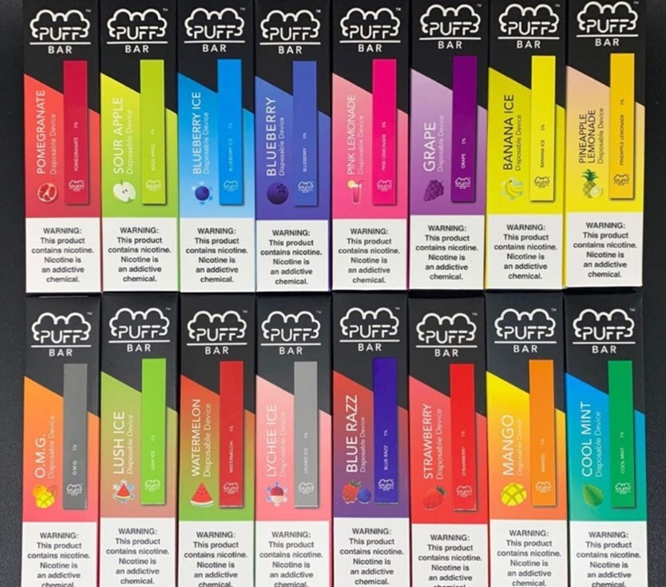
Sample vape sold by defendant Puff BAR, Inc. demonstrating a variety
of child-friendly flavors, such as strawberry, pink lemonade,
watermelon, and blend called “O.M.G.” Image credit: SRITA database.
The city’s case represents an ongoing effort by the Adams administration to ensure compliance with laws that protect public health. In July of 2023, the administration announced that the City of New York had filed a federal lawsuit against several distributors of illegal flavored vapes, including the nation's largest vape distributor. In April 2024, the administration announced a second lawsuit against 11 local wholesalers, which has now been transferred to federal court. In November 2024, the city sued Price Point, a major distributor of e-cigarettes based on Long Island. All three actions target distributors for their part in the illegal sale of flavored disposable e-cigarettes, the most popular vaping devices among middle school and high school youth. All three cases are pending.
In addition to taking legal action, the Adams administration has been laser focused on enforcement against illegal operators that threaten communities and children. After Mayor Adams successfully advocated for and won legal authority to seal illegal cannabis shops last year that state law originally failed to grant the city, the administration launched “Operation Padlock to Protect,” which, since May 2024, has already sealed over 1,370 shops and taken over $94 million in illegal products off city streets. Under the state legislature’s 2024 amendments to the Administrative Code related to searches, penalties, and sealings of illegal cannabis shops, the New York City Sheriff’s Office was granted authority to seal illegal operators for up to one-year. With the one-year mark approaching since the city closed the first shops under its new authority, the Adams administration is informing businesses of their next steps and urging them to contact the New York City Sheriff’s Office at (718) 707-2100 or email SmokeShopRelease@nyc.gov to schedule an appointment. The New York City Department of Finance will be mailing letters to the building owners and businesses with a secure code to present to the New York Cit Sheriff’s Office with detailed instructions.
The Adams administration has implemented supports for legal operators to help them thrive. Cannabis entrepreneurs with Conditional Adult-Use Retail Dispensary licenses can apply for loans of up to $100,000 through the Cannabis NYC Loan Fund. There is no application fee, no minimum credit score, and a 36-month repayment period. The New York City Department of Small Business Services (SBS) also offers FastTrac® for Cannabis Entrepreneurs, a 10-session course covering the fundamentals of starting, operating, and scaling a cannabis-focused business in New York City. Additionally, SBS provides support with commercial lease negotiations, permitting, and licensing through the NYC Business Express Service Team, and the NYC LEASE initiative helps to connect dispensary licensees with viable storefronts and education about state regulations.
###

