
THE CITY OF NEW YORK
OFFICE OF THE MAYOR
NEW YORK, NY 10007

FOR IMMEDIATE RELEASE: October 26, 2023
CONTACT: pressoffice@cityhall.nyc.gov, (212) 788-2958

MAYOR ADAMS ANNOUNCES MORE THAN 100 CAR-FREE ‘TRICK-OR-STREETS’ LOCATIONS FOR HALLOWEEN

Second Annual ‘Trick-or Streets’ Event Features More Than 100 Locations on Car-Free Streets and Plazas to Expand Safe Public Space for Young People on Halloween

Updated Interactive Map Details All 2023 ‘Trick-or-Street’ Locations for Second Annual Program, Including Día De Los Muertos Celebrations

NEW YORK – New York City Mayor Eric Adams and New York City Department of Transportation (DOT) Commissioner Ydanis Rodriguez today announced 107 car-free locations across all five boroughs for the Halloween season as part of the city’s second annual “Trick-or-Streets” program. Earlier this month, Mayor Adams and Commissioner Rodriguez announced 15 premier “Trick-or-Streets” locations with DOT-produced programming and invited Open Streets partners, plaza partners, and community-based organizations to apply to join the 2023 program. Following an impressive response from communities across the city, this year’s program will be even larger than last year’s, with more than 100 car-free locations throughout all five boroughs.

This year’s program also builds on the success of last year’s inaugural version of “Trick-or-Streets,” with the addition of new, car-free “Trick-or-Streets” programming and giveaways at locations in all five boroughs, where DOT and its partners are hosting Halloween-themed activities and performances throughout the month. Events are also planned into November to celebrate the Mexican holiday of Día De Los Muertos, or “Day of the Dead.” An interactive map and full list of car-free streets are available online.

“Every young New Yorker deserves a Halloween experience that is not only spooky but also fun and safe — and we’re proud to deliver that with our ‘Trick-or-Streets’ program,” said Mayor Adams. “One of New York City’s most valuable resources is our space, and we’re making better use of it than ever before. We’re making sure that all of our city’s residents can safely enjoy our public spaces this Halloween and Día De Los Muertos.”

“Our streets are New Yorkers’ front yards — and this Halloween season, we’re going to make sure that children and families can safely enjoy a spooky ‘Trick-or-Streets’ experience,” said Deputy Mayor for Operations Meera Joshi. “We’re making the most of our public spaces across this city to make New York City a better place to be outside, because high-quality public spaces aren’t a luxury — they’re a necessity. We’re excited for this to be the biggest, best ‘Trick-or-Streets’ yet!”

“‘Trick-or-Streets’ is back and bigger than ever — and we invite all New Yorkers to take part in a spooky night of Halloween fun as well as our Día De Los Muertos celebrations! Our streets serve all New Yorkers, and ‘Trick-or-Streets’ is a great example of how we can use them to bring joy and greater safety to so many children,” said DOT Commissioner Rodriguez. “We thank Mayor Adams for his support building on the tremendous success of last year’s event.”

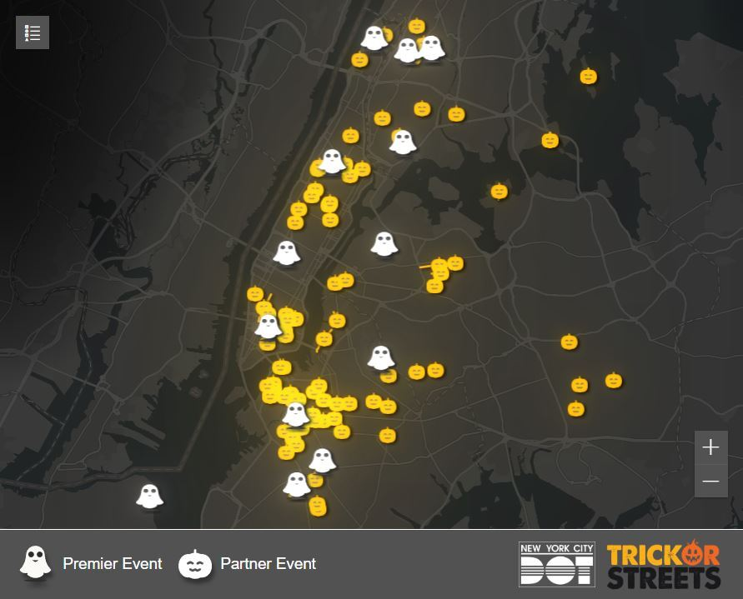
A map of premier and partner events for the Adams administration’s second annual “Trick-or-Streets.”
Credit: New York City Department of Transportation

“As we prepare to celebrate fall activities in communities across our city, I commend New York City Mayor Eric Adams and DOT Commissioner Ydanis Rodriguez for expanding this year’s ‘Trick-or-Streets’ to provide a festive, safe, and entertaining Halloween haven for New York City families,” said U.S. Representative Adriano Espaillat. “The Open Streets initiative boosts local businesses, expands access to safe car-free pedestrian spaces, and encourages families and neighbors to get involved in fun-filled activities throughout the community.”

“I’m thrilled that Trick-or-Streets is returning so that New York’s youngest ghouls, ghosts, and goblins can take full advantage of the city on Halloween. This is a spirited step toward ensuring a spooktacular and safe night for trick-or-treaters,” said Manhattan Borough President Mark Levine. “I’m grateful to DOT for coordinating the initiative and to all of the community partners who are committed to making these Halloween streets safe and festive.”

“Halloween gives us a great reason to enjoy sweets and come together as a community. But when it comes to the safety of our families out trick or treating, we can’t afford any frights,” said Queens Borough President Donovan Richards Jr. “With some of our major streets being car-free for the second straight year, I encourage all our families to come out and have a spook-tacular time enjoying Trick-or-Streets!”

“I am pleased to see Trick-or-Streets return to New York City this fall and look forward to the joy that the program and its events will bring to children and families across Brooklyn,” said Brooklyn Borough President Antonio Reynoso. “I thank Mayor Eric Adams and New York City Department of Transportation Commissioner Ydanis Rodriguez for adding pedestrian spaces across the city so that residents can safely celebrate Halloween and Día De Los Muertos.”

“Halloween is meant to be a spooky time for children — but as a parent, I know that its history as the deadliest day of the year for child pedestrians means that the fun holiday is only one driver’s poor choice away from downright scary,” said New York State Senator Andrew Gounardes. “I applaud Mayor Adams and Commissioner Rodriguez for taking clear steps to keep trick or treaters and their families safer this Halloween with the Trick-or-Streets program, and to up our public spaces for all New Yorkers to safely enjoy.”

“Amidst the concrete jungle, DOT is painting the town orange!” said New York State Senator Robert Jackson. “City Hall and the New York City Department of Transportation will cast a spell of car-free delight, transforming New York City into a Halloween haven for our youth to celebrate, play, and make lasting memories. Let the streets come alive with 'Trick-or-Streets,' where the spirit of community thrives!”

“New York City is home to 1.7 million children, most of whom will be out celebrating on Halloween,” said New York State Assemblymember Jenifer Rajkumar. “On this night fraught with horror, the greatest horror of all may be a car accident: the risk of a pedestrian fatality increases 43 percent on Halloween. Mayor Adams and Commissioner Rodriguez’s ‘Trick-or-Streets’ program will create over 100 car-free locations across the five boroughs, ensuring children and their families enjoy a safe and fun Halloween. Instead of worrying about a car accident, the only thing children will have to fear is getting candy they dislike. Combined with the city’s giveaway of 1,500 pumpkins and squash and 1,000 pounds of candy, along with hosting numerous live performances, Halloween 2023 promises to be the most spooktacular in history.”

“Thank you to Mayor Adams and Commissioner Rodriguez for bringing the ‘Trick-or-Streets’ program to Staten Island!” said New York City Councilmember Kamillah Hanks. “This program provides safe, public access for families to enjoy the Halloween festivities. A special thanks to The Angiuli Group for co-sponsoring the event on Minthorne Street on Halloween!”

“By pedestrianizing spaces and opening our streets to people, we have unlocked so much creativity and made our communities stronger, safer, and more vibrant,” said New York City Councilmember Carlina Rivera. “The return of the Trick-or-Streets program supports research that shows Open Streets boost the local economy and strengthen community bonds. I’m glad to see our neighborhood partner Loisaida Open Streets Community Coalition is participating, and I commend the administration for their continued commitment to pedestrianizing streets and plazas to create safe public space for families.”

“New York City streets are for everyone, and we are glad to see Mayor Adams and Commissioner Rodriguez recognize the need for safe, car-free spaces for young people and their families during Halloween season,” said Ken Podziba, CEO, Bike New York. “With this year's robust schedule of activities and programming, families in every borough will have the opportunity to enjoy the best of what New York has to offer — community.”

“The ‘Trick or Streets’ program is a perfect example of how we can creatively adapt our streets to fit day-to-day needs,” said Sabina Sethi Unni, schools planner, Open Plans. “Streets can be fun, community spaces if we’re willing to make them that way! Kudos to DOT for recognizing this opportunity and starting a new city tradition. These are the programs that help families make memories that last a lifetime.”

###

