
FOR IMMEDIATE RELEASE: June 18, 2025
CONTACT: pressoffice@cityhall.nyc.gov, (212) 788-2958
MAYOR ADAMS CELEBRATE’S CITY PLANNING COMMISSION’S
APPROVAL OF MIDTOWN SOUTH MIXED-USE PLAN
TO CREATE NEARLY 10,000 NEW HOMES
Plan Would Bring Nearly 3,000 Permanently Affordable Homes to Midtown South Neighborhood
Proposal is Part of Adams Administration’s Ambitious “Manhattan Plan” to
Add 100,000 New Homes to Borough Over Next Decade
Plan Now Heads to City Council for Review and Final Vote
NEW YORK – New York City Mayor Eric Adams and New York City Department of City Planning (DCP) Director and City Planning Commission (CPC) Chair Dan Garodnick today celebrated the CPC’s vote in favor of the Midtown South Mixed-Use (MSMX) Plan, an ambitious proposal to bring approximately 9,700 new homes across 42 blocks of Midtown South where housing is largely not allowed today. By mapping Mandatory Inclusionary Housing onto the neighborhood for the first time, and requiring new developments to include affordable housing, MSMX ensures that up to 2,900 of those units will be permanently affordable as well. New housing in the neighborhood will be paired with public realm improvements and additional investments to create a more vibrant, 24/7 neighborhood with affordable housing, good jobs, and accessible open space. MSMX is a key component of Mayor Adams’ “Manhattan Plan” to create over 100,000 new homes across the borough over the coming decade to bring the total number of homes in Manhattan to 1 million. First unveiled in his State of the City address earlier this year, the Manhattan Plan utilizes neighborhood rezonings like MSMX, the redevelopment of city-owned sites like 100 Gold Street in Lower Manhattan, and individual applications for zoning changes like the creation of nearly 700 homes above a future Second Avenue Subway station in East Harlem.
“Midtown South is home to some of our city’s most iconic parks, buildings, and businesses, yet for too long, outdated zoning has stopped it from actually being a home for many New Yorkers. With today’s vote, we are one step closer to finally building new housing in Midtown and making it a vibrant neighborhood to live, work, and play in,” said Mayor Adams. “Our Midtown South Mixed-Use plan will not only bring nearly 10,000 new homes to the neighborhood, but it will bring us closer to our vision of 100,000 new homes across all of Manhattan over the next decade and help make sure that New York City is the best place to raise a family.”
“The City of New York is in a housing crisis, and to overcome that crisis and make New York more affordable we need to build a little more housing in each neighborhood, including Midtown South,” said Deputy Mayor for Housing, Economic Development, and Workforce Adolfo Carrion, Jr. “That’s what the Midtown South Mixed-Use Plan does — it provides updated zoning that will allow for meaningful housing production in a transit-rich section of the city, including almost 3,000 affordable units, and help write a new chapter for the future of midtown as a dynamic, mixed-use district.”
“With commercial vacancies too high and housing vacancies at historically low levels, it’s a perfect time to seize this opportunity to create a 24/7, mixed-use neighborhood. This plan will bring forth a vibrant mix of commercial, manufacturing, and residential uses, creating a truly dynamic community here,” said DCP Director and CPC Chair Garodnick. “Today’s vote takes us one step closer to the affordable homes, jobs, and infrastructure improvements Midtown South deserves. Thanks to the City Planning commissioners for their support.”
The MSMX plan covers four distinct areas centered around Herald and Greeley Squares located roughly between West 23rd and West 40th Streets as well as 5th and 8th Avenues. This part of Midtown South is largely saddled with outdated industrial zoning that prohibits new housing, severely limiting opportunities for future growth. While Midtown South has long been a powerful economic center — including over 7,000 businesses, 135,000 jobs, and access to important transit hubs at Penn Station, the Port Authority Bus Terminal, Herald Square, and Bryant Park — the neighborhood has struggled since the COVID-19 pandemic with commercial vacancies and restrictive zoning rules that limit opportunities for New Yorkers to live near their jobs.
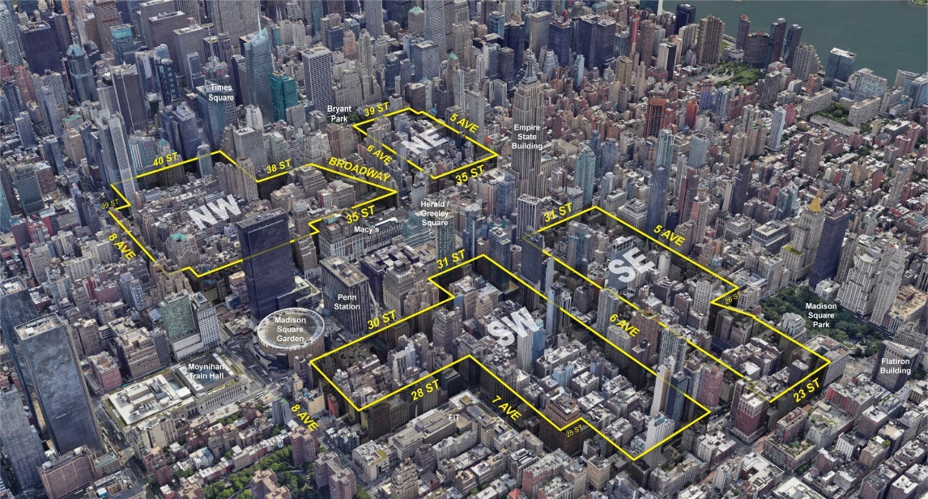
Mayor Adams’ MSMX plan will create nearly 10,000 new homes across
four distinct areas in Midtown South, including 2,900 affordable units. Credit: DCP.
The MSMX plan works to address these challenges and bring new housing to the neighborhood. By establishing mixed-use zoning districts that allow housing, industrial enterprises, and commercial businesses all in the same area, the MSMX plan could create around 9,700 new homes — including up to 2,900 income-restricted affordable homes via Mandatory Inclusionary Housing, which would apply to Midtown for the first time. The plan also marks the first use of new, high-density R11 and R12 zoning districts, which allow higher residential “floor-to-area ratios” (FAR) of 15 and 18. These new districts were created through a combination of Mayor Adams’ “City of Yes for Housing Opportunity” initiative and the Adams administration’s successful advocacy in Albany to lift the outdated FAR cap, which had previously arbitrarily limited housing density in New York City. With these new tools, the Adams administration was able to more than double the amount of projected housing with the MSMX neighborhood rezoning. These changes would also allow buildings to convert offices to housing, unlocking another important way to create new homes and repurpose vacant or underutilized space in this area.
The new zoning districts proposed in MSMX will continue to allow for a wide range of non-residential uses — including light manufacturing, office space, and retail — as well as permit new uses by community facilities like schools and libraries. To improve the public realm in the neighborhood, the plan would create a new zoning special district — the Special Midtown South Mixed-Use District — that will ensure new buildings with higher residential densities reflect the area’s existing loft-like character such as high ceilings, open spaces, and a flexible layout. The new zoning district will also maintain active street fronts with uses such as ground-floor retail. This will help to create an open, welcoming streetscape environment for residents, workers, and visitors.
Complementing the Adams administration’s “Broadway Vision” initiative to enhance public space along Broadway, the MSMX plan will provide a density bonus allowing developments to add additional housing if they provide local improvements in the neighborhood. These improvements — which can include increased accessibility to public transit stations, privately-owned public spaces, and public indoor spaces like atriums — would help establish a more active and dynamic public realm. Buildings will also receive a floor area exemption if they set aside space for a public school.
The MSMX plan grew from over a year of community engagement. That public planning process included a kickoff meeting, a town hall, a public information session presenting the draft plan, one-on-one conversations with New Yorkers, and stakeholder events with residents, business owners, local groups, non-profit organizations, and social service providers. DCP also used online tools, including an interactive map and survey, to garner further input on what New Yorkers wanted to see in Midtown South. Throughout this process, DCP repeatedly heard strong support for creating housing opportunities in the neighborhood; boosting small businesses and jobs; and prioritizing active, safe streets.
The CPC’s vote today for MSMX follows favorable recommendations from Manhattan Community Board 5, the Manhattan Borough Board, and Manhattan Borough President Mark Levine. The proposal now goes to the New York City Council for a public hearing and vote.
With the CPC’s approval of MSMX, DCP has also released a new FAQ guide to the plan. It provides clear answers to common questions, covering key topics like the introduction of new zoning districts, the requirement for affordable housing, and how MSMX aligns with the neighborhood. The FAQ is available to download, alongside other informational materials, at midtownsouthplan.nyc.
The Adams Administration’s Record on Housing
Since entering office, Mayor Adams has made historic investments to create more affordable housing and ensure more New Yorkers have a place to call home. The Adams administration is advancing several robust neighborhood plans that, if adopted, would deliver more than 50,000 units over the next 15 years to New York neighborhoods. In addition to the Bronx-Metro North Station Area Plan and the Atlantic Avenue Mixed-Use Plan, both of which have been passed by the New York City Council, the Adams administration is advancing plans Jamaica and Long Island City in Queens, as well as in Midtown South in Manhattan.
Moreover, last December, Mayor Adams celebrated the passage of City of Yes for Housing Opportunity,” the most pro-housing proposal in city history that will build 80,000 new homes over 15 years and invest $5 billion towards critical infrastructure updates and housing. Last June, City Hall and the City Council agreed to an on-time, balanced, and fiscally-responsible $112.4 billion Fiscal Year (FY) 2025 Adopted Budget that invested $2 billion in capital funds across FY25 and FY26 to the New York City Department of Housing Preservation and Development and the New York City Housing Authority’s capital budgets. In total, the Adams administration has committed $24.7 billion in housing capital in the current 10-year plan as the city faces a generational housing crisis. Mayor Adams celebrated back-to-back record breaking fiscal years, as well as back-to-back calendar years, in both creating and connecting New Yorkers to affordable housing. Last spring, the city celebrated the largest 100 percent affordable housing project in 40 years with the Willets Point transformation.
The Adams administration has continued to advance bold, forward-looking projects to build more housing, including reimagining Gansevoort Square to build mixed-income housing, building 100 percent affordable housing at the Grand Concourse Library in the Bronx, advancing the 388 Hudson development in Manhattan to provide hundreds of critically-needed affordable housing units, announcing the next phase of an ambitious, bold new vision for Coney Island in Brooklyn that will deliver 1,500 new homes and invest in the reconstruction of the historic Riegelmann Boardwalk, and moving forward on a MTA proposal to transform a long-vacant lot in East Harlem into a mixed-use tower with nearly 700 new homes. All of these projects build on this year’s State of the City address, where Mayor Adams unveiled his “City of Yes for Families” vision, a multi-pronged approach to housing, zoning, and public space that will create more family-friendly neighborhoods and build new housing.
Additionally, to help more New Yorkers reach homeownership and build generational wealth, Mayor Adams announced multiple new tools, including a $4 million state grant, to help New York City homeowners create accessory dwelling units that will not only help older adults afford to remain in the communities they call home but also help build generational wealth. In addition to creating more housing opportunities, the Adams administration is actively working to strengthen tenant protections and support homeowners. The Partners in Preservation program was expanded citywide in 2024 through an $24 million investment in local organizations to support tenant organizing and combat harassment in rent-regulated housing. The Homeowner Help Desk, a trusted one-stop shop for low-income homeowners to receive financial and legal counseling from local organizations, was also expanded citywide in 2024 with a $13 million funding commitment.
Finally, Mayor Adams and members of his administration successfully advocated for new tools in the 2024 New York state budget that will spur the creation of urgently needed housing. These tools include a new tax incentive for multifamily rental construction, a tax incentive program to encourage office conversions to create more affordable units, lifting the arbitrary FAR cap that held back affordable housing production in certain high-demand areas of the city, and the ability to create a pilot program to legalize and make safe basement apartments.
“The Midtown South plan is an exciting proposal to redevelop a greatly undervalued area of Manhattan, building on the legacy of the Garment District to create a new creative industry and residential cluster that features the city’s excellence in fashion and retail, the arts, and entertainment,” said Kathryn Wylde, president & CEO, Partnership for New York City. “It will be transformational!”
“Today’s vote is a major milestone for Midtown South and a win for New York. With over 135,000 jobs and 7,000 businesses in the area, this neighborhood has long deserved a plan that matches its potential,” said Carlo A. Scissura, Esq., president and CEO, New York Building Congress. “The Midtown South Mixed-Use Plan will deliver more housing, vibrancy, and a stronger, more connected community. The Building Congress applauds the city for advancing this vision and looks forward to continuing our support for the growth it will bring.”
“We’re thrilled to see the City Planning Commission vote in favor of the Midtown South Mixed-Use Plan, a major milestone on the path toward a more livable and inclusive Midtown,” said Rachel Fee, executive director, New York Housing Conference. “For far too long, outdated zoning policies have limited the potential of this well-resourced area to help address New York City’s urgent housing needs. In the midst of a dire housing crisis, this plan opens the door to new housing opportunities, including much-needed affordable housing. We’re eager to see this vibrant, mixed-used community come to life in the heart of New York City.”
"With the best public transit connections in the nation, Midtown South is poised to emerge from the post-pandemic era as a 24/7 community,” said Danny Pearlstein, policy and communications director, Riders Alliance. “New zoning for today’s needs will enable the neighborhood to help ease the housing crisis while taking advantage of excellent subway and bus access.”
“The city needs high density housing, and the Garment District needs a lifeline. The MSMX rezoning is the perfect solution to both problems. Allowing more people to live in the neighborhood will enable the district to develop into a robust, mixed-use community, with residents supporting our restaurants and enlivening our streets. The Jane Jacobs-coveted ‘eyes on the streets’ have been missing for too long in the Garment District,” said Barbara Blair, president, Garment District Alliance. “MSMX is a one-time opportunity to reverse the wrongs of past failed policies which have suppressed economic development in the neighborhood. Fostering the development of a mixed-use community will allow the Garment District to take its rightful place as an ideal location to live, work, and visit. Our future depends on it. The Garment District Alliance wholly supports MSMX.”
“There is no more appropriate place to build more housing than a neighborhood that's within walking distance to virtually every major subway line, the busiest bus and rail stations in the country, and the largest jobs hub in the western hemisphere,” said Moses Gates, vice president for housing and neighborhood planning, Regional Plan Association. “We are excited to see the future of Midtown South as a mixed-use, mixed-income community with room for jobs, tourists and residents alike.”
“The Midtown South Mixed-Use Plan presents a thoughtful vision, delivering urgently needed housing, fostering a vibrant 24/7 neighborhood, and preserving the historic and contextual character through a mix of new construction and adaptive reuse that defines this iconic part of New York,” said Helen Hwang, urban land institute new york chair and senior executive managing director, Meridian Investment Sales. “By updating zoning to support modern light manufacturing, allowing for greater residential density, incorporating mandatory inclusionary housing — along with opportunities for future schools and libraries for the first time — and enabling office-to-residential conversions, the plan paves the way for a thriving, inclusive community built for the future.”
“Abundance New York — a community of over 2,500 pro-housing New Yorkers — applauds the progress of the Midtown South Mixed-Use Plan. This is exactly the kind of bold action New York needs to address its historic housing shortage, skyrocketing rents, and record homelessness. New York is not full; especially in Midtown, we have capacity for thousands of new homes that will lower rent pressure for everyone while preventing displacement, reducing sprawl, and supporting the density that is our climate superpower,” said Ryder Kessler, co-founder, Abundance New York. “Thanks to state action that ended arbitrary limits on our density, New York City can once again build residences like many of our most beloved buildings citywide. New York can have more than enough of everything we need to thrive, and MSMX is an important step towards that future.”
###

