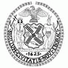
THE CITY OF NEW YORK
OFFICE OF THE MAYOR
NEW YORK, NY 10007

FOR IMMEDIATE RELEASE, May 17, 2017
CONTACT: pressoffice@cityhall.nyc.gov, (212) 788-2958

VISION ZERO: MAYOR DE BLASIO ANNOUNCES MORE THAN TWO YEARS WITHOUT A FATALITY ON QUEENS BOULEVARD, AS NEXT PHASE OF REDESIGN MOVES FORWARD

Coming in June: New protected bike lanes, crosswalks, and expanded medians will come to Rego Park and Forest Hills

NEW YORK—Mayor Bill de Blasio announced today that Queens Boulevard has seen zero fatalities since 2014, and New York City will further extend the redesign of Queens Boulevard beginning in June. After overwhelming approval by Queens Community Board 6 last week, DOT will add major safety improvements to the street - including new protected bike lanes, more crosswalks, and expanded medians -- through Rego Park and Forest Hills. Queens Boulevard, which had 22 traffic fatalities as recently as 1997, has not had a single traffic fatality in two and a half years, the same time DOT began the street’s conversion into a Vision Zero Priority Corridor.

“Queens Boulevard offers the best and most dramatic proof that our efforts at Vision Zero are working,” said Mayor de Blasio. “What was once a ‘Boulevard of Death’ is no longer -- as pedestrians, cyclists and motorists all have become accustomed to enjoying a more vital, welcoming and safe street. As changes come this year to Forest Hills and Rego Park, we thank Councilmember Karen Koslowitz for her leadership and Community Board Six for its recognition that a new Queens Boulevard is a win-win for all of the community’s businesses, children and seniors.”

Last week, Community Board Six in Forest Hills voted overwhelmingly, by a 34-3 margin, to support DOT’s plan for a third phase of Queens Boulevard redesign, for the 1.3-mile portion of the street between Eliot Avenue and Yellowstone Boulevard. In the first two phases, DOT transformed 2.5 miles of Queens Boulevard through Woodside and Elmhurst. In addition to the absence of fatalities, DOT statistics show that since work began, crashes in the Phase 1 corridor have declined by 14 percent, with pedestrian injuries down by 49 percent and cyclist injuries down by 42 percent, yet cycling increased by 120%.

All of DOT’s changes to Queens Boulevard will cost approximately $4 million. Starting next year, the Department of Design and Construction (DDC) will begin major capital work -- for which the de Blasio Administration has committed $255 million – to transform the boulevard, making all three phases permanent, including by widening medians and adding new amenities like trees, landscaping and benches.

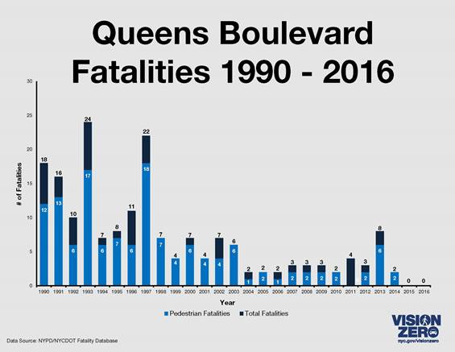

The Mayor also cited the latest Vision Zero fatality statistics for 2017. Year-to-date, New York City has seen 69 traffic fatalities in 2017, compared to 78 by this date in 2016 – a 12 percent decline. The number of pedestrians struck and killed has gone from 46 in 2016 to 38 in 2017, a 17 percent decline.

“The transformation of Queens Boulevard is among the greatest achievements of the Vision Zero era,” said DOT Commissioner Polly Trottenberg. “In just a few years, what was once a forbidding highway-like street bisecting communities has started to become a grand and welcoming boulevard worthy of Queens. But we have much more to do -- and so we gratefully acknowledge Council member Koslowitz and Community Board Six for embracing the next phase of these exciting changes.”

“DDC is working in every borough to improve safety for pedestrians, motorists, and bicyclists alike,” said DDC Commissioner Feniosky Peña-Mora. “Vision Zero is a great success and DDC is proud to be a significant part of it through our work on Queens Boulevard, and other Great Streets projects such as Atlantic Avenue in Brooklyn and the Grand Concourse in the Bronx. We will continue to create projects that realize Mayor de Blasio’s vision for a healthier, more resilient, and more equitable New York.”

“This latest DOT plan, with its pedestrian and bike safety improvements, will continue the transformation of this major thoroughfare from the ‘Boulevard of Death’ to the ‘Boulevard of Life.’” said Council Member Karen Koslowitz.

“Far too many people have been injured and killed because of unsafe conditions on Queens Boulevard,” said Majority Leader Jimmy Van Bramer. “I am proud of the work we’ve done to transform Queens Boulevard from the Boulevard of Death to the Boulevard of Life. The safety improvements made along Queens Boulevard have saved people's lives. Simply put, extending the safety improvements further along Queens Boulevard will save lives.”

"I lost a friend on Queens Boulevard, Robert Livingston, and my hope is that now the Boulevard of Death will finally become the Boulevard of Life. This is about safety for everyone--plain and simple." said Joseph C. Hennessy, Chairman of Queens Community Board 6.

"This is a momentous day, for Queens and for all of New York City. Local residents have spent decades calling on officials to fix what has long been known as the 'Boulevard of Death,' and now even more Queens residents will benefit from the newly re-designed 'Boulevard of Life,'" said Paul Steely White, Executive Director of Transportation Alternatives. "We thank Mayor de Blasio, Commissioner Trottenberg and the City Council for continuing to make life-saving improvements on Queens Boulevard a priority. The redesign of Queens Boulevard can serve as a model for how we improve our most dangerous corridors across the five boroughs in order to make Vision Zero a reality."

"Cities of tomorrow are shaped by decisions of today, and the upgrades to bike, pedestrian, and vehicular arteries, like Queens Boulevard, are fundamental to ensuring the future vitality of our borough. Mayor de Blasio's Vision Zero Action Plan is both a direction and a goal. It is effort that all residents of Queens should support, as we seek out these much needed civic dollars and projects that will make our community safer." said James McIntyre of Queens Bike Initiative.

"This victory is one for the community and has come from a lot of regular neighbors actively participating in the process. While phase 3 of this project may have seemed like an easier win, that's because the data shows that these safety improvements and additions for pedestrians and cyclists are actually making the Boulevard safer and more accessible. We are proud of the hard work and commitment from the Department of Transportation, Mayor de Blasio, Council Member Koslowitz, and surrounding communities. Their proactive approach to congestion, traffic and reckless driving gives our neighbors more and better options than what the MTA and private cars provide." said Co-founder Make Queens Safer, Cris Furlong.

"Ciclistas Latinoamericanos de New York welcomes the third phase of improvements for Queens Boulevard. In this road where a lot of people commute, work and live is a huge impact for more livable streets. To expand the bike lane in Queens Boulevard gave us the importance of this mode of transportation in New York City, because is not for recreation only. It is an important alternative for transportation and a way to connect with other alternatives as the train. Communities as far as Jamaica will be positively impacted by this transformation. Thank you to the Department of Transportation and to Mayor de Blasio.” said Founder Claudia Corcino.

About Vision Zero
In January 2017, after three successive years of declines in traffic fatalities, Mayor Bill de Blasio announced New York City would make an additional $400 million investment in Vision Zero – for a total of $1.6 billion over the next five years. DOT is implementing its most aggressive street redesign safety program, an increased investment in street redesign and traffic-calming measures citywide. Other Vision Zero changes announced by the Mayor include ensuring NYPD crossing guards at every post, faster replacement of street markings, intersection upgrades in the bike-lane network, more left-turn calming efforts, brighter lighting and more equipment at each police precinct to catch speeding.

For more information about the de Blasio Administration’s Vision Zero initiative, please see www.nyc.gov/visionzero

###

