
FOR IMMEDIATE RELEASE: June 5, 2025
CONTACT: pressoffice@cityhall.nyc.gov, (212) 788-2958
MAYOR ADAMS INVESTS $50 MILLION TO FURTHER REVITALIZE “THE ARCHES,”
PUBLIC SPACE ON MANHATTAN SIDE OF BROOKLYN BRIDGE
Investment Part of “Best Budget Ever” and “We Outside Summer,”
Will Improve Revitalized Public Space
Major Restoration of Brooklyn Bridge Closed Adjacent Space for Past 15 Years
NEW YORK – New York City Mayor Eric Adams today cut the ribbon on a newly-revitalized portion of “The Arches” — the public space on the Manhattan side of the Brooklyn Bridge adjacent to City Hall that is named for the 53 adjacent arches under the Brooklyn Bridge — and announced $50 million in additional funding to improve the public space. As part of Mayor Adams’ Fiscal Year 2026 Executive Budget — referred to often as the city’s “Best Budget Ever” — this investment will add additional amenities to the public space, including public seating, plantings, lighting, and more. The announcement continues Mayor Adams’ “We Outside Summer” — a new initiative that will include a series of announcements, events, investments, and new programming across the five boroughs to ensure New Yorkers have a safe, enjoyable summer.
“Public space in this city is precious — it’s where our families create memories, it’s where our children play, and it’s where communities come to relax. Today, we return two more acres of public space back to the local Chinatown community at ‘The Arches,’ giving New Yorkers more outdoor space to exercise, engage with others, and enjoy,” said Mayor Adams. “We are also investing $50 million in funding to bring this space back to life, and transform it into a lively, inclusive space for friends and neighbors to come together — welcoming New Yorkers from all walks of life. Right in time for our ‘We Outside Summer,’ The Arches brings us closer to creating a more equitable, livable, and prosperous New York.”
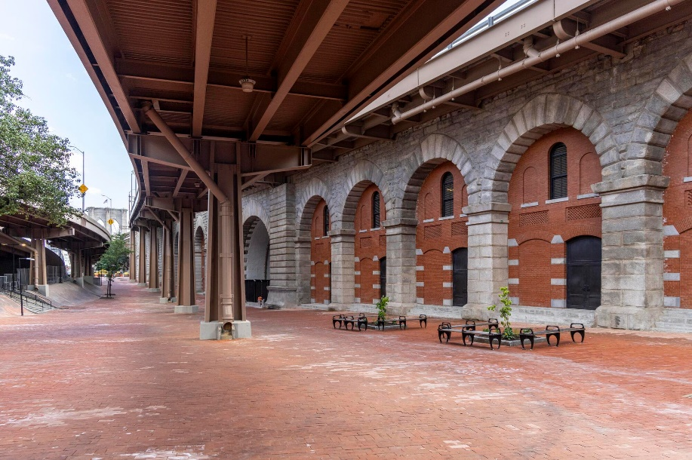
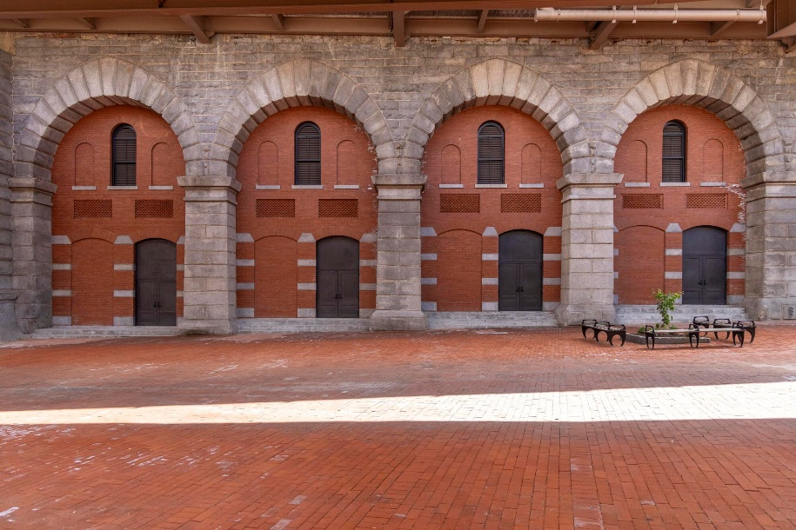“The Arches” is named for the 53 adjacent arches under the Brooklyn Bridge.
Source: New York City Department of Transportation (DOT).
“In the shade of the iconic Brooklyn Bridge, this project delivers many things — an architectural marvel, a proper home for skating in one of the sport’s global hubs, and a place to relax in a neighborhood with too few,” said Deputy Mayor for Operations Jeff Roth. “We are grateful to our agency partners; to Rosa Chang, who relentlessly helped us push this over the finish line; The Skatepark Project; and our many local friends and advocates who got us to this moment.”
“In a city where public space is at a premium — especially in neighborhoods like Chinatown and Lower Manhattan — bringing this iconic stretch under the Brooklyn Bridge back to life is a big win for New Yorkers,” said Chief Public Realm Officer Ya-Ting Liu. “We’re turning concrete into community — a place that will be a respite and gathering place for residents, workers, and visitors alike. By opening up more welcoming, active spaces, we’re also helping local businesses thrive and shining a spotlight on the culture and energy that make neighborhoods like Chinatown so special.”
“The Lower Manhattan community, and all who visit it each day, can celebrate this special day as we return the space around this beautiful bridge to a neighborhood where public space is so precious,” said New York City Department of Transportation (DOT) Commissioner Ydanis Rodriguez. “As the weather warms, we invite the community and tourists who are visiting the bridge and Chinatown to come enjoy this beautiful new public space.”
The phased re-opening of “The Arches” began in 2023 but today marks the return of the largest plaza portion — more than two acres of new public space — to the local lower Manhattan community, to be combined with the more than one acre previously opened. The new space includes access to space under the Brooklyn Bridge’s dramatic vaulted archways — part of the National Historic Landmark that is managed by DOT — which in the last decade has undergone more than $1 billion in improvements, its most significant rehabilitation and restoration since the bridge was first completed in 1883.
“New York City is fortunate to be shaped by the breathtaking diversity of New Yorkers who, for centuries, have dared to dream big and worked relentlessly to make those dreams a reality,” said Rosa Chang, co-founder and president, Gotham Park. “Our cityscape is the embodiment of that collective yearning and achievement. The Brooklyn Bridge is one of its most powerful symbols — a love letter to New Yorkers, written in stone 142 years ago. It reaches across time to connect us, inspire us, and challenge us to be better. With this new chapter of Gotham Park, we commit to building a welcoming space to gather, share, play, grow, and thrive. The space itself is a majestic canvas — but we, the people who bring it to life, are the ever-changing art. Our deepest thanks go to Mayor Eric Adams, who keeps saying ‘yes’ when it matters most; to every hard-working public servant at City Hall and at the New York City Department of Transportation, which has made this possible; to our community partners at Trinity Church, Community Board 1, and Community Board 3; and to the countless local stakeholders who helped bring us to this moment. Gotham Park is the adventure of a lifetime, and we’re just getting started. Let’s keep dreaming together and write a love letter to our children.”
“The revitalization and re-opening of the Brooklyn Banks is a monumental moment for skateboarding,” said Benjamin Anderson Bashein, CEO, The Skatepark Project. “This historic skate spot is a special place where people from across the world have come to skate and to find community, and we’re thrilled to see it open to the public once again. We are grateful to our partners at City Hall, who have prioritized this project, along with Gotham Park and Vans, whose unwavering support has helped make this dream project become a reality.”
The area opening today had served as a contractor staging area for more than a decade, supporting restoration for the Brooklyn Bridge, projects which together totaled more than $1 billion in investments. In spaces re-opened over the last two years, public space was added for pickleball, basketball, and shuffleboard, as well as quiet benched areas.
In May 2023, Mayor Adams also announced the plaza space would be open to the community for a range of recreational activities, including the return of the “Brooklyn Banks” site, once known as the “mecca of New York skateboarding.” The newest public plaza space honors this history with a revitalized space designed in partnership with Gotham Park and Tony Hawk’s non-profit organization, The Skatepark Project. The Adams administration continues to work closely with The Skatepark Project to ensure all materials and design features of the park meet the safety, wellness, and performance needs of the action sports community, and with Gotham Park and community leaders to ensure the historic site serves New Yorkers for years to come.
“I’m thrilled that New York City has committed $50 million to the revitalization of ‘The Arches’ beneath the Brooklyn Bridge,” said U.S. Representative Dan Goldman. “This vital investment, combined with the federal funding that Senator Schumer, Senator Gillibrand, and I helped secure, will play a major role in reconnecting and revitalizing the long-separated communities of Chinatown, Two Bridges, and Lower Manhattan. I commend the city for investing in this area and will continue working alongside them to direct even more resources to this exciting project.”
###

