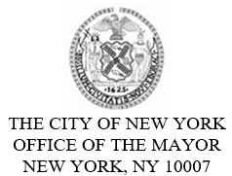
FOR PLANNING PURPOSES
CONTACT: pressoffice@cityhall.nyc.gov, (212) 788-2958

UPDATED PUBLIC SCHEDULE FOR MAYOR ERIC ADAMS FOR FRIDAY, DECEMBER 8, 2023

**Updated Schedule**

On Friday, New York City Mayor Eric Adams will deliver remarks at the New York City Hispanic Chamber of Commerce’s 18th Annual Hispanic Business Award Banquet and Scholarship Ceremony. This event is open press.

Press Schedule
Approximately 8:00 PM – Delivers Remarks at 18th Annual Hispanic Business Award Banquet and Scholarship Ceremony
Maestro’s Caterers
1703 Bronxdale Avenue
Bronx, NY 10462
Official photos will be available following the event.

###

