
THE CITY OF NEW YORK
OFFICE OF THE MAYOR
NEW YORK, NY 10007

FOR IMMEDIATE RELEASE
CONTACT: pressoffice@cityhall.nyc.gov, (212) 788-2958

MAYOR DE BLASIO AND NYC FERRY CELEBRATE ONE MILLION RIDERS SINCE MAY 1
Astoria route will launch August 29, connect New Yorkers with 15 Landings for $2.75
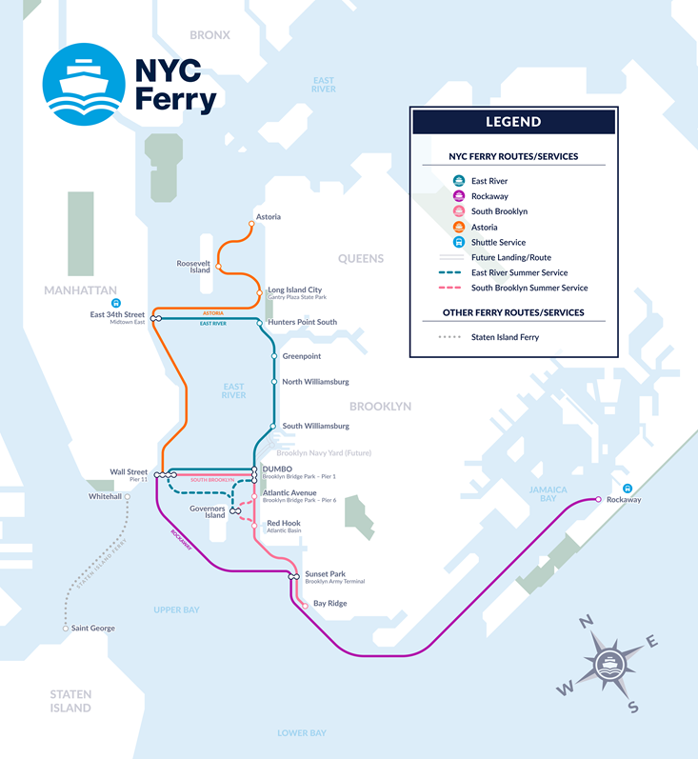
NEW YORK—Mayor Bill de Blasio today joined local officials and residents in Long Island City to celebrate one million riders served by NYC Ferry and announce the that the fourth NYC Ferry route, connecting Astoria, Long Island City, Roosevelt Island, 34th Street and Wall Street, will launch Tuesday, August 29, the week before Labor Day Weekend.
“It’s been less than three months and NYC Ferry has already served one million riders. As we prepare to launch the Astoria route, we continue to add capacity to this brand new and wildly popular system – one that connects transit-starved neighborhoods and commuters to jobs and the wider city,” said Mayor Bill de Blasio.
Based on preliminary ridership projections, NYC Ferry was not anticipated to hit one million riders until August 23 – and will hit that today. Responding to the huge demand, the City already announced NYC Ferry is adding capacity to three of its 20 boats. The larger vessels will have bigger engines and hold up to 249 passengers, compared to 149 seats on the standard boats.
Based on preliminary ridership numbers from Tuesday night, NYC Ferry will surpass one million riders the morning of Wednesday, July 26 – with more than 625,000 riders on the East River Route, 221,000 on the Rockaway Route, and 154,000 on the South Brooklyn Route. Weekday ridership across the three routes ranges from 8,000 to 12,000 riders.
To celebrate one million riders, NYC Ferry is giving riders a chance to win a free annual pass. Anyone who activates a ticket on the NYC Ferry app between Friday, July 21 and Friday, July 28 will be entered to win. For more information go to https://www.ferry.nyc/1M/. In addition, NYC Ferry will be offering half price draft beverages – including cold brew coffee, beer and wine – throughout the day on all vessels equipped with Newstand concessions.
“We knew NYC Ferry would be popular, but a million riders in less than three months is beyond our wildest expectations,” said New York City Economic Development Corporation President and CEO James Patchett. “More and more New Yorkers are taking to the water to get to work or enjoy our parks and beaches – all for just $2.75. And with the Astoria route launching next month, we’ll be at two million riders before you know it!”

“With serving one million riders and counting, it’s clear that the NYC Ferry has become a critical and valued addition to public transportation in our city in a short amount of time,” said Speaker Melissa Mark-Viverito. “With three boroughs now linked by direct water service-and a fourth on the horizon-transit is more accessible than ever. I am proud of the city for their commitment to developing a reliable system to serve the outer boroughs, and of the rider who have integrated this alternate method of travel into their commutes.”

“The overwhelming demand for NYC Ferry service has far exceeded the City's expectations, affirming the ferry as a key component of building a reliable transit future for Queens. The predictability brought by the NYC Ferry has already been a boon for Queens tourism, economic development and investment along Queens' coasts. It's also provided fast and affordable transportation to hundreds of thousands of Queens residents, who have long been underserved by traditional mass transit,” said Queens Borough President Melinda Katz.

“Manhattan is the economic heart of our city, and every new transit link to and from Manhattan makes the city stronger,” said Manhattan Borough President Gale A. Brewer. “Today, mass transit between most of the neighborhoods on this route can be a crowded, complicated hassle, requiring two- and even three-seat rides on packed buses and subways. This new, one-seat ride to and from midtown and the Financial District could be life-changing for commuters from Roosevelt Island and western Astoria, and will be a boost to Roosevelt Island’s Cornell Tech campus.”

“I am thrilled that the Astoria ferry service route will be officially opening on August 29th. With stops in Astoria, Long Island City, Roosevelt Island, East 34th Street, and Wall Street, this route will connect many different communities in the 12th Congressional District which I’m privileged to represent. NYC Ferry Service is a boon to commuters, tourists, and New Yorkers just trying to experience a new neighborhood. I’m proud to work with the mayor in support of expanding ferry service, which has served more than a million riders already. This is an important addition to New York City’s transportation options,” said Representative Carolyn B. Maloney.

“Increased access to reliable transportation options, including ferry service, is among the most critical needs for western Queens residents. As we welcome new ferries, I will redouble my efforts to ensure our subway system improves during the current MTA crisis,” said State Senator Michael Gianaris.
“I'm glad that Astoria will have now have a ferry landing and increased transportation options. Anyone from Greece, where ferries are ubiquitous, will tell you it's a great way to travel. Being on the open water can be soothing and relaxing and beats being underground in a packed subway car any day,” said Assembly Member Aravella Simotas.
“With more and more people choosing to live and build a small business in Long Island City and Western Queens, it’s more important than ever to have a variety of safe and reliable transportation options that have the capacity to handle this growth,” said Council Majority Leader Jimmy Van Bramer. “The announcement of a new ferry route connecting Astoria, Long Island City, Roosevelt Island, and Manhattan and added capacity to existing boats that service Western Queens is welcome news that I hope will alleviate overcrowding to better serve my constituents.”
“Our water is our city's greatest resource. The NYC Ferry system is an innovative and sustainable use of our waterways to help residents commute to their jobs, see family, and run errands in Manhattan,” said Council Member Costa Constantinides. “The ferry will help Western Astoria, where residents have to endure long subway rides, stay better connected with our city and help revitalize Hallets Peninsula. Expanding public transit options will move us closer towards our goal of reducing carbon emissions 80% by 2050 and ensure that our city remains a global leader on the environment. I look forward to seeing an on-time launch of the Astoria route on August 29th and thank Mayor de Blasio for his bold vision.”
“NYC Ferry has provided not only a new fun and exciting transportation option for communities near and far, but has added important resiliency to our existing networks,” said Council Member Ydanis Rodriguez, Chair of the Council Transportation Committee. “It is great to see the popularity of our new ferry system exceeding expectations, while bringing a new service to transit deserts. The new East River service beginning in Astoria will be a welcome addition to the map as we continue to expand across the city’s waterways.”
“Since its launch, the NYC Ferry service has quickly become one of the most popular and effective transportation alternatives for residents, commuters and visitors. By investing in upgraded ferry stops and a mobile ticket system, our City has taken the steps to revolutionize our NYC transportation system to be more affordable, environmentally friendly, and accessible for New Yorkers on the go. Congratulations to everyone behind the NYC Ferry service for reaching this important milestone,” said Council Member Margaret Chin.
“Roosevelt Island has waited generations for ferry service which will finally arrive this summer,” said Council Member Ben Kallos, who represents Roosevelt Island. “After so many years of advocating for ferry service for Roosevelt Island it is hard to believe it is starting this summer. Thank you to Mayor de Blasio and the Economic Development Corporation President James Patchett for answering Roosevelt Island's call for ferry service and bringing it to all five boroughs. The number of riders is sure to double from a million with the addition of the Roosevelt Island stop to NYC Ferry.”
“The Astoria NYC Ferry route will greatly serve residents in Western Queens, who have lacked reliable mass transportation options for years despite a growing population. We are excited to have this new, affordable service as an option to get around the City and we look forward to a successful launch in August,” said Florence Kouloris, District Manager of Queens Community Board 1.

“As Lower Manhattan continues to transform into an increasingly 24/7 mixed-use neighborhood, it is increasingly important that we have ample and varied transit options for our residents, workers and visitors. We look forward to the continued implementation of Citywide Ferry Service with the launching of the fourth route on August 29th which will further improve Lower Manhattan’s transportation network,” said Anthony Notaro, Jr., Chair of Manhattan Community Board 1.

“The Hunters Point Community is excited and grateful for the new Ferry route,” said Brent O’Leary, President of the Hunters Point Civic Association. “Public transportation is vital for our residents for work and enjoyment. This new affordable option connecting the diverse neighborhoods of Long Island City, Astoria, Roosevelt Island and midtown Manhattan will help all our neighborhoods and let us enjoy one of New York City' great natural assets; our waterways.”

“The addition of ferry service for Roosevelt Island has been anticipated for many years as development continues and our population grows. Public transportation has been an issue here since the days when our aerial Tramway was the last two-fare zone in the City prior to being incorporated into the MTA MetroCard system. And our F-train subway continues to provide sporadic service especially on weekends. Ferry service returns us to the norms of prior centuries when travel by boat on the East River was our only option,” said Matthew Katz of the Roosevelt Island Residents Association.
“RIOC is very excited to have NYC Ferry connected with Roosevelt Island, providing an additional mode of transportation for our commuters, especially as our Island’s population increases. What a picturesque way to go to work! We look forward to our first trip!” said Susan Rosenthal, President and CEO Roosevelt Island Operating Corporation.

“We are so excited for the NYC Ferry Astoria route to launch at the end of August, just in time for Cornell Tech’s Roosevelt Island campus to open in September. The ferry will provide another seamless connection for island residents, students, faculty, staff, and companies at The Bridge to travel between Roosevelt Island, Manhattan, and the growing tech community in western Queens -- all while enjoying beautiful expansive views of the city,” said Meghan French, Senior Director of External Relations at Cornell Tech.

“This expansion of the ferry system is tremendously exciting – providing key north south access for our residents, visitors and workers to all the great culture, jobs, restaurants, bars and waterfront parks – and access across the river to the great innovation opportunities at Cornell Tech and the medical corridor along the eastern shore of Manhattan all the way to Wall Street," said Elizabeth Lusskin, President of the LIC Partnership, the local development corporation for Long Island City. “The success of the Hunters Point South ferry stop has shown how well this quick and enjoyable ride can bring LIC residents to the rest of the city, and the rest of the city to our community. The new LIC stop in Gantry Plaza State Park will be an essential gateway. This is a great ‘sea change’ for our neighborhood.”

“The Hunters Point Park Conservancy is happy to support NYC Ferry which helps to alleviate the inundated 7 train. We look forward to welcoming NYC Ferry’s Astoria Route, and we appreciate the support NYC Ferry has provided the Hunters Point Park Conservancy,” said Rob Basch, President of the Hunters Point Park Conservancy.

“The NYC Ferry Astoria Route will greatly enhance the quality of life for residents that live in and around the community. Commuting times to Manhattan will be cut in half, giving Astoria residents the opportunity to spend more time with their families and friends. Moreover, the new ferry route is going to provide affordable and efficient transportation that will reconnect New Yorkers with the City’s unrivaled waterfront scenery,” said Claudia Coger, President of Astoria Houses Residents Association.
NYC Ferry, which will eventually be six routes, has so far launched three. The Rockaway and East River routes launched May 1. The South Brooklyn Route began operating ferries June 1. While the Astoria Route launches Aug. 29, the final two, the Lower East Side and Soundview routes, will launch next year. Detailed timetables, along with a map of all 2017 routes are available here.
Once the NYC Ferry system is fully operational, the combined routes will cover more than 60 miles of waterway at $2.75 per ride, the same cost of a subway ride. The cost of a 30-day unlimited ferry pass is $121, mirroring the cost of a 30-day MetroCard. This price point builds on Mayor de Blasio's commitment to ensuring that NYC Ferry is affordable to New Yorkers.

Earlier this year, the City revealed names for what will ultimately be the 20 new NYC Ferry boats. Second graders with schools near ferry landings were invited to name the 2017 fleet of boats, selected names included Munsee, The Connector, Owl's Head, Great Eagle, Happy Hauler, McShiny, Opportunity, and Flyer. Also, Lunchbox, Waves of Wonder, The Friendship Express, and Sunset Crossing.

Ferry riders can download the NYC Ferry App to purchase e-tickets, allowing for easy scan-and-go boarding, and get detailed maps and schedules, as well as real-time notifications and service alerts. Use of the app provides a more environmentally friendly service by reducing the use of paper tickets, although ticketing kiosks are available at each landing. The NYC Ferry App is live and available for download in both the Apple and Google Play stores.

NYC Ferry homeport construction is currently underway at the Brooklyn Navy Yard. The 56,000-square-foot maintenance and storage facility will include berthing space for 25 boats, supplies and parts, and utilities, including a 40,000-gallon diesel fueling system. The homeport will also be the site for routine maintenance, including exterior and interior cleaning, restocking of food and beverage items, fueling and basic repairs. It will be fully outfitted by early 2018.

Additionally, there will be a new ferry landing at the Brooklyn Navy Yard near the homeport facility that will be part of the East River Route and is slated to start service by fall 2018.

NYC Ferry is hiring for various jobs, including captains and deckhands. Jobseekers can apply directly through Hornblower's website, www.ferry.nyc. NYC Ferry will ultimately provide at least 200 jobs, all of which will pay the City's Living Wage or higher and includes comprehensive benefits.

For those seeking inspiration for their NYC Ferry travels, NYC & Company has listed suggested places to check out by neighborhood at nycgo.com/nycferry and encourage sharing experiences on social media using the hashtag #seeyourcity.

See this link for a self-guided tour of NYC Parks via NYC Ferry.

###

