
FOR IMMEDIATE RELEASE: July 2, 2025
CONTACT: pressoffice@cityhall.nyc.gov, (212) 788-2958
MAYOR ADAMS MARKS CLOSURE OF NYC ASYLUM ARRIVAL CENTER,
RECOGNIZES CITY’S HISTORIC ACCOMPLISHMENTS IN RESPONSE
TO INTERNATIONAL HUMANITARIAN CRISIS
Since Spring 2022, Over 237,000 Asylum Seekers Have Come Through New York City’s Care
In Two Years, New York City Tripled Shelter Capacity to Handle Humanitarian Crisis,
Stood Up Vaccination Program That Provided Over 200,000 Vaccinations,
Enrolled 50,000 Children in NYC Public Schools
Amidst Nationwide Shortage of Immigration Lawyers, City Created First-In-The-Nation
Asylum Application Help Center That Helped Complete Over 111,000 Applications for
Work Authorization, Temporary Protected Status, and Asylum
Adams Administration’s Asylum Seeker Management Strategies and Border Policy
Advocacy Helped Lead to Nearly 12 Months of Shelter Census Decreases,
Total Savings Reaching More Than $5.2 Billion Over Three Fiscal Years
84 Percent of Migrants That Have Sought Care from City Have Taken Next Steps in Journeys,
Average Weekly Arrivals Have Fallen from Peak of 4,000 to Fewer than 100 Individuals
Between June 2024 and June 2025, Adams Administration Closed 62
Emergency Migrant Shelters Thanks to Exit Policies
NEW YORK – New York City Mayor Eric Adams today marked the closure of the city’s Asylum Seeker Arrival Center and Humanitarian Emergency Response and Relief Center located at The Roosevelt Hotel, and recognized the city’s historic response to the international humanitarian crisis over the past three years that has sheltered, fed, clothed, educated, and vaccinated the hundreds of thousands of asylum seekers who have sought care from the city. Since the spring of 2022, more than 237,000 asylum seekers have come through New York City’s care, demonstrating the magnitude of the crisis that New York City responded to and managed, largely without support from the state or federal governments. In two years, the Adams administration worked to triple shelter capacity to handle the humanitarian crisis, stood up a vaccination program that provided over 200,000 vaccinations, enrolled 50,000 children in New York City Public Schools, and more. Amidst a nationwide shortage of immigration lawyers, New York City also created a first-in-the-nation Asylum Application Help Center that helped complete over 111,000 applications for work authorization, Temporary Protected Status (TPS), and asylum.
Thanks to the Adams administration’s asylum seeker management strategies and advocacy for change of policies at the border, New York City has seen nearly 12 months of shelter census decreases — reaching total savings of more than $5.2 billion over three fiscal years. Additionally, 84 percent of migrants that have sought care from the city have taken the next steps in their journeys, and average weekly arrivals have fallen from a peak of 4,000 in May 2023 to fewer than 100 individuals this past week. Additionally, thanks to the city’s exit policies, the Adams administration closed 62 emergency migrant shelters between June 2024 and June 2025, and closures will continue in the coming months.
“New York City has always been, and will always be, a city of immigrants, so it’s easy to forget, that just three years ago, New York City became the forefront of an international humanitarian crisis that eventually peaked at more 4,000 individuals arriving in our city weekly asking for shelter and support. At a moment when others stepped back, New York City stepped up, building a system that provided immediate support, providing over 200,000 life-saving vaccinations, temporary shelter for those in need, and schooling for thousands of children,” said Mayor Adams. “I’m proud that no family with children was forced to sleep on the streets, and that we built, in a moment of urgent need, a nation-leading asylum application help center that helped over 111,000 people apply for work authorization, TPS, and asylum. We’ve also managed this crisis and helped over 84 percent, or over 200,000 people, move out of our care and take the next steps in their journeys. Our response was a model for cities across the country dealing with the same challenges, and while the work continues, our Arrival Center at the Roosevelt Hotel will always stand as a symbol of the work of thousands of city workers, volunteers, faith leaders, and community-based organizations to respond to this historic crisis.”
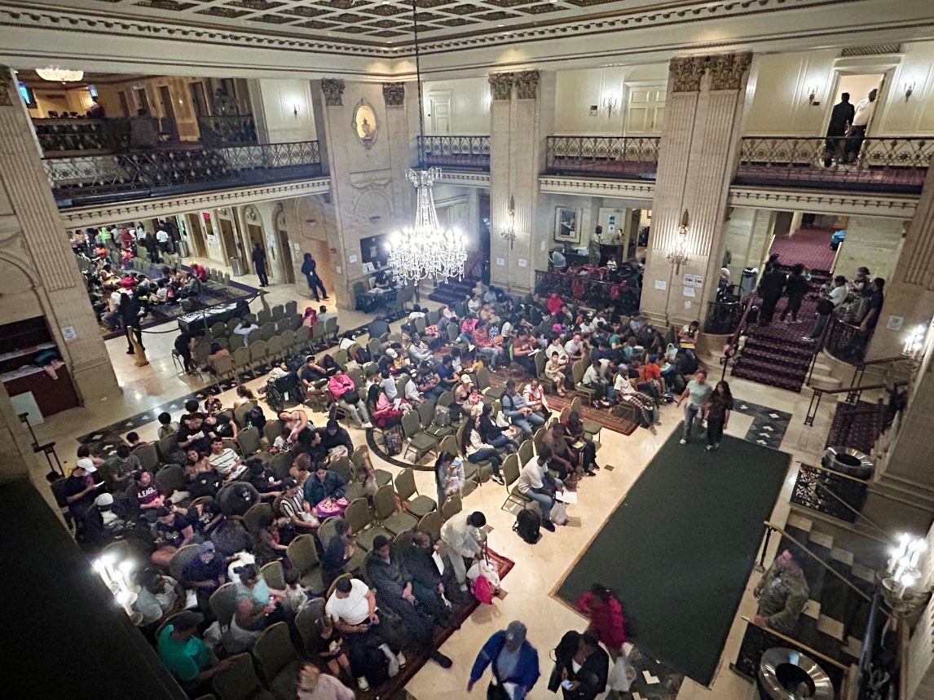
The Asylum Seeker Arrival Center’s waiting area in May 2024 when the facility
was receiving approximately 2,800 new arrivals per week
Opened in May 2023 — during the height of the international asylum seeker crisis, with the city receiving an average of 4,000 arrivals each week — the facility assisted asylum seekers across more than 300,000 visits, functioning as a centralized intake center for newly arriving asylum seekers and serving individuals representing over 160 countries and speaking over 60 languages. The site provided a variety of supportive services to migrants, including legal assistance, medical care, and reconnection services, as well as serving as a humanitarian relief center for families with children. Going forward, these intake functions and supportive services will now be integrated into other areas of the general homelessness intake system. The closure of the Arrival Center, alongside the closures of 62 other emergency shelter sites completed last month, reflects the dedicated efforts of the Adams administration to address an international crisis and to support asylum seekers as they pursue their path towards the American Dream.
There are currently fewer than 37,000 migrants left in the city’s care, down from a high on a single day of 69,000 in January of 2024, and out of the more than 237,000 that have arrived in New York City seeking city services since the spring of 2022. The city’s efforts have directly resulted in approximately 32,000 fewer asylum seekers in the city’s care on a day-to-day basis, and allowed the Adams administration to announce multiple site closures in December 2024, January 2025, and February 2025.
Since the first asylum seekers arrived in the spring of 2022, New York City has continued to focus on the support needed to help migrants take their next steps towards self-sufficiency. The city’s Asylum Application Help Center — a first-in-the-nation entity — has helped complete more than 111,000 applications for work authorization, TPS, and asylum. The work of the New York City Department of Small Business Services and workforce development teams have connected this population to hundreds of job opportunities. The Adams administration’s case management and resettlement teams — in conjunction with teams across multiple city agencies — continue to find creative ways to assist recent arrivals through direct outreach, resource fairs, and onsite English as a Second Language courses at shelters, to name a few examples.
Over 90 percent of eligible adults in the city’s care either have or have applied for work authorization thanks to the Adams administration’s efforts. The city has also purchased more than 65,000 tickets to help migrants exit the shelter system and reach their preferred destinations as they also help reduce the long-term costs for New York City taxpayers. Additionally, staff have conducted nearly 1 million case management meetings with migrants, dedicated to helping them identify self-sufficient pathways out of city shelter, in addition to implementing the city’s 30- and 60-day notice policies.
As a result, more than 200,000 migrants who requested services from the city in the last three years have taken the next steps in their journeys towards self-sufficiency. Since intensive case management services began in October 2023, 71 percent of families with children in humanitarian centers have left the shelter system. Additionally, Mayor Adams successfully reduced the city’s asylum seeker spending over Fiscal Years 2024 through Fiscal Year 2026 by more than $5.2 billion.
“From the moment asylum seekers began arriving, New York City launched one of the most complex emergency operations in its history,” said New York City Emergency Management (NYCEM) Commissioner Zach Iscol. “Under this administration, agencies and partners came together to provide shelter, health care, legal services, humanitarian support, and more for more than 237,000 people. The Roosevelt Hotel served as the primary Arrival Center. It was built from the ground up and supported by the coordination of city services. NYCEM played a key role in maintaining that coordination, operating its own respite sites and a dedicated Reticketing Center to meet the growing need. As we mark the closure of The Roosevelt, the scale and speed of this response remain a model for what is possible when government acts with focus, urgency, and care.”
“Millions of future Americans will one day trace their family’s immigration story back to places like the Arrival Center at The Roosevelt Hotel and at Port Authority, sites where New York City met them with humanity, dignity, and hope” said Mayor’s Office of Immigrant Affairs Commissioner Manuel Castro. “Being part of this once-in-a-generation response has been an honor. I couldn’t be prouder to have played a role in this historic effort over the past three years. I’m deeply grateful to all the public servants who stood with us in this extraordinary chapter of our city’s story.”

“When asylum seekers came to New York City — often exhausted, scared, and unsure of what lay ahead — they were met at the Arrival Center and our humanitarian centers on day one with care, respect, and the services they needed to pursue a better life,” said NYC Health + Hospitals Senior Vice President of Ambulatory Care and Population Health Dr. Ted Long. “This was never a faceless crisis. We recognize that each person who entered our city is a human in need of help and built a compassionate and effective model to meet their needs so they could support themselves. Thank you to every Humanitarian Emergency Response and Relief Center team member, city agency, community-based organization, and advocate that helped make that possible — you’ve made a life-changing difference for hundreds of thousands of people.”
###

