
THE CITY OF NEW YORK
OFFICE OF THE MAYOR
NEW YORK, NY 10007

FOR IMMEDIATE RELEASE: November 7, 2016
CONTACT: pressoffice@cityhall.nyc.gov, (212) 788-2958

MAYOR DE BLASIO, DOT, MTA NYC TRANSIT AND ELECTED OFFICIALS ANNOUNCE LAUNCH OF SELECT BUS SERVICE ON MANHATTAN’S 23RD STREET

New M23 SBS service will provide faster and more reliable service for about 13,000 daily bus riders along a critical crosstown corridor, better connecting them to multiple subway lines and other buses

New York––Mayor Bill de Blasio, the Department of Transportation, MTA NYC Transit and elected officials today announced that the new M23 Select Bus Service (SBS) has launched along 23rd Street in Manhattan. The M23, operated by the MTA NYC Transit, serves 13,000 commuters and provides a key connection between multiple other subway and bus routes, providing crucial links to jobs, education, retail and world-class recreation facilities such as Madison Square Park. M23 SBS marks the 12th SBS corridor in the City and the 5th serving Manhattan. Select Bus Service is a key part of Mayor de Blasio’s OneNYC goal of equitable and sustainable transit expansion.

“In 2013, we committed ourselves to expanding the number of communities that see the benefits of Select Bus Service,” said Mayor Bill de Blasio. “From Chelsea Piers to Turtle Bay, communities with limited subway options will now learn that SBS has a winning formula to transform bus commutes. SBS saves commuters precious time while also making streets – including the newly added 23rd Street route – much safer, suiting our Vision Zero goals. I thank DOT and the MTA for once again working together cooperatively to deliver for New Yorkers.”

“Riders of the M23 have joked for years that traveling the nearly two miles across Manhattan could sometimes be done faster on foot,” said DOT Commissioner Polly Trottenberg. “With 11 routes already under our belt, we know that Select Bus Service on the M23 can change that. With curbside fare collection, all-door boarding and new dedicated bus lanes, riders can now reliably get where they need to go – in much less time.”

“Select Bus Service is a proven winner for our bus customers reducing travel times and boosting bus ridership along these corridors in the process,” said MTA New York City Transit Senior Vice President and MTA Bus President Darryl Irick. “Customers appreciate the convenient off-board fare technology that allows them to pre-pay and enter and exit through any door, eliminating the need for customers to wait to pay at a single fare box and reducing the amount of time the bus spends at each stop.”

DOT and MTA NYC Transit jointly developed the design for the M23 SBS with the complementary goals of providing faster and more reliable bus service, safer streets for pedestrians and drivers and maintaining traffic flow. The SBS implementation comes after several meetings with the local community, including public workshops and open houses, meetings with three local community boards, elected officials and local business organizations. Included among those entities DOT contacted are Baruch College, the VA Hospital, Flatiron/23rd Street Partnership, as well as the management of Peter Cooper Village/Stuyvesant Town. With feedback from the local community and stakeholders – as well as hundreds of bus riders, DOT and NYC Transit developed a design that will provide faster and more reliable bus service and maintain traffic flow.

Design elements along this route include off-board fare collection and dedicated bus lanes. DOT installed flexible bollards along certain portions of the route, restricted turns at certain intersections and installed real time passenger information wayfinding totems along the route. Additionally, bus lane cameras were activated as of November 6th to keep the lanes clear for buses, with warnings being issued for the first 60 days, followed by summonses. Similar to other SBS routes, the M23 SBS route will feature three-door articulated buses branded with the blue SBS logo, and will feature new blue flashing signs.

SBS has increased ridership and improved bus service, speed and reliability along the several existing routes, including 34th Street, 86th Street, First and Second Avenues in Manhattan, 125th Street to LaGuardia Airport connecting Manhattan and Queens, Fordham Road and Webster Avenue in the Bronx, the Bronx to Flushing and Jamaica, Nostrand/Rogers avenues in Brooklyn and Hylan Boulevard on Staten Island, as well as the new Q70 LaGuardia Link SBS. These routes carry more than 275,000 riders daily, reduce travel times by 10-30 percent, provide high levels of customer satisfaction and a reduction in crashes which lead to safer streets for all.

The launch of the M23 SBS route is latest step toward Mayor Bill de Blasio’s commitment to reach 20 routes citywide, providing reliable and sustainable transit options as well as better connections to retail and job centers. This also is part of Mayor de Blasio’s OneNYC goal, which aims to create a more sustainable, resilient and equitable City.

"This critical transportation and traffic easement will help improve accessibility for our city's veterans, particularly those who use the VA New York Harbor Healthcare System Manhattan Campus on East 23rd Street as their primary health care facility," said Brigadier General Loree Sutton (Ret.), Commissioner of the Department of Veterans Services. "I want to thank the MTA, NYC Transit and the DOT for recognizing the needs of our veterans in this very busy thoroughfare."

"The SBS crosstown bus has been extremely successful, and I am glad the Department of Transportation and NYC Transit are bringing it to additional lines with the M23 SBS being launched today," said Congresswoman Carolyn B. Maloney. "Making bus service faster and more frequent is critical to making buses an attractive option for commuters, and that's why this expansion of SBS service is so welcome."

"My constituents agree: the M23 is one of the slowest bus routes in the city and it's often faster to walk than take the bus,” said State Senator Brad Hoylman. "The new M23 Select Bus Service will make life easier for thousands of New Yorkers, and I applaud the DOT and MTA NYC Transit for this important investment in crosstown transit."

"I applaud the MTA and DOT on the launch of the M23 Select Bus Service – the third bus rapid transit line within my district," said State Senator Liz Krueger. "As the closure of the L Train becomes an impending reality, the expansion of efficient, fast and reliable crosstown bus service has never been more important. New York is a world-class city, and deserves a modern and reliable bus system. I greatly appreciate Mayor de Blasio's efforts in quickly growing the number of SBS routes across the five boroughs."

“The new 23rd Street SBS service will promote and improve mass transportation in Manhattan. It is important that the City and the MTA worked together to make it happen,” said Assembly Member Richard N. Gottfried.

"Making transit safer and more efficient is key to moving our city into the future," said Council Member Ydanis Rodriguez, Chair of the Committee on Transportation. "As more bus routes incorporate dedicated lanes and off board fare payment, bus riders will soon experience better service that makes the bus a more attractive option. I'm glad to see the M23 going in this direction and hope we can bring SBS to even more routes citywide"

“The M23 has consistently been the pokiest of all pokey buses, and that is about to change,” said Council Member Dan Garodnick. “Thanks to the new SBS service, speeds will rise, travel time will fall and rider experience will be greatly improved. Good transportation is central to a livable, vibrant and affordable city, and this SBS route is a big step in the right direction.”

"I am excited that the Select Bus Service has debuted on 23rd street," said Council Member Rosie Mendez. "The crosstown traffic on 23rd street causes a great deal of congestion and the introduction of the SBS route will provide a welcome relief to residents of my district and commuters in general. I want to thank the MTA, NYC Transit and DOT for working with me, Council Members Dan Garodnick and Corey Johnson, and Community Boards 5 and 6 in ensuring community input and making SBS a reality on 23rd street."

For more information about the City’s Select Bus Service routes, please visit www.nyc.gov/dot.

M23 SBS Route Map
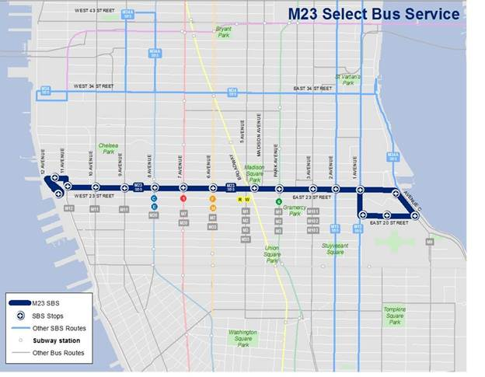

M23 SBS Community Outreach




