
THE CITY OF NEW YORK
OFFICE OF THE MAYOR
NEW YORK, NY 10007

FOR IMMEDIATE RELEASE: September 23, 2016
CONTACT: pressoffice@cityhall.nyc.gov, (212) 788-2958

MAYOR DE BLASIO, FORMULA E ANNOUNCE INAUGURAL NYC EPRIX COMING TO BROOKLYN

Brooklyn Cruise Terminal will host electric racing event in July 2017

NYC ePrix will bring economic investment, education opportunities to Red Hook

Event will help promote sustainable technology, key part of Mayor de Blasio’s OneNYC Plan and vision for 21st century innovation economy

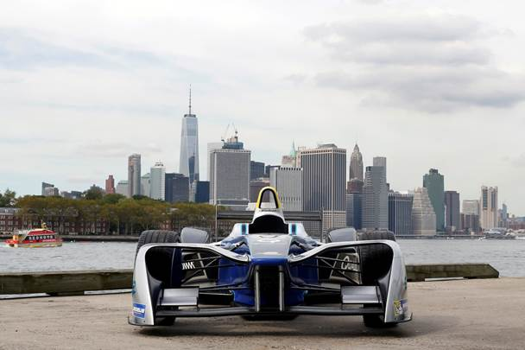

NEW YORK––The de Blasio Administration and Formula E CEO Alejandro Agag, FIA President Jean Todt, and Brooklyn community leaders today announced that the Brooklyn Cruise Terminal in Red Hook will host the inaugural New York City ePrix in July 2017. The race will be part of the FIA Formula E Championship, the world’s first fully-electric racing series, which is entering its third season.

The New York City ePrix double-header in mid-July will be the first FIA-sanctioned open-wheel race to take place within the five boroughs of New York City. Preliminary plans for the 1.947km (1.21mile) track will feature 13 turns and will wind its way around Pier 11 and the Brooklyn Cruise Terminal. The course will be entirely off-street, ensuring safety and minimizing disruption for the surrounding community.

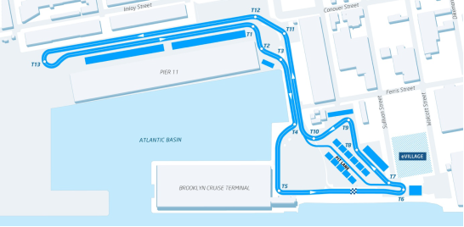

The FIA Formula E Championship is the world’s first fully-electric single-seater racing series, competing against the backdrop of some of the most iconic cities - including New York, Hong Kong, Marrakesh, Buenos Aires, Monaco, Paris, and Montreal. The championship represents a vision for the future of the motor industry, and serves as a platform to showcase the latest innovations in electric vehicle technology and alternative energy solutions.

“New York City is where technology, sustainability and commerce all connect. There’s no better home for the ePrix. Bringing this international event to the five boroughs is a huge win for New York City. It will bring thousands of visitors, boost Brooklyn tourism and spur investment in our neighborhoods,” said Mayor Bill de Blasio.

“Electric vehicles are not technologies for tomorrow, but are ready today. Hosting the ePrix helps demonstrate New York City's commitment to climate action,” said Daniel Zarrilli, Senior Director for Climate Policy and Programs and Chief Resilience Officer for the Mayor’s Office. “Investing in our own fleet and creating smart pathways for the private sector to transition to electric vehicles is an essential part of achieving the ambitious goal the City has set of reducing greenhouse gas emissions 80 percent by 2050. ePrix will help drive new excitement for these goals.”

“To race in New York City is a historic moment - not only for Formula E, but for motorsport in general – and again highlights the philosophy of Formula E to bring fully-electric racing to the world’s greatest cities,” said Alejandro Agag, CEO of Formula E. “When we originally started the project, we could only dream of bringing Formula E to a place like New York, with arguably the most recognizable skyline of any city in the world. I’d like to thank everyone involved in helping bring Formula E to New York for many years to come.”

“Just being able to bring a motor race to the heart of a great city like New York is already an amazing achievement in itself,” said Jean Todt, President of the FIA. “I am really pleased that this city is going to feature on the calendar of an FIA championship, especially Formula E, which provides the best possible combination of the two pillars that form the basis of the Federation, namely sport and mobility. Formula E brings motorsport to the heart of the most important and fascinating cities in the world - New York joins a list that includes, among others, Hong Kong, Buenos Aires, Paris, Marrakesh and Montreal, proving just how vibrant and attractive this series has become, even though it is about to embark on what is only its third season.”

“New York is one of the world's great cities,” said Sebastien Buemi, Renault e.DAMS Driver and Reigning Formula E champion. “I think it will be an amazing event, particularly with that backdrop! I can't wait to race there – I expect it's going to be one of the most spectacular tracks we have been to so far. Formula E is always pushing the boundaries with where we go and, along with Hong Kong, Paris and Berlin, we can genuinely say we have the most exciting calendar ever seen in motorsport.”

In addition to investing millions of dollars in infrastructure improvements at the Brooklyn Cruise Terminal, Formula E has also committed to working with the City to ensure that the NYC ePrix benefits the local community, including efforts to:

- Hire local workers for employment opportunities
- Partner with local small businesses and hotels
- Offer New York City students hands on opportunities to learn about engineering, technology, and automotive trades
- Provide discounted or complimentary tickets to community organizations.

The NYC ePrix will provide a unique opportunity to highlight sustainable technology, which is a key component of Mayor de Blasio’s OneNYC plan. Among the commitments in OneNYC are the reduction of greenhouse gas emissions in New York City by 80 percent by 2050, and ensuring New York has the best air quality of any large U.S. city by 2030.

Today’s announcement also builds upon NYCEDC’s efforts to grow sustainable technology as a key part of the City’s innovation economy. Just this week, NYCEDC launched the Hub @ Grand Central Tech, a 50,000 square foot facility offering flexible and affordable space, and dedicated resources for fast-growing clean-tech and smart cities companies.

"Growing sustainable technology is core to New York City's innovation economy and to Mayor de Blasio's OneNYC plan," said NYCEDC President Maria Torres-Springer. "This makes Formula E a perfect fit for New York, and we're extremely excited to welcome this event - along with the economic investment it brings - to the Red Hook community."‎

“We are so pleased to welcome Formula E’s inaugural New York City ePrix to Brooklyn in 2017,” said Fred Dixon, NYC & Company’s President and CEO. “This fully-electric racing series will not only showcase the best of what New York City has to offer, but will also reaffirm NYC’s position as one of the world’s best big event destinations.”

“A race in New York is for me and my fellow drivers like a small dream,” said Lucas di Grassi, ABT Schaeffler Audi Sport driver. Congratulations to everyone at Formula E who has worked so hard for it, and have now let this dream be a reality. Just imagine seeing the Statue of Liberty and the Manhattan skyline from the pitlane! It will also be a sporting highlight as the track has a mix of fast sections, hairpin bends and a narrow infield directly on the waterfront."

“Brooklyn is one of America’s hottest innovation hubs, making it the perfect home for Formula E,” said Carlo A. Scissura, President and CEO of the Brooklyn Chamber of Commerce. “Formula racing is also one of the most popular sports in the world, and when you need to host something unique that appeals to a diverse audience, you obviously come to Brooklyn. This is yet another coup for the borough, the flourishing neighborhood of Red Hook and our growing tourism industry, and it’s terrific to see the Cruise Terminal being utilized in new, creative ways. Congratulations to Mayor Bill de Blasio, Deputy Mayor Alicia Glen and NYCEDC President Maria Torres-Springer on this incredible achievement.”

###

