
FOR IMMEDIATE RELEASE: May 12, 2025
CONTACT: pressoffice@cityhall.nyc.gov, (212) 788-2958
MAYOR ADAMS, NYCEDC ANNOUNCE DEVELOPERS FOR
OVER 500 NEW HOUSING UNITS ON STAPLETON,
ADVANCING STATEN ISLAND NORTH SHORE ACTION PLAN
Artimus and Phoenix Reality Group Will Build Over 500 Mixed-Income Housing
Units on North Shore of Staten Island, 25 Percent of Units Designated as Affordable
Project Will Be Largest Mass Timber Residential Development in New York City,
Utilizing New, Sustainable Construction Material
Announcement Advances Key Commitments in Mayor Adams’
Staten Island North Shore Action Plan, Green Economy Action Plan
NEW YORK – New York City Mayor Eric Adams and New York City Economic Development Corporation (NYCEDC) President and CEO Andrew Kimball today announced that Artimus and Phoenix Realty Group have been selected to build over 500 new mixed-income housing units on two vacant land parcels along the New Stapleton Waterfront on the North Shore of Staten Island, with a quarter of the new units set aside for affordable housing. The development will be the largest mass timber residential project in New York City and one of the largest mass timber residential development projects with affordable housing in the entire country — utilizing a newer, more sustainable construction material to reduce the project’s carbon footprint and speed up its timeline. Today’s announcement advances several key initiatives in Mayor Adams’ “Staten Island North Shore Action Plan: Building a Vibrant, Mixed-Use Waterfront Community,” which outlines a four-year roadmap for a clear and unified vision for the future of Staten Island’s North Shore, with $400 million in city investment, 2,400 homes, over 20 acres of public space, more than 7,500 family-sustaining jobs, and $3.8 billion in economic impact over 30 years. Additionally, by utilizing sustainable mass timber to build these new homes, the development also advances commitments in Mayor Adams’ “Green Economy Action Plan,” a first-of-its-kind plan that lays out a roadmap to growing the city’s green economy, invests in jobs and sectors that help the city combat climate change, and positions New Yorkers to benefit from the nearly 400,000 projected "green-collar" jobs in New York City by 2040.
“New York is a five-borough city, and I am a five-borough mayor. That is why we have put Staten Island front and center from day one of this administration, unveiling our ‘Staten Island North Shore Action Plan’ to bring thousands of homes and jobs to the borough, launching construction on a vibrant new public space, and breaking ground on a brand-new recreation center,” said Mayor Adams. “With today’s announcement, we are checking another key box of our North Shore checklist. We are not only building the affordable homes New Yorkers need but using sustainable materials to reduce our carbon footprint and help turn New York City’s waterways into the ‘Harbor of the Future.’”
"This project is a milestone for New York City — bringing mass timber construction to scale while delivering affordable housing and good jobs,” said Deputy Mayor for Housing, Economic Development, and Workforce Adolfo Carrión Jr. “By selecting a forward-thinking development team, we’re showing how sustainable building isn’t just the future — it’s happening now on Staten Island."
“By developing over 500 new mixed-income housing units and expanding public green spaces, we are not only addressing New York City’s housing crisis and advancing promises made in the North Shore Action Plan, but we are also creating a more resilient and sustainable built environment through the use of low-carbon building materials like mass timber,” said NYCEDC President and CEO Kimball. “This transformative redevelopment project exemplifies the city’s commitment to creating mixed-used, mixed income neighborhoods along the vibrant waterfront that benefit all New Yorkers.”
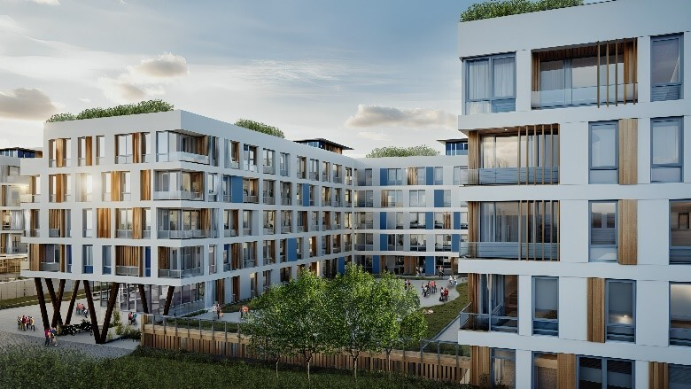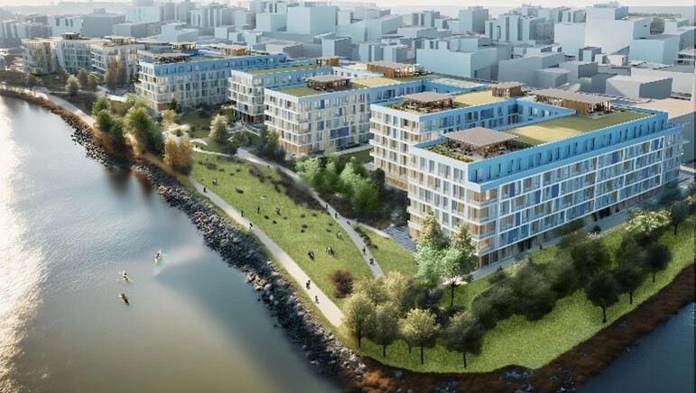
The development will build hundreds of new housing units on the North Shore of Staten Island and
utilize sustainable mass timber to reduce carbon footprint and accelerate the timeline of the project.
All renderings are available on NYCEDC’s website. Credit: GF55 Architects.
The development — located at the corner of Front and Canal Streets — will create over 500 new housing units, with around 25 percent of units reserved for families earning between 40 and 80 percent of the area median income. Following today’s announcement, the development team will begin site investigations and advance its designs ahead of construction, which is expected to begin in 2027.
The development is the first publicly-awarded project to use mass timber — an engineered wood-based building material with a low-carbon footprint and the potential to achieve a faster construction timeline — at scale in the Northeast United States. Additionally, the developer’s design team will participate in the NYC Mass Timber Studio, a technical assistance program that is supporting the successful delivery of mass timber projects with technical and regulatory assistance.
This project represents the next phase in development of the New Stapleton Waterfront, helping transform a former U.S. naval base into a 32-acre mixed-use, mixed-income waterfront neighborhood. In total, the New Stapleton Waterfront will deliver over 2,100 mixed-income residential units, ground floor retail, a 600-seat public school, and other community facilities — all set within 12 acres of interconnected public open space. In September, NYCEDC broke ground on Stapleton’s next six acres of open space and esplanades, including the demolition of the old U.S. naval homeport buildings.
Since announcing the North Shore Action Plan in September 2023, the city and its partners have advanced several of its initiatives:
- In February 2024, Mayor Adams and the New York City Department of Parks and Recreation broke ground on the Mary Cali Dalton Recreation Center in Tompkinsville, the first groundbreaking for a recreation center on Staten Island in over 14 years.
- In July 2024, U.S. Representative Nicole Malliotakis announced $2.5 million in federal funding secured for NYCEDC to renovate the currently closed Pier 1 on the North Shore, reestablishing public access to the waterfront pier for the local community.
- In September 2024, in celebration of the Action Plan’s one-year anniversary, Mayor Adams and NYCEDC broke ground on 12 acres of interconnected public open space on the New Stapleton Waterfront.
- In December 2024, following a competitive request for proposal process, NYCEDC and the New York City Department of Transportation announced that concessions will return to the Staten Island Ferry, with Dunkin as the selected concessionaire.
- Also in December 2024, following a competitive request for proposal process, the New York City Department of Housing Preservation and Development announced its selected developer team to convert the city-owned sanitation garage on the North Shore into affordable housing with a grocery store, community services, and world-class public open-space.
- In April 2025, Mayor Adams and NYCEDC announced the start of construction on Tompkinsville Esplanade to build two-acres of new public waterfront open space that will fill a critical gap in public waterfront access along the North Shore and restore the long-deteriorated shoreline.
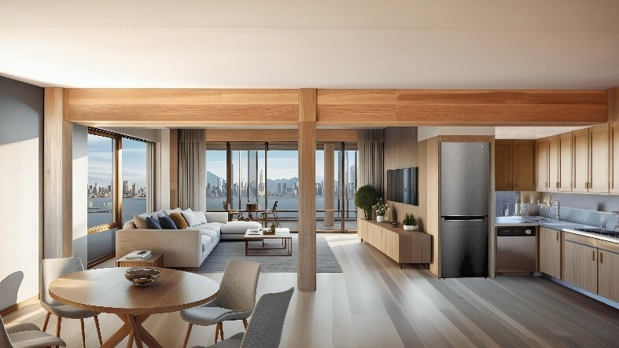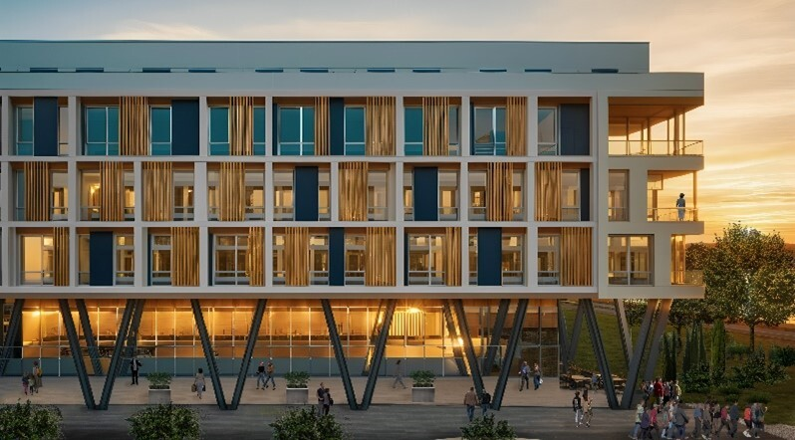
The development will advance key goals in Mayor Adams’ Staten Island North Shore Action Plan
to create thousands of new homes and jobs on Staten Island. Credit: GF55 Architects.
Today’s announcement continues Mayor Adams’ efforts to turn New York City’s waterfront into a “Harbor of the Future” and advance generational projects that will set New Yorkers up in fast-growing industries. In addition to a revitalized North Shore of Staten Island, the Adams administration is helping create a Science Park and Research Campus in Kips Bay in Manhattan, a $700 million climate research facility on Governors Island, the country’s largest offshore wind port at the South Brooklyn Marine Terminal, a modern maritime port and vibrant mixed-use community hub at the Brooklyn Marine Terminal in Red Hook, the Willets Point Transformation in Queens, and a cleaner, greener Hunts Point Terminal Produce Market in the Bronx.
“We at Phoenix Realty Group, in conjunction with our partners at Artimus, are grateful and honored to be selected to develop the Stapleton site,” said Ron Orgel, managing director, Phoenix Realty Group. “We are excited to both be a part of activating Staten Island’s North Shore and implementing the innovative mass timber design, and we look forward to a successful partnership with EDC.”
“WoodWorks is proud to support the groundbreaking Stapleton development project as a catalyst for mass timber construction in New York City and the broader region. This initiative aligns with our mission to advance efficient, sustainable, and innovative wood-based building solutions,” said Jennifer S. Cover, PE, president and CEO, WoodWorks. “We are excited to provide technical design assistance to project teams committed to leveraging mass timber for developments that prioritize community impact.”
“Constructing the New Stapleton Waterfront housing with mass timber will represent a significant and influential achievement. By utilizing mass timber, these buildings will dramatically reduce embodied carbon emissions, lessening the environmental impact on Staten Island and New York City,” said Martha Bush, director, Marvel. “Additionally, the project will serve as a powerful precedent and catalyst for future large-scale mass timber developments, reshaping the way we build and advancing a more sustainable future. Congratulations to the project teams on this important milestone.”
“The Adams administration’s decision to develop Staten Island’s New Stapleton Waterfront, presents a significant opportunity to add much needed housing,” said Zachary Steinberg, SVP of policy, REBNY. “With over 500 new mixed-income housing units and 25 percent reserved for affordable housing, this new sustainable construction will reduce carbon emissions and serve as a model for future sustainable building.”
###

