
FOR IMMEDIATE RELEASE: May 21, 2025
CONTACT: pressoffice@cityhall.nyc.gov, (212) 788-2958

MAYOR ADAMS TEMPORARILY CO-NAMES NYC STREETS AFTER NEW YORK
KNICKS PLAYERS, AS TEAM ADVANCES TO 2025 EASTERN CONFERENCE FINALS

Streets Across Manhattan Will Honor Each Player on
Knicks Active Roster for Remainder of Knicks 2025 NBA Playoff Run

Jalen Brunson Boulevard, Josh Hart Street, and Other Streets Will Be Unveiled Today

WATCH: DOT Officials Install Temporary Street
Signs Co-Naming Streets After New York Knicks Players

NEW YORK – New York City Mayor Eric Adams and New York City Department of Transportation (DOT) Commissioner Ydanis Rodriguez today announced that — in partnership with Madison Square Garden Sports and the New York Knicks — streets across Manhattan will be temporarily co-named after New York Knicks players as the team advances to the 2025 Eastern Conference Finals and will stay up for the remainder of the Knicks playoff run. Each sign is designed in blue and orange and features the name and jersey number of a current player on the team. The streets where the signs are hung will correspond with each team member’s uniform number.

“The Knicks embody the spirit of New York — resilient, passionate, and unstoppable,” said Mayor Adams. “On the path to a championship, we recognize the hard work and determination that has gotten this team to the Eastern Conference Finals and we’re celebrating this team by temporarily co-naming our city streets so all New Yorkers can celebrate their Knicks pride. Nearly 8.5 million New Yorkers, and millions more, are behind the New York Knicks as they continue this incredible journey.”

“The New York Knicks are part of the fabric of our city, and have the best fans in the NBA,” said DOT Commissioner Rodriguez. “The entire city has your back as the Eastern Conference Finals are underway, and we are proud to rep the blue and orange, including on our street signs. Go Knicks!”

“This has been an incredible time for the Knicks, our fans, and for all of New York City,” said Jamaal Lesane, chief operating officer, MSG Sports. “We thank Mayor Adams and Commissioner Rodriguez for this recognition. As the playoffs continue, the Knicks will continue to look for opportunities to spread excitement and bring people together through their shared passion for the team.”

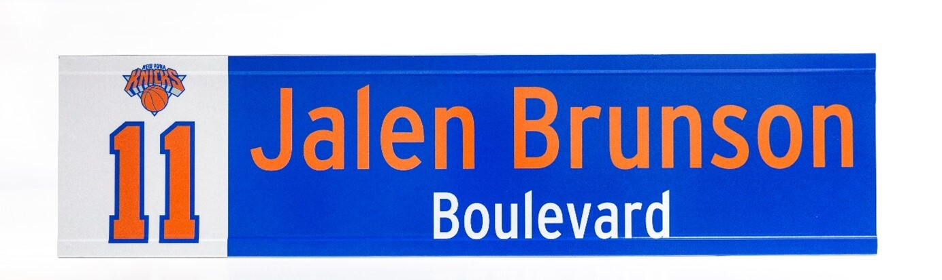
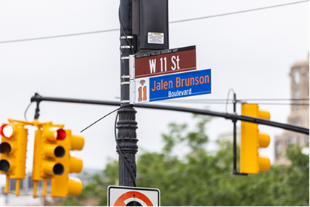
One of the street signs DOT is temporarily installing as the New York Knicks advance to the 2025 Eastern Conference Finals. Source: DOT.

- Precious Achiuwa Place – 6th Avenue and West Washington Place
- OG Anunoby Alley – 6th Avenue and West 8th Street
- Mikal Bridges Block – 7th Avenue and West 25th Street
- Jalen Brunson Boulevard – 7th Avenue and West 11th Street
- Pacome Dadiet Drive – 6th Avenue and West 4th Street
- Josh Hart Street – 6th Avenue and West 3rd Street
- Ariel Hukporti Street – 7th Avenue and West 55th Street
- Tyler Kolek Lane – 7th Avenue and West 13th Street
- Miles McBride Street – 6th Avenue and Minetta Lane
- Cam Payne Place – 6th Avenue and Bleecker Street
- Mitchell Robinson Road – 7th Avenue and West 23rd Street
- Landry Shamet Circle – 7th Avenue and West 44th Street
- Karl-Anthony Towns Square – 7th Avenue and West 32nd Street
- PJ Tucker Terrace – 7th Avenue and West 17th Street
- Delon Wright Circle – 6th Avenue and Houston Street

The New York Knicks will make the franchise’s ninth Eastern Conference Finals appearance beginning tonight at Madison Square Garden against the Indiana Pacers. The series follows the Knicks defeating the 2024 National Basketball Association (NBA) Champion Boston Celtics in the Eastern Conference Semi-Finals last week and the Detroit Pistons in the first round. The Knicks finished the regular season 51-31, the team’s best record since the 2012-2013 season. The winner of the Eastern Conference Finals will face either the Oklahoma City Thunder or the Minnesota Timberwolves in the 2025 NBA Finals.

Temporary street signs are posted across the city and will remain on display for the duration of the Knicks playoffs run. Permanent name changes for streets must go through a legislative process with the New York City Council.

The DOT Sign Shop is in Maspeth, Queens and manufactures over 70,000 signs each year. A team of 32 Sign Shop employees hand-make street signs, highway signs, directional signs, parking signs, and more. There are approximately 1 million DOT signs in use across the 6,000 miles of streets in New York City.

###

