
THE CITY OF NEW YORK
OFFICE OF THE MAYOR
NEW YORK, NY 10007

FOR IMMEDIATE RELEASE: April 18, 2016
CONTACT: pressoffice@cityhall.nyc.gov, (212) 788-2958

MAYOR DE BLASIO ANNOUNCES THREE YEAR, FIVE-BOROUGH PLAN TO PROTECT NEW YORKERS FROM THE ZIKA VIRUS

City’s Zika action plan enhances mosquito surveillance and control
Expands testing of humans and mosquitos, and launches public awareness campaign

NEW YORK––Marking the start of mosquito season, Mayor de Blasio today detailed a three-year, five-borough plan to protect New Yorkers and prevent the spread of the Zika virus in New York City.

“We are doing all we can to target the mosquito that could transmit Zika here in the city, and building the capacity to respond to every possible scenario, no matter how unlikely,” said Mayor Bill de Blasio. “We will spare no effort to protect pregnant New Yorkers from the devastating consequences of Zika, and we ask New Yorkers to help us by taking simple steps to get rid of standing water where mosquitos can breed. We also ask pregnant women who may have been exposed to Zika to talk to their doctors about getting tested.”

Building on the Health Department’s robust West Nile virus mosquito control program, the Mayor’s plan expands mosquito surveillance and control to identify and target mosquitos that could potentially transmit the Zika virus; creates capacity to meet a growing need for testing pregnant New Yorkers and local mosquitos for the virus; and launches a comprehensive campaign to disseminate prevention and testing information throughout the city. The plan will add 51 new positions to address all these needs – including inspectors, exterminators, disease inspectors and lab analysts – and it will double the number of mosquito traps placed across the city. Zika investment totals $21 million over a three-year period, including a New York State match.

The City’s Health Department activated its Incident Command System – an internal organization structure deployed during emergency situations – in February, after the World Health Organization rang the alarm about the Zika outbreak. The City’s Zika Action Plan was informed by the latest scientific evidence, conversations with the Centers for Disease Control and Prevention, and advice from clinical and mosquito control experts who participated in two high-level consultations convened by the City over the past two months. The plan was reviewed and discussed with 14 relevant City agencies last week at a tabletop exercise held at the Office of Emergency Management.
“There are a lot of unknowns around the Zika virus, but New York City is prepared to confront all possible scenarios, including a dramatic increase in imported cases over the summer and the potential for local transmission,” said Deputy Mayor for Health and Human Services Dr. Herminia Palacio. “We already have one of the most robust mosquito control infrastructures in place to manage West Nile virus, and we are building on that to reduce the chance of a local outbreak.”

“The City’s Health Department has successfully helped limit mosquito borne diseases for more than 15 years, when the West Nile virus emerged. We are using our technical knowledge and experience to gather as much information as possible and to respond swiftly to this emerging situation,” said Health Commissioner Dr. Mary T. Bassett. “New Yorkers best defense against Zika is to avoid travelling to affected areas, talk to their doctor if they are concerned about having been infected, use mosquito repellant, and remove standing water in and around their homes.”

The City’s plan to combat the Zika virus focuses on the following three areas:

1. Clinical Services

Increased human testing: As the City encourages pregnant women who visited an affected area while pregnant to get tested for Zika, the Health Department is expanding capacity to meet the increasing demand for testing. In March, the Department established a new dedicated call center for health care providers to process testing requests. More information on who should seek testing can be found here.
Increased mosquito surveillance: The Department is also expanding its capacity to trap, test, and report about the types of mosquitos in NYC and the viruses they may carry. Enhanced surveillance will help the City quickly detect and respond to locally transmitted cases. The Department is working closely with the New York State Health Department and Centers for Disease Control (CDC) and Prevention on the latest testing methods.

Care Management for Women: The Department has distributed travel advisory posters to 1,051 healthcare providers likely to see pregnant women, including urgent care centers, community health centers and OB/GYN practices. It is also working with the American College of Obstetrics and Gynecology to disseminate medical guidance and answer provider questions about testing, on implementing protocols for care management of pregnant women, and collaborating with CDC on a national registry of Zika-infected pregnant women. In March, the Health Department deployed Community Outreach Teams to conduct outreach to over 200 health care providers catering to New York City women.

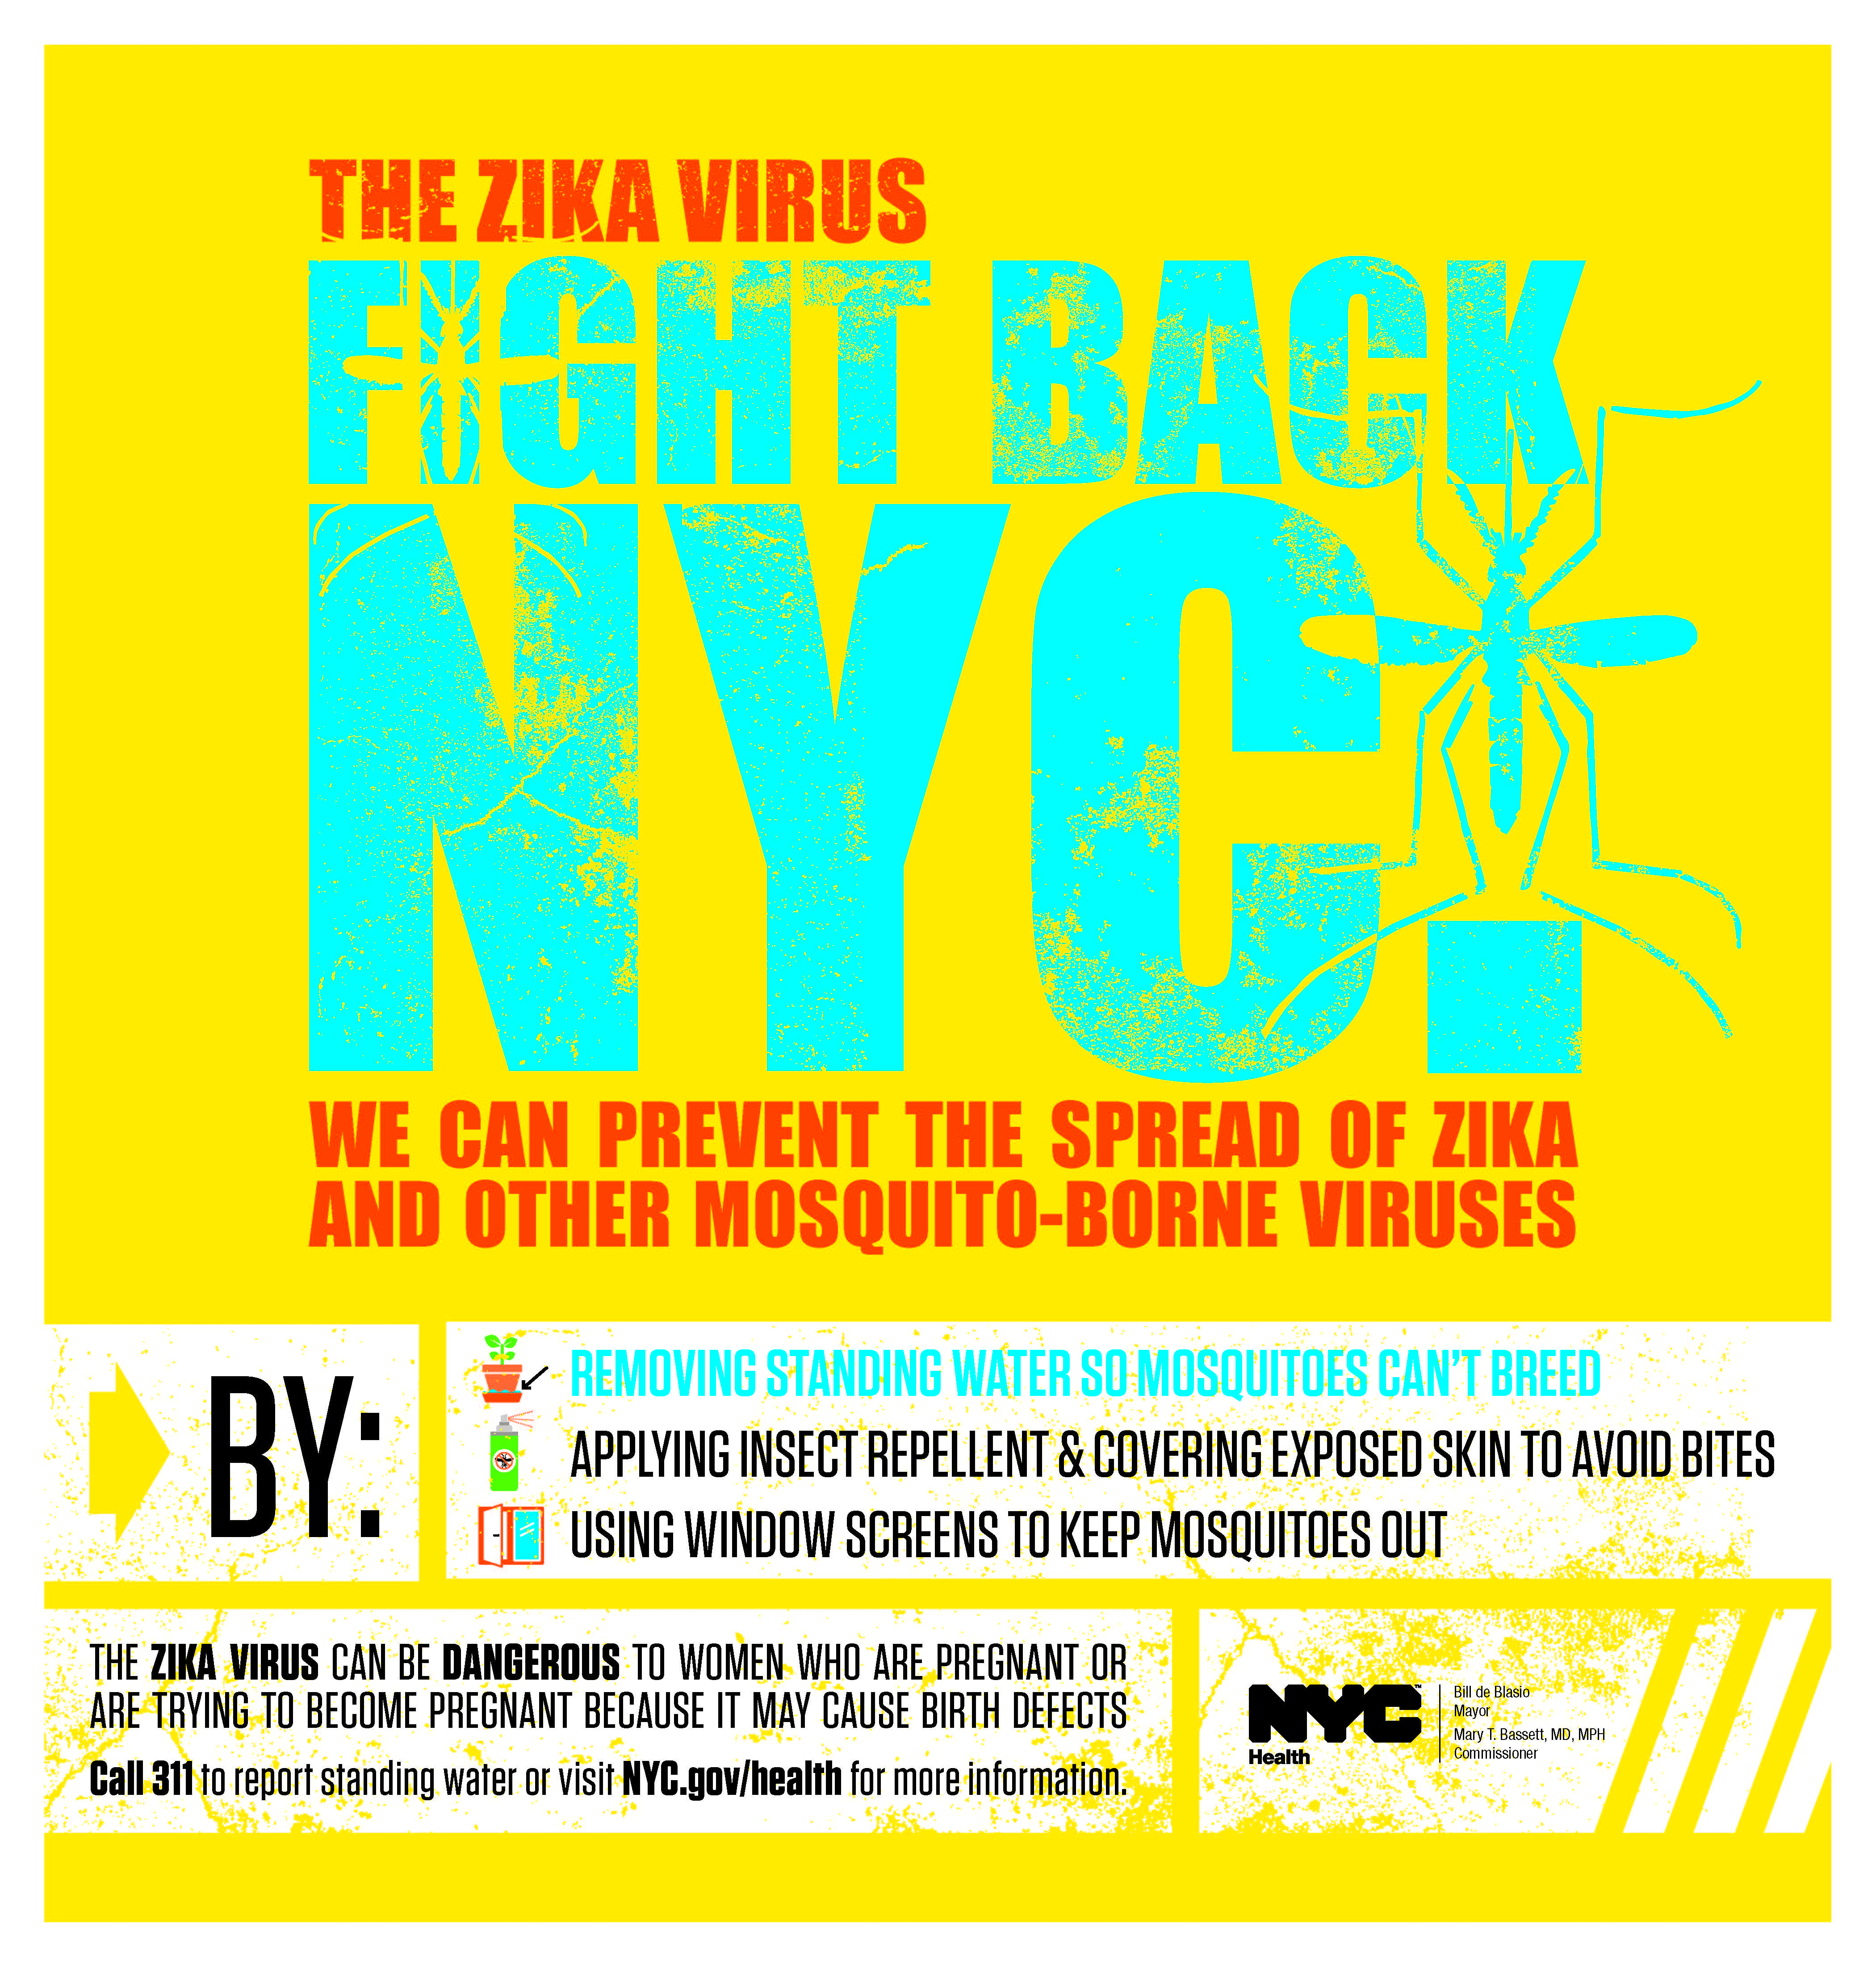
2. Mosquito control
The Aedes aegypti mosquito causing the Zika outbreak in Latin America has never been found in New York City. Nevertheless, there is concern that a similar species that does live in the City, Aedes albopictus, could carry and transmit the virus if it bites a New Yorker who was originally infected elsewhere.
Building on its successful West Nile virus control infrastructure, throughout mosquito season (typically April through September) the Health Department will monitor Aedes mosquito populations weekly throughout the city. Areas with higher numbers of Aedes mosquitoes will be targeted earlier and more frequently for enhanced mosquito abatement, including: breeding ground control, which eliminates standing water; larviciding, which targets the larval life stage of a mosquito; and adulticiding, which kills the adult insects. The agency will add 61 new mosquito traps that specifically attract Aedes species of mosquitos and will place additional traps in areas where they are found in large numbers.

3. Public Awareness

Media campaign: On Monday, April 18th, the City will launch a citywide awareness campaign with the tagline Fight Back NYC (ad on the right). The $1.2 million campaign will be on buses, subways, TV and radio in all five boroughs. The campaign reminds residents of the steps they can take to reduce and prevent mosquito bites. New Yorkers can protect themselves from mosquito bites by wearing protective clothing, using mosquito repellant, eliminating standing water – the breeding sites for mosquitos – and by emptying any standing water in bird baths, cans, flower pots or any place where water could gather and mosquitoes could lay eggs. New Yorkers should call 311 to report any standing water they cannot manage themselves.

Community outreach: The Health Department has scheduled more than 200 community outreach events across the city to disseminate information about travel warnings, mosquito prevention and available testing, with a particular focus on neighborhoods with high mosquito activity and on communities with large numbers of immigrants from countries affected by the Zika outbreak. The Health Department will also coordinate the distribution of free insect repellent to pregnant women by working with clinicians and community health providers.
Staten Island Borough President Jimmy Oddo said, “I appreciate the communication we’ve had with the administration on this important issue and for taking these common sense steps. The bottom line is, we can hope for the best, but we need to ready ourselves for the worst.”

"Preparation is critical to manage the impact of any potential health emergency. I thank the leadership of the de Blasio administration for mobilizing City resources in advance of mosquito season, preparing and educating New Yorkers for the Zika virus," said Brooklyn Borough President Eric Adams.

“Proactive planning for emerging public health threats is smart, responsible and exactly what government is supposed to do,” said Manhattan Borough President Gale A. Brewer. “I thank Mayor de Blasio and Commissioner Bassett for pursuing this initiative. Preparation and prevention are key to protecting public health.”

“As we move into mosquito season, it’s essential that New York bring all its resources to bear in our efforts to prevent the spread of Zika. That means increased testing and stronger mosquito control efforts, as well as improved public awareness and outreach. I want to thank Mayor de Blasio and Health Commissioner Bassett for their on-going vigilance,” said State Senator Brad Hoylman, Ranking Member of the Environmental Conservation Committee and Member of the Health Committee.

“The de Blasio administration’s comprehensive three-year plan to combat the Zika virus shows why New York City is a national leader when it comes to protecting public health. By aggressively targeting the mosquitoes that can transmit the virus, increasing testing and alerting the public and health care providers to the danger, particularly to pregnant women, City health authorities are moving effectively to combat this potential threat to New Yorkers’ health,” said Assembly Member Richard N. Gottfried, Chair of the Committee on Health.

“I commend Mayor de Blasio and Health Commissioner Dr. Mary T. Bassett for the City’s visionary and far-reaching plan to combat the Zika virus in New York,” said Assembly Member Luis Sepúlveda. “Encompassing enhanced mosquito surveillance and control, expanded testing of mosquitoes and humans, and a sweeping public awareness campaign, the administration is showing excellent leadership and its relentless vigilance in protecting the public, which is especially urgent for pregnant women.”

“All necessary measures must be taken to protect New Yorker's from Zika virus,” said Council Member Corey Johnson, Chair of the Committee on Health. “The Department of Health's comprehensive plan will fortify our city's robust mosquito control system. With increased awareness and community surveillance, we must be vigilant against mosquito-transmitted Zika virus. I thank Mayor de Blasio and Deputy Mayor Palacio and Commissioner Dr. Bassett for marshaling the resources to keep New Yorkers healthy and safe.”

More information about the Zika virus, including latest number of cases, facts about the disease, travel warnings, countries affected and mosquito prevention tips, can be found here on the City’s Health Department website.

###

