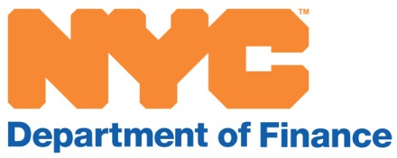

Local Law 249 passed by the City Council on November 16, 2017, which took effect July 1, 2018, requires the New York City Department of Finance (DOF) to send notification of recording of real estate instruments.
The law mandates DOF to provide a quarterly report to the council and publish on the department’s website, beginning November 1, 2018 the following information for the prior quarter.
- Total number of individuals registered to receive notification, disaggregated by the type of interested party.
- Total number of individuals registered to receive notification for multiple properties
- Total number of properties for which an individual’s registered to receive notifications
- Total number of individuals who opted out of receiving notifications
- Total number of individuals who contacted the department regarding an incorrect or suspected fraudulent document recording, group by the source of information that lead to contacting the agency
- Total number of referrals made by the City Register or Richmond County Clerk related to suspected fraudulent document recording and the outcome of the referral and if an investigation was started by the Sheriff.
As mandated this is DOF’s first report on Local Law 249. The data in this report is as of September 30, 2018
 | Registered Parties | Parties with Multiple Registrations | Properties with Registrations | Number who Opt-out
Manhattan | 145,784 | 7,796 | 156, 171 | 0
Bronx | 102,214 | 4,732 | 106,141 | 0
Brooklyn | 331,900 | 15,599 | 330,659 | 0
Queens | 368,078 | 13,454 | 363,150 | 0
Staten Island | 131,050 | 4,136 | 133,403 | 0
There are 2772 distinct types of interested parties; the attached report lists the various types.
The City Register referred 20 cases to the Sheriff. Nineteen cases were due to suspected fraudulent document submission. One case was from an individual who visited the office and demanded a suspected fraudulent document to be recorded. The Sheriff did not receive any referrals from the Richmond County Clerk.
Manhattan | 1
Bronx | 2
Brooklyn | 9
Queens | 8

