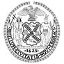
THE CITY OF NEW YORK
OFFICE OF THE MAYOR
NEW YORK, NY 10007

FOR IMMEDIATE RELEASE: May 16, 2016
CONTACT: pressoffice@cityhall.nyc.gov, (212) 788-2958

MAYOR BILL DE BLASIO AND THE BROOKLYN NAVY YARD DEVELOPMENT CORPORATION ANNOUNCE BROOKLYN BREWERY TO BUILD NEW HEADQUARTERS, BREWERY AND ROOF-TOP RESTAURANT AND BEER GARDEN AT THE BROOKLYN NAVY YARD

Brewery to bring 124 jobs the yard in 2018, growing to 225 in years ahead

Ground floor and rooftop space will be open to the public

NEW YORK––In a move that will both boost food and beverage manufacturing and create greater public access to the Brooklyn Navy Yard, Mayor Bill de Blasio and the Brooklyn Navy Yard Development Corporation today announced that Brooklyn Brewery is expanding its operations and building a new brewery, headquarters and roof-top restaurant and beer garden at the Brooklyn Navy Yard’s Building 77.

The de Blasio administration has invested over $100 million to transform Building 77 into a 1 million square foot manufacturing center. Brooklyn Brewery will employ 124 people at the Yard, with the long-term goal of creating an additional 100 quality jobs.

“Today we are proud to announce that Brooklyn Brewery will be making its new home in Building 77 at the Brooklyn Navy Yard – a world-class industrial and innovation hub that continues to attract New Yorkers’ hometown favorites,” said Mayor de Blasio. “Brooklyn Brewery is a welcome addition to the Yard’s growing roster, bringing along with it more than a hundred quality jobs and some of the best brews our city has to offer. I hope New Yorkers will join me in raising a glass to toast Brooklyn Brewery and the continued revitalization of Brooklyn’s waterfront at the Brooklyn Navy Yard.”

Brooklyn Brewery, which opened its first brewery in Williamsburg 20 years ago, will lease a total of 75,000 square feet in the building, which is now undergoing a $185 million redevelopment. It joins anchor tenant Russ & Daughters in the ground floor food manufacturing hub, and other food manufacturers including chocolate maker Mast Brothers and coffee maker Brooklyn Roasting Company – both of which have recently announced plans to open manufacturing facilities at the Brooklyn Navy Yard – in the Yard more broadly. The Brewery will produce 50,000 barrels annually at the Yard.

“We’re thrilled that Brooklyn Brewery will be expanding their manufacturing at Building 77, creating good-paying and accessible jobs,” said Brooklyn Navy Yard President and CEO David Ehrenberg. “The Brewery will play a pivotal role in creating a vibrant publicly accessible food manufacturing and retail hub on the ground floor, while the rooftop beer garden and restaurant will be a welcome place for tenants and community members to relax, collaborate, and meet. The Brewery will also help attract and support the next generation of food and beverage entrepreneurs to the Yard.”

“We are very excited to be in the Navy Yard,” said Brooklyn Brewery Founder Steve Hindy. “The Navy Yard gives us a future in Brooklyn. It’s incredible to see what’s grown around us here in Brooklyn and our long-term lease at the Yard will ensure a presence in Brooklyn alongside many similar Brooklyn entrepreneurial success stories. We are very proud to be a part of this creative community that has become an engine of job creation in Brooklyn.”

The $185 million renovation of Building 77 will convert 1 million square feet of underutilized storage space into a state of the art manufacturing, tech and design hub. When completed in early 2017, the 1 million square foot building will add 3,000 jobs.

In addition to the Navy Yard site, which will become operational in early 2018, Brooklyn Brewery CEO Eric Ottaway said the company is hoping to build a large brewery in Staten Island to handle production that is now done in Utica, NY. The Brewery will maintain its brewing operations in its original site in Williamsburg, Brooklyn, until its leases expire in 2025. Ottaway said the company is hoping to extend that lease beyond 2025 and maintain a presence in Williamsburg.

"Bringing the Brooklyn Brewery to the Brooklyn Navy Yard is great news for keeping Brooklyn in Brooklyn," said State Senator Daniel Squadron. "The Navy Yard continues to deliver exciting news for economic development and local jobs. I thank the City, Brooklyn Navy Yard, Brooklyn Brewery, and my colleagues."

“Since its inception 32 years ago, Brooklyn Brewery has established itself as one of America’s premiere brewers. I’m happy to hear they will continue Brooklyn’s rich brewing tradition, and breathe new life into our borough’s growing manufacturing and innovative industries,” said State Senator Martin Malave Dilan.

State Senator Marty Golden said, "Economically, Brooklyn continues to expand and soar to new heights, and today, we celebrate continued success in Kings County. The Brooklyn Brewery will be help to further stimulate the economy and create jobs, and I can already see it becoming the next big thing, the next awesome place to go. I commend Mayor Bill de Blasio and all those involved in making this happen for Brooklyn and for our City."

“Brooklyn Brewery has played an important role in building the Brooklyn brand as a standard of excellence known to consumers around the world,” said Brooklyn Borough President Eric L. Adams. “Its headquarters at the Brooklyn Navy Yard will provide good jobs that are accessible to public housing residents in Bedford-Stuyvesant and Fort Greene, helping the popularity of our brand translate into prosperity for more Brooklynites.”

Congresswoman Nydia M. Velázquez, Ranking Democrat of the Committee on Small Business, said, “Brooklyn Brewery is a New York original and an institution in our neighborhood and Borough. This announcement is great news for our community. It will mean additional, well paying, local jobs and will further contribute to this growing, thriving hub of entrepreneurship.”

Assembly Member Joseph R. Lentol said, “The Brooklyn Brewery set the standard for the contemporary brewery movement setting the course for the coffee and foodie revolution we now enjoy. I’m glad that Brooklyn Brewery’s “beer is here” at the Navy Yard! The Navy Yard continues its smart, progressive advancement of what a manufacturing center needs to be in the 21st century.”

“It’s exciting to see the combination of new jobs, local production, and collaborative public-private partnerships come together right here in our backyard. This new chapter for the Brooklyn Brewery and the Brooklyn Navy Yard will make it easier than ever to eat, shop, and work locally,” said Council Member Stephen Levin.

“From film and television to food and beverage manufacturing, the expansion of production at the Brooklyn Navy Yard is reminiscent of a renaissance that has attracted new businesses and created thousands of jobs. The addition of Brooklyn Brewery to the growing number of tenants at the Yard will boost our borough’s economic growth, spur innovation, and create new opportunities for area residents – particularly women, public housing residents, and our youth. The redevelopment of this underutilized industrial space is an incredible way to engage and meet the needs of the neighboring community,” said Council Member Laurie A. Cumbo.

To encourage Brooklyn Brewery to expand its New York City operations, the New York City Regional Economic Development Council (REDC) has designated the multi-borough expansion as a priority project for two straight years.
“Brooklyn Brewery has been at the forefront of Brooklyn’s revitalization, and it's exciting to see them expand to the iconic Brooklyn Navy Yard, which was a historic manufacturing site and is now a modern industrial center,” said Winston Fisher, Co-Chair of the New York City REDC. “Under Governor Cuomo’s leadership, New York State is experiencing tremendous job growth and innovative economic development."

The Brooklyn Brewery’s Navy Yard and Staten Island breweries are being designed by Davis Brody Bond, a leading design firm whose significant achievements include the National September 11 Memorial Museum and the Smithsonian Institution's National Museum of African American History and Culture.

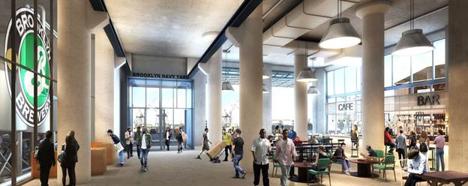
Rendering by Marvel Architects and Davis Brody Bond
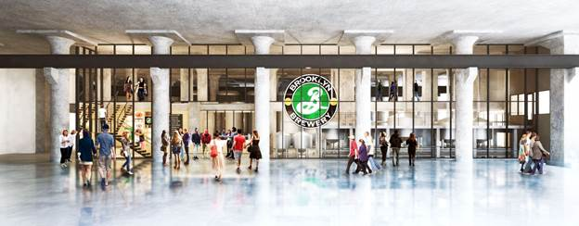
Rendering by Davis Brody Bond

About the Brooklyn Navy Yard
The Brooklyn Navy Yard Development Corporation (BNYDC) is the not-for-profit corporation that serves as the real estate developer and property manager of the Yard on behalf of its owner, the City of New York. BNYDC’s mission is to fuel New York City’s economic vitality by creating and preserving quality jobs, growing the City’s modern industrial sector and its businesses, and connecting the local community with the economic opportunity and resources of the Yard. BNYDC’s vision is a vibrant and dense, modern manufacturing community where businesses are provided the stability needed to invest, grow, and thrive. The Yard is now home to over 300 businesses employing approximately 7,000 people and generating over $2B per year in economic impact for the City. BNYDC’s goal is to more than double employment – to 16,000 jobs – by 2020.

About the Brooklyn Brewery
Founded in 1988, The Brooklyn Brewery is one of the foremost craft breweries in the world, currently ranking #12 in volume among United States craft breweries. While developing both delicious traditional styles and boundary-defying creations alike, Brooklyn Brewery produces award-winning beers that are available in 27 states and more than 30 countries. The Brooklyn Brewery is located in the Williamsburg section of Brooklyn and has been a proud supporter of the arts, music and community efforts since its inception. BrooklynBrewery.com

###

