
THE CITY OF NEW YORK
OFFICE OF THE MAYOR
NEW YORK, NY 10007

FOR IMMEDIATE RELEASE: January 07, 2025
CONTACT: pressoffice@cityhall.nyc.gov, (212) 788-2958

MAYOR ADAMS, GOVERNOR HOCHUL, AND REPRESENTATIVE ESPAILLAT UNVEIL WINNING PROPOSAL TO REIMAGINE KINGSBRIDGE ARMORY

El Centro Kingsbridge Will Include Event Space, Sports Fields, Cultural, Commercial and Community Spaces in Phase One, Affordable Housing in Phase Two

Plan Informed by “Together for Kingsbridge Vision Plan,” Backed by $215 Million City, State, and Federal Investment

NEW YORK – New York City Mayor Eric Adams, New York Governor Kathy Hochul, U.S. Representative Adriano Espaillat, and New York City Economic Development Corporation (NYCEDC) President and CEO Andrew Kimball today unveiled El Centro Kingsbridge — a new plan for the future of the Kingsbridge Armory — after they kicked off a request for proposal process last summer to redevelop the historic and long-underutilized site and create new economic opportunities in the Bronx. Phase One of the project envisions a vibrant, mixed-use development with a state-of-the-art event venue space, sports fields for local youth academies, cultural and commercial space, over 25,000 square-feet of dedicated community space, an educational facility focused on workforce development, and more. Phase Two includes 450 units of permanently affordable rental housing adjacent to the armory. The redevelopment is expected to generate nearly $2.6 billion in economic impact over the next 30 years, creating over 3,000 construction jobs and 360 permanent jobs.

The development team for the project will be led by 8th Regiment Partners LLC selected through a competitive request for proposals for the development rights.

“At the Kingsbridge Armory, our administration saw a historic yet underutilized site as an opportunity to dream and deliver a bold, forward-looking vision for the Bronx,” said Mayor Adams, “In just one location, we’re delivering affordable housing for our neighbors, sports fields for our children, community spaces for our families, and so much more. The future of the Bronx rests in the Kingsbridge Armory, a proposal made possible thanks to the partnership of Governor Hochul, Representative Espaillat, and the countless, everyday New Yorkers who made their voices heard. Together, we are building a brighter, better future for the Bronx, starting with the Kingsbridge Armory.”

“For decades, Bronx residents have been promised a new Kingsbridge Armory — and we’re partnering with the city to finally get the job done,” said Governor Hochul. “This transformative project will unite communities across the Bronx, provide spaces for recreation and academics, and deliver much-needed affordable housing.”

“We are a city where we take on ambitious, generational projects that serve as models for other cities,” said First Deputy Mayor Maria Torres-Springer. “El Centro Kingsbridge follows this principle, as it will bring us cultural space, sports fields, venue space, community facility space, a recreation center, an educational facility, permanently affordable housing, and over 3,000 jobs.”

“After a competitive selection process, we are thrilled to announce 8th Regiment Partners as our partner to redevelop the historic Kingsbridge Armory,” said NYCEDC President and CEO Kimball. “8th Regiment Partners’ proposal embraced the community’s vision plan for the Armory and demonstrated through their thoughtful design, programmatic uses, and financial viability that, in partnership with the city and state, they can finally deliver the economic engine and community amenities that the Bronx wants and deserves. I want to thank Governor Hochul, Mayor Adams, Congressmember Espaillat, Bronx Borough President Gibson, and New York City Councilmember Sanchez for their remarkable support, without which this unique public-private partnership would not have been possible.”

“We will soon witness a historic transformation of the Kingsbridge Armory and thanks to the collaborative support from Mayor Adams, Governor Hochul, and stakeholders, our city is one step closer to reimagining this visionary project,” said Representative Espaillat. “Congratulations to the winning proposal, led by the 8th Regiment Partners, to develop El Centro Kingsbridge into a vibrant multi-purpose facility and economic engine that all throughout our community can enjoy for many years to come.”

“We are pleased by the progress we are making toward reimagining the iconic Kingsbridge Armory into a space that will serve the Kingsbridge community and our entire borough,” said Bronx Borough President Vanessa Gibson. “El Centro Kingsbridge has the potential to boost the economy; increase tourism; invest in workforce development and small businesses; and create community space, recreational space, and opportunities for education and emerging markets. We are proud to have invested $2 million into the Kingsbridge Armory and appreciate the leadership and support of Governor Kathy Hochul, Mayor Eric Adams, the New York City Economic Development Corporation, ‘Together for Kingsbridge’ Co-Chairs Councilmember Pierina Sanchez and Sandra Lobo, and coalition members. We look forward to reimagining the Kingsbridge Armory and fulfilling the community vision that ‘Together for Kingsbridge’ has worked so hard to achieve. Together, we will work towards our common goals and priorities that serve to uplift our Kingsbridge community and our borough.”

“As a daughter of Kingsbridge, I know firsthand the Kingsbridge Armory represents the vast potential of our community,” said New York City Councilmember Pierina Sanchez, and co-chair, “Together for Kingsbridge” Community Visioning Process. “As this project enters its next stage, I remain committed to the guiding principles set forth in the ‘Together for Kingsbridge Vision Plan”: to prioritize our youth, uplift older adults, foster intergenerational relationships, create jobs and wealth for local workers, grow a regenerative, Bronx-centered economy, and maximize community ownership. Over nine months, we successfully engaged more than 4,000 community members through 20 community events and 900 survey responses — culminating in the creation of the vision plan. With our community’s priorities as the North Star, I look forward to a close review of the selected proposal. We must ensure that the redevelopment of this great structure is both transformative and equitable for generations to come.”

The project is backed by a $200 million investment by Mayor Adams and Governor Hochul, $2 million from Borough President Gibson, $12 million from Councilmember Sanchez, and a $1.05 million grant from the U.S. Department of Housing and Urban Development with the support of Representative Espaillat. The construction will be executed under a project labor agreement, ensuring fair wages and benefits for construction workers. 8th Regiment Partners’ proposal was selected after a rigorous request for proposal process that was informed by a nine-month public engagement process with over 4,000 community members, which produced the “Together for Kingsbridge Vision Plan.” The environmental review is expected to begin this winter, and the uniform land use review procedure is anticipated to commence in mid-2025.

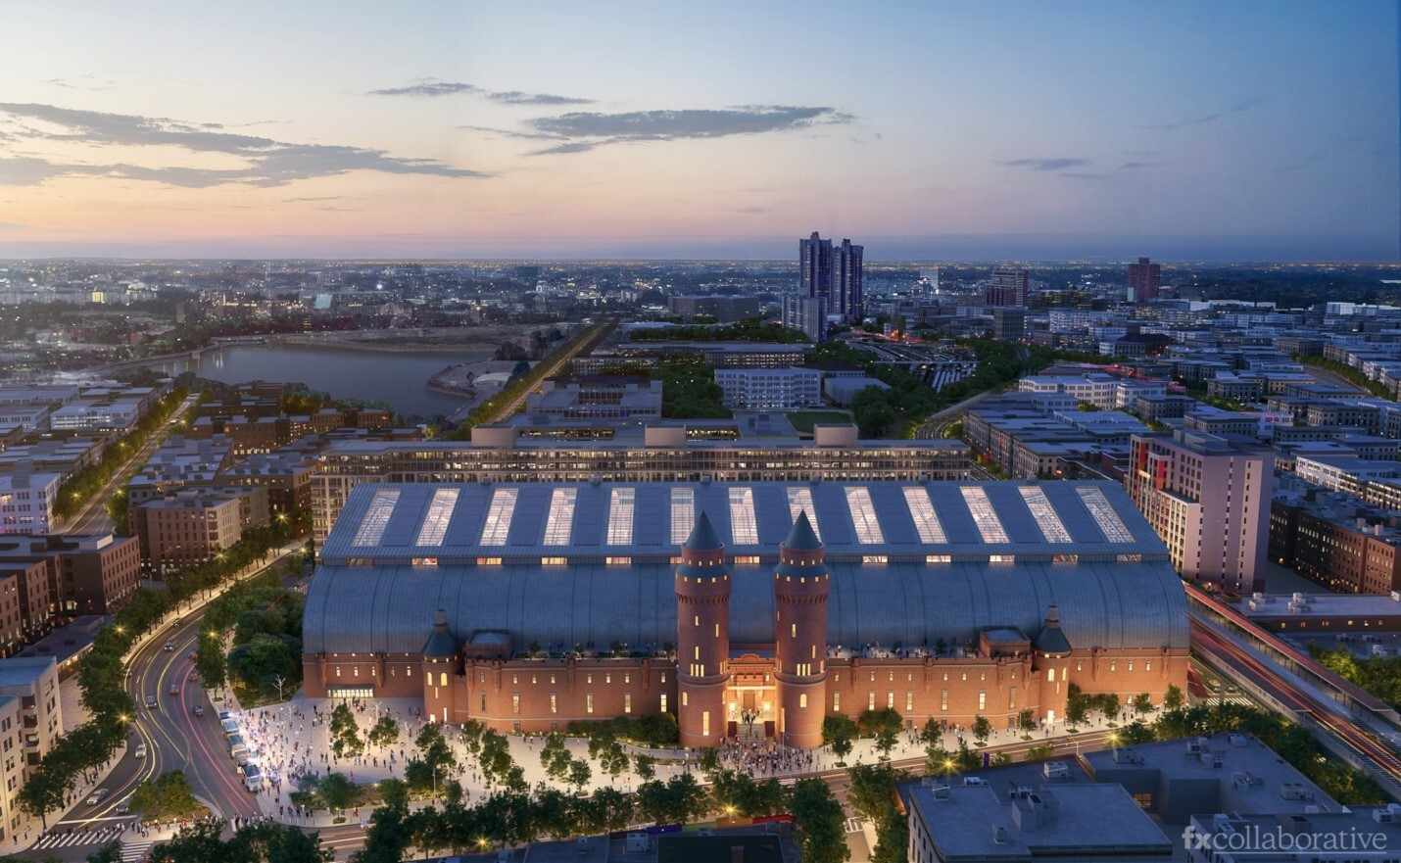

Renderings of the Redeveloped Kingsbridge Armory. Credit: FXCollaborative

Through a collaborative effort, led by NYCEDC, the public-engagement process gathered feedback from over 4,000 participants and included over 950 survey responses, nine Community Board meetings, 16 small group discussions, and conversations with approximately 75 additional stakeholders across various industries. Participants included local elected officials, as well as representatives from community-based organizations, nearby schools and colleges, health care providers, merchant associations, and labor.

The development team put forth a two-part proposal with a diversity of uses designed to serve both the local community and the broader region. Their proposal’s programming is centered around the 180,000 square foot column-free Drill Hall within the Armory, delivering on the community’s vision for a series of cultural, commercial, and community spaces. The development team will lead the design and construction stages of the project, as well as the operation of the renovated Armory.

Mayor Adams’ vision for the redevelopment of the Kingsbridge Armory builds on core goals in his “Rebuild, Renew, Reinvent: A Blueprint for New York City’s Economic Recovery” and “Housing Our Neighbors: A Blueprint for Housing and Homelessness,” including leveraging neighborhood infrastructure investments to catalyze equitable community development and creating housing opportunities in neighborhoods with strong access to jobs, transit, schools, parks, and other amenities. It also builds on the administration’s track record of advancing generational projects to build and reinvent neighborhoods in all five boroughs, including the South Brooklyn Marine Terminal, SPARC Kips Bay in Manhattan, the Willets Point Transformation in Queens, the Staten Island North Shore Action Plan, and more.

“We are excited for this opportunity to work with all of our government partners to transform this incredible, landmarked space into a thriving center of economic activity for the community, the borough, and the City of New York,” said Gabriella Madruga, principal, Maddd Equities on behalf of 8th Regiment Partners. “This is a wonderful example of a public-private partnership that will revitalize one of the most unique and historical buildings in New York. We are humbled to be the stewards of a property and a project that will leverage New York’s rich historical past to create an exciting and dynamic future.”

“The redevelopment of the Kingsbridge Armory is a transformational project that will see this historic structure become another major destination in the Bronx and provide much needed well-paying union construction jobs for New Yorkers,” said New York City and New York State Building and Construction Trades Council President Gary LaBarbera. “We applaud Mayor Adams and Governor Hochul for the city and state’s tremendous investment of $100 million respectively towards this development, and our members look forward to working with NYCEDC and the 8th Regiment Partners on making El Centro Kingsbridge a reality.”

“Revitalizing the Kingsbridge Armory is a monumental step forward in creating opportunities for our communities,” said New York State Senator James Sanders Jr. “This project brings jobs, affordable housing, and vital resources that will transform lives and strengthen our city. I applaud Mayor Adams, Governor Hochul, and NYCEDC for their vision and commitment to New Yorkers.”

“As we unveil the transformative El Centro Kingsbridge project, we are taking a historic step toward unlocking the immense potential of the Kingsbridge Armory,” said New York State Assemblymember Jeffrey Dinowitz. “Having lived much of my life in Kingsbridge Heights within blocks of the Armory, I am thrilled that this is finally happening. This redevelopment is not just about revitalizing a landmark—it's about creating opportunities for our community. With affordable housing, workforce development, and dedicated spaces for recreation and education, this project will provide lasting benefits for Bronx families. I appreciate all included for delivering an economic engine that will generate jobs, empower local youth, and serve as a beacon of progress in Kingsbridge Heights.”

“The redevelopment of the Kingsbridge Armory is a transformative opportunity for our residents in the Bronx,” said New York State Assemblymember Yudelka Tapia. “This project will not only create much-needed affordable housing and community spaces, but will also provide invaluable opportunities for our youth, working families, and small businesses. By integrating cultural, recreational, and workforce development facilities, this plan addresses critical needs in our community while honoring Kingsbridge Armory’s historic significance.”

“This planned redevelopment of the Kingsbridge Armory into a community hub with affordable housing is a big win for all New Yorkers — utilizing the Armory's abundant space and premier location as a cultural center, sports field, commercial space and much more, while spurring the development of 450 affordable housing units,” said New York State Assemblymember Rodneyse Bichotte Hermelyn. “The $215 million investment in our city's future will not only pay massive dividends for the community, but also generate $2.6 billion in economic impact and create over 3,000 construction jobs. I applaud Governor Hochul, Mayor Adams, and EDC President and CEO Kimball for this winning proposal of El Centro Kingsbridge as we keep innovatively building new opportunities for New York City.”

“El Centro Kingsbridge is an urban planning triumph, demonstrating all that can be accomplished when government and the community come together to understand their exact wants and needs,” said New York State Assemblymember Jenifer Rajkumar. “After months of workshops, surveys, community board meetings, tours, and small group discussions with over 4,000 community residents, NYCEDC crafted a people-powered plan for a five-acre hub of activity in the Northwest Bronx. There will be a mosaic of cultural, commercial, community, and educational spaces with a recreation center, workforce development facility, and 450 units of affordable housing. This will bring unprecedented energy to the neighborhood, generating billions in economic impact, over 3,000 construction jobs, and 360 permanent jobs. I look forward to El Centro Kingsbridge becoming a new beloved institution in the Boogie Down Bronx.”

“I'd like to thank Mayor Adams, Governor Hochul, and EDC President and CEO Kimball for their support of the ‘Together for Kingsbridge’ initiative, and for their generous investment in El Centro Kingsbridge. The future of the Kingsbridge Armory is bright, transforming into an economic engine for the Bronx, and a place for our vibrant, dynamic, and diverse communities to come together to work, play, and live in our beloved borough,” said New York State Assemblymember George Alvarez.

###

