

THE CITY OF NEW YORK
OFFICE OF THE MAYOR
NEW YORK, NY 10007

FOR IMMEDIATE RELEASE: December 20, 2019
CONTACT: pressoffice@cityhall.nyc.gov, (212) 788-2958

MAYOR DE BLASIO AND SPEAKER JOHNSON ANNOUNCE FAIR FARES OPEN ENROLLMENT TO BEGIN JANUARY 2020

The City will also launch an ad campaign on subways, bus shelters, and online to ensure eligible New Yorkers are aware of and able to access the first-of-its-kind program

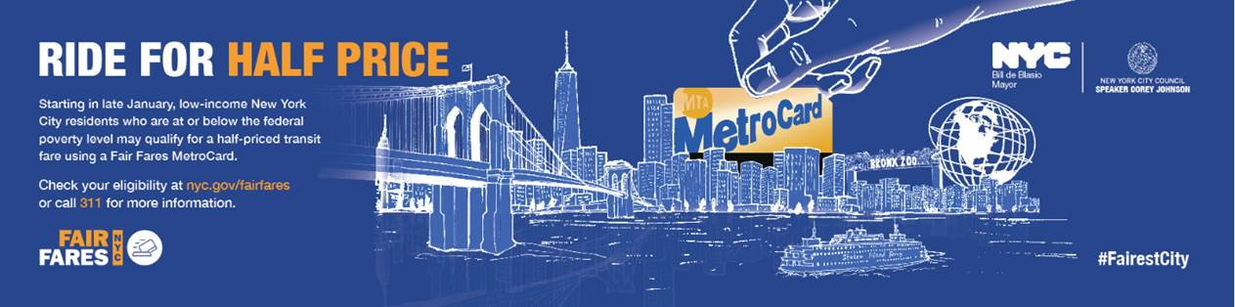

NEW YORK–– Mayor de Blasio and City Council Speaker Johnson today announced that open enrollment for the City’s Fair Fares initiative will begin on January 27. Open enrollment means that all eligible New Yorkers at or below the Federal Poverty line who don’t have discounted transportation from the MTA or the City will be able to apply for reduced-fare MetroCards via an online platform, further expanding to hundreds of thousands of additional New Yorkers. Currently, Fair Fares is only open to certain NYCHA residents, CUNY Students, veteran students or New Yorkers receiving Cash Assistance or SNAP benefits from the City’s Human Resources Administration (HRA).

“We're a city that puts working people first, and no New Yorker should have to choose between taking mass transit and putting food on the table," said Mayor Bill de Blasio. “With the expansion of the Fair Fares program, we’ve connected nearly 100,000 New Yorkers to a half-priced MetroCard, getting us one step closer to our goal of being a just and equitable city for all.”

“We know how hard it can be to make ends meet in New York and that’s why we want everyone to know about the expansion of the Fair Fares program, which gives half-priced MetroCards to residents who meet the poverty threshold. With the launch of open enrollment and this dedicated outreach effort, we hope to assist as many New Yorkers as we can in the new year. Thank you to the all of the advocates who have partnered with us on this important endeavor. Together, we can make New York a more fair and just city,” said City Council Speaker Corey Johnson.

This next phase in the Fair Fares initiative builds on the City’s progress connecting New Yorkers in need to this vital resource in the program’s first year. In the first phase of Fair Fares, nearly 100,000 New Yorkers enrolled in the program, representing a more-than 50 percent take-up rate after targeting more than 180,000 New Yorkers.

Following the launch of the online platform in April, which introduced the option to sign up for Fair Fares through the City’s Access HRA application, participation increased dramatically, with nearly all of current enrollees opting in digitally, including through the mobile and web applications. In March of this year, to provide eligible New Yorkers with even more options, the City launched the pay-per-ride option, enabling those in need to obtain single fares.

This month, the City will also launch a comprehensive multi-million dollar campaign to ensure eligible New Yorkers across the five boroughs are aware of and able to access the program, including advertising on the subways, in buses and bus shelters, and online, as well as in local businesses, and community and ethnic newspapers in 11 languages. Together with the Council, the City will work with local community-based organizations to spread the word through on-the-ground outreach. Ahead of open enrollment, the Department of Social Services continues to conduct outreach to New Yorkers eligible in the first phase, including sending notifications, making telephone calls, and alerting HRA clients via their digital Access HRA accounts.

Currently, eligible New Yorkers can opt-in by going to www.nyc.gov/fairfares and following the link to enroll now. They can also visit the nearest Fair Fares NYC location or call 311 for assistance enrolling.

In January, the City will transition to a new online platform, open to all New Yorkers living at or below the poverty line. Visit www.nyc.gov/fairfares today and stay tuned for more information on how you can apply when the program opens on January 27.

“Access to public transportation is fundamental to the health and well-being of New Yorkers,” said Deputy Mayor for Health and Human Services Dr. Raul Perea-Henze. “With the Fair Fares program, New Yorkers in need can reach jobs, health and social services, and recreational activities, and stay connected with family and friends. This next phase of the Fair Fares program will empower more New Yorkers with access to opportunities that support healthy communities.”

“New Yorkers should not have to choose between a MetroCard or their next meal and therefore we are launching the next phase of Fair Fares to open up enrollment for residents of our City with income below the federal poverty level,” said Department of Social Services Commissioner Steven Banks. “In less than a year of the initial phase of Fair Fares, we have connected approximately 100,000 New Yorkers to this vital transportation assistance, providing lifelines to families and individuals struggling to make ends meet. We are committed to continuing our work with the Speaker and the City Council to address income inequality by helping New Yorkers pay for the cost of public transportation.”

“All New Yorkers should be afforded the dignity to use public transportation to meet their basic needs, regardless of socio-economic status,” said HRA Administrator Grace Bonilla. “Today’s announcement guarantees that even more individuals will benefit from our transformative Fair Fares initiative, making life easier for thousands of hard-working New Yorkers who rely upon mass transit every day. We are proud to work alongside City Council, Community Service Society, the Riders Alliance, and other advocacy groups in our joint mission of making New York City fairer and more equitable for all.”

“Few things are as essential to survive in our city as a MetroCard, your ticket to work, to classes, to health care, and home to your kids at night. Now hundreds of thousands of additional low-income New Yorkers will be able to better afford bus and subway rides, thanks to the full rollout of Fair Fares announced today by Mayor Bill de Blasio and Speaker Corey Johnson,” said David R. Jones, President and CEO of the Community Service Society. “We look forward to a robust public outreach effort, on par with other successful landmark city initiatives, like preK, that are providing the means for upward mobility to those working hard to get ahead.”

"Fair Fares is changing lives. For me, it's lifted a weight off my shoulders,” said Riders Alliance Member Clementine James from Jamaica, Queens. “ Making ends meet is tough enough for myself and my family as a working mother and part-time student. It's one less thing that I have to worry about every month. I was proud to work alongside other transit riders to make Fair Fares a reality. I'm looking forward to seeing it transform even more lives next year. Thanks to Mayor de Blasio and Speaker Johnson for investing in the program and opening enrollment to everyone eligible."

###

