
THE CITY OF NEW YORK
OFFICE OF THE MAYOR
NEW YORK, NY 10007

FOR IMMEDIATE RELEASE: August 2, 2016
CONTACT: pressoffice@cityhall.nyc.gov 212-788-2958

MAYOR DE BLASIO ANNOUNCES 45 PERCENT REDUCTION IN SERIOUS VIOLENCE INDICATORS AT DEPARTMENT OF CORRECTION

For first time since 2011, uses of force and assaults on staff trending downward following anti-violence reforms

Violence reductions achieved with 75 percent fewer inmates in punitive segregation

NEW YORK – Mayor Bill de Blasio and Department of Correction Commissioner Joe Ponte today announced the department’s anti-violence reforms are showing strong results in the first half of 2016, with the most serious uses of force and most serious inmate assaults on staff dropping by nearly half compared to the same period in 2015. For the first time since 2011, overall uses of force and overall assaults on staff are now trending downward. Since his appointment, Commissioner Ponte has reduced the use of punitive segregation by 75 percent while achieving these violence reductions.

“Every day, our dedicated correction officers work to drive down violence in our city's jails – and today, it's clear their hard work is paying off,” said Mayor Bill de Blasio. "Today’s numbers are a heartening sign that a culture of safety is taking hold throughout the Department. The most serious assaults on staff are down by nearly half; the most serious uses of force are down by nearly half. Newly refurbished jails are safer places for inmates to live and officers to work. Commissioner Ponte is showing the nation: we can run humane jails that keep our officers and inmates safe from harm.”

“As these statistics show, our focused reforms on better staff training, added educational opportunities, and smarter inmate classification are leading to a safer environment for inmates and staff alike,” said Department of Correction Commissioner Ponte. “I want to thank our hardworking and committed staff members, who have learned the latest de-escalation tactics, for this tremendous achievement and for helping build a culture of safety in our jails.”

“The statistics released today substantiate our belief that – piece by piece – we can dismantle the culture of violence in City jails,” said Elizabeth Glazer, Director of the Mayor’s Office of Criminal Justice. “Programs built to meet the unique needs of individuals with behavioral health issues, including de-escalation training for corrections officers and access to clinical care, are showing that consistent safety is possible – even for populations historically linked to frequent violent incidents in jail.”

Inmate Assaults on Staff
- Inmate assaults on staff resulting in serious injuries: down 45 percent, to 24 from 44
- Inmate assaults on staff resulting in minor injuries: down 25 percent, to 191 from 253
- Total Inmate Assaults on Staff: down 20 percent, to 394 from 494

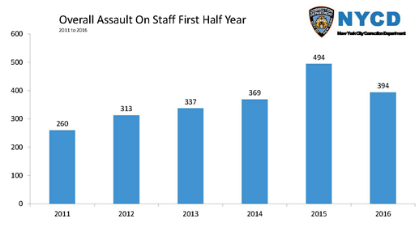

Uses of Force
- Uses of Force resulting in serious injuries: down 46 percent, to 39 from 72
- Uses of Force resulting in minor injuries: down 18 percent, to 800 from 981
- Total Uses of Force: down 2 percent, to 2,223 from 2,268

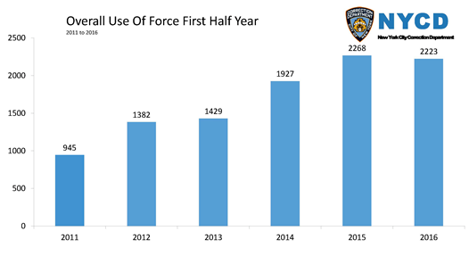

Since 2011, stabbings and slashings have also continued to rise until now. In the first six months of this year compared to last, stabbings and slashings held even, at 66 – and as of July 31, stabbings and slashings are now down to 78 for the year, compared to 87 at this time last year. Additionally, in the first six months of this year, serious injuries to inmates from assaults and fights dropped 15 percent, to 81 from 95.
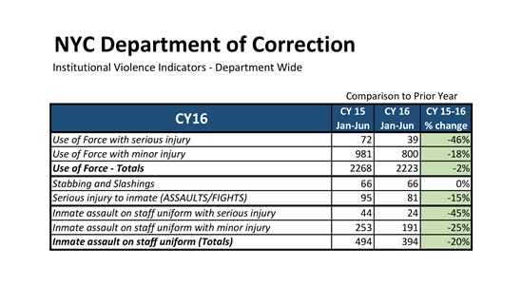
The department achieved these strong reductions in violence through Commissioner Ponte’s 14-point anti-violence agenda, which is aimed at making staff and inmates safer. This agenda includes training officers in the department’s new Use of Force policy, adding de-escalation training for officers, and offering new training on crisis management, adolescent populations, and mentally ill populations. The Commissioner’s reforms also include adding recruitment and vetting standards to bring in more qualified officers, and graduating the largest recruit classes in recent history.

At the same time, since his appointment the Commissioner has reduced punitive segregation by 75 percent, from 594 (on March 10, 2014, before he arrived) to 146 (on June 30, 2016), and ended punitive segregation for 16- to 18-year olds. Commissioner Ponte is also expanding camera coverage to 100 percent by the end of 2016 to reduce violent incidents, and he has added at least two hours of educational and vocational programming per day for most inmates to reduce idleness and improve inmate outcomes. The Commissioner has also created a dedicated arrest unit of 9 to put together priority cases to present to the Bronx DA’s office.

"Reforms aimed at reducing violence while reducing reliance on punitive segregation work, as these figures plainly demonstrate," said Council Member Daniel Dromm. "I applaud Commissioner Ponte for this significant progress and encourage him to continue to focus on evidence-based solutions. Both individuals held in our jails and the staff that run the facilities deserve to be in an environment that avoids brutalization and prepares individuals for release."

“This represents great progress built on systematic improvements in training and programming with the potential and promise for continued progress into the future,” said Chair of the Board of Correction Stanley Brezenoff.

###

