From: NYC Health Department Press Office [mailto:pressoffice@health.nyc.gov]
Sent: Wednesday, June 22, 2016 2:25 PM
To: NYC Health Department Press Office
Subject: HEALTH DEPARTMENT TO CONDUCT THIRD AERIAL LARVICIDE TREATMENT OF THE SEASON TO REDUCE THE NUMBER OF MOSQUITOES, MINIMIZE THE RISK OF MOSQUITO-BORNE DISEASE

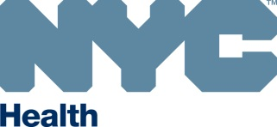
NEW YORK CITY DEPARTMENT OF HEALTH
AND MENTAL HYGIENE
Mary T. Bassett, MD, MPH
Commissioner

FOR IMMEDIATE RELEASE
Wednesday, June 22, 2016
(347) 396-4177

HEALTH DEPARTMENT TO CONDUCT THIRD AERIAL LARVICIDE
TREATMENT OF THE SEASON TO REDUCE THE NUMBER OF
MOSQUITOES, MINIMIZE THE RISK OF MOSQUITO-BORNE DISEASE

Aerial larviciding will take place over nonresidential areas such as marsh and other wetlands

There is no local transmission of Zika virus in New York City at this time

No human cases of West Nile virus have been reported this season

June 22, 2016 – As part of its mosquito control program, the Health Department will conduct its third aerial larvicide treatment to marsh and other non-residential areas of Staten Island, Brooklyn, Queens and the Bronx from Friday, June 24 to Sunday, June 26, between the hours of 6 a.m. and 7 p.m., weather permitting. In case of bad weather, application will be delayed until Saturday, June 25 to Monday, June 27 during the same hours. Due to size and limited accessibility, these areas will be treated using a low-flying helicopter. While three to four days are allotted for this activity, the application may be completed in less time. The areas to be treated appear below.

The first citywide larvicide treatment occurred May 12, 13, and 14th, and the second treatment took place from June 9 to June 11th. The Health Department monitors mosquitoes that carry the West Nile virus and could carry the Zika virus, and applies pesticides to their breeding grounds when appropriate throughout the summer. During warm weather, mosquitoes can breed in any still water standing for more than four days. In the targeted areas, existing hot and wet weather conditions are predicted to escalate a rise in mosquito populations.

The most effective way to control mosquitoes is to eliminate any standing water. New Yorkers are also encouraged to mosquito-proof their homes and take precautions when spending time outdoors.

The Health Department will be using naturally occurring and environmentally friendly larvicides to kill infant mosquito eggs before they grow into adults. VectoMax® FG containing naturally occurring bacteria − will be used for this application. These products are approved by the U.S. Environmental Protection Agency and the New York State Department of Environmental Conservation and will be used on mosquito-breeding sites throughout the mosquito season.
Reducing Exposure to Mosquitoes
- Use an approved insect repellent containing picaridin, DEET, oil of lemon eucalyptus (not for children under three), or products that contain the active ingredient IR3535.
- Make sure windows have screens and repair or replace screens that have tears or holes.
- Eliminate any standing water from your property and dispose of containers that can collect water. Standing water is a violation of the New York City Health Code.
- Make sure roof gutters are clean and draining properly.
- Clean and chlorinate swimming pools, outdoor saunas and hot tubs. Keep them empty or covered if not in use; drain water that collects in pool covers.
- Report standing water by calling 311 or visiting nyc.gov/health/wnv.
Locations of Application

Borough | Neighborhoods | Marsh/Wetland Areas To Be Treated | Boundaries | Zip Code
Staten Island | Arlington, Old Place, Howland Hook | Goethals North | Marsh areas bounded by South Avenue to the east; former North Shore Railroad to the north; Arthur Kill Channel to the west; and Staten Island Expressway to the south | 10303
Staten Island | Bloomfield | Corporate Park North | Marsh areas bound by Graham Avenue and Felton Street to the east; Goethals Road North to the north; Gulf Avenue to the west; and Teleport Drive and Edward Curry Avenue to the south | 10311  10314
Staten Island | Chelsea,  Bloomfield | Saw Mill Marsh North | Marsh areas bounded by Chelsea Road to the east; River Road to the north; Arthur Kill Channel to the west; and Sawmill Creek to the south | 10314
Staten Island | Chelsea,  Bloomfield | Saw Mill Marsh | Marsh areas bounded by South Avenue to the east; Edward Curry Avenue, Chelsea Road and River Road to the north; Pralls River to the west; Meredith Avenue, Chelsea Road and South Avenue to the south | 10314
Staten Island | Chelsea,  Bloomfield | Corporate Park | Marsh areas bounded by south Avenue to the east and south; Edward Curry Avenue to the north; and Chelsea Road and Bloomfield Avenue to the west | 10314
Staten Island | Chelsea | Chelsea East | Marsh areas bounded by Victory Boulevard to the east; South Avenue and Travis Avenue to the North; Chelsea Road to the west; and Meredith Avenue to the south | 10314
Staten Island | Chelsea , Travis | Chelsea | Marsh areas bounded by Victory Boulevard to the east; Meredith Avenue, Chelsea Road, South Avenue, and Travis Avenue to the north; Arthur Kill Channel to the west; and Wild Avenue and Victory Boulevard to the south | 10314
Staten Island | Fresh Kills | Fresh Kills | Marsh areas bounded by Richmond Avenue to the east; Main Creek to the north; West Shore Expressway to the west; and Arthur Kill Road to the south | 10314
 | Fresh Kills, Richmond Town | La Tourette | Marsh areas bounded by Richmond Hill Road to the east; Forest Hill Road to the north; Richmond Avenue to the west; and Arthur Kill Road to the south | 10306  10308 10314
 | Port Mobile | Port Mobile | Marsh and wetland areas bounded by Arthur Kill Road to the east; Arthur Kill Channel to the north and the west; and Outerbidge Crossing to the south | 10309
 | Wolfes Pond Park | Wolfes Pond Park | Marsh areas bounded by Staten Island Railway to the north; Luten Avenue, Cornelia Avenue and Chisholm Street to the east; Holton Avenue to the west; and Boardwalk Avenue to the south | 10309  10312
 | Blue Heron Park | Blue Heron Park | Marsh areas bounded by Hylan Boulevard to the south; Amboy Road to the north; Barclay Avenue to the east; and Arbutus Avenue to the west | 10312
 | South Beach | South Beach | Marsh areas bounded by Seaview Avenue to the west; Father Capodonna Boulevard to the south; Mason Avenue to the North; and Quintard Street and Sand Lane to the east | 10305
 | Old Town | Old Town | Marsh areas bounded by Zoe Street to the north; Stobe Avenue, Rowan Avenue and Graham Boulevard to the west; Father Capodonna Boulevard to the south; and Naughton Avenue and Seaview Avenue to the east | 10305
 | Clove Lake Park | Clove Lake Park | Marsh areas bounded by Forest Avenue to the north; Clove Road to the east; Brookside Avenue and Royal Oak Road to the east; and Victory Boulevard to the south | 10310  10314
Brooklyn | Marine Park | Marine Park | Marsh areas bounded by Avenue U to the north; Gerritsen Avenue to the west; Belt Parkway to the south; and Flatbush Avenue to the east | 11229  11234
Brooklyn | Fresh Creek Basin | Fresh Creek | Marsh areas bounded by Louisiana Avenue to the east, East 108th Street to the west; Stanley Avenue to the north; and Belt Parkway to the south | 11239
Queens | Alley Pond Park | Alley Creek | Marsh areas inside Alley Pond Park; areas bounded by Grand Central Parkway to the south; Northern Boulevard to the north; Douglaston Parkway and 240th Street to the east, Cross Island Parkway and East Hampton Boulevard to the west | 11362 11363
Queens | Linden Hill/ College Point | Abandoned  Flushing Airport | Marsh areas bounded by Whitestone Expressway to the east; 20th Avenue to the north; 130th Avenue and Ulmer Street to the west; and Ulmer Street and 28th Street to the south | 11354  11356  11357
Queens | Edgemere,  Somerville | Dubos Point and Edgemere Park | Marsh areas bounded by Norton Basin to the east; Mott Point to the north; Grass Hassock Channel to the west; and Beach 65th Street, De Costa Avenue and Almeda Avenue to the south | 11691 11692
 | Brookville Park | Brookville Park | Marsh areas bounded by Rockaway Boulevard to the south; 149th Avenue (to 225th Street), 148th Avenue (to 230th Street) and 147th Avenue (to 235th Street) to the north; 150th Road to the west; and Huxley Street to the east | 11413  11422
 | Kissena Park | Kissena Park | Marsh areas bounded by Booth Memorial Avenue to the south; 164th Street to the east; Oak Avenue and Rose Avenue to the north; and Kissena Boulevard to the west | 11355  11365
The Bronx | Pelham Bay Park North | Pelham Bay North | Marsh areas bounded by Amtrak Railroad to the east; New England Thruway to the north; and the Hutchinson River to the west and south | 10464  10475
The Bronx | Pelham Bay Park South | Pelham Bay South | Marsh areas bounded by Erskine Place to the north and west; and Pelham Bay Parkway and Hutchinson River to the south and east | 10465  10475  10464

Maps Depicting Specific Areas for Larvicide Application
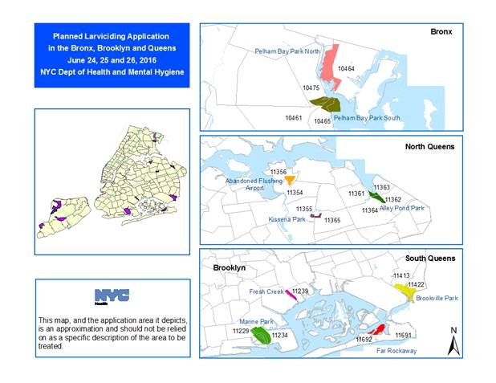
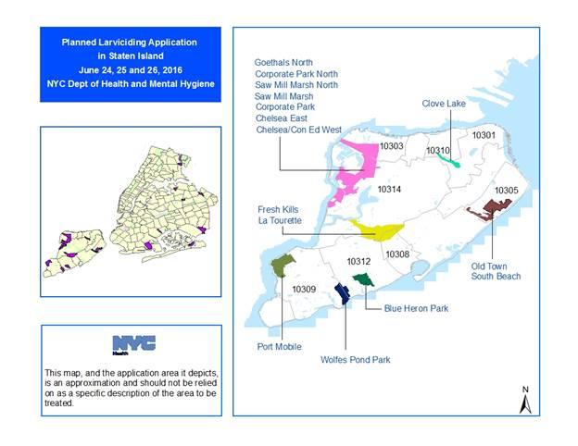

###

#M003-16

MEDIA CONTACT: (347) 396-4177
Christopher Miller/Julien Martinez: pressoffice@health.nyc.gov
Sent from the New York City Department of Health & Mental Hygiene. This email and any files transmitted with it may contain confidential information and are intended solely for the use of the individual or entity to whom they are addressed. This footnote also confirms that this email message has been swept for the presence of computer viruses.

