FOR IMMEDIATE RELEASE
#19-16

NYC EMERGENCY MANAGEMENT HERO - READY GIRL - STARS IN MARVEL CUSTOM COMIC BOOK WITH MARVEL’S THE AVENGERS
As hurricane season looms, Ready Girl teams up with Marvel’s The Avengers
to prepare New Yorkers

May 19, 2016 — As hurricane season looms, NYC Emergency Management teamed up with Marvel Custom Solutions on a new custom comic book that teaches kids about preparedness. The new project stars Ready Girl alongside The Avengers: Captain America, Iron Man, and Ms. Marvel, as the heroes aim to fight off the elements of severe weather that are rapidly approaching the New York area.
“This project is a creative way to get kids excited about preparedness,” said NYC Emergency Management Commissioner Joseph Esposito. “If we can engage them from an early age, the hope is that they can use this information throughout their lives. Thanks to Marvel Custom Solutions for working with us to create a fun and educational comic that will get kids, parents, and families thinking about how to prepare for hurricanes and emergencies in general.”

“The Avengers were formed when a group of Marvel’s heroes came together to combat a threat too dire for any one of them to handle alone,” said Mark Basso, editor of the custom Avengers comic featuring Ready Girl. “In that same spirit, we’re proud to team-up with NYC Emergency Management to help communicate this important message to kids by entertaining them with an action-packed adventure story while passing along these crucial lessons.”

“We are so excited to welcome Ready Girl to PS 39. Our third grade students are honored to be a part of the release of Ready Girl’s new Marvel custom comic book,” said Anita de Paz, Principal at PS 39. “Emergency preparedness is an important skill for all New Yorkers and we are happy to partner with New York City Emergency Management to engage our students and the community in getting ready.”
To launch the new project, Ready Girl appeared with Iron Man at PS 39 in Brooklyn, where she showed third graders everything they needed to know about hurricane preparedness. The students used an interactive Know Your Zone map to learn about New York City’s six hurricane evacuation zones. They also received their own signed copy of the new custom comic book.

The new custom comic book begins with Rosie Green, the real-life Ready Girl, at her Long Island City apartment browsing the Internet and listening to the radio. Just then, the announcer warns that a tropical storm traveling along the eastern seaboard has intensified and could bring hurricane force winds and heavy rains to the city. Rosie, who has her emergency plan in place, peeks outside to find a group of unassuming kids hanging out in the playground. Eager to help, she transforms into Ready Girl to warn them about the impending danger.
Meanwhile, in Brooklyn, Ms. Marvel is caught in a fierce battle with Whirlwind. She summons her emergency Super Hero contacts and fellow Avengers, Captain America and Iron Man, for back up. The Avengers, along with Ready Girl, duke it out with Whirlwind, the self-proclaimed “force of nature.” Are they able to stop Whirlwind in his tracks? Is he the only force of nature the super heroes are up against, or is the fight just beginning?

Since she burst onto the scene back in October 2015, Ready Girl has taken her message all over New York City, visiting dozens of schools, community centers and youth organizations, and local fairs. She has trained thousands of children throughout the five boroughs to be ready for any emergency. She focuses on three key messages:

- Get Ready: Make a Plan – Have at least two phone numbers – one local and one out-of- state number – that you can call in an emergency, and practice your emergency plan with adults in your home.
- Get Set: Prepare a Stay-at-Home Kit – During emergencies that require you to stay at home, have extra food and water for all family members and a battery-operated radio for news updates.
- Get Ready to Go: Pack a Go Bag – During emergencies that require you to leave your home, have a Go Bag packed with emergency supplies that you can grab in a hurry.
To keep up-to-date with Ready Girl, visit her blog. You can also visit nyc.gov/readyny to learn more about the Ready New York program. Click here to see The Avengers and Ready Girl in action.
###
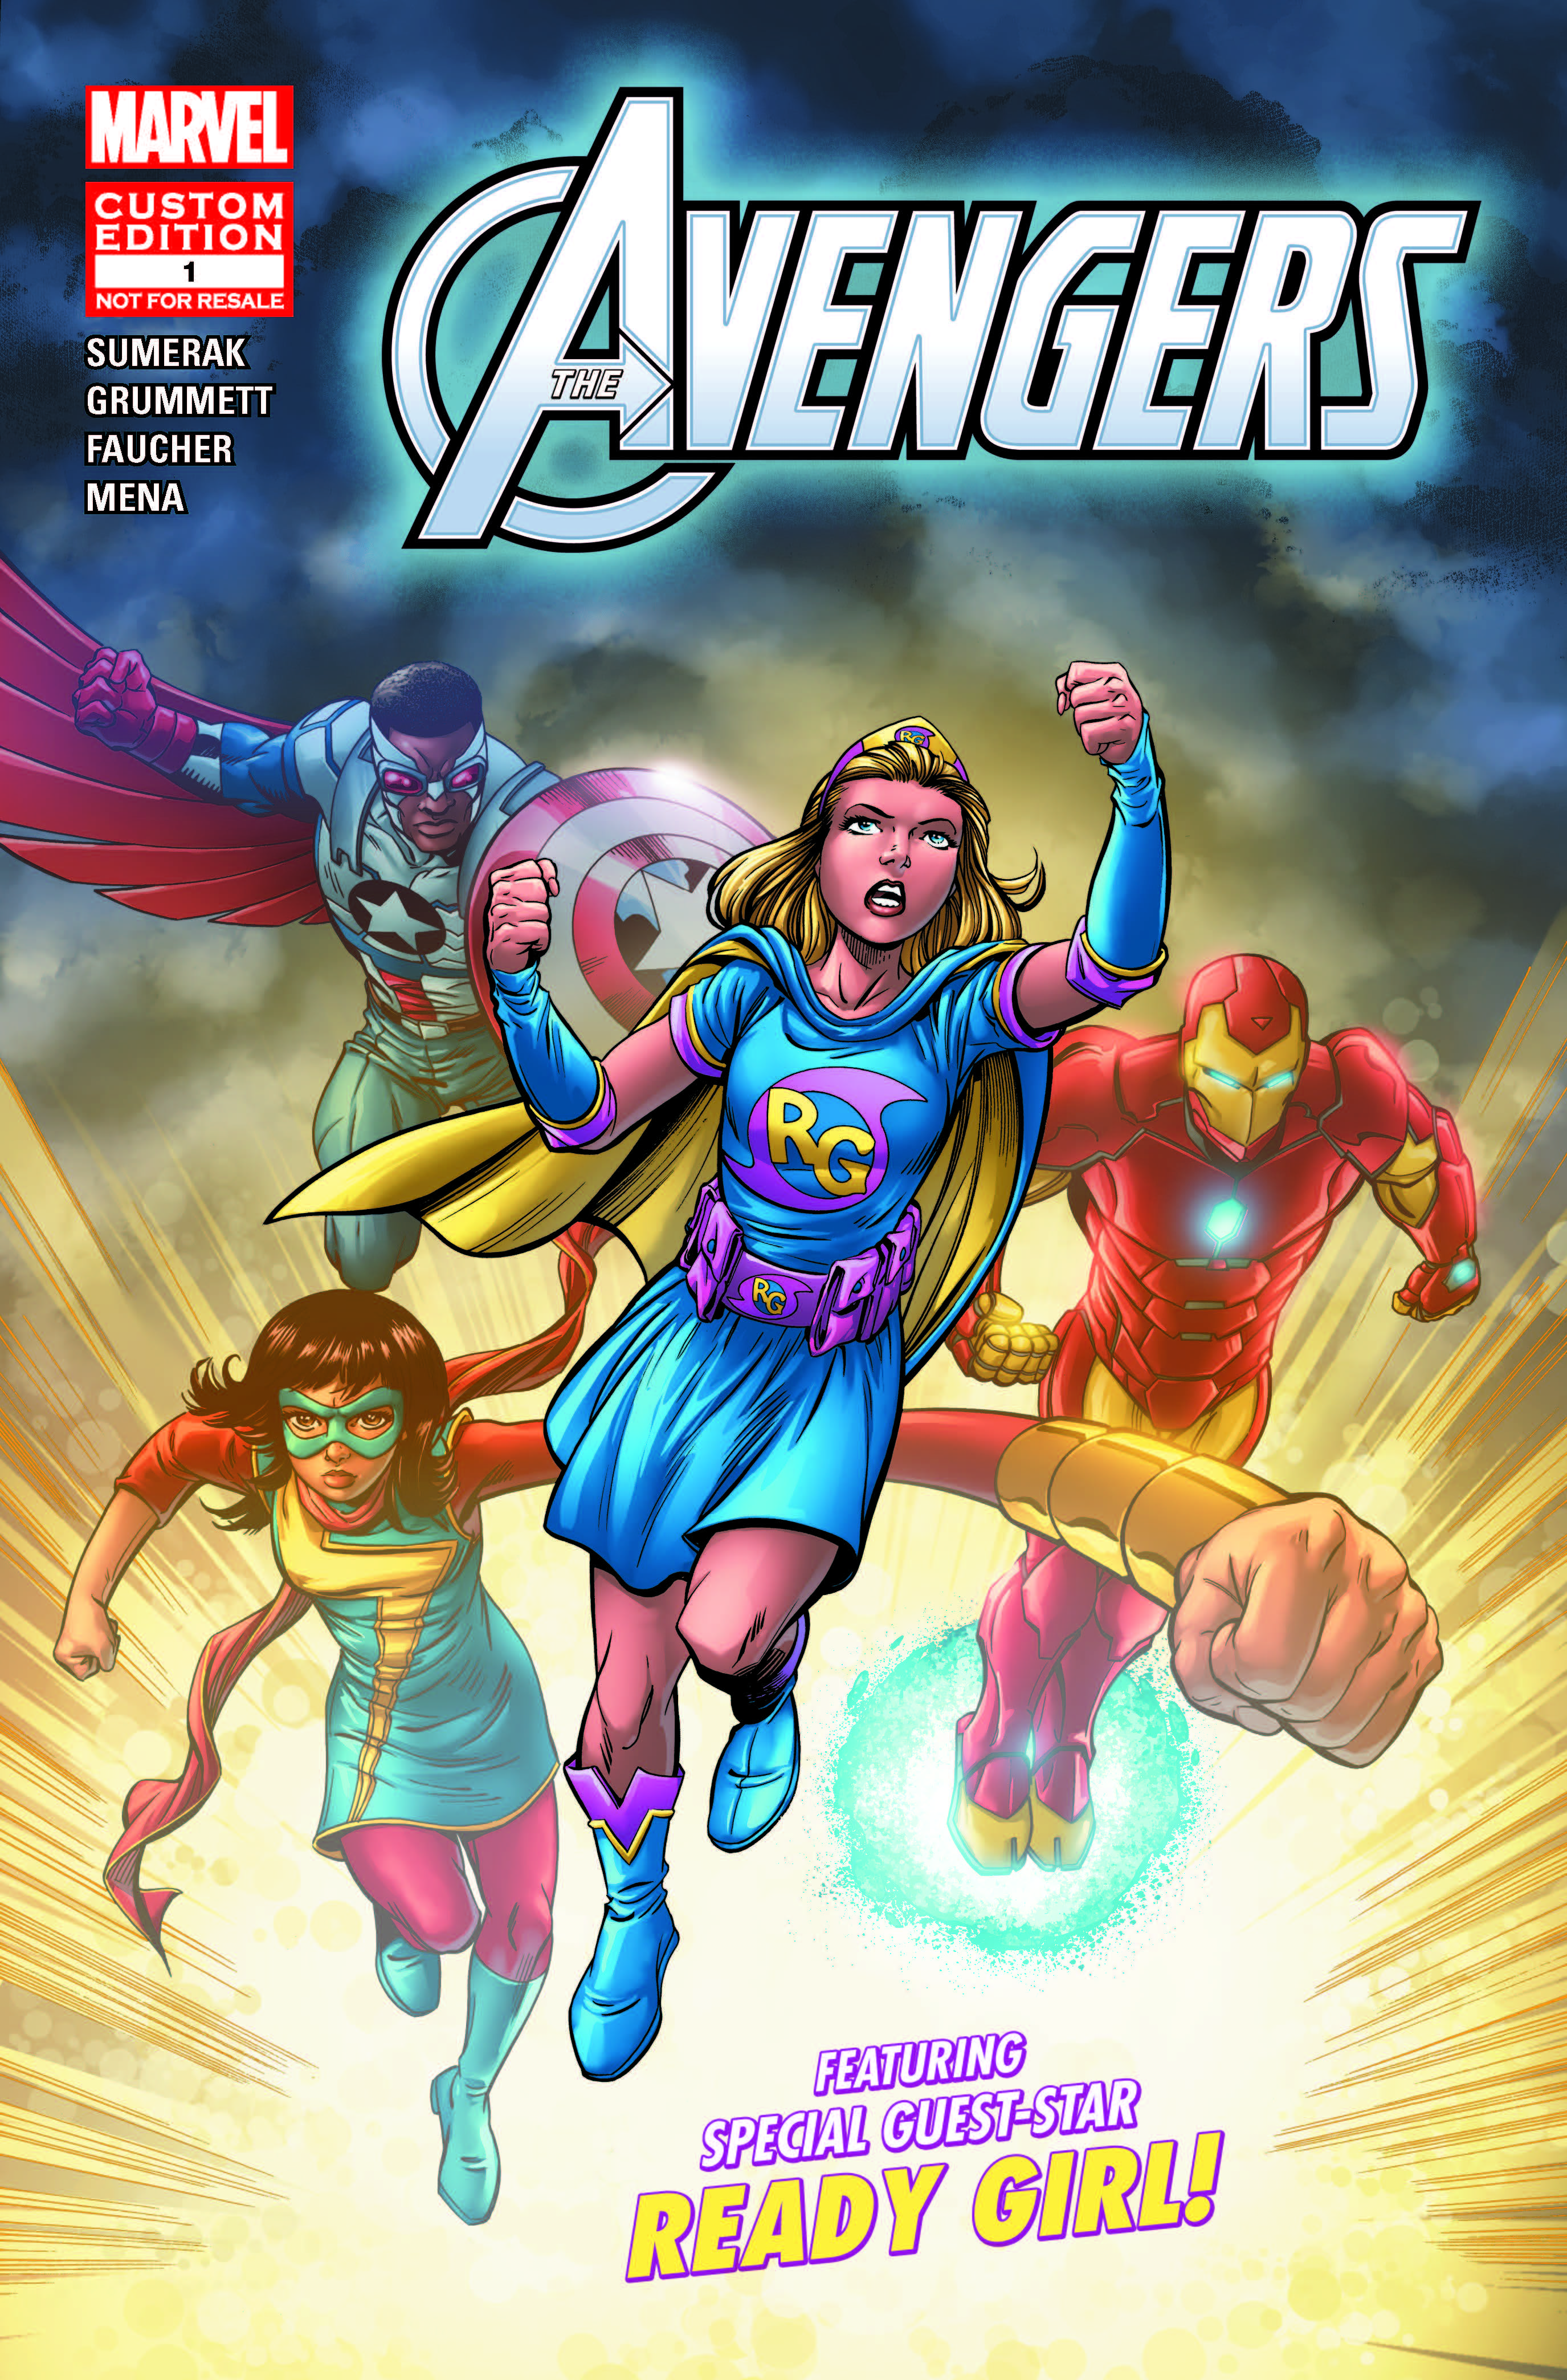

About Marvel Custom Solutions
Custom Solutions is Marvel’s in-house creative agency that leverages all the greatest talent within Marvel Entertainment to create highly dynamic and compelling content and campaigns for global brands. Marvel Custom Solutions enables brands to make an emotional connection with Marvel consumers globally through the art of storytelling, and has the ability to deploy the work it creates through its robust print, digital, social and theatrical platforms, adding scale to the programs it creates.
About Marvel Entertainment
Marvel Entertainment, LLC, a wholly-owned subsidiary of The Walt Disney Company, is one of the world's most prominent character-based entertainment companies, built on a proven library of more than 8,000 characters featured in a variety of media over seventy-five years. Marvel utilizes its character franchises in entertainment, licensing and publishing. For more information visit marvel.com. © 2016 MARVEL
Joe Taraborrelli
Marvel Entertainment
jtaraborrelli@marvel.com
212-576-8500

MEDIA CONTACT: Nancy Silvestri/Omar Bourne (718) 422-4888

STAY CONNECTED: Twitter: @NotifyNYC (emergency notifications)
@nycoem (emergency preparedness info)

Facebook: /NYCemergencymanagement

