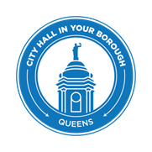
THE CITY OF NEW YORK
OFFICE OF THE MAYOR

FOR IMMEDIATE RELEASE: July 21, 2017
CONTACT: pressoffice@cityhall.nyc.gov, (212) 788-2958

MAYOR DE BLASIO ANNOUNCES START OF DIVERSITY PLAZA CONSTRUCTION IN JACKSON HEIGHTS

NEW YORK – Mayor Bill de Blasio, NYC Department of Transportation (DOT) Commissioner Polly Trottenberg, and NYC Department of Design and Construction (DDC) Acting Commissioner Ana Barrio joined with local elected officials and community residents today to break ground on the new Diversity Plaza at Broadway and 37th Road in Queens. The new plaza will encompass two blocks and a large traffic island near the busy Roosevelt Avenue subway station, increasing pedestrian space, calming traffic and beautifying a heavily used area around one of the City’s busiest transportation hubs.

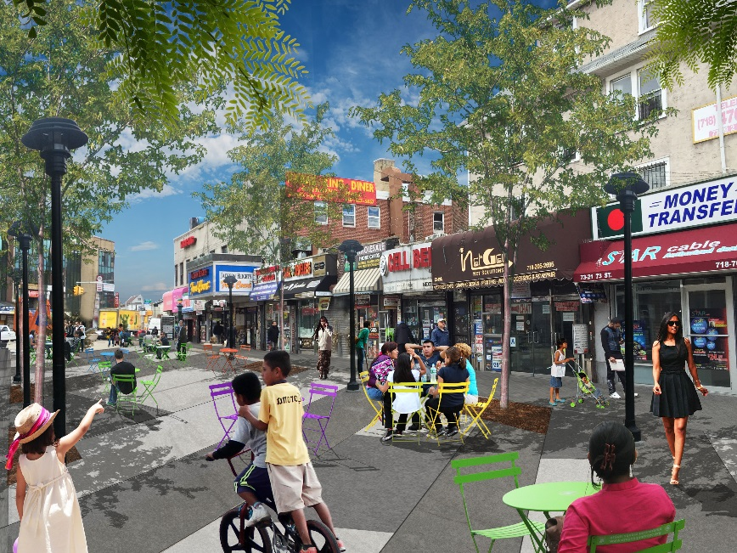
The $4.45 million project includes 37th Road from Broadway to 74th Street, and 73rd Street from Roosevelt Avenue to Broadway. The two block stretch, which was converted into pedestrian space in 2012, will feature new trees, raised planters, bike racks, moveable furniture, wayfinding signage as well as open space for performances.

“Diversity Plaza is an epicenter of culture, community, and vibrancy within New York City’s most diverse borough, Queens,” said Mayor de Blasio. “I am thrilled to see these first steps today towards major revitalization at this incredible space -- the progress and commitment to improvements will ensure Diversity Plaza will be an invaluable public place for this community to gather and celebrate for many decades to come.”

"Diversity Plaza has a become an iconic public space in Jackson Heights, proudly bringing the countless different cultures of this community together in one vibrant plaza,” said DOT Commissioner Polly Trottenberg. “We and our partners at DDC are proud to join Council Member Dromm to kick off construction work that will make this plaza a permanent part of the community, joining more than seventy public plazas Citywide. We also thank the Horticultural Society of New York for being our partners here when the work is completed, providing daily maintenance services and technical assistance through DOT’s One NYC Plaza Equity Program.”

“The City’s plaza program is a remarkable effort to make neighborhoods safer and more livable by simplifying complicated intersections and carving out more space for people as opposed to cars and trucks,” said DDC Acting Commissioner Ana Barrio. “Similar projects throughout the City have seen great success, and we are very pleased to be part of it.”

“No place is as diverse as the borough of Queens, nor as deserving of a community gathering place like Diversity Plaza,” said Bitta Mostofi, Assistant Commissioner of the Mayor’s Office of Immigrant Affairs. “This groundbreaking in Jackson Heights will lead to infrastructure upgrades making Diversity Plaza an even better place to share a meal, attend a cultural event, or participate in civic engagement. Diversity Plaza has been a great home for the Mayor’s Office of Immigrant Affairs to join with immigrant New Yorkers over the years, and we celebrate the partnership bringing these upgrades to life, the Department of Transportation and the Department of Design and Construction.”

"This is the intersection of the world. Diversity Plaza is where people from all communities, all walks of life, and all over the globe gather to meet, laugh, cry, sing, pray, dance, eat, play. It’s our borough’s public hub for the unabated exercise of speech, assembly, religion, expression. Thanks to investments secured by Councilmember Dromm and the dedication of the Department of Transportation, the new features and attention to Diversity Plaza will help enhance safety, aesthetics and utility in this plaza." said Queens Borough President Melinda Katz.

"This major upgrade is great news for Jackson Heights," said Council Member Daniel Dromm. "The capital improvements I helped fund will ensure that Diversity Plaza remains the epicenter of our neighborhood. As someone who worked hard to establish the plaza six years ago, I am delighted to see it come so far. Not only is Diversity Plaza home to many important cultural events, it serves as a town hall for residents who wish to protest, celebrate and mourn as one community. Thanks to these improvements, it will continue to serve our community for years to come. I applaud this progress and remain committed to bringing additional improvements to this invaluable public space."

"Diversity Plaza has proven to be an essential part of Jackson Heights," said State Senator Toby Ann Stavisky. "This communal space allows people of all backgrounds to come together by celebrating our differences as well as our similarities, something the Borough of Queens has long stood for. It has acted as a central gathering point for events such as the Pulse Nightclub Shooting Vigil, countless South Asian, Latino and other cultural events and even community board meetings. While we certainly will miss Diversity Plaza as it undergoes revitalization, the improvements will ensure an even better space that will continue to be enjoyed by the community for a long time to come."

“The expansion of Diversity Plaza will benefit the community by creating additional space for people to relax while remaining safe from vehicles,” said Assembly Member Michael DenDekker. “The proximity to one of Queens’ busiest transportation hubs, Diversity Plaza will continue to reach thousands of New Yorkers daily. I would like to thank Councilmember Daniel Dromm, Commissioner Trottenberg (DOT), and Commissioner Barrio (DDC) for their efforts in expanding Diversity Plaza.”

“In just a few short years, Diversity Plaza has come to exemplify the best kind of public space – inclusive, democratic, and populist. We are pleased to have played a role in this Plaza’s success for the past five years. We look forward to continuing our year-round sanitation and horticulture services, and to working alongside NYCDOT, Council Member Danny Dromm and the impressive array of local stakeholders to ensure that the ‘new’ Diversity Plaza continues as a model of civic engagement,” said Sara Hobel, Executive Director of The Horticultural Society of New York. The Hort’s Neighborhood Plaza Program works with ACE New York to provide maintenance services at 14 DOT Plazas citywide via the OneNYC Plaza Equity Program.

"We are thrilled that the big day for Diversity Plaza has arrived,” said Shekar Krishnan and Eirik Davey-Gislason, Co-Chairs, Friends of Diversity Plaza. “This public space holds much meaning for our community, reflecting all that makes Jackson Heights so vibrant and inclusive. It is the town square of our neighborhood: here, we have celebrated the cultures of our world; rallied and protested for the civil rights of the most vulnerable in our city; enjoyed music and art from across our community and around the globe; and engaged in civic activism or sipped a cup of chai with our neighbors. Diversity Plaza represents a powerful message of solidarity at a time when we need it most. It showcases the very best of Jackson Heights. We are incredibly excited to see it now transformed and for the next chapter of its special story."
“We are proud of the work that SUKHI has accomplished in the past five years – from rebuilding the image of the plaza, to the renaming the street, and now Diversity Plaza has been listed as ‘A Reason to Celebrate America’ by Time Magazine,” said Fatima Baryab, Co-founder of SUKHI New York and Diversity Plaza Partner. “Even in the light of challenges we have successfully provided the context and handwork, that today the City is readily reclaiming Diversity Plaza, in order to initiate a new chapter.”

The project will resurface several nearby streets, and also includes infrastructure upgrades such as new water mains, catch basins, sidewalks, curbs, street lighting and traffic signals. Work is expected to be complete in summer 2018. Upon completion of the plaza project daily maintenance services and technical assistance will be provided by NYCDOT’s One NYC Plaza Equity Program through a contract with the Horticultural Society of New York.

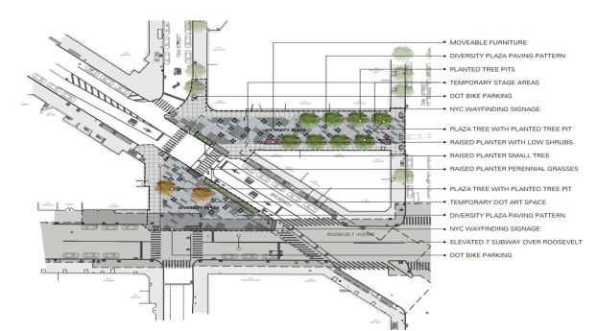
A site plan for the new Diversity Plaza near the Roosevelt Avenue subway station

To manage communication and other issues with residents and local businesses that may arise during the project, DDC will have a full-time Community Construction Liaison (CCL) on-site during construction. M. Manzur Alam is fluent in Bengali, Urdu and Hindi, and can be reached in person at the site, at 37plazaccl@gmail.com or by phone at 347-495-4171.

DDC and DOT this week also announced the completion of the new Myrtle-Cooper Plaza in Glendale. The creation of Diversity Plaza mirrors other efforts by the de Blasio administration to calm traffic and reclaim pedestrian space throughout the City. The DOT Plaza Program now has 73 plazas citywide, including 13 in Queens.

# # #

