
THE CITY OF NEW YORK
OFFICE OF THE MAYOR
NEW YORK, NY 10007

FOR IMMEDIATE RELEASE: December 13, 2023
CONTACT: pressoffice@cityhall.nyc.gov, (212) 788-2958

MAYOR ADAMS CELEBRATES FIRST PHASE OF 10TH AVENUE UPGRADE
WITH EXTRA-WIDE PROTECTED BIKE LANE

Safety Upgrades Include 10-Foot-Wide Bike Lane, Among Manhattan’s Widest,
Better Accommodating E-Bikes on Popular Street for Delivery Workers

Concrete Pedestrian Islands, Intersection Safety Upgrades, and
Bike Parking Will Enhance Safety for All Road Users

Adams Administration on Track to Complete Record
Number of New Protected Bike Lane Miles in 2023

NEW YORK – New York City Mayor Eric Adams and New York City Department of Transportation (DOT) Commissioner Ydanis Rodriguez today celebrated the first phase of the Adams administration’s new safety upgrades to Manhattan’s 10th Avenue. The upgrades — installed between West 38th Street and West 52nd Street in Hell’s Kitchen — feature a 10-foot-wide northbound bicycle lane to improve safety with a growing number of cyclists, e-bike riders, and users of other micromobility modes. The administration also built new concrete pedestrian islands, redesigned intersections to slow turning vehicles, and installed new bicycle corrals — making the street safer for pedestrians, cyclists, and drivers. The Adams administration is on track to complete a record number of new protected bike lane miles for New York City in 2023.

“As New Yorkers change how they use our streets, we need to change our streets with them — and on 10th Avenue and across the city, we’re doing just that,” said Mayor Adams. “The upgrades we have completed will make 10th Avenue safer for everyone, and the extra-wide bike lane will make it easier for cyclists to feel comfortable riding through the neighborhood. We are proud to partner with the Hell’s Kitchen community to deliver a better experience for residents and visitors alike, and we look forward to continuing on down 10th Avenue.”

“As biking grows in popularity, our infrastructure must grow alongside it. A 10-foot lane on 10th Avenue will enable e-bikes and traditional bikes to coexist, creating room for faster vehicles to pass and promoting safe behavior on the road, while supporting our growing cargo bike delivery industry,” said Deputy Mayor for Operations Meera Joshi. “We are grateful to DOT for its vision and advocacy in making this a reality.”

“The 10th Avenue redesign proves that when we reimagine our streets to be safer for cyclists and pedestrians, all road users see the benefits,” said DOT Commissioner Rodriguez. “This project brings essential safety upgrades to Hell’s Kitchen and represents just one way we are upgrading our infrastructure to support legal micromobility options. We thank the elected officials — especially Councilmember Bottcher — and the advocates for their partnership in making this happen.”

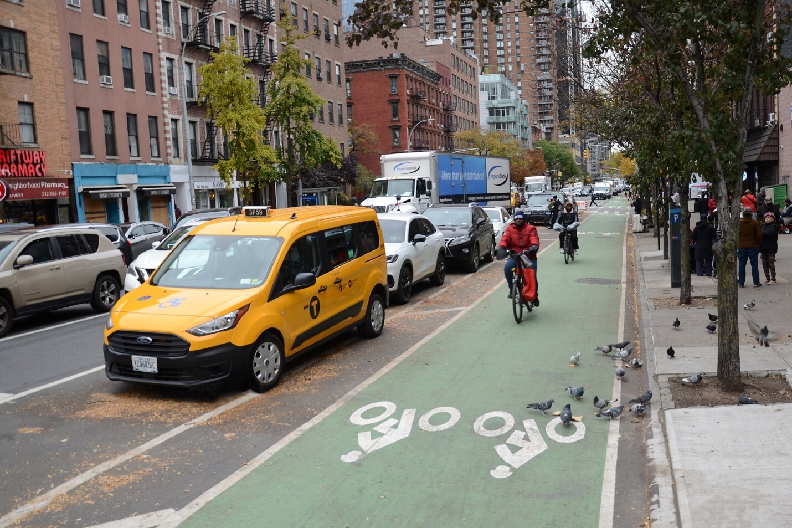
The new, extra-wide bike lane on 10th Avenue. Credit: New York City Department of Transportation

The new, extra-wide bike lane and other cycling safety improvements on 10th Avenue deliver on commitments in Mayor Adams’ “Charge Safe, Ride Safe: New York City’s Electric Micromobility Action Plan.” Released in March 2023, the plan highlights the importance of adapting street designs to accommodate the growth of e-bikes and other micromobility devices on city streets.

Following conversations with Manhattan Community Board 4 in 2022, DOT widened the proposed bike lane to 10 feet for most of the project, maintained a three-foot buffered space between parked cars and the bike lane, and quadrupled the original number of pedestrian islands included in the project. DOT continues to develop wider lane designs for projects across the city. Protected bike lanes improve safety for all road users by shortening crossing distances for pedestrians at intersections, calming vehicle traffic, and improving visibility for those walking, driving, and riding a bike or e-mobility device. These designs have reduced deaths and serious injuries among all road users by 18.1 percent, with a 29.2 percent decline for pedestrians.

At West 41st and West 42nd Streets near the Lincoln Tunnel, where many vehicles make turns, DOT will install left-turn lanes with dedicated signal timing to give pedestrians a head start crossing the street. Known as leading pedestrian intervals, these treatments have been shown to reduce pedestrian deaths and serious injuries by almost 35 percent. DOT also installed protected intersections, known as “offset crossings,” at West 39th, West 43rd, West 45th, West 47th, and West 49th Streets. These intersections feature painted pedestrian space designed to improve visibility between cyclists and drivers and naturally slow driver turns. DOT installed 10 bicycle corrals across the 14 blocks of the project to provide additional bike parking and further protect the space.

DOT plans to implement the second phase of this project — from West 14th Street to West 38th Street — with a similar design in 2024.

Under Mayor Adams’ leadership, New York City has launched and completed significant bike infrastructure and greenway projects across all five boroughs. After winning a $7.25 million federal grant, Mayor Adams launched an effort to add 40 miles of new greenways in five outer-borough corridors. The Adams administration is also undertaking a groundbreaking effort to expand the Harlem River Greenway seven miles into the Bronx — delivering critical public space in a community too often left behind. Additionally, the administration has launched and completed major bike infrastructure projects in East New York in Brooklyn, on Soundview Avenue in the Bronx, and on Third Avenue in Manhattan, among other locations.

“Traffic violence is on the rise nationwide, but we have the power to reverse this trend in New York City by building infrastructure that prioritizes safety and accessibility for all road users. I enthusiastically welcome the new 10th Avenue bike- and pedestrian-friendly improvements in my district,” said New York State Senator Brad Hoylman-Sigal. “The avenue will now boast a 10-foot-wide bike lane and expanded pedestrian islands from 38th to 52nd Streets thanks to the great collaboration between Mayor Adams, Commissioner Rodriguez, and Community Board 4. Street safety improvements are a matter of life or death for my constituents and vulnerable road users throughout the city. These latest upgrades, one of many to come, prioritize the safety of New Yorkers and are a great step in the direction towards Vision Zero.”

“I am thrilled to see this great progress on the improvements of 10th Avenue,” said New York State Assemblymember Tony Simone. “The widened bike lane, which is protected with pedestrian islands, is a fantastic investment in street infrastructure that will make conditions safer for everyone, especially bikers and pedestrians. Hell’s Kitchen has seen a huge uptick in users of e-bikes, in particular, and we should be encouraging the safe use of these environmentally friendly alternatives to cars by making the street a safe place for them to operate. The more protected bike lanes we have, the less cars we’ll have on the road and the more pedestrians will be able to use sidewalks safely. I am glad to see these improvements being made right in my neighborhood where they are so badly needed.”

“Safer streets start with infrastructure changes like the ones we’re seeing on the West Side today. This holistic approach to building out pedestrian and cyclist protections makes traveling on 10th Avenue safer for everyone,” said Manhattan Borough President Mark Levine. “I look forward to the project’s extension to 14th Street next year.”

“This is a big victory for our community,” said New York City Councilmember Erik Bottcher. “Tenth Avenue is one of the most dangerous stretches of roadway for pedestrians and cyclists in New York City. It’s basically a four-lane highway in the middle of our community. During my first month as a city councilmember, we organized a rally on 10th Avenue with PTA parents, block associations, and community board members who have long been calling for a redesign that includes a protected bike lane, pedestrian refuge islands, and shorter pedestrian crossings. I want to thank Mayor Adams, Commissioner Rodriguez, Community Board 4, and all the community members who made their voices heard in support of this vital project.”

“The extended protected bike lane on 10th Avenue is another excellent improvement to our streetscape,” said Jeffrey LeFrancois, chair, Manhattan Community Board 4. “With a wider path for cyclists and concrete islands for pedestrians, the new segment moves 10th Avenue towards a more complete street and will hopefully encourage more to enjoy the power of the pedal as they make their way around town. Congratulations to DOT on the swift implementation and a big thanks to Councilmember Bottcher for prioritizing this important infrastructure project.”

“HYHK has supported a bike lane on 10th Avenue for many years as a way to connect the far West Side with the existing bike network in the neighborhoods of Hell’s Kitchen, Chelsea, Midtown, and beyond,” said Robert J. Benfatto, president, Hudson Yards Hell's Kitchen (HYHK) Alliance. “Transit infrastructure, such as dedicated bike lanes, allows bikers safer access to city streets. We also love the opportunity for additional greenery the bike lane has created in areas of the district where there was none. We look forward to working with the community to advocate for future bike corridors on the West Side.”

“Worker’s Justice Project and Los Deliveristas Unidos applaud the mayor and DOT Commissioner Rodriguez on the completion of these transformative transportation upgrades on 10th Avenue,” said Gustavo Ajche, leader, Los Deliveristas Unidos. “These enhancements mark an important step in the efforts to foster a safer urban environment for all — including delivery workers who navigate these streets.”

“These new wider bike lanes are really important,” said Corey Hannigan, active transportation program manager, Tri-State Transportation Campaign. “Most people get around Hell’s Kitchen without driving, but until now, there hasn’t been a safe and convenient northbound option for bikes. Meanwhile, the Lincoln Tunnel entrance generates endless traffic, creating unsafe street conditions and poor air quality for everyone. This new protected bike lane will work with the southbound bike lane on Ninth Avenue to provide a seamless, safe connection all the way up to 110th Street and eventually down to 14th Street, helping residents and delivery workers get in and out of the congestion pricing zone toll-free.”

“The expansion of the 10th Avenue bike lanes and the increase in pedestrian islands are informed and pragmatic responses to the increase in micromobility traffic in the city — including e-bikes,” said Ken Podziba, CEO, Bike New York. “We’re thrilled to see New York City responding to this new reality by accommodating the influx through safety and accessibility measures. Not only will these updates improve the flow of traffic, but they’re also shown to reduce traffic injuries by nearly 20 percent. Mayor Adams, Commissioner Rodriguez, and the team at DOT continue to lead by example by creating positive change for urban cyclists.”

“By widening protected bike lanes and implementing innovative safety features at intersections, the 10th Avenue redesign project will at once encourage the use of micromobility options — which is exactly what we need to reduce climate-damaging emissions from our transportation sector — and make for a safer journey for everyone, including pedestrians,” said Alia Soomro, deputy director for New York City policy, New York League of Conservation Voters. “The New York League of Conservation Voters is thrilled to see the swift completion of phase one of this project and we applaud Mayor Adams and Commissioner Rodriguez for their commitment to creating a safer and greener New York City.”

“It’s encouraging to see DOT iterate on proven and popular street treatments with this holistic design that prioritizes comfort and accessibility for everyone, especially our most vulnerable neighbors,” said Carl Mahaney, director of StreetopiaUWS, Open Plans. “New Yorkers want choices in how they get around, and everyone deserves to feel safe and welcome on our streets — projects like this inch us closer to that very attainable goal. We’re eager to see the 10th Avenue improvements extend further south in 2024 and would love to see similar projects from DOT connecting neighborhoods all across the city.”

“As bike ridership continues to set records, creating more protected spaces for New Yorkers to bike is vital. We’re glad to see DOT cut the ribbon on new, wider protected bike lanes and redesigned intersections on 10th Avenue. Projects like this make our streets safer for not only bike riders but pedestrians and drivers, too,” said Danny Harris, executive director, Transportation Alternatives. “We look forward to working with DOT to replicate this project across New York City to meet the requirements of the New York City Streets Plan.”

###

