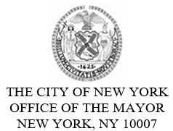
FOR PLANNING PURPOSES
CONTACT: pressoffice@cityhall.nyc.gov, (212) 788-2958

PUBLIC SCHEDULE FOR MAYOR ERIC ADAMS FOR SUNDAY, FEBRUARY 23, 2025

On Sunday, New York City Mayor Eric Adams will appear on NY1’s “In Focus with Cheryl Wills.” This appearance is pre-taped, and timing is subject to change.

Later, the mayor will call in for a live interview on WBLS 107.5 FM’s “Caribbean Fever.”

Press Schedule

Approximately 10:30 AM – Appears on NY1’s “In Focus with Cheryl Wills”

Approximately 9:45 PM - Calls In for Live Interview on WBLS 107.5 FM’s “Caribbean Fever”

###

