Thrive’s Commitment to the NYPD is Unbreakable

Aug. 19, 2019

Nine NYPD officers have died by suicide since January, seven since June. Our city is grieving right now. Our police officers serve and protect us, and it is incumbent upon every New Yorker to do all we can to support them.
I am proud that in this heart wrenching time, the Office of Thrive NYC has provided critical support to the NYPD. We have worked closely with police leadership to help the Department shape its comprehensive suicide prevention strategy. We have brought in national experts to guide this work. We have collaborated to design the executive level training on suicide now underway, as well as the precinct level training that began this week. Over the next month, every Patrol Borough in the City will partner with Thrive to offer Mental Health First Aid training. Thrive will also help train those selected to participate in the Department’s new Peer Support Program. Many other strategies are on the way.

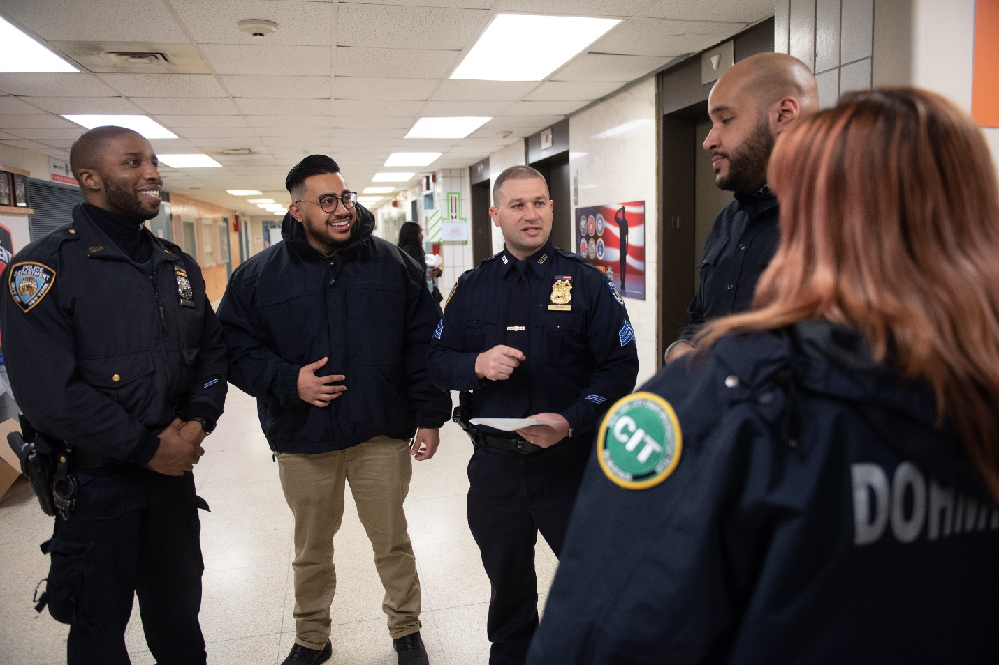
NYPD/DOHMH Co-Response Unit in Manhattan on Thursday, December 13, 2018. Michael Appleton/Mayoral Photography Office
In light of this record of collaboration between Thrive and the NYPD to respond to the suicide crisis, it was particularly troubling to see a minor misunderstanding between my office and a member of City Council blown up into an accusation that Thrive refused to offer mental health training to first responders. Nothing could be further from the truth.
Let me share the facts.
In May, I met with Council Member Borelli and asked him, as I do every elected official, to host a Mental Health First Aid training for his constituents. He proposed a training for first responders. We confirmed that our trainers would be happy to provide specialized training. The Council Member secured a room and we agreed on a date.
Last week, the Council Member’s office shared a flyer they wanted to use to advertise the training. My staff called and suggested that the training, which was open only to first responders, not be advertised to the public — because the public was not invited. The Council Member’s staff got angry, said he no longer wanted to work with Thrive, hung up the phone, and did not return subsequent calls. The next day, the Council Member tweeted an invitation to the training. We therefore assumed it was still on and planned to conduct it. Three days later, without any further contact with Thrive, the Council Member starting pitching news outlets saying we had canceled the training. We had not. A reporter confirmed that the Council Member’s office told the location it was no longer happening.
It’s troubling that such a minor misunderstanding, that could have easily been cleared up with more conversation, has been used to divide the City when we should be united. The implication that Thrive is not working on behalf of law enforcement, particularly in this time of great need, is both false and harmful.
In fact, since its launch, Thrive and the NYPD have been strong partners. For the last three years, we have worked together to enhance the critical role officers play responding to mental health crises, de-escalating tough situations and connecting those in need to care. We invest over $22 million a year in mental health strategies at the NYPD. This investment includes $5.3 million for Crisis Intervention Training, so that officers can recognize the signs of mental health disorders and substance misuse, and better assist people in crisis. Over 13,000 officers have been trained so far. Thrive has also partnered with the NYPD to train over 8,000 staff in Mental Health First Aid and over 3,500 school safety agents in Youth Mental Health First Aid.
Now our work with the NYPD goes beyond training officers in how to assist the public; we are doing everything we can to help officers help each other.
The truth is that Thrive is working across City government to ensure that every New Yorker, including every member of the NYPD, has access to the mental health support they need. Our commitment to the wellbeing of police officers serving our city has been — and will continue to be — unbreakable.
Susan Herman
Director, Mayor’s Office of Thrive NYC
Former Deputy Commissioner, Collaborative Policing, NYPD

