
FOR IMMEDIATE RELEASE: June 30, 2025
CONTACT: pressoffice@cityhall.nyc.gov, (212) 788-2958

MAYOR ADAMS ANNOUNCES 100,000 FREE TICKETS FOR NEW YORKERS
TO WATCH MACY’S 4TH OF JULY FIREWORKS®

Lighting Up Iconic New York City Skyline, 49th Edition of Macy’s 4th of July Fireworks
Will Fire from Barges From Lower Section of East River and Near Iconic Brooklyn Bridge

10 Times More Free Tickets Being Offered Than Last Year Provides More New Yorkers Miles of Prime Viewing for Show

NEW YORK – New York City Mayor Eric Adams today announced that 100,000 free tickets will be available to the public for viewing the Macy’s 4th of July Fireworks on Friday. The tickets will be available for designated viewing areas in Brooklyn Bridge Park or designated sections of Pier 16 and Pier 17 at The Seaport. Tickets will be available beginning at 8:30 AM tomorrow, Tuesday, July 1, and will be distributed on a first-come, first-served basis online. Each person may request up to four tickets for Brooklyn Bridge Park or up to two tickets for The Seaport viewing area in Manhattan.

New Yorkers looking to secure their spots early for the Brooklyn Bridge Park location only can text “FIREWORKS” directly to Mayor Adams at 917-909-2288 right now as he will be giving the first 2,500 texters four free tickets each before the general release to the public.

“Every New Yorker deserves a chance to celebrate under the sparkle of the Macy’s 4th of July Fireworks, and this year, 100,000 lucky residents will have front-row access to one of the city’s most iconic events as our city celebrates its 400th anniversary this year and we get ready to celebrate our nation’s 250th anniversary next year,” said Mayor Adams. “Whether you're watching from Brooklyn Bridge Park or the piers at The Seaport in Manhattan, our administration is making sure this celebration is for everyone. I can’t wait to join hundreds of thousands of New Yorkers and visitors as we light up the night and honor America’s birthday right here in the greatest city in the world.”

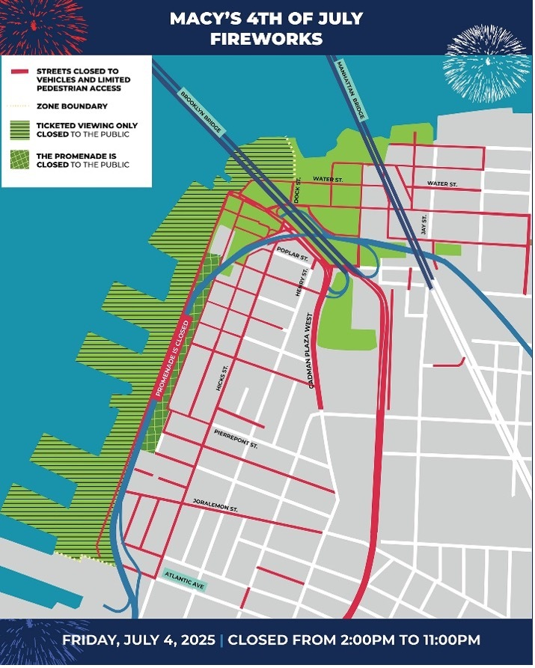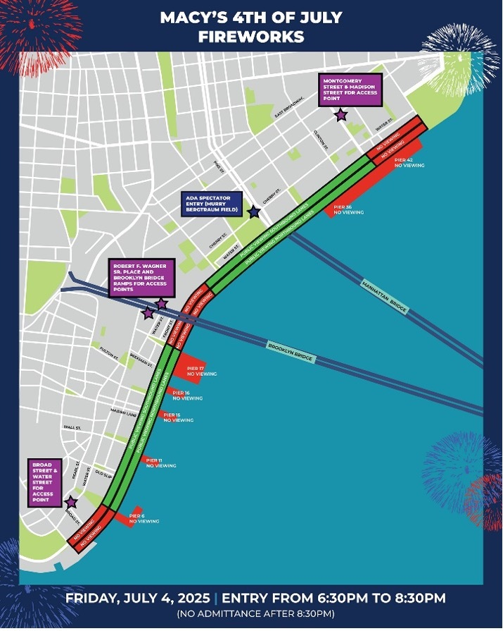
Macy’s Public Viewing Maps of Brooklyn Bridge Park (L) & FDR Drive (R) Courtesy: New York City Mayor’s Office

Please note: All of Brooklyn Bridge Park will be a fully ticketed area, and guests must present a ticket for entry. The fireworks show will be visible along the FDR Drive for those who do not receive a ticket. Entry points for the general public are:

- Montgomery Street and Madison Street
- Robert F. Wagner Sr. Place and Brooklyn Bridge On/Off Ramp
- Broad Street and Water Street

The ADA accessible viewing location will be located on the Manhattan side at Murry Bergtraum Field. Guests should enter at Pike Street and Cherry Street for this location

The Macy’s 4th of July Fireworks show will light up the New York City skyline with a stunning display launched from barges along the East River, near the Brooklyn Bridge. The 49th edition of the nation’s largest Independence Day celebration will fire more than 80,000 shells that will include 30 vibrant colors and awe-inspiring effects, including state-of-the-art projection mapping on the Brooklyn Bridge.

###

