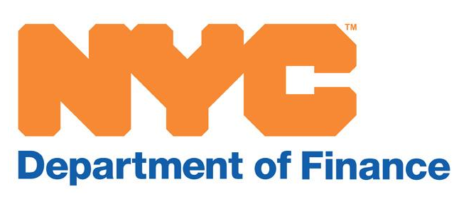

NYC Banking Commission

Early Payment Discount Rate and
Late Payment Interest Rates Recommendations

All property tax bills have payment due dates. Property owners can pre-pay their property tax bills and receive a discount. If payments are not received or postmarked by the due date (or the grace period due date), payments are considered late. The City of New York is required to charge interest on the amount of tax that is late.

Each May, the NYC Banking Commission recommends a discount rate and penalty rates for the upcoming fiscal year beginning on July 1.

