
THE CITY OF NEW YORK
OFFICE OF THE MAYOR
NEW YORK, NY 10007

FOR IMMEDIATE RELEASE, June 1, 2017
CONTACT: pressoffice@cityhall.nyc.gov, (212) 788-2958

MAYOR DE BLASIO LAUNCHES SERVICE ON NYC FERRY'S SOUTH BROOKLYN ROUTE

First trip on South Brooklyn route departed from Bay Ridge at 6:30 a.m.; new schedules for South Brooklyn and East River Routes posted at Ferry.NYC

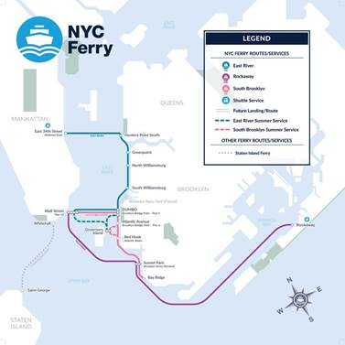

NEW YORK—Today, Mayor de Blasio officially launched NYC Ferry’s South Brooklyn route, with the first trip departing from Bay Ridge at 6:30 a.m. headed to Wall Street/Pier 11.

Additional stops along the new route include: Brooklyn Army Terminal in Sunset Park, Atlantic Basin in Red Hook, Atlantic Avenue (BBP Pier 6), DUMBO (BBP Pier 1), and Wall Street’s Pier 11. With 25 daily departures, this new route will better connect residents and workers from Bay Ridge, Sunset Park, Red Hook, DUMBO and Lower Manhattan, and shorten commutes for thousands of New Yorkers.

Full, updated schedules for South Brooklyn, Rockaway, and East River routes went into effect today and can be found here.

“I am delighted to see NYC Ferry’s South Brooklyn Route launch today. It’s another step forward as we connect what have been transit-starved waterfront communities to the wider city – and making it easier for people to get to work and kids to get to schools. As we continue to launch routes over the next year, we are creating a true citywide ferry,” Mayor Bill de Blasio said.

“Southwest Brooklyn has historically been a transit desert for thousands of New Yorkers, but that changes today with the launch of the South Brooklyn Route,” said New York City Economic Development President and CEO James Patchett. “For the same cost of a subway ride, residents and workers in Bay Ridge, Sunset Park, and Red Hook will now have a fast and affordable commuting option to Lower Manhattan and other parts of the City.”

“One month into NYC Ferry by Hornblower, we’ve seen the excitement first hand from New Yorkers and visitors alike who have chosen to hop on board and experience the newest way to work, live, play across our growing waterfront network,” said Cameron Clark, Senior VP for NYC Ferry by Hornblower. “That excitement continues to build with the launch of the South Brooklyn Route, which includes our newest connections in Bay Ridge and Red Hook along with the ability to transfer to the Rockaway Route at Brooklyn Army Terminal and the East River Route at Brooklyn Bridge Park, all for the same price as a single subway ride.”

Ferries on the new South Brooklyn Route will run every 30 minutes during peak hours on week days, and every 45 to 55 minutes on weekends. The launch of the South Brooklyn Route follows the successful start of the Rockaway Route and the integration of the East River Route, both on May 1. Combined, the routes have served approximately 243,000 riders to date, surpassing initial projections by nearly 93,000 passengers.

The South Brooklyn Route will add more frequent ferries between some of the system’s busiest destinations – easing crowds and congestion. It will add 40 percent more service between DUMBO and Wall Street during weekday morning and evening peak times.

On summer weekends, when NYC Ferry experiences high demand to park destinations across the harbor, the new route will provide the NYC Ferry system with additional service between DUMBO and Wall Street, and more connections from Brooklyn to Governors Island.

Ferry riders can download the NYC Ferry App to purchase e-tickets, allowing for easy scan-and-go boarding, and get detailed maps and schedules, as well as real-time notifications and service alerts. NYC Ferry tickets are $2.75 per ride, the same cost of a subway ride, and the cost of a 30-day unlimited ferry pass will be $121, mirroring the cost of a 30-day MetroCard.

Use of the app for ticket purchase provides a more environmentally friendly service by reducing the use of paper tickets, although ticketing kiosks will also be available at each landing. The NYC Ferry App is live and available for download in both the Apple and Google Play stores.

###

