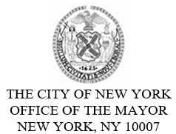
FOR PLANNING PURPOSES
CONTACT: pressoffice@cityhall.nyc.gov, (212) 788-2958

PUBLIC SCHEDULE FOR MAYOR ERIC ADAMS FOR SUNDAY, MARCH 2, 2025

On Sunday, New York City Mayor Eric Adams will march in Staten Island’s St. Patrick’s Day Parade. This event is open press.

Press Schedule

Approximately 12:30 PM – Marches in Staten Island’s St. Patrick’s Day Parade
Beginning at 372 Forest Avenue
Staten Island, NY 10301
Official photos will be available following the event.

###

