
FOR IMMEDIATE RELEASE: November 13, 2023
CONTACT: pressoffice@cityhall.nyc.gov, (212) 788-2958

MAYOR ADAMS RECOGNIZES ACS EMPLOYEE, BRONX NATIVE
SHIRLEY WILLIAMS FOR 70 YEARS OF SERVICE TO CITY OF NEW YORK

Beginning Her Public Service Career in 1953,
Williams is Currently Longest-Serving New York City Employee

NEW YORK – New York City Mayor Eric Adams and New York City Administration for Children’s Services (ACS) Commissioner Jess Dannhauser today presented Shirley Williams of the ACS — currently the longest-serving city employee ― with a proclamation marking 70 years of service to the City of New York.

“Our public servants are the lifeblood of New York City. They show up every day and carry us through the storms we face in our city,” said Mayor Adams. “For 70 years, Shirley Williams has weathered those storms and served New York City’s children at ACS. We are in awe of her dedication to the city, and we are grateful for her lifetime commitment to public service.”

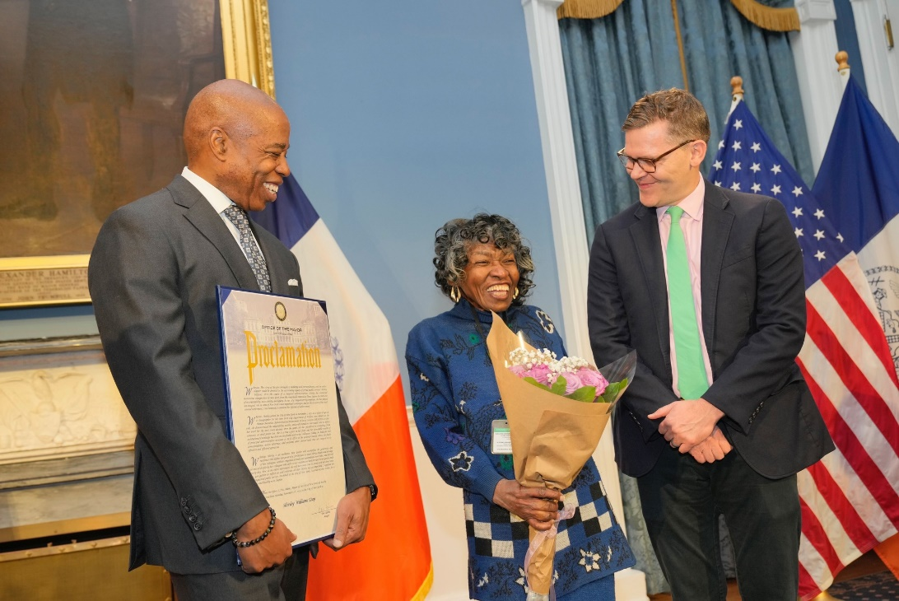

Mayor Adams and Commissioner Dannhauser present Williams with a proclamation marking 70 years of service to the City of New York. Credit: Ed Reed / Mayoral Photography Office.

“I am so proud to work alongside such an outstanding workforce here in New York City,” said Deputy Mayor for Health and Human Services Anne Williams-Isom. “Dedicated staff members like Ms. Williams keep this city running. I want to thank her for her 70 years of passionate city service.”

“I’m thrilled to celebrate Ms. Williams for her lifelong commitment to ACS, where she has undoubtedly made an impact on the lives of so many,” said ACS Commissioner Dannhauser. “It is our hope that through this recognition, she feels the deep gratitude of her colleagues and fellow New Yorkers, who have been so proud to work alongside her for all these years.”

“I am proud, and it gives me great pleasure to celebrate 70 years of city service this year,” said ACS employee Shirley Williams. “The secret for my long career is that the work has to be challenging. This job has meant so much to me over so many years and has made a major impact on my life. I want to thank my colleagues at ACS for always supporting me and Mayor Eric Adams for recognizing my tenure.”

After graduating in 1953 from Theodore Roosevelt High School in the Bronx, Williams decided to follow in her father’s footsteps by applying for a job with the City of New York. Although her father worked at the New York City Department of Transportation, she accepted her first job at the age of 18 as a stenographer with what was then called the New York City Department of Welfare, now the New York City Department of Social Services.

Today, Williams works at ACS as a principal administrative associate in the office of the general counsel. Her daily responsibilities include assisting agency attorneys and other staff with clerical tasks, including drafting and reviewing correspondence and coordinating the provision of documents to requestors. Her colleagues describe her as pleasant, efficient, and professional — and say she has rarely missed a day of work.

###

