
FOR IMMEDIATE RELEASE: March 21, 2025
CONTACT: pressoffice@cityhall.nyc.gov

MAYOR ADAMS RELEASES NEW REPORT HIGHLIGHTING BEST PRACTICES
FOR BUILDING FAMILY-FRIENDLY PUBLIC SPACES

Report Includes New Survey Data on What New Yorkers Want in Public Spaces,
Recommendations for Making Public Spaces More Accessible for Families, Case Studies
Illustrating Real-World Improvements to Public Spaces in New York City

Guidelines to Serve as Valuable Resource for City Agencies,
Private-Sector Partners, Urban Planners, and More

NEW YORK – New York City Mayor Eric Adams and New York City Public Design Commission (PDC) Executive Director Sreoshy Banerjea today released “Building a Family-Friendly City: Design Guidelines for a Safer, More Livable Public Realm,” a comprehensive report laying out best practices for creating safe, accessible, and inclusive public spaces for children, parents, and older adults alike. The report lays out concrete steps from the planning process to ongoing maintenance that will help the city build public spaces that support a wide range of families; the report also includes case studies illustrating these guidelines in practice across New York City. The Building a Family-Friendly City report also includes survey data from nearly 8,000 respondents showcasing what New Yorkers value in their public spaces. The report — which fulfills another commitment from Mayor Adams’ “Women Forward NYC: An Action Plan for Gender Equity” initiative to take steps to fulfill the ambitious goal of making New York the most women-forward city in the United States — is designed to serve as a resource for city agencies, private-sector partners, urban planners, and all citizens working to design more family-friendly public spaces in cities.

“Our administration is committed to making New York City the best place to raise a family, and that includes creating the best public spaces to take your family,” said Mayor Adams. “With this report, we outline some of the best practices for making sure our public spaces uplift families of all kinds. Ultimately, though, this report is not meant to sit on a shelf or stay buried deep on a government website; it is meant to inform the next generation of public spaces, not only in New York but in cities across the world.”

“At the Public Design Commission, we recognize that how we plan and design our public realm directly shapes family experiences in our city,” said PDC Director Banerjea. “Working alongside more than 20 city agencies, we’ve developed guidelines that transform community feedback into practical design best practices prioritizing safety, accessibility, and inclusion for New Yorkers of all ages. We invite designers, agencies, and community partners to use these guidelines as you shape our city's next generation of public spaces.”

“A truly family-friendly city begins with public spaces that are safe, accessible, and welcoming for all. These guidelines offer a clear roadmap to ensure our streets, plazas, and parks serve the needs of children, parents, older adults, and caregivers,” said Chief Public Realm Officer Ya-Ting Liu. “Through the collaboration and dedication of our city agencies and partners, we are creating a more vibrant, inclusive, and family-friendly New York City — one that fosters connection, inspires play, and brings joy for generations to come.”

To inform best practices and hear directly from people about what they value in their public spaces, the Adams administration surveyed nearly 8,000 New Yorkers last year. Survey results revealed that safety, cleanliness, and location were the most important factors for New Yorkers when determining when to spend time in a public space. Survey results also found that New Yorkers are satisfied with many aspects of the city’s public realm. A total of 79 percent of survey respondents reported that they are satisfied with their proximity to a park, 68 percent of respondents were satisfied with the accessibility of public spaces, and 71 percent of respondents with children under five years old were satisfied with the availability of spaces for young children to play. Additionally, the survey revealed that only 40 percent of New Yorkers were satisfied with the availability of restrooms in public spaces. Last year, the Adams administration launched “Ur In Luck,” a new effort to build 46 new restrooms and 36 existing restrooms across the city as well as launch a Google Maps layer to help New Yorkers find every public restroom available citywide.

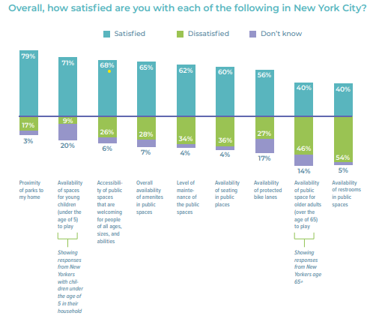

Survey results found that New Yorkers were largely satisfied with the city’s public realm, including proximity to a park, availability of spaces for young children to play, and overall availability of amenities.
Source: Mayor’s Office of Creative Communications.

Building on those survey results, the report lays out best practices for building family-friendly public spaces in three key sections. First, the report encourages designers to ensure that public spaces are engaging and welcoming for all by seeking community input from a diverse group of stakeholders, designing spaces for multi-generational users, and making sure that spaces are safe and well-lit. Second, the report urges designers to increase accessibility by designing spaces to support users of all abilities and make it easy to get around. Finally, the report stresses the importance of planning for the future by making sure that public spaces are sustainable, equitable, and adaptable. The report offers dozens of concrete strategies across all three pillars to bring these principles to life. To showcase these principles in action, the report details real-world improvements made at Luther Gulick Park in Manhattan, Callahan Kelly Playground in Brooklyn, and the Pollinator Port Project across the entire city.

Originally announced by Mayor Adams in his 2024 State of the City address, Women Forward NYC is $43 million investment aimed at making New York City a national leader on gender equity, including for transgender and gender expansive New Yorkers. Supported through city dollars, private and public partnerships, academic institutions, and grant funding, the action plan lays out dozens of initiatives — including new guidelines to support family-friendly design in the public realm to improve safety and accessibility — that will take steps to fulfill the ambitious goal of making New York the most women-forward city in the United States.

The Adams administration has prioritized building safe, accessible public spaces for families. Since 2022, the Adams administration has created over 85 football fields of new public space and implemented a record amount of newly-pedestrianized space since coming into office, finishing 2024 with nearly 500,000 square feet of new plazas, curb and sidewalk extensions, pedestrian safety islands, and traffic triangles. To keep families safe and city pools and beaches, the Adams administration hired 930 lifeguards last year alone, announced a historic $1 billion investment in city pools, and is expanding New York City’s free swim classes to reach nearly 18,000 young people. In his fourth State of the City address, Mayor Adams announced that New York City will open more schoolyards in underserved neighborhoods for use during the summer, after school, and on the weekends to put another 20,000 individuals within a 10-minute walk of a park. Additionally, to keep New York City parks cleaner, Mayor Adams announced that New York City will add a second cleaning shift to 100 new hot spots across 64 parks throughout the city, ensuring they are cleaned each afternoon between Thursday and Monday. As part of the second shift, New York City Department of Parks and Recreation staff will also keep restrooms open, on average, for another two hours each day, five days a week. This investment builds on the 62 parks that received a second cleaning shift earlier this year as part of the Fiscal Year 2025 Adopted Budget and will help allow more families to enjoy safe, clean, accessible parks.

###

