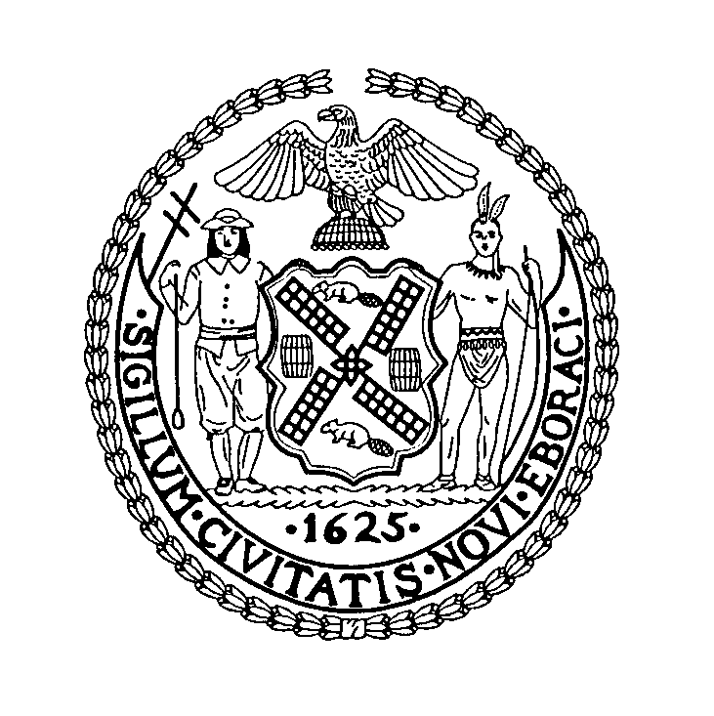
HON. SYLVIA HINDS-RADIX  Corporation Counsel | The City of New York  Law Department  100 CHURCH STREET  NEW YORK, NY 10007 | SHERYL R. NEUFELD  Chief Assistant for Regulatory Law and Policy  phone: 212-356-2207  email: sneufeld@law.nyc.gov

January 30, 2023
Hon. Eric Adams
Mayor
City Hall
New York, New York 10007

Hon. Adrienne Adams
Speaker of the City Council
City Hall
New York, New York 10007
Re: Nuisance Abatement Reporting
Dear Mayor Adams and Speaker Adams:
Administrative Code Section 7-112, which was added by Local Law 40 of 2018, requires the Law Department to compile a report regarding certain Nuisance Abatement actions brought on behalf of the City of New York, and post that report on the Law Department’s website. The Code further requires that we notify you of such posting.

The report, covering the period from July 1, 2022 through December 31, 2022, has been posted to the Law Department’s website in compliance with the January 31, 2023 posting deadline. See https://www1.nyc.gov/site/law/divisions/nuisance-abatement.page

Sincerely yours,
HON. SYLVIA HINDS-RADIX
Corporation Counsel of the City of New York
By: ___________________
Sheryl R. Neufeld
Chief Assistant for Regulatory Law and Policy

