FY 2025 Agency Quarterly Diversity, Equity, Inclusion and EEO Report

Part I: Narrative Summary

Agency Name: __New York City Department of Transportation__________________________

☐ 1st Quarter (July -September), due November 6, 2024 ☒ 2nd Quarter (October – December), due February 7, 2025
☐ 3rd Quarter (January -March), due April 30, 2025 ☐ 4th Quarter (April -June), due July 30, 2025

Prepared by:

Benjamin Graham Assistant Commissioner of EEO, Diversity and Inclusion bgraham1@dot.nyc.gov 212-839-6600 _ ________ _______________________________
Name Title E-mail Address Telephone No.

Date Submitted: February 7, 2025
FOR DCAS USE ONLY: Date Received:

Instructions for Filling out Quarterly Reports FY 2025

[NOTE: These forms are cumulative and designed to retain and preserve information for the entire FY 2025.
For Q1 please copy the goals, programs, and initiatives from your draft of the FY 2025 DEI-EEO plan. Insert these statements in the corresponding sections of the Quarterly Report below, particularly sections IV, V, and VI.
For Q2, Q3 and Q4, use previous quarter’s submission to update their status, retaining all information for the prior quarters. You should also add programs and initiatives begun in these quarters even if they were not mentioned in the Annual Plan]

- Please save this file as “XXXX Quarter X FY 2025 DEI-EEO Quarterly Report.Part I”, where ‘XXXX’ is the commonly used acronym of your agency. You must submit this file in MS Word format. Please do not convert it to PDF.

- Complete the “Diversity, Equity, Inclusion and EEO Training Summary” details in Part II – Training Summary [see the attached Excel file].

Core EEO Training: Copy the information from the Training Completion Report you receive quarterly from DCAS Learning & Development onto grey-shaded cells in rows 26, 30, 34, and 38. Include any of these trainings that were administrated by your agency in the rows immediately below (27, 35, 39).
Other Diversity, Equity, Inclusion and EEO Related Training: Beginning with row 45, include training classes co-organized or co-sponsored by your agency EEO and/or HR that are related to the development of the agency staff in the areas of equal employment, diversity, inclusion, civil rights, workplace culture and behavior, interpersonal relations, and community relations.

- Mark progress in check boxes in the column for the current quarter. [Note: Delayed = behind schedule; Deferred = put off until later when better resources become available.]

- Please save the Excel file as “XXXX Quarter X FY 2025 DEI-EEO Report.Part II Training Summary”, where ‘XXXX’ is the commonly used acronym of your agency. You must submit this file in MS Excel format. Please do not convert it to PDF.

Commitment and Accountability Statement by the Agency Head

Distributed to all agency employees? ☐ Yes, On (Date): ________________ ☒ No
☐ By e-mail
☐ Posted on agency intranet and/or website
☐ Other _________________

Recognition and Accomplishments

The agency recognized employees, supervisors, managers, and units demonstrating superior accomplishment in diversity, equity, inclusion, and equal employment opportunity through the following:

☐ Diversity, equity, inclusion and EEO Awards
☒ Diversity, equity, inclusion and EEO Appreciation Events
☒ Public Notices
☐ Positive Comments in Performance Appraisals
☐ Other (please specify): ___________________________________________

* Please describe DEI&EEO Awards and/or Appreciation Events below:

- In the first quarter, DOT’s Employee Resource Groups (ERGs) held events in recognition of (1) the anniversary of the Americans with Disabilities Act, (2) African American Day, and (3) Latinx American Heritage Month.

- DOT employees, led by DOT Commissioner Ydanis Rodriguez (Commissioner Rodriguez), also participated in the Dominican Day Parade and West Indian Day Parade.

- The July edition of Byways, DOT’s official newsletter, also recognized Women Empowering Women in Nontraditional Work (We Win) for their Career Day in June 2024, the African American Career Advancement Network (AACAN) ERG for their Juneteenth Event with special guest, Chaplain Dr. Ingrid Lewis-Martin, Chief Advisor to Mayor Eric Adams, and LGBT@DOT for their participation in the 2024 Pride March.

- In the second quarter, DOT’s ERGs held events in recognition of (1) Latinx American Heritage Month and (2) National Disability Employment Awareness Month. In recognition of Native American Heritage Month, DOT’s Indigenous Peoples’ Collective (IPC) ERG launched the “Indigenous@DOT Visibility Project,” a yearlong visibility campaign to spotlight and feature DOT’s Indigenous employees on SharePoint and Byways. The campaign will culminate in next year’s Native American Heritage Month (November 2025) with a celebratory exhibition event that showcases the complete collection of Native American/Indigenous DOT employee images and their quotes.

Workforce Review and Analysis

- Agency Headcount as of the last day of the quarter was:

Q1 (9/30/2024): 5592 Q2 (12/31/2024): 5889 Q3 (3/31/2025): __________ Q4 (6/30/2025): __________

- Agency reminded employees to update self-ID information regarding race/ethnicity, gender, and veteran status.

☒ Yes On (Date): 12/20/2024 ☐ Yes (again) on (Date): ________________ ☐ No
☒ NYCAPS Employee Self Service (by email; strongly recommended every year)
☐ Agency’s intranet site
☒ On-boarding of new employees
☐ Newsletters and internal Agency Publications

- The agency conducted a review of the quarterly CEEDS reports and the dashboard sent by DCAS to the EEO Officer with demographic data and trends, including workforce composition by job title, job group, race/ethnicity and gender; new hires, promotions and separation data; and utilization analysis.

☒ Yes - on (Dates):
Q1 Review Date: 11/1/2024 Q2 Review Date: 1/20/2025 Q3 Review date: ________ Q4 Review date: ________
The review was conducted with:

☐ Agency Head ☐ Agency Head ☐ Agency Head ☐ Agency Head
☐ Human Resources ☐ Human Resources ☐ Human Resources ☐ Human Resources
☐ General Counsel ☐ General Counsel ☐ General Counsel ☐ General Counsel
☒ Other A/C of APM ☒ Other A/C of APM ☐ Other __________ ☐ Other __________
☐ Not conducted ☐ Not conducted ☐ Not conducted ☐ Not conducted

EEO, Diversity, Inclusion and Equity Initiatives for FY 2025

Please describe your progress this quarter in implementing the primary goals in Section IV of your Agency Diversity, Equity, Inclusion and EEO Plan for FY 2025.

- Workforce:

Please list the Goals, Planned Programs, Initiatives, and Actions aimed at Workforce included in Section IV: Diversity, Equity, Inclusion and EEO Initiatives for FY 2025, which you set/declared in your FY 2025 Diversity, Equity, Inclusion and EEO Plan (e.g., underutilization, workforce planning, succession planning and diverse applicant pool, among others).

            - Workforce Profile Report (WPF): In FY 2025, DOT will complete and release the calendar year 2024 WFP, DOT’s fifth annual release of the report which tracks DOT’s efforts to address underutilization. Once completed, the WFP is shared with DOT’s Commissioner, Executive Staff, Division Heads, the Diversity, Equity and Inclusion (DE&I) Committee, DOT’s ERGs, and then released agency-wide.

Please describe the steps that your agency has taken to meet this goal/initiative. Include actions aimed at the composition of your workforce, recruitment, retention, promotion, and professional development to enhance equity, inclusion, and race relations in an integrated agency workforce. Pay attention to age inclusivity, non-traditional minorities, and engagement of traditional and older employees. A well-balanced, integrated workforce should help establish your agency as a leading service provider to the citizens of New York City focused on diversity, equity, and inclusion, while reflecting the variety of communities that are served. How do you evaluate the effectiveness of these actions?

In the first quarter, the “End of Calendar Year (CY) ’23 WFP Report” was reviewed with Commissioner Rodriguez, presented to division heads and released to the entire agency on SharePoint. This is an annual practice that generally happens around this time of year after DOT’s Analytics and Performance Management (APM) team has analyzed the data and compiled the final report. This year’s findings were very positive, showing increases in non-white representation among supervisory and management positions across the board.

In the second quarter, APM is in between reporting periods, so there were no new findings or trends to mention. This upcoming quarter, we will be working on the “End of CY ’24 WFP Report,” which will report on progress made over the past calendar year. Those findings will inform our strategies for recruitment and retention initiatives this calendar year.

Workforce Goal/Initiative #1 Update:
Q1 Update: ☐ Planned ☐ Not started ☒ Ongoing ☐ Delayed ☐ Deferred ☐ Completed
Q2 Update: ☐ Planned ☐ Not started ☒ Ongoing ☐ Delayed ☐ Deferred ☐ Completed
Q3 Update: ☐ Planned ☐ Not started ☐ Ongoing ☐ Delayed ☐ Deferred ☐ Completed
Q4 Update: ☐ Planned ☐ Not started ☐ Ongoing ☐ Delayed ☐ Deferred ☐ Completed

            - Structured Hiring Initiative: DOT created a Structured Hiring Guide (SHG) for Hiring Managers and Personnel Coordinators which provides guidance on why and how to use structured hiring practices and conduct structured interviews. While structured hiring is encouraged for all interviews, it is mandatory for the hiring of “Titles of Interest.” In FY 2025, DOT will continue to work to implement and mandate structured hiring for an increased number of interview panels, starting by requiring structured hiring for titles to monitor before the end of CY 2024.

Please describe the steps that your agency has taken to meet this goal/initiative. Include actions aimed at the composition of your workforce, recruitment, retention, promotion, and professional development to enhance equity, inclusion, and race relations in an integrated agency workforce. Pay attention to age inclusivity, non-traditional minorities, and engagement of traditional and older employees. A well-balanced, integrated workforce should help establish your agency as a leading service provider to the citizens of New York City focused on diversity, equity, and inclusion, while reflecting the variety of communities that are served. How do you evaluate the effectiveness of these actions?

In the first quarter, on September 17, 2024, Commissioner Rodriguez, in collaboration with DOT’s Office of Equal Employment Opportunity, Diversity and Inclusion (EDI) announced to DOT’s division heads that starting October 1, 2024, DOT will transition from requiring structured hiring and diverse interview panels only for positions deemed Titles of Interests, to requiring both for Titles of Interest and Titles to Monitor, as identified by DOT’s annual agency-wide and divisional workforce profile reports annually. EDI’s Lead Trainer updated the SHG and structured hiring training PPT training deck accordingly.

In the second quarter, on October 1, 2024, DOT expanded the structured hiring initiative to include both Titles of Interests and Titles to Monitor, as identified by DOT’s agency-wide and divisional workforce profile reports. The expansion’s progress and results will be monitored by the aforementioned workforce profile reports. In collaboration with EDI’s Lead Trainer, the Assistant Commissioner of EDI reviewed and continued to update the SHG and structured hiring training deck.

Workforce Goal/Initiative #2 Update:
Q1 Update: ☐ Planned ☐ Not started ☒ Ongoing ☐ Delayed ☐ Deferred ☐ Completed
Q2 Update: ☐ Planned ☐ Not started ☒ Ongoing ☐ Delayed ☐ Deferred ☐ Completed
Q3 Update: ☐ Planned ☐ Not started ☐ Ongoing ☐ Delayed ☐ Deferred ☐ Completed
Q4 Update: ☐ Planned ☐ Not started ☐ Ongoing ☐ Delayed ☐ Deferred ☐ Completed

            - Ensure alignment of diversity recruiting, internal candidate development, and equitable selection practices strategically with current employment needs and in conjunction with our “Titles of Interest”.

Please describe the steps that your agency has taken to meet this goal/initiative. Include actions aimed at the composition of your workforce, recruitment, retention, promotion, and professional development to enhance equity, inclusion, and race relations in an integrated agency workforce. Pay attention to age inclusivity, non-traditional minorities, and engagement of traditional and older employees. A well-balanced, integrated workforce should help establish your agency as a leading service provider to the citizens of New York City focused on diversity, equity, and inclusion, while reflecting the variety of communities that are served. How do you evaluate the effectiveness of these actions?

In the first quarter, DOT encouraged employees to participate in civil service exams to promote growth towards advancement by sending monthly e-mails with the DCAS Monthly Exam Schedule, providing the link to specific DCAS exams, and posting schedules and exam announcements on the Agency’s intranet. DOT’s Human Resources (HR) Division emailed civil service exam notices to the Agency Personnel Coordinators, who in turn distributed the information to all of their division’s staff. Information on exams was also posted on DOT’s kiosks, bulletin boards, and intranet. Information was similarly passed on to those employees serving in the lower titles that are promotable. HR reached out to non-traditional sources to generate applicant interest for underutilized titles. For underutilized titles of interest, HR posted external job vacancy notices on multiple recruitment websites which target underrepresented populations. HR also facilitated divisional participation in job fairs which target underrepresented populations and maintained a roster of recruitment sources which target underrepresented populations, and where possible, sent posting notices for titles of interest to those organizations.

DOT’s second quarter steps/actions for this goal were the same as the first quarter.

Workforce Goal/Initiative #3 Update:
Q1 Update: ☐ Planned ☐ Not started ☒ Ongoing ☐ Delayed ☐ Deferred ☐ Completed
Q2 Update: ☐ Planned ☐ Not started ☒ Ongoing ☐ Delayed ☐ Deferred ☐ Completed
Q3 Update: ☐ Planned ☐ Not started ☐ Ongoing ☐ Delayed ☐ Deferred ☐ Completed
Q4 Update: ☐ Planned ☐ Not started ☐ Ongoing ☐ Delayed ☐ Deferred ☐ Completed

            - Marine Oiler Trainee Program: In FY 2024, to address the shortages and recruitment challenges for the title of Marine Oiler, a Title of Interest, DOT’s Ferries Division (Ferries) began the steps to establish a Marine Oiler Trainee Program for the Staten Island Ferry. HR reviewed the Marine Oiler Trainee program and passed it to DCAS, which also approved it in concept. Captain John Garvey, DOT Deputy Commissioner of Ferries and Chief Operations Officer of the Staten Island Ferry, discussed the trainee program with both the NYC Mayor’s Office of Management and Budget (OMB) and the NYC Mayor’s Office of Labor Relations (OLR) at the union negotiations and was told that we should proceed with the program. In FY 2025, DOT will continue to work towards the launch of the program.

Please describe the steps that your agency has taken to meet this goal/initiative. Include actions aimed at the composition of your workforce, recruitment, retention, promotion, and professional development to enhance equity, inclusion, and race relations in an integrated agency workforce. Pay attention to age inclusivity, non-traditional minorities, and engagement of traditional and older employees. A well-balanced, integrated workforce should help establish your agency as a leading service provider to the citizens of New York City focused on diversity, equity, and inclusion, while reflecting the variety of communities that are served. How do you evaluate the effectiveness of these actions?

In the first quarter, DOT continued to wait for DCAS to approve and create the Marine Oiler Trainee title.

In the second quarter, DOT continued to wait for DCAS to approve and create the Marine Oiler Trainee title.

Workforce Goal/Initiative #4 Update:
Q1 Update: ☐ Planned ☐ Not started ☐ Ongoing ☒ Delayed ☐ Deferred ☐ Completed
Q2 Update: ☐ Planned ☐ Not started ☐ Ongoing ☒ Delayed ☐ Deferred ☐ Completed
Q3 Update: ☐ Planned ☐ Not started ☐ Ongoing ☐ Delayed ☐ Deferred ☐ Completed
Q4 Update: ☐ Planned ☐ Not started ☐ Ongoing ☐ Delayed ☐ Deferred ☐ Completed

            - Advancement of Black and Brown Women in DOT (ABBW) Equity Working Group: In FY 2024, EDI continued to hold meetings with individuals interested in the formation of and being a part of ABBW. Currently, the group’s mission statement has been finalized and the group is in the process of finalizing the charter, application form, and other materials necessary for the group’s launch. In FY 2025, EDI and the founding members of ABBW will present the group, its history, and its objectives to the DE&I Committee, and if approved, will formally announce the group and launch the recruitment period in November 2024.

Please describe the steps that your agency has taken to meet this goal/initiative. Include actions aimed at the composition of your workforce, recruitment, retention, promotion, and professional development to enhance equity, inclusion, and race relations in an integrated agency workforce. Pay attention to age inclusivity, non-traditional minorities, and engagement of traditional and older employees. A well-balanced, integrated workforce should help establish your agency as a leading service provider to the citizens of New York City focused on diversity, equity, and inclusion, while reflecting the variety of communities that are served. How do you evaluate the effectiveness of these actions?

In the first quarter, EDI and the founding members of ABBW met on August 9, 2024, to finalize the application form and other materials necessary for the group’s launch. EDI presented the group, its history, and its objective to the DE&I Committee on October 16, 2024, and received approval to launch the group on November 11, 2024. EDI, in collaboration with the founding members of ABBW, are working on the agency-wide announcement of the group, as well as strategies to advertise and recruit potential members among field operation staff.

In the second quarter, EDI and the founding members of ABBW continued to prepare for the launch of the working group. The launch date was been pushed back after DOT’s executive staff requested additional time to review the group’s purpose and mission. After further discussion and feedback, the group updated the launch plans and will be formed in a process and structure similar to an ERG, which will include an election meeting to establish leadership. The group is expected to launch in the spring of 2025.

Workforce Goal/Initiative #5 Update:
Q1 Update: ☐ Planned ☐ Not started ☒ Ongoing ☐ Delayed ☐ Deferred ☐ Completed
Q2 Update: ☐ Planned ☐ Not started ☒ Ongoing ☐ Delayed ☐ Deferred ☐ Completed
Q3 Update: ☐ Planned ☐ Not started ☐ Ongoing ☐ Delayed ☐ Deferred ☐ Completed
Q4 Update: ☐ Planned ☐ Not started ☐ Ongoing ☐ Delayed ☐ Deferred ☐ Completed

            - City Parking Equipment Service Work (CPESW) Training Program: In FY 2025, DOT’s Traffic Operations (TO) Division plans to restart its CPESW Training Program, which was postponed in FY 2024. Last run in 2018 in conjunction with DOT’s HR and Traffic Planning and Management (TPM) Divisions, this training program was developed to provide hands-on training and experience to staff so each person would possess the necessary certified qualifications to apply for the promotional Traffic Device Maintainer (TDM) exam, giving these individuals a career path that currently is not available to the CPESW. Participants in the training receive hands-on practice installing street furniture, wiring muni-meters, installing signs, posts, and meter bases, and learning the standard operating procedures for both divisions. Many individuals in TO and TPM volunteered their job experience, skills, and talents to provide the CPESWs with equipment, tools and classroom training along with an overview of the duties and responsibilities of a NYC DOT Traffic Device Maintainer, including study manuals and safety gear for use. TO is currently considering ways to improve the program and increase the number of participants who pass the TDM exam.

Please describe the steps that your agency has taken to meet this goal/initiative. Include actions aimed at the composition of your workforce, recruitment, retention, promotion, and professional development to enhance equity, inclusion, and race relations in an integrated agency workforce. Pay attention to age inclusivity, non-traditional minorities, and engagement of traditional and older employees. A well-balanced, integrated workforce should help establish your agency as a leading service provider to the citizens of New York City focused on diversity, equity, and inclusion, while reflecting the variety of communities that are served. How do you evaluate the effectiveness of these actions?

In the first quarter, TO has decided to put preparations to launch the CPESW training program on hold due to current staffing issues.

In the second quarter, the CPESW training program was still on hold due to current staffing issues.

Workforce Goal/Initiative #6 Update:
Q1 Update: ☐ Planned ☐ Not started ☐ Ongoing ☒ Delayed ☐ Deferred ☐ Completed
Q2 Update: ☐ Planned ☐ Not started ☐ Ongoing ☒ Delayed ☐ Deferred ☐ Completed
Q3 Update: ☐ Planned ☐ Not started ☐ Ongoing ☐ Delayed ☐ Deferred ☐ Completed
Q4 Update: ☐ Planned ☐ Not started ☐ Ongoing ☐ Delayed ☐ Deferred ☐ Completed

            - Efforts to reduce Workforce underutilization:
Please describe steps that were taken or planned to address underutilization identified through quarterly workforce reports. Please list Job Groups where underutilization exists in the current quarter.

In the first quarter, the focus of the workforce analytics program was around presenting the annual findings of the CY ’23 WFP report to the agency. Sharing the findings of the annual report is the first part of the annual iterative process where the prior year’s progress and short comings are reviewed to improve upon internal practices that promote diversity across titles at DOT. The findings from CY ’23 are generally positive, but there is room for improvement. In Quarter 2, we plan to hone in on strategies for CY ’25.

Below is the current underutilization picture by job group:

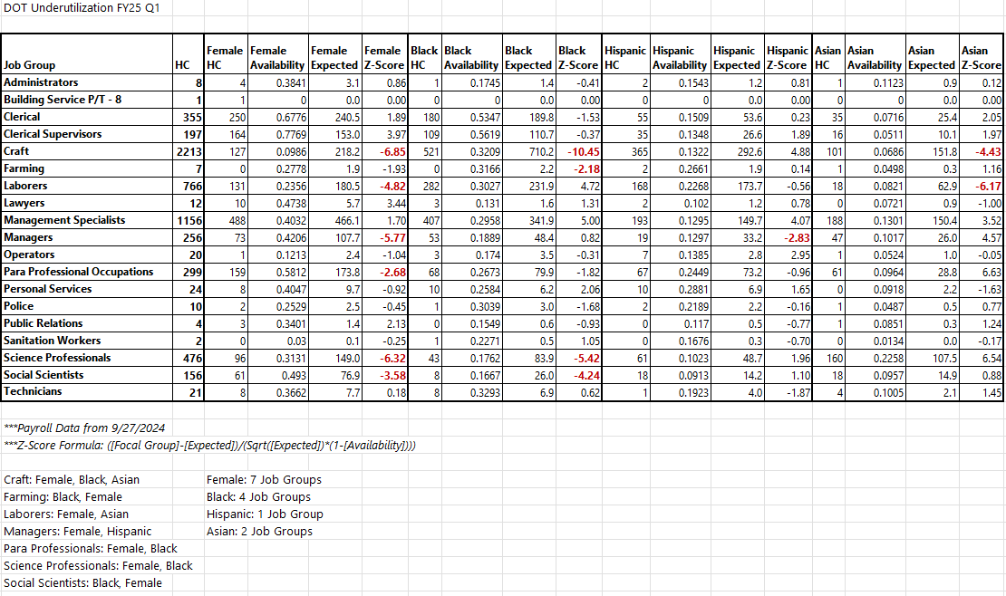

In the second quarter, the program saw a quiet quarter in terms of work related to tackling underutilization. Hiring has slowed dramatically given OMB’s strict PAR guidelines, so there was not a whole lot of recruitment strategies to employ this quarter. We anticipate more work to be done in Quarter 3, as we will be working on the “End of CY ’24 Workforce Profile Report,” which will report on progress made in CY ’24.

Below is the current underutilization picture by job group:
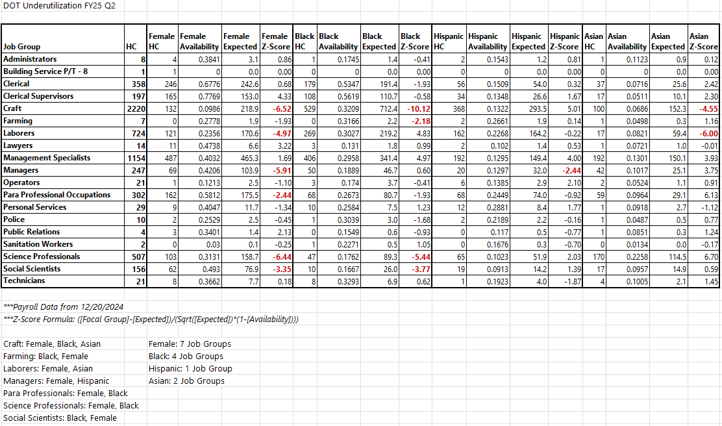

- Workplace:

Please list the Goals, Planned Programs, Initiatives, and Actions aimed at Workplace included in Section IV: Diversity, Equity, Inclusion and EEO Initiatives for FY 2025, which you set/declared in your FY 2025 Diversity, Equity, Inclusion and EEO Plan (e.g., job satisfaction/engagement surveys, exit interviews/surveys, and onboarding surveys).

            - Agency-wide Recognition & Commemoration of Diverse Holidays and Heritage Months: Throughout FY 2024, EDI shared agency-wide, via email and postings on DOT’s SharePoint homepage, announcements recognizing, explaining, and providing guidance on religious holidays, heritage months, and other significant days of observances. These emails and postings explained the history and significance of these holidays and heritage months, listed celebrations throughout the City, and provided educational resources. Beginning in April 2024, EDI has collaborated with the Office of the Commissioner to prepare and send out these agency-wide emails via the Commissioner’s email address to send DOT’s workforce a clear message that the Commissioner supports an inclusive workplace culture. In FY 2025, EDI will continue to work with the Office of the Commissioner to send and expand and improve upon these announcements.

Please describe the steps that your agency has taken to meet this goal/initiative. Include actions taken to create equitable work environment which values differences and maintain focus on retaining talent. How do you evaluate the effectiveness of these actions?

In the first quarter, DOT sent agency-wide emails recognizing and providing guidance on Latinx American Heritage Month, Rosh Hashanah, Yom Kippur, and the Jewish High Holy Days. DOT began to plan agency-wide emails to recognize Italian American Heritage/Indigenous Peoples’ Day for the second quarter.

In the second quarter, DOT sent agency-wide emails recognizing and providing guidance on National Pregnancy and Infant Loss Awareness Month, Italian American Heritage/Indigenous Peoples’ Day, Native American Heritage Month, Diwali, and December Holidays. In preparation for the third quarter, DOT began drafting an email for Martin Luther King Jr. Day.

Workplace Goal/Initiative #1 Update:
Q1 Update: ☐ Planned ☐ Not started ☒ Ongoing ☐ Delayed ☐ Deferred ☐ Completed
Q2 Update: ☐ Planned ☐ Not started ☒ Ongoing ☐ Delayed ☐ Deferred ☐ Completed
Q3 Update: ☐ Planned ☐ Not started ☐ Ongoing ☐ Delayed ☐ Deferred ☐ Completed
Q4 Update: ☐ Planned ☐ Not started ☐ Ongoing ☐ Delayed ☐ Deferred ☐ Completed

            - DOT Employee Resource Group (ERG) Program: In FY 2025, ERGs will continue to strategize ways to address the concerns of their constituents, and by extension the entire DOT workforce. They will be involved in high-level strategy meetings with the DOT’s Strategy Office regarding the aforementioned DOT Strategic Plan, the Commissioner via the Roundtable Discussion Event, and their quarterly meetings with the DE&I Committee.

Please describe the steps that your agency has taken to meet this goal/initiative. Include actions taken to create equitable work environment which values differences and maintain focus on retaining talent. How do you evaluate the effectiveness of these actions?

In the first quarter, DOT’s ERGs held events in recognition of (1) the anniversary of the Americans with Disabilities Act, (2) African American Day, and (3) Latinx American Heritage Month. DiverseAbilities ERG began planning events in recognition of National Disability Employment Awareness Month for October 2024.

On July 1, 2024, EDI launched a special election period to fill in vacancies on the executive boards of the following ERGs: Arab, Turkic, and Persian (ATP), Asian Pacific Islander Association (APIA), Indigenous Peoples’ Collective (IPC), LGBT@DOT (LGBT), Organización LatinoAmericana (OLA), and Working Parents. In order to set clear expectations and consistency going forward, special elections to fill vacancies on ERG boards will now be held biannually in a fiscal year’s first quarter (July-September) and third quarter (January to March) as necessary. The ERG Toolkit has been updated to reflect this new rule.

On September 17, 2024, We Win hosted an agency-wide virtual wellness workshop, Love Your Heart: Stay Healthy & Prevent Hypertension, which was led by Brenda Dash, Senior Wellness Educator at WorkWell NYC.

In furtherance of DOT’s commitment to support ERGs, EDI’s Diversity Specialist planned monthly check-in meetings with the ERGs. The Assistant Commissioner of EDI will also meet quarterly with the ERG boards to assist them in preparing for the quarterly DE&I Committee meetings, and support them overall.

In the second quarter, DOT’s ERGs held events in recognition of (1) Latinx American Heritage Month and (2) National Disability Employment Awareness Month. In honor of Native American Heritage Month (NAHM), IPC also launched the “Indigenous@DOT Visibility Project,” a yearlong visibility campaign to spotlight and feature DOT’s Indigenous employees on SharePoint and Byways. Accepted participants will share their profile shots and quotes on their experiences as Indigenous DOT employees. The campaign will culminate in next year’s NAHM (November 2025) with a celebratory exhibition event that showcases the complete collection of Native American/Indigenous DOT employee images and their quotes. ERGs also began to prepare for events honoring Three Kings Day, Black History Month, and Lunar New Year, scheduled for early 2025.

On November 6, 2024, the Assistant Commissioner of EDI met the ERG boards for the first quarterly meeting to assist them in preparing for the quarterly meetings with the DE&I Committee. After a successful meeting, EDI and the ERG boards finalized discussion items for the DE&I Committee and ERG boards meeting, which took place on November 20, 2024. The feedback from the meeting was positive, and together, the DE&I Committee and ERG boards produced a number of action items, which will be followed up on at the next DE&I Committee and ERG boards meeting on February 19, 2025.

In addition to the aforementioned meetings, EDI’s Diversity Specialist conducted monthly check-ins with the ERG boards in November and December. During these meetings, the boards discussed ERG-related matters and potential initiatives with the Diversity Specialist. The Diversity Specialist also provided refreshers on ERG standard operating procedures.

During the week of December 9th, DOT’s Arab, Turkic and Persian (ATP) ERG, in collaboration with local non-profit community aid organizations, Thrift4Gaza and Malikah Center, conducted a successful donation drive at two worksites (55 Water Street, Manhattan and 34-02 Queens Blvd, Queens) for mutual aid efforts in Gaza. Also, ATP, in collaboration with EDI, developed a proposal for an agency-wide training event on Anti-Arab bias awareness, aiming to launch the program in April 2025 in recognition of Arab American Heritage Month.

Workplace Goal/Initiative #2 Update:
Q1 Update: ☐ Planned ☐ Not started ☒ Ongoing ☐ Delayed ☐ Deferred ☐ Completed
Q2 Update: ☐ Planned ☐ Not started ☒ Ongoing ☐ Delayed ☐ Deferred ☐ Completed
Q3 Update: ☐ Planned ☐ Not started ☐ Ongoing ☐ Delayed ☐ Deferred ☐ Completed
Q4 Update: ☐ Planned ☐ Not started ☐ Ongoing ☐ Delayed ☐ Deferred ☐ Completed

            - DOT EEO Liaison Program: In FY 2025, EDI will continue to increase coverage of the EEO Liaison Program in field operations worksites across the five boroughs. Currently, the EEO Liaison program has coverage in Brooklyn, Manhattan, Queens, and Staten Island, with ongoing efforts to provide EEO Liaisons to the Bronx as soon as possible.

Please describe the steps that your agency has taken to meet this goal/initiative. Include actions taken to create equitable work environment which values differences and maintain focus on retaining talent. How do you evaluate the effectiveness of these actions?

In the first quarter, EDI hosted monthly check-in meetings on July 31, 2024, September 4, 2024, and October 1, 2024. Throughout the quarter, liaisons were tasked to print and post signage of DEI-EEO-related projects, such as Local Law 101 2024 Workplace Climate Survey, DOT’s DEI-EEO policy statements for 2024 (updated to include the contact information of Assistant Commissioner of EDI and his status as a direct report to the Commissioner), and the 2024 DOT EDI Talk.

EDI also presented to the EEO Liaisons its plans to enroll them for Train the Trainer sessions for the Sexual Harassment Prevention (SHP) mandatory training. The goal is to equip and qualify Liaisons to conduct SHP trainings in-persons for DOT employees, especially those in field operations. This will increase employees’ awareness of the EEO Liaison program, as well as potentially recruit employees from field operations. This initiative will be managed by and in conjunction with EDI’s Lead Trainer.

EDI also began preparations to conduct Meet and Greet events, in order to introduce EEO Liaisons to their respective work areas. EDI’s Lead Trainer and Diversity Specialist will help plan these events and distribute information regarding DOT’s DEI-EEO programs and trainings. The purpose of these events is to increase employees’ knowledge of the EEO Liaison program, and DOT’s EEO program and policies.

In the second quarter, EDI hosted monthly check-in meetings on October 30, 2024, and November 27, 2024. The December meeting was cancelled because of the holidays. During this quarter, liaisons were tasked to print and post signage of DEI/EEO-related projects, such as the agency-wide memorandum on Guidance on December Holidays and End of The Year Celebrations.

Workplace Goal/Initiative #3 Update:
Q1 Update: ☐ Planned ☐ Not started ☒ Ongoing ☐ Delayed ☐ Deferred ☐ Completed
Q2 Update: ☐ Planned ☐ Not started ☒ Ongoing ☐ Delayed ☐ Deferred ☐ Completed
Q3 Update: ☐ Planned ☐ Not started ☐ Ongoing ☐ Delayed ☐ Deferred ☐ Completed
Q4 Update: ☐ Planned ☐ Not started ☐ Ongoing ☐ Delayed ☐ Deferred ☐ Completed

            - The Future Leaders Program: DOT’s Future Leaders Program is a year-long fellowship that provides approximately 30 early to mid-career agency employees, with a particular focus on employees of color and women, with exposure to agency leadership and the full range of agency functions, including a month-long rotation in another agency division, and opportunity to develop networking, communication, and presentation skills, and culminating with group presentations to pitch an idea to senior staff.

Please describe the steps that your agency has taken to meet this goal/initiative. Include actions taken to create equitable work environment which values differences and maintain focus on retaining talent. How do you evaluate the effectiveness of these actions?

In the first quarter, the Future Leaders Program was paused due to staffing changes. DOT hopes to launch it at the beginning of CY 2025.

In the second quarter, a staff member from DOT’s Commissioner’s Office, Communications and Press Unit was designated to restart and lead the Future Leaders Program, with a planned launch in April 2025.

Workplace Goal/Initiative #4 Update:
Q1 Update: ☐ Planned ☐ Not started ☐ Ongoing ☐ Delayed ☒ Deferred ☐ Completed
Q2 Update: ☒ Planned ☐ Not started ☐ Ongoing ☐ Delayed ☐ Deferred ☐ Completed
Q3 Update: ☐ Planned ☐ Not started ☐ Ongoing ☐ Delayed ☐ Deferred ☐ Completed
Q4 Update: ☐ Planned ☐ Not started ☐ Ongoing ☐ Delayed ☐ Deferred ☐ Completed

            - Age-Inclusive Initiatives: Following NYC Department for Aging guidance and recognizing the need and opportunity for focused and increased age-inclusive practices and strategies at DOT, in FY 2025 DOT is committed to creating and implementing age-inclusive initiatives and strategies aimed at creating an age-inclusive workplace. As mentioned above, these will include exploring the formation of an Intergenerational ERG and an Intergenerational Mentoring Initiative, surveying DOT job titles to identify those where focused promotion of upskilling across all age groups is needed and providing age-inclusive trainings to all supervisors and agency staff involved in the hiring process.

Please describe the steps that your agency has taken to meet this goal/initiative. Include actions taken to create equitable work environment which values differences and maintain focus on retaining talent. How do you evaluate the effectiveness of these actions?

In the first quarter, EDI has continued work on the Age Inclusive Initiatives by exploring the formation of an intergenerational ERG. EDI is planning to launch an agency-wide email to determine employees’ interest and recruiting potential members to form an intergenerational ERG by the end of FY 2025.

In the second quarter, EDI’s Diversity Specialist drafted an agency-wide announcement to determine employees’ interest in forming and joining an intergenerational ERG. EDI plans to send the announcement in early 2025.

Workplace Goal/Initiative #5 Update:
Q1 Update: ☐ Planned ☐ Not started ☒ Ongoing ☐ Delayed ☐ Deferred ☐ Completed
Q2 Update: ☐ Planned ☐ Not started ☒ Ongoing ☐ Delayed ☐ Deferred ☐ Completed
Q3 Update: ☐ Planned ☐ Not started ☐ Ongoing ☐ Delayed ☐ Deferred ☐ Completed
Q4 Update: ☐ Planned ☐ Not started ☐ Ongoing ☐ Delayed ☐ Deferred ☐ Completed

            - Modeling Inclusive Language: In FY 2025, EDI plans to launch an agency-wide reminder of why and how to include one’s pronouns in DOT correspondence.

Please describe the steps that your agency has taken to meet this goal/initiative. Include actions taken to create equitable work environment which values differences and maintain focus on retaining talent. How do you evaluate the effectiveness of these actions?

In the first quarter, EDI made plans to launch an agency-wide reminder explaining why and how to include an employee’s pronouns in DOT correspondence. EDI hopes to launch this reminder at the beginning of CY 2025.

In the second quarter, EDI’s Diversity Specialist began drafting the agency-wide reminder and updating the content, based on feedback received from the initial launch in 2023. EDI plans to send out the reminder in the spring of 2025.

Workplace Goal/Initiative #6 Update:
Q1 Update: ☒ Planned ☐ Not started ☐ Ongoing ☐ Delayed ☐ Deferred ☐ Completed
Q2 Update: ☐ Planned ☐ Not started ☒ Ongoing ☐ Delayed ☐ Deferred ☐ Completed
Q3 Update: ☐ Planned ☐ Not started ☐ Ongoing ☐ Delayed ☐ Deferred ☐ Completed
Q4 Update: ☐ Planned ☐ Not started ☐ Ongoing ☐ Delayed ☐ Deferred ☐ Completed

            - Climate Survey Action Plan: In FY 2024, EDI continued to accomplish many of the goals in DOT’s Climate Survey Action Plan and continues to take steps in working towards them. In FY 2024, EDI successfully concluded the 3rd annual EDI Talk, guided discussions that DOT supervisors and managers are required to lead annually with their subordinates about, among other things, employee protections under DOT’s sexual harassment prevention policies and the EEO Policy’s protections from discrimination, retaliation, and harassment, with a focus on sexual harassment. EDI worked with divisional Personnel Coordinators to ensure that each division achieved at least an 85% completion rate. DOT achieved a 92% agency-wide completion rate in FY 2024, slightly higher than the 91% completion rate achieved in FY 2023. In FY 2025, this training will take place again in September. In FY 2025, EDI will continue to work towards improving channels of communications with DOT’s employees in field operations, and getting them more involved in DOT’s DEI-EEO related programming.

Please describe the steps that your agency has taken to meet this goal/initiative. Include actions taken to create equitable work environment which values differences and maintain focus on retaining talent. How do you evaluate the effectiveness of these actions?

In the first quarter, EDI’s Lead Trainer conducted six in-person SHP trainings on August 20th, August 22nd, August 23rd, August 28th, August 29th, and August 30h. A total of 94 employees participated in these trainings.

The Lead Trainer continued to deliberately track workforce compliance with mandatory EEO and DE&I trainings. However, with the transition of online trainings being done through NYCLearn, the Lead Trainer is coordinating with DOT’s Training and Development Unit on how to obtain training numbers, as the mandatory trainings are no longer listed in the DCAS database.

In the second quarter, EDI successfully concluded the 2024 Annual EDI Talk, which launched on September 23, 2024. This year, DOT achieved a 92.7% agency-wide completion rate, a slight but notable increase from last year's rate of 92%. 15 divisions reported completion rates above 91%, with 6 divisions achieving 100% completion rates. This year, EDI implemented a new process to track training compliance for temporary employees without DOT employee IDs. The Lead Trainer developed a comprehensive tracker and sent targeted email communications to these employees to confirm their compliance. This initiative ensured that all DOT employees (full-time, seasonal, or temporary) completed this year’s EDI Talk and were informed about their protections under DOT’s EEO policy.

EDI’s Lead Trainer continued to track workforce compliance with mandatory EEO and DE&I trainings, in coordination with DOT’s Training and Development Unit. APM, at EDI’s request, developed a PowerBi dashboard that tracks agency-wide and divisional completion rates with these trainings. The dashboard is refreshed regularly with the current training data.

As the “Everybody Matters: EEO and Diversity and Inclusion for NYC Employees” (“Everybody Matters”) training cycle concludes in March 2025, EDI has been exploring new strategies to ensure that all staff, particularly among field operations personnel, complete the four modules of this training. In the next quarter, the Lead Trainer will conduct multiple in-person “Everybody Matters” training sessions, in order to help DOT meet its training mandate before the cycle ends.

Workplace Goal/Initiative #7 Update:
Q1 Update: ☐ Planned ☐ Not started ☒ Ongoing ☐ Delayed ☐ Deferred ☐ Completed
Q2 Update: ☐ Planned ☐ Not started ☒ Ongoing ☐ Delayed ☐ Deferred ☐ Completed
Q3 Update: ☐ Planned ☐ Not started ☐ Ongoing ☐ Delayed ☐ Deferred ☐ Completed
Q4 Update: ☐ Planned ☐ Not started ☐ Ongoing ☐ Delayed ☐ Deferred ☐ Completed

            - Traffic Operations (TO) Division Mentoring Program: In FY 2024, TO ran its mentoring program for the fifth cohort. There have been 71 participants to date for this cohort. This program will complete by the end of CY 2024. The mentoring program will continue and begin its sixth cohort in early 2025. Selection occurs in January and the program begins in February.

Please describe the steps that your agency has taken to meet this goal/initiative. Include actions taken to create equitable work environment which values differences and maintain focus on retaining talent. How do you evaluate the effectiveness of these actions?

In the first quarter, the TO Mentoring Program organized a field trip to the Traffic Management Center in early July as well as group mentee presentations on special topics within TO. In August, the program had a zoom call with HR on “Navigating the World of Civil Service” as well as a roundtable with Deputy Commissioner of TO, Joshua Benson. In September, the program organized a full day workshop with the Learning Center on Critical Thinking and then a roundtable with DOT’s Borough Commissioner offices to learn more about their work.

In the second quarter, the mentees met with their mentoring groups in October, engaged on the topic of “Building Relationships,” and also chose projects within TO to shadow different units considering the following questions:
- Parking Planning – How are parking sign regulations determined?
- Signal Design – Once a new signal has been approved, what is the design process for building the signal
- Streetlight Design – What happens when someone says there isn’t enough light on their block?
- Intersection Control Unit – How does DOT determine if an intersection needs a signal?
- Electrical Inspection Unit – How does DOT monitor construction of streetlights and traffic signals in the field?
- Parking Facilities – How does DOT make sure its Parking Facilities are maintained and safe for the public?
- ITS/TMC – How does DOT monitor and help to ease midtown congestion?
- Meter Collections – How does DOT collect coins from the parking meters?

In November, the mentees did a field trip with Paul Mercurio of DOT’s Capital Program Initiation Unit, Budget and Capital Management Division to look at the timeline of a capital project that is near completion such as Pershing Square East. Also, the mentees met with their mentoring groups and engaged on the topic of “Managing Up, Below and Across.” Finally, mentees had their final workshop with the Learning Center, “Communicate to Lead.”

In December, TO hosted a panel “Building Your Career at DOT” with DOT’s First Deputy Commissioner as moderator, and panelists included Assistant Commissioner of Special Events, Claudette Workman, Executive Director of Traffic Control and Engineering, Leland Robinson, and Executive Director of Engineering Services and Construction Programs in ACCO, Udaya Dommaraju. Finally, the program had a closing ceremony, during which DOT’s Commissioner presented certificates of completion to all the mentees and mentors.

Workplace Goal/Initiative #8 Update:
Q1 Update: ☐ Planned ☐ Not started ☒ Ongoing ☐ Delayed ☐ Deferred ☐ Completed
Q2 Update: ☐ Planned ☐ Not started ☐ Ongoing ☐ Delayed ☐ Deferred ☒ Completed
Q3 Update: ☐ Planned ☐ Not started ☐ Ongoing ☐ Delayed ☐ Deferred ☐ Completed
Q4 Update: ☐ Planned ☐ Not started ☐ Ongoing ☐ Delayed ☐ Deferred ☐ Completed

            - Guidance on December Holidays and End of The Year Celebrations: With six to seven holidays potentially celebrated during December, unique challenges arise in maintaining an inclusive workplace environment for employees who may celebrate their own particular holidays or those who do not celebrate at all. To provide employees guidance on December holidays and end of the year celebrations, in FY 2025, EDI will distribute agency-wide its second memorandum providing employees knowledge of how EEO Policy affects celebrations of holidays, particularly religious ones, and also best practices for creating an inclusive workplace environment and improving employees’ cultural sensitives towards one another during this holiday season.

Please describe the steps that your agency has taken to meet this goal/initiative. Include actions taken to create equitable work environment which values differences and maintain focus on retaining talent. How do you evaluate the effectiveness of these actions?

In the first quarter, EDI’s Diversity Specialist began research and preparations for the second memorandum providing employees knowledge of how EEO policy affects celebrations of holidays. EDI also requested EEO Liaisons to be on the lookout for possibly inappropriate/non-inclusive holiday decorations in common areas, and to report common area holiday decoration concerns to the Diversity Specialist.

In the second quarter, on November 26, 2024, EDI finalized and distributed agency-wide its second memorandum providing employees knowledge of how EEO Policy affects celebrations of holidays, particularly religious ones. The memorandum provided best practices for fostering an inclusive workplace and promoting cultural sensitivity during the holiday season. Employees were also advised to choose appropriate (non-religious, winter-themed decorations decoration) for the workplace, when decorating common areas such as hallways, break rooms, and conference rooms. Employees were informed that these guidelines applied to common areas only, not personal work stations.

Workplace Goal/Initiative #9 Update:
Q1 Update: ☐ Planned ☐ Not started ☒ Ongoing ☐ Delayed ☐ Deferred ☐ Completed
Q2 Update: ☐ Planned ☐ Not started ☐ Ongoing ☐ Delayed ☐ Deferred ☒ Completed
Q3 Update: ☐ Planned ☐ Not started ☐ Ongoing ☐ Delayed ☐ Deferred ☐ Completed
Q4 Update: ☐ Planned ☐ Not started ☐ Ongoing ☐ Delayed ☐ Deferred ☐ Completed

            - Other Workplace Activities:
Please describe any other EEO-related activities designed to improve/enhance the workplace (e.g., postings, meetings, cultural programs promoting diversity, newsletters/articles, etc.) and describe them, including the dates when the activities occurred.

- Event: Dominican Day Parade
- Inclusion Event
- Commissioner Rodriguez, along with DOT employees, at the Dominican Day Parade, honoring Dominican heritage in New York City.

- Event: Diverse Abilities ERG Presents ADA Anniversary 2024 – Inclusive Design Along the Travel Chain
- Guest Speaker and Q&A Event
- August 14, 2024
- In celebration of the 34th anniversary of the Americans with Disabilities Act (ADA), DiverseAbilities ERG hosted a live webinar about Inclusive Design along the Travel Chain – from Trip Planning to Destination - presented by Professor Jordana Maisel, PhD, an associate professor in the Department of Urban and Regional Planning and a research director for the Center for Inclusive Design and Environmental Access with the School of Architecture and Planning at the University of Buffalo, and co-director of the Rehabilitation Engineering Research Center on Accessible Public Transportation from the National Institute on Disability, Independent Living, and Rehabilitation Research.

- Event: West Indian American Day Parade
- Inclusion Event
- September 2, 2024
- Commissioner Rodriguez, along with DOT employees, marched at the West Indian American Dat Parade, honoring Dominican heritage in New York City.

- Event: We Win ERG Presents “Love Your Heart: Stay Healthy & Prevent Hypertension” Virtual Wellness Workshop
- Guest Speaker and Q&A Event
- September 11, 2024
- We Win ERG hosted a virtual wellness workshop, Love Your Heart: Stay Healthy & Prevent Hypertension, led by Brenda Dash, Senior Wellness Educator at WorkWell NYC, a workplace wellness program for City employees, The workshop explored the health risks of hypertension, also known as high blood pressure, and ways to prevent and combat it.

  - Posting: Latinx American Heritage Month 2024
    - Agency-wide Email
    - September 23, 2024
    - DOT’s EEO Office sent an agency-wide email, informing employees of Latinx American Heritage Month 2024. The email explained the history of Latinx American Heritage Month and also provided with ways to celebrate and commemorate this month and raise awareness.

- Event: African American Day Parade
- Inclusion Event
- September 15, 2023
- Commissioner Rodriguez, along with AACAN ERG and DOT employees, participated in the African American Day Parade, honoring African American Day heritage in New York City.

  - Event: OLA ERG presents - Latinx American Heritage Month 2024 - Latinx Employee Spotlight Event
    - Virtual Panel Discussion with Q&A
    - September 18, 2024
    - In recognition of Latinx American Heritage Month, OLA ERG hosted a virtual panel discussion celebrating Latinx employees and their careers at NYC DOT.

- Event: Racial Equity Plan Virtual Briefing
- Virtual Debriefing Event
- September 26, 2024
- Commissioner Rodriguez held a virtual briefing on DOT’s first-ever Racial Equity Plan (REP), which will guide DOT in creating more equitable outcomes for all New Yorkers by proposing specific changes to DOT’s operations, budgeting, and recruitment and retention efforts.

  - Event: OLA ERG presents – Latinx American Heritage Month 2024 – Potluck Picnic with OLA ERG
    - Potluck Picnic and Soccer Event Celebrating Latin American Heritage
    - October 1, 2024
    - In recognition of Latinx American Heritage Month, OLAERG hosted their annual picnic event, this time at Harbor View Lawn at Brooklyn Bridge Park, for DOT employees and their guests.

  - Event: OLA ERG presents – Latinx American Heritage Month 2024 – Happy Hour Networking Event
    - Networking event for DOT employees, celebrating Latin American Heritage.
    - October 9, 2024
    - In recognition of Latinx American Heritage Month, OLA ERG hosted a networking happy hour event at Mad Dog and Beans Mexican Cantina to provide a space for DOT employees to connect and celebrate Latinx American Heritage Month’s end. The Commissioner attended and provided opening remarks at this event.

  - Posting: Italian Heritage/Indigenous Peoples’ Day 2024
    - Agency-wide Email
    - October 11, 2024
    - DOT’s EEO Office sent an agencywide email, informing employees of Italian Heritage/Indigenous Peoples’ Day and acknowledging the complex history of this holiday. The email shared resources about this holiday and how to celebrate them.

  - Event: OLA ERG presents - Latinx American Heritage Month 2024 - Al Punto con Luis A. Molina, Commissioner of the NYC Department of Citywide Administrative Services (DCAS)
    - Guest Speaker and Q&A Event
    - October 15, 2024
    - As their closing event in honor of Latinx American Heritage Month 2024, OLA ERGhosted their annual Al Punto event with special guest NYC DCAS Commissioner Luis A. Molina, in a hybrid format.

  - Posting: National Pregnancy and Infant Loss Awareness Month
    - Agency-wide Email
    - October 15, 2024
    - DOT’s EEO Office sent an agencywide email informing employees of National Pregnancy and Infant Loss Awareness Month and offering ways to commemorate this month and raise awareness.

  - Posting: Happy Diwali 2024!
    - Agency-wide Email
    - October 31, 2024
    - DOT’s EEO Office sent an agencywide email in recognition of Diwali 2024. Employees were informed of Diwali’s background and significance to employees of South Asian backgrounds, and were provided best practices and guidance on inclusivity.

  - Event: DiverseAbilities ERG presents – National Disability Employment Awareness Month 2024 – Panel on Inclusive Hiring for People with Disabilities
      - Hybrid Panel Discussion and Q&A Event
      - November 6, 2024
      - In recognition of National Disability Employment Awareness Month (NDEAM) 2024, DiverseAbilities ERG hosted a hybrid panel discussion, which focused on issues that people with disabilities face in the hiring process, the value of inclusive hiring, and best practices for creating an inclusive recruitment and hiring process. Panelists included: Kadian Outar, Assistant Commissioner of Workforce Operations – Human Capital, NYC DCAS; Liliana Katechis, Community Relations Manager, NYC: AtWork, NYC Mayor’s Office for People with Disabilities; Hannah Milson, Acting Borough Director, Manhattan Employment and Business Services, AHRC New York City; and, Glennis Gomez, Director of Workforce Development, NYC DOT.

  - Event: DiverseAbilities ERG presents – National Disability Employment Awareness Month 2024 – Innovations in Assistive Technology and Transportation
      - Guest Speaker and Q&A Event
      - November 12, 2024
      - In recognition of NDEAM 2024, DiverseAbilities ERG hosted guest speaker, Dr. John-Ross Rizzo, Director of the NYU Rehabilitation Engineering Alliance and Center Transforming Low Vision laboratory. During his presentation, Dr. Rizzo presented his team’s work on the development of innovative assistive technologies, including an app to make navigating subway stations easier for people with blindness and low vision.

  - Posting: Join NYC DOT in Celebrating Native American Heritage Month – November 2024
    - Agency-wide Email
    - November 19, 2024
    - DOT’s EEO Office sent an agencywide email, informing employees of Native American Heritage Month and offering ways to commemorate this month and raise awareness.

  - Posting: Celebrate Inclusion This Holiday Season – A Message from the Office of Equal Employment Opportunity, Diversity and Inclusion (EDI)
    - Agency-wide Email
    - November 26, 2024
    - DOT’s EEO Office sent an agencywide email regarding the various holidays that are celebrated in December and January each year. In this email, employees were provided background information on these holidays (Hanukkah, Holi, Yule Christmas, and Kwanzaa) as well as best practices and guidance on inclusivity for both people who celebrate these holidays and those who do not celebrate.

  - Posting: IPC ERG presents Native American Heritage Month 2024 – Indigenous@DOT Visibility Project
      - Agency-wide Email
      - December 12, 2024
      - In honor of Native American Heritage Month 2024, NYC DOT’s IPC ERG launched the Indigenous@DOT Visibility Project—a yearlong visibility campaign to spotlight and feature NYC DOT’s Indigenous employees on SharePoint and Byways. IPC ERG invited all employees who identify as Indigenous, Native Americans, or Alaskan Native (including Indigenous peoples from outside of North America) to apply to participate in this project. Accepted participants will share their profile shots and quotes on their experiences as Indigenous DOT employees. The campaign will culminate in next year’s NAHM (November 2025) with a celebratory exhibition event that showcases the complete collection of Native American/Indigenous DOT employee images and their quotes.

- Community and Equity, Inclusion and Race Relations:

Please list the Planned Programs, Initiatives, Actions aimed at Community, Equity, Inclusion and Race Relations included in Section IV: Diversity, Equity, Inclusion and EEO Initiatives for FY 2025, which you set/declared in your FY 2025 Diversity, Equity, Inclusion and EEO Plan (e.g., community outreach and engagement, M/WBE participation and customer satisfaction surveys).

            - Equity & Inclusion in Planning Working Group (EWG): In 2024, EWG had 2 main focuses: recruit more Community Experts for the program and brief leadership and determine next steps for the Draft Equity & Inclusion in Planning Action Plan. EWG updated DOT’s TPM Division leadership and the Strategy Office on the status of the Equity & Inclusion in Planning Action Plan strategies. The recommendation was to continue to implement the strategies that are ongoing and have momentum, like the Equitable Engagement Toolkit and the Community Expert Program. In FY 2025, EWG’s work will focus on DOT’s efforts to produce the mayoral-mandated Racial Equity Plan (REP). Additionally, the Equity & Inclusion in Planning Action Plan will no longer be the guiding document for DOT’s equity work. Instead, there will be a new structure and group guiding the agency’s equity work. The DOT’s REP is projected to be released in late 2024. Once the plan is officially released, we will know better how the equity work at DOT will be shaped and who will be leading different aspects of it.

Please describe the steps that your agency has taken to meet this goal/initiative. Include actions taken to establish your agency as a leading service provider to the citizens of New York City focused on diversity, equity, and inclusion, while reflecting the variety of communities that are served. How do you evaluate the effectiveness of these actions?

In the first quarter, the EWG team’s focus was the REP. The agency was given a few short months to put together the plan. Building on the work of the existing EWG, DOT put together a team of 13 people from across the agency to put together the plan.

The team worked all summer on the REP, brainstorming ideas and meeting with stakeholders whose work will be impacted by the plan to discuss appropriate goals and strategies. In mid-September the final REP was submitted to the Mayor’s Office of Equity and Racial Justice (MOERJ). The plan is organized around 5 pillars that represent different aspects of DOT’s work:

  - Setting a Foundation for Equity; Transportation & Infrastructure
    - Goal 1: Develop an internal structure for centering equity at NYC DOT and supporting racial equity goals.
  - Workforce Diversity & Workplace Culture
    - Goal 2: Build a safer city for all New Yorkers, with a focus on reducing racial disparities in victims of traffic violence.
    - Goal 3: Assess if there are disparities in the quality and maintenance of transportation infrastructure in underserved communities of color.
  - Community Engagement
    - Goal 4: Drive greater workforce diversity by reducing titles interest and intensifying recruitment, mentorship, and capacity-building efforts to better reflect and serve City residents.
    - Goal 5: Build an internal culture that prioritizes racial equity, inclusion, and belonging.
  - Budgeting & Contracting.
    - Goal 8: Prioritize investment of agency dollars in underserved communities of color to close race-based disparities in transportation-related outcomes.
    - Goal 9: Create more opportunities for Minority and Women-Owned Business Enterprises (MWBEs) to conduct business with NYC DOT.
    - Goal 10: Assess the impact of NYC DOT’s fine- and fee-based programs in underserved communities of color.

Under each goal there is a set of outcomes, strategies, and indicators that outline how we will achieve those goals.

In addition to submitting the REP to MOERJ, the EWG hosted 2 virtual agency-wide briefings about the plan and 5 discussion forums. These internal engagement events were designed to present the REP to all DOT employees, answer questions, and get feedback. The next step is to get feedback from MOERJ on the REP and collaborate with them as they pull together a citywide REP.

In the second quarter, the focus continued to be the mayoral mandate that every agency produce a REP. The agency submitted the REP to MOERJ late September and has since been waiting for feedback. A response was expected in November, but as of December 31, 2024, we had not heard from MOERJ.

Community/Equity/Inclusion Goal/Initiative #1 Update:
Q1 Update: ☐ Planned ☐ Not started ☒ Ongoing ☐ Delayed ☐ Deferred ☐ Completed
Q2 Update: ☐ Planned ☐ Not started ☒ Ongoing ☐ Delayed ☐ Deferred ☐ Completed
Q3 Update: ☐ Planned ☐ Not started ☐ Ongoing ☐ Delayed ☐ Deferred ☐ Completed
Q4 Update: ☐ Planned ☐ Not started ☐ Ongoing ☐ Delayed ☐ Deferred ☐ Completed

            - Equity In Enforcement Working Group: Through a series of roundtable sessions held in 2020, DOT identified key areas around the misuse of authority, protocol, and the impact of enforcement on DOT initiatives, and from this, explored strategies to address employee concerns and cultivate collaborative communication with agency partners. In FY 2025, the Equity in Enforcement Working Group will work towards completing the proposal for a training plan for police officers interacting on a regular basis with DOT workers in the field and will continue its work on a comprehensive asset management assessment to put a value on safety engineering that is blocked or damaged by police vehicles and barricades. Additional recommendations will be made related to traffic enforcement as we move ahead with Vision Zero into FY 2025.

Please describe the steps that your agency has taken to meet this goal/initiative. Include actions taken to establish your agency as a leading service provider to the citizens of New York City focused on diversity, equity, and inclusion, while reflecting the variety of communities that are served. How do you evaluate the effectiveness of these actions?

Community/Equity/Inclusion Goal/Initiative #2 Update:
Q1 Update: ☐ Planned ☐ Not started ☐ Ongoing ☒ Delayed ☐ Deferred ☐ Completed
Q2 Update: ☐ Planned ☐ Not started ☐ Ongoing ☒ Delayed ☐ Deferred ☐ Completed
Q3 Update: ☐ Planned ☐ Not started ☐ Ongoing ☐ Delayed ☐ Deferred ☐ Completed
Q4 Update: ☐ Planned ☐ Not started ☐ Ongoing ☐ Delayed ☐ Deferred ☐ Completed

            - Equity in Infrastructure Working Group/Equity in Asset Management (EAM) Tool: In FY 2025, the working group has two goals for the EAM tool: (1) increase tool usage by integrating the EAM tool into regular decision-making processes across the agency and establishing key performance indicators (KPIs) to measure tool and impact; and (2) evaluate tool effectiveness by conducting a thorough evaluation of the EAM tool’s impact on asset distribution and maintenance decisions, identifying and prioritizing areas for improvement based on evaluation findings, and communicating the tool’s successes and lessons learned with DOT’s executive staff and divisional partners.

Please describe the steps that your agency has taken to meet this goal/initiative. Include actions taken to establish your agency as a leading service provider to the citizens of New York City focused on diversity, equity, and inclusion, while reflecting the variety of communities that are served. How do you evaluate the effectiveness of these actions?

In the first quarter, the EAM tool's online web version has transitioned from development to production (limited access) on the APM Analytics webpage. A dropdown option has been added to the map, allowing users to “exclude or include” park, cemetery, and airport NTAs for normalization purposes. APM reached out to TPM to provide a demo, as TPM contributes the most datasets to the tool, with a meeting scheduled with the TPM-OLS Unit next week. An official launch date is still to be determined.

In the second quarter, the EAM Tool's online web version is in production on the APM Analytics webpage. Limited access has been granted until full deployment. APM met with TPM’s leadership to discuss the tool, its full functionality, and any data concerns, as TPM has the greatest number of datasets included in the tool. The EAM Tool team drafted and submitted a launch email to DOT’s Executive Deputy Commissioner for review. Once approved, the email will go out to key agency stakeholders and past EAM Tool users. An official launch date is still to be determined.

Community/Equity/Inclusion Goal/Initiative #3 Update:
Q1 Update: ☐ Planned ☐ Not started ☒ Ongoing ☐ Delayed ☐ Deferred ☐ Completed
Q2 Update: ☐ Planned ☐ Not started ☒ Ongoing ☐ Delayed ☐ Deferred ☐ Completed
Q3 Update: ☐ Planned ☐ Not started ☐ Ongoing ☐ Delayed ☐ Deferred ☐ Completed
Q4 Update: ☐ Planned ☐ Not started ☐ Ongoing ☐ Delayed ☐ Deferred ☐ Completed

            - Environmental Justice Interagency Working Group (IWG): In FY 2025, DOT will continue to participate in the launch of the Environmental Justice (EJ) Plan. After the April release of the EJ Report & Mapping Tool, the Mayor’s Office of Climate and Environmental Justice (MOCEJ) has begun preparing for development of the EJ Plan.

Please describe the steps that your agency has taken to meet this goal/initiative. Include actions taken to establish your agency as a leading service provider to the citizens of New York City focused on diversity, equity, and inclusion, while reflecting the variety of communities that are served. How do you evaluate the effectiveness of these actions?

In the first quarter, IWG had its first convening since the April 2024 release of the Environmental Justice Report and Data Tool on August 21. This “IWG Kick-Off” gave the MOCEJ a chance to describe the next stage of the group’s work, which is to create a legislatively-mandated EJ Plan for release sometime in early 2026. MOCEJ scheduled a meeting with DOT for October 1, in which the two teams would collectively discuss potential lines of effort with regard to the plan development.

In the second quarter, staff from DOT and MOCEJ met on October 1st to discuss potential areas of DOT focus for the newly launched EJ Plan planning effort. DOT staff also participated in MOCEJ-facilitated meetings of the interagency working group on November 19th and December 17th. Discussions in both meetings focused on the findings from MOCEJ’s individual agency meetings, and on the 18-month timeline for EJ Plan completion.

Community/Equity/Inclusion Goal/Initiative #4 Update:
Q1 Update: ☐ Planned ☐ Not started ☒ Ongoing ☐ Delayed ☐ Deferred ☐ Completed
Q2 Update: ☐ Planned ☐ Not started ☒ Ongoing ☐ Delayed ☐ Deferred ☐ Completed
Q3 Update: ☐ Planned ☐ Not started ☐ Ongoing ☐ Delayed ☐ Deferred ☐ Completed
Q4 Update: ☐ Planned ☐ Not started ☐ Ongoing ☐ Delayed ☐ Deferred ☐ Completed

            - New York City Clean Trucks Program (NYCCTP): In FY 2025, NYCCTP plans to continue outreach efforts with a goal of targeting the Industrial Business Zones (IBZs) that have yet to utilize our program. Our goal is to fund trucks and reach funding milestones with our VW grant that enables us to request additional money. We continue to search for additional funding sources that would allow us to fund more trucks and expand the program to include fleet advisory services as well as incentive funding for truck refrigeration units (TRUs). Fleet advisory services would be a free service to help businesses understand the transition and steps to fleet electrification. TRUs use approximately one gallon of diesel fuel per hour to maintain required temperatures for perishable goods, particularly in the Hunts Point Food Distribution Center. There are nearly 1,000 TRUs in operation at the food markets 24/7. Replacing older TRUs in IBZs with the newest, cleanest TRU technology such as hybrid or full electric units, would substantially reduce emissions within the IBZs and adjacent communities.

Please describe the steps that your agency has taken to meet this goal/initiative. Include actions taken to establish your agency as a leading service provider to the citizens of New York City focused on diversity, equity, and inclusion, while reflecting the variety of communities that are served. How do you evaluate the effectiveness of these actions?

In the first quarter, NYCCTP conducted outreach, accepted applications for truck rebates, fielded calls from interested stakeholders, and processed funding for trucks. Progress was tracked using the USEPA Diesel Emission Quantifier. Our consultant inputs truck rebate information into the model to determine the overall emissions reduction benefits of the program. Our data analysis continues to indicate significant emissions reductions occurring with the use of cleaner vehicle technologies. Significant activities this quarter included the funding of 6 trucks (5 Compressed Natural Gas (CNGs) and 1 Battery Electric Vehicle (BEV)). There are 7 CNGs and 1 BEV anticipated to be funded in Q2 of FY 2025. NYCCTP also anticipates submitting invoices for 31 BEVs (UPS and Bimbo Bakeries) with the possibility for funding to be distributed before the end of quarter. There are also 25 BEV and 11 CNG applications in the pipeline and under review. NYCCTP also promoted several initiatives that benefit businesses, communities, and the environment including the Off-Hour Deliveries Program and the NYC DOT Truck Route Redesign.

In the second quarter, NYCCTP conducted outreach, fielded calls from interested stakeholders, accepted applications for truck rebates, and worked with fleets on completing their applications. Progress was tracked using the USEPA Diesel Emission Quantifier. Our consultant inputs truck rebate information into the model to determine the overall emissions reduction benefits of the program. Our data analysis continues to indicate significant emissions reductions occurring with the use of cleaner vehicle technologies. In Q2 of FY2025, NYCCTP funded 7 trucks (6 CNGs and 1 BEV). The program anticipates funding 5 CNGs and 32 BEVs (for Bimbo Bakeries, UPS, and Manhattan Beer Distributors) in Q3 of FY 2025. There are currently 14 CNG applications and 25 BEV applications in the pipeline and under review. To confirm compliance with program requirements, we continued the transition to an upgraded automatic vehicle locator (AVL) system for tracking truck location and mileage. The new AVL system will provide additional data related to BEVs and the benefits to air quality and the environment. NYCCTP promoted several events and initiatives that benefit businesses, communities, and the environment including the 2024 Empire Clean Vehicle Festival and the Industrial Plan Survey. The program also started informing our stakeholders that NYCCTP’s current funding source (VW Settlement) will shift to only zero-emission trucks on March 10, 2025.

Community/Equity/Inclusion Goal/Initiative #5 Update:
Q1 Update: ☐ Planned ☐ Not started ☒ Ongoing ☐ Delayed ☐ Deferred ☐ Completed
Q2 Update: ☐ Planned ☐ Not started ☒ Ongoing ☐ Delayed ☐ Deferred ☐ Completed
Q3 Update: ☐ Planned ☐ Not started ☐ Ongoing ☐ Delayed ☐ Deferred ☐ Completed
Q4 Update: ☐ Planned ☐ Not started ☐ Ongoing ☐ Delayed ☐ Deferred ☐ Completed

            - Street Ambassador Program: In FY 2025, the Street Ambassador Program aims to expand the number of annual participants as it continues to build new pipelines to employment at DOT, helping to further the agency’s commitment to becoming more diverse and representative of the city.

Please describe the steps that your agency has taken to meet this goal/initiative. Include actions taken to establish your agency as a leading service provider to the citizens of New York City focused on diversity, equity, and inclusion, while reflecting the variety of communities that are served. How do you evaluate the effectiveness of these actions?

In the first quarter, projects involved ongoing work with multiple planning units across TPM. Work for TPM has included projects overseen by Transit Development (TD), Research Implementation & Safety (RIS), and the Freight Mobility units (FM). The Ambassadors also conducted outreach in support of the Bike Share & Shared Mobility (BKS) unit in Franchises, Concessions & Consents.

Highlights this quarter included a standard merchant survey for TD along Hillside Ave. from Queens Blvd. to 179th St. in Queens. The Ambassadors also conducted pedestrian intercept surveys in support of E-Scooter Share for Bike Share in Queens; for RIS along Court St. in Brooklyn, for TD along Flatbush Ave. in Brooklyn and along 34th St. in Manhattan looking at bus related projects, and for Freight Mobility looking at potential micro hub expansion in Brooklyn.

Metrics related to the participation rate and number of deployments completed are tracked for final project deliverables and a representation of the team’s production for the Mayor’s Management Report (MMR).

In the second quarter, projects involved ongoing work with multiple planning units across TPM, which included projects overseen by TD, FM, and the Public Realm units.

Highlights this quarter included two standard merchant surveys for TD along 34th St. in Manhattan and along Grand St. / Grand Ave. in Queens. The team also conducted Intercept surveys at static sites along the 34th St. corridor in Manhattan. The Ambassadors also conducted a merchant survey along stretches of Broadway and Amsterdam Avenues in support of a Microhubs Pilot project for FM, looking at potential microhub expansion in the Upper West Side. The team concluded the outreach season in continued support of the Prospect Park East Drive Pilot, conducting additional surveys around Prospect Park in Brooklyn.

Metrics related to the participation rate and number of deployments completed are tracked for final project deliverables and a representation of the team’s production for the MMR.

Community/Equity/Inclusion Goal/Initiative #6 Update:
Q1 Update: ☐ Planned ☐ Not started ☒ Ongoing ☐ Delayed ☐ Deferred ☐ Completed
Q2 Update: ☐ Planned ☐ Not started ☒ Ongoing ☐ Delayed ☐ Deferred ☐ Completed
Q3 Update: ☐ Planned ☐ Not started ☐ Ongoing ☐ Delayed ☐ Deferred ☐ Completed
Q4 Update: ☐ Planned ☐ Not started ☐ Ongoing ☐ Delayed ☐ Deferred ☐ Completed

            - Summer Streets Program: In FY 2025, Summer Streets will be held from July 2024 to August 2024, with extended programming hours and a new Staten Island Route, with a total of nearly 20 miles of car-free streets across all five boroughs. It will feature over 300 programming partners with hundreds of thousands of attendees. This year, Summer Streets will expand its hours of programming from its historic 7:00 AM - 1:00 PM to 7:00 AM - 3:00 PM.

Please describe the steps that your agency has taken to meet this goal/initiative. Include actions taken to establish your agency as a leading service provider to the citizens of New York City focused on diversity, equity, and inclusion, while reflecting the variety of communities that are served. How do you evaluate the effectiveness of these actions?

In the first quarter, DOT held Summer Streets and saw its most successful year ever with nearly 20 miles of car-free streets in all five boroughs, 286 programming partners, 50 performance groups, and over 300 thousand attendees per event for five consecutive weeks. Summer Streets returned on July 27th in Queens along Vernon Boulevard, from 44th Drive to 30th Road and in Staten Island along Broadway from Clove Rd to Richmond Terrace. On August 3rd, 10th, and 17th , Summer Streets in Manhattan took place from Brooklyn Bridge to Harlem's 125th Street and Adam Clayton Powell Jr. BLVD. Finally, Summer Streets 2024 concluded on August 24th, in the Bronx along Grand Concourse from East Tremont Avenue to Mosholu Parkway and in Brooklyn along Eastern Parkway from Grand Army Plaza to Buffalo Avenue. Furthermore, DOT presented three art installations along the routes and saw the event once again be received very positively throughout all the 5 boroughs.

In the second quarter, Summer Streets team began planning for the 2025 program, with the goal of identifying and bringing in new communities to participate while enhancing the programming and activations. As mentioned above, Summer Streets were held throughout August 2024, with programming extended from “7 AM to 1 PM” in 2023 to “7AM to 3PM” in 2024. These additional two hours of programming allowed more New Yorkers to enjoy health and wellness activities. In 2024, a robust outreach effort led to 286 programming partners, a 95% growth from 2023. Ranging from fitness to entertainment, these activations and performances were entirely free to the public and featured representation of all cultural and religious backgrounds as well as youth, elderly and people with disabilities. Furthermore, thousands of New Yorkers in all five boroughs were provided with free NYC DOT helmets along with Vision Zero safety educational programming. This growth underscores the New York City Department of Transportation's ongoing dedication to enhancing this celebration of the city's public spaces for all.

Community/Equity/Inclusion Goal/Initiative #7 Update:
Q1 Update: ☐ Planned ☐ Not started ☐ Ongoing ☐ Delayed ☐ Deferred ☒ Completed
Q2 Update: ☐ Planned ☐ Not started ☒ Ongoing ☐ Delayed ☐ Deferred ☐ Completed
Q3 Update: ☐ Planned ☐ Not started ☐ Ongoing ☐ Delayed ☐ Deferred ☐ Completed
Q4 Update: ☐ Planned ☐ Not started ☐ Ongoing ☐ Delayed ☐ Deferred ☐ Completed

            - Car-Free Earth Day: In FY 2025, Car-Free Earth Day will continue to take place across the five boroughs on Saturday April 19, 2025. The event will attract thousands of New Yorkers, and feature hundreds of partners. The DOT will also expand its outreach and marketing efforts to increase participation and awareness.

Please describe the steps that your agency has taken to meet this goal/initiative. Include actions taken to establish your agency as a leading service provider to the citizens of New York City focused on diversity, equity, and inclusion, while reflecting the variety of communities that are served. How do you evaluate the effectiveness of these actions?

Car-Free Earth Day 2024 took place on April 29, 2024, between 10 AM and 4 PM and was a huge success attracting thousands of New Yorkers. The event saw 210 programming partners, 66 performances, 7 signature locations, and 47 partner produced locations. Signature locations included: Dyckman Street from Broadway to La Marina(Manhattan), St. Nicholas Avenue from 181st Street to 190th Street(Manhattan), Broadway from East 17th Street to West 46th Street(Manhattan), Fifth Avenue from 40th Street to 45th Street(Brooklyn), Woodside Avenue from 75th Street to 78th Street(Queens), East 188th Street from East Fordham Road to Grand Concourse & Creston Avenue from East 188th Street to East Fordham Road(Bronx), and Port Richmond Avenue from Post Avenue to Castleton Avenue(Staten Island). DOT has begun planning for 2025 and expected this Car-Free Earth Day to be the biggest year yet as the city celebrates the 400th anniversary of the founding of New York City with new and expanded routes that are currently being evaluated.

In the second quarter, the Car-Free Earth Day team continued planning for Car-Free Earth Day 2025 by exploring ways to expand and implement feedback collected from past attendees and partners.

Community/Equity/Inclusion Goal/Initiative #8 Update:
Q1 Update: ☐ Planned ☐ Not started ☒ Ongoing ☐ Delayed ☐ Deferred ☐ Completed
Q2 Update: ☐ Planned ☐ Not started ☒ Ongoing ☐ Delayed ☐ Deferred ☐ Completed
Q3 Update: ☐ Planned ☐ Not started ☐ Ongoing ☐ Delayed ☐ Deferred ☐ Completed
Q4 Update: ☐ Planned ☐ Not started ☐ Ongoing ☐ Delayed ☐ Deferred ☐ Completed

            - Mobility Management Program (MMP): MMP coordinates and improves mobility for New Yorkers who have been historically excluded and underserved in the transportation planning process. In FY 2025, MMP will continue to offer trainings based on their current curriculum, and develop others around the themes of accessibility and inclusion, including an interactive workshop to build empathy for people with vision disabilities. MMP will also continue to conduct public outreach, by participating in community events and launching the Access to Independence program.

Please describe the steps that your agency has taken to meet this goal/initiative. Include actions taken to establish your agency as a leading service provider to the citizens of New York City focused on diversity, equity, and inclusion, while reflecting the variety of communities that are served. How do you evaluate the effectiveness of these actions?

In the first quarter, MMP held another round of capacity building trainings around making documents accessible. MMP held 3 trainings, and 5 people attended. The team is looking into why attendance was so low and what we can do to increase attendance for future trainings.

The MMP team also attended 6 community events that were focused on people with disabilities and low-income New Yorkers. At these events the team used a Transportation Jeopardy game to test and build knowledge about NYC DOT and street safety. Additionally, MMP distributed Mobility Management Resource Guides to the community, along with other DOT swag.

In the second quarter, MMP held another round of capacity building trainings around making documents accessible. MMP held 3 trainings, and 49 people attended. Because of the low attendance at the trainings held in Q1, we changed the times of the trainings hoping it would be an easier time. Whether it was the new time or just that DOT staff had more availability, the attendance at this quarter’s trainings was on par with what we have come to expect. Additionally, because it was the end of the calendar year, MMP did a short survey with training participants to assess the clarity and quality of our trainings. Participants gave the trainings an average rating of 4.8 out of 5 stars. Feedback included: “I just wish more of my colleagues attended these trainings, so the knowledge isn't concentrated among a spare few of us who are passionate about accessibility. Given compliance with accessibility law is mandatory, could the accessibility trainings be prioritized by TPM leadership as mandatory for those who work on public presentations?”

The MMP team also attended 4 community events that were focused on people with disabilities and low-income New Yorkers. At these events the team used a Transportation Jeopardy game to test and build knowledge about NYC DOT and street safety. Additionally, we distributed Mobility Management Resource Guides to the community, along with other DOT swag.

Community/Equity/Inclusion Goal/Initiative #9 Update:
Q1 Update: ☐ Planned ☐ Not started ☒ Ongoing ☐ Delayed ☐ Deferred ☐ Completed
Q2 Update: ☐ Planned ☐ Not started ☒ Ongoing ☐ Delayed ☐ Deferred ☐ Completed
Q3 Update: ☐ Planned ☐ Not started ☐ Ongoing ☐ Delayed ☐ Deferred ☐ Completed
Q4 Update: ☐ Planned ☐ Not started ☐ Ongoing ☐ Delayed ☐ Deferred ☐ Completed

            - Minority and Women-Owned Business Enterprises (MWBEs) GROW Program: DOT remains steadfast in its commitment to achieving the citywide MWBEs goal of 30%. Based on preliminary data, a 31% MWBE utilization is expected for FY 24, with plans to sustain this utilization in FY 25. In order to ensure the achievement of our goal for FY 25, we will persist in utilizing the MWBE Small Purchase procurement method, establishing MWBE Only Pre-Qualified Lists (PQLs), organizing MWBE networking events, and engaging in the Citywide MWBE mentoring program.

Please describe the steps that your agency has taken to meet this goal/initiative. Include actions taken to establish your agency as a leading service provider to the citizens of New York City focused on diversity, equity, and inclusion, while reflecting the variety of communities that are served. How do you evaluate the effectiveness of these actions?

The Citywide Construction Mentoring Program is anticipated to commence in the summer of 2025. DOT is actively assessing projects that align with the program's goals and is collaborating with the Chief Business Diversity Officer and the Office of Minority and Women-Owned Business Enterprises (MWBE) to ensure effective coordination.

In the second quarter, the City’s Chief Business Diversity Officer convened a meeting with all agencies participating in the Citywide Construction Mentoring Program. The agenda included discussions on the projects anticipated for allocation within the program, as well as the identification of potential funding requirements for fiscal year 2025. This encompasses requests for supplementary funding from OMB to support the construction managers overseeing these projects. In preparation for the next scheduled meeting, we have been tasked with finalizing an Excel spreadsheet to confirm the list of projects and their corresponding additional funding needs.

Community/Equity/Inclusion Goal/Initiative #10 Update:
Q1 Update: ☐ Planned ☐ Not started ☒ Ongoing ☐ Delayed ☐ Deferred ☐ Completed
Q2 Update: ☐ Planned ☐ Not started ☒ Ongoing ☐ Delayed ☐ Deferred ☐ Completed
Q3 Update: ☐ Planned ☐ Not started ☐ Ongoing ☐ Delayed ☐ Deferred ☐ Completed
Q4 Update: ☐ Planned ☐ Not started ☐ Ongoing ☐ Delayed ☐ Deferred ☐ Completed

            - Accessible Pedestrian Signals (APS) Installation Program: DOT’s goals for 2025 are to meet the requirements of the court mandate for number of installations per year and holding the required town halls with the low vision/ visually impaired community as required and improving our public engagement with the low vision/ visually impaired community.

Please describe the steps that your agency has taken to meet this goal/initiative. Include actions taken to establish your agency as a leading service provider to the citizens of New York City focused on diversity, equity, and inclusion, while reflecting the variety of communities that are served. How do you evaluate the effectiveness of these actions?

In the first quarter, APS continued its efforts to meet the requirements of the court order, with the installation of APS equipment at 193 signalized intersections, both new and existing signalized intersections. Over calendar years 2024 and 2025, DOT plans to install APS at no fewer than 700 and 900 (respectively) signalized intersections, both new and existing signalized intersections. APS also held the required two town halls per calendar year with the blind and low vision community as required and improving our public engagement with the blind and low vision community.

In the second quarter, APS continued its efforts to meet the requirements of the court order, with the installation of APS equipment at 194 signalized intersections.

Community/Equity/Inclusion Goal/Initiative #11 Update:
Q1 Update: ☐ Planned ☐ Not started ☒ Ongoing ☐ Delayed ☐ Deferred ☐ Completed
Q2 Update: ☐ Planned ☐ Not started ☒ Ongoing ☐ Delayed ☐ Deferred ☐ Completed
Q3 Update: ☐ Planned ☐ Not started ☐ Ongoing ☐ Delayed ☐ Deferred ☐ Completed
Q4 Update: ☐ Planned ☐ Not started ☐ Ongoing ☐ Delayed ☐ Deferred ☐ Completed

            - Parking Permits for People with Disabilities Unit: DOT’s goal for 2025 is to continue to meet the needs of the people with disabilities and ensure they receive their permits in a timely fashion and to deploy the new Authorized Parking Application (APA) system which will improve the user experience for all DOT permit applicants and holders. The new system will have a new online application/renewal processing interface and an updated website presence

Please describe the steps that your agency has taken to meet this goal/initiative. Include actions taken to establish your agency as a leading service provider to the citizens of New York City focused on diversity, equity, and inclusion, while reflecting the variety of communities that are served. How do you evaluate the effectiveness of these actions?

In the first quarter, the Parking Permits for People with Disabilities (PPPD) Unit continued to review and approve applications for parking permits for people with disabilities. A total of 724 new PPPD permits were issued between July and September.
- July: 251 permits
- August: 186 permits
- September: 287 permits

In the second quarter, the PPPD Unit continued to review and approve applications for parking permits for people with disabilities. A total of 608 new PPPD permits were issued between October and December.
- July: 236 permits
- August: 149 permits
- September: 223 permits

Community/Equity/Inclusion Goal/Initiative #12 Update:
Q1 Update: ☐ Planned ☐ Not started ☒ Ongoing ☐ Delayed ☐ Deferred ☐ Completed
Q2 Update: ☐ Planned ☐ Not started ☒ Ongoing ☐ Delayed ☐ Deferred ☐ Completed
Q3 Update: ☐ Planned ☐ Not started ☐ Ongoing ☐ Delayed ☐ Deferred ☐ Completed
Q4 Update: ☐ Planned ☐ Not started ☐ Ongoing ☐ Delayed ☐ Deferred ☐ Completed

            - Public Equity Space Program (PSEP): The PSEP addresses the needs of NYC plazas, Open Streets and other DOT public spaces in under-resourced neighborhoods where community-based partner organizations struggle to maintain a high-quality public space. To achieve the goal of equitable public space throughout the City, PSEP provides horticultural care, maintenance services, financial subsides, and a host of technical assistance tools to public space partner organizations in Priority Investment Areas as identified by the NYC Streets Plan (NYSP). In FY 2025, the goal is to add more public spaces in Streets Plan Priority Investment Areas with support from PSEP.

Please describe the steps that your agency has taken to meet this goal/initiative. Include actions taken to establish your agency as a leading service provider to the citizens of New York City focused on diversity, equity, and inclusion, while reflecting the variety of communities that are served. How do you evaluate the effectiveness of these actions?

In the first quarter, PSEP supported 100 active sites, the most sites supported ever. The PSEP team conducted regular check-ins with DOT contractors, partners, elected officials, community boards and other stakeholders, as well as feedback surveys and workshops as needed.

In the second quarter, PSEP saw the largest Open Streets and Public Real programming season to date, and most Public Realm programming events in Tier 1 and 2 NYSP Priority Investment Areas. PSEP provided funding for over 500 events via DOT Public Realm Programming initiative, over 47 miles of Open Streets in calendar year 2024, and saw nearly $9 million invested in the management and operations of public spaces citywide (via the Hort PSEP contract).

The PSEP team conducted (1) regular check-ins with DOT contractors, partners, elected officials, community boards and other stakeholders, (2) feedback surveys and workshops as needed, and (3) mapping and fiscal analysis.

Community/Equity/Inclusion Goal/Initiative #13 Update:
Q1 Update: ☐ Planned ☐ Not started ☒ Ongoing ☐ Delayed ☐ Deferred ☐ Completed
Q2 Update: ☐ Planned ☐ Not started ☒ Ongoing ☐ Delayed ☐ Deferred ☐ Completed
Q3 Update: ☐ Planned ☐ Not started ☐ Ongoing ☐ Delayed ☐ Deferred ☐ Completed
Q4 Update: ☐ Planned ☐ Not started ☐ Ongoing ☐ Delayed ☐ Deferred ☐ Completed

            - Other Community programs and activities:
Please describe any other Community-directed programs and activities (e.g., meetings, educational and cultural programs, promotion of agency services, community fairs, etc.) and describe them, including the dates when the activities occurred.

Language Access Initiatives
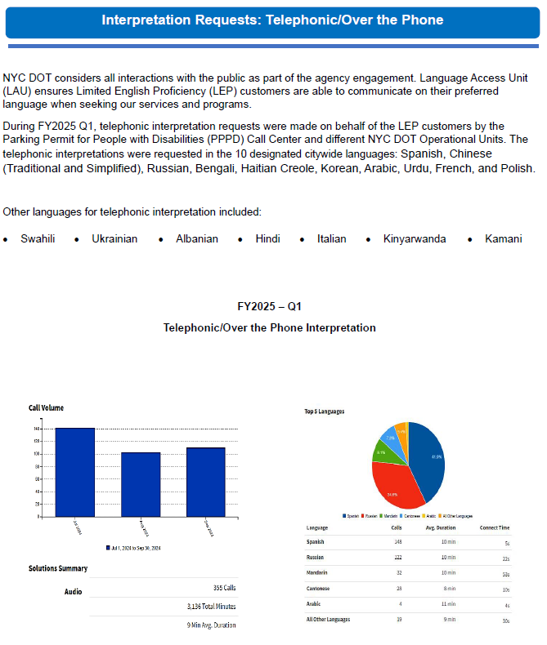

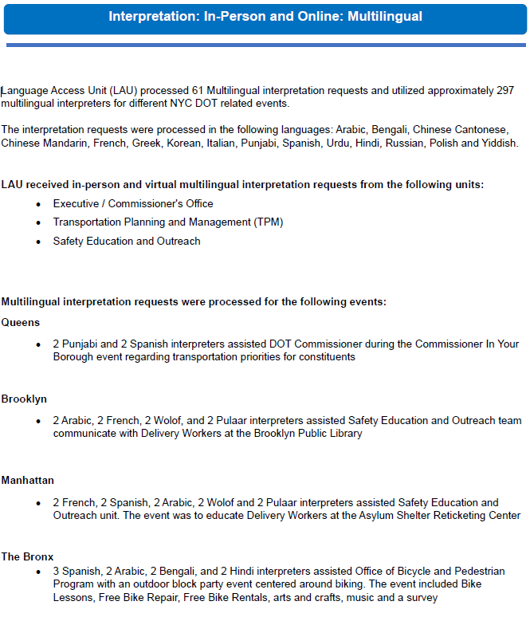

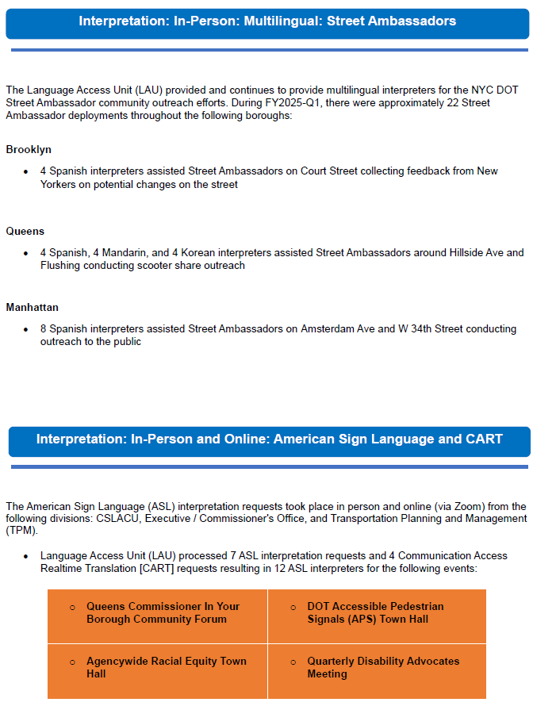

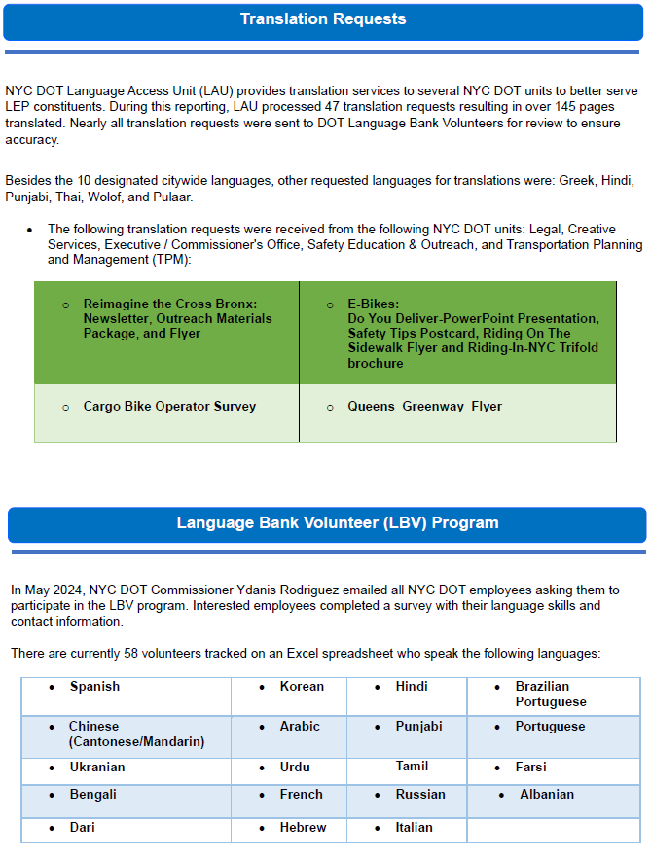

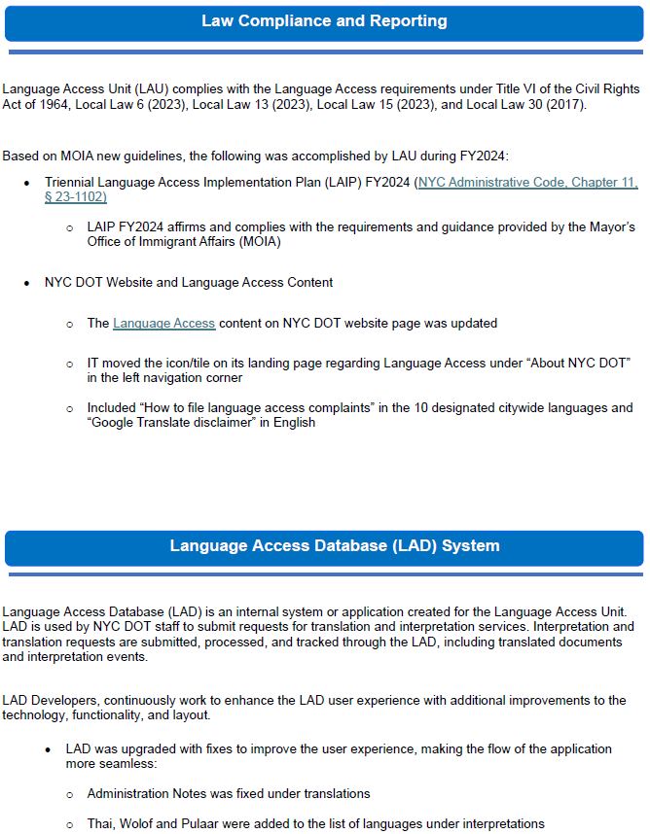

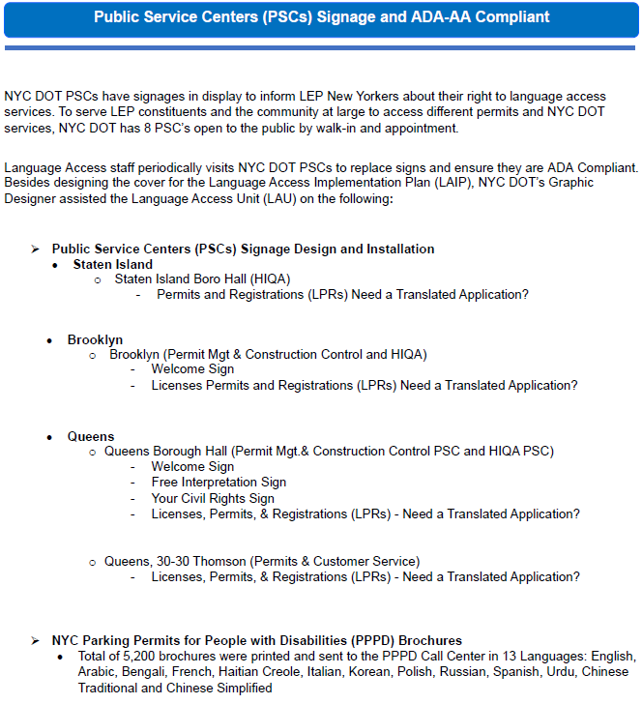

In the second quarter, the following updates were made regarding Language Access Initiatives:

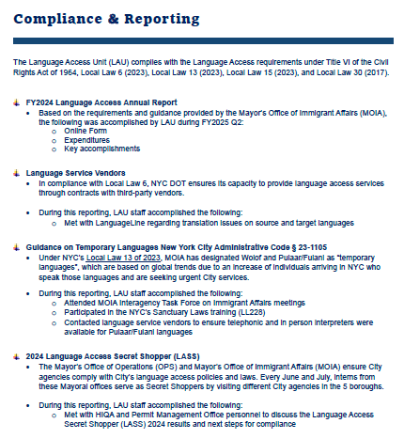

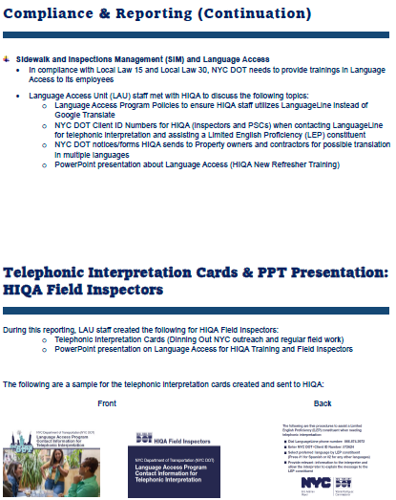
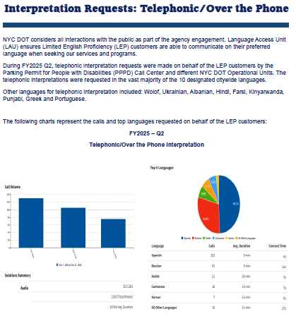
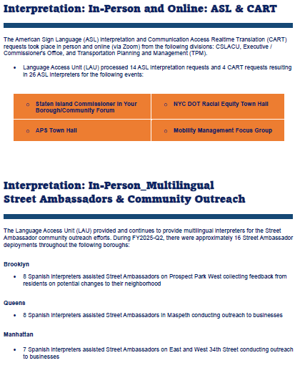
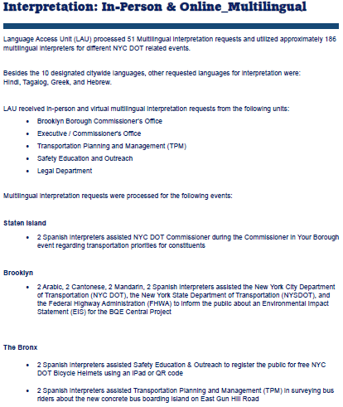
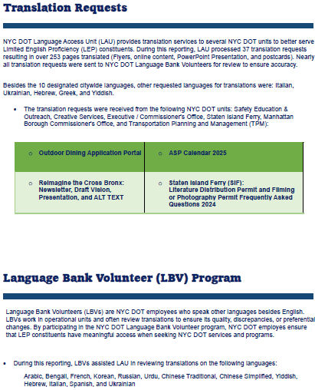
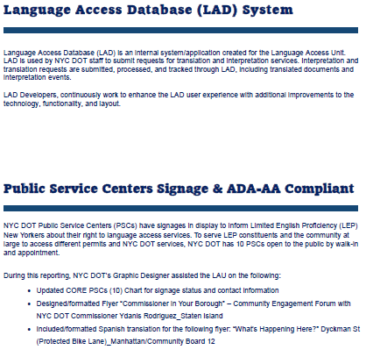

Recruitment
- Recruitment Efforts
Please list Recruitment Initiatives and Strategies which you set/declared in your FY 2025 Diversity, Equity, Inclusion and EEO Plan (e.g., targeted outreach and outreach, diversity recruitment, social media presence, where jobs are posted, EEO and APO collaboration, evaluation of best recruitment sources, structured interview training and unconscious bias training).

- Review policies, procedures, and practices related to targeted outreach and recruitment and utilize Inclusive Recruitment Guide issued by the Office of Citywide Equity and Inclusion to develop strategic recruitment plans.

Please describe the steps that your agency has taken to implement and achieve these initiatives/strategies. How do you evaluate the effectiveness of these actions?

In the first quarter, the Director of Workforce Development focused on creating meaningful partnerships with key stakeholders and building pathways for job seekers. She collaborated with executive staff and hiring managers in the development of recruiting strategies to attract and retain a diverse workforce. The Director conducted outreach to organizations which represent populations who are underrepresented in various Agency titles. She has built partnerships with community-based, non-profit organizations, such as NYCHA Cornerstone programs, the Renaissance Technical Institute, the Consortium for Worker Education, the NYC Pathways to Industrial & Construction Careers, and the Hispanic Federation. She pursued opportunities to partner with other City agencies, including the Mayor’s Office for Talent and Workforce Development, the Mayor’s Office of Immigrant Affairs, the Mayor’s Office for People with Disabilities, HRA and CUNY. She has also worked on expanding social media campaigns which highlight the work of the Agency, describe the types of DOT jobs and positions, and promote civil service exams.

DOT’s second quarter steps/actions for this goal were the same as the first quarter.

Recruitment Initiatives/Strategies #1 Update:
Q1 Update: ☐ Planned ☐ Not started ☒ Ongoing ☐ Delayed ☐ Deferred ☐ Completed
Q2 Update: ☐ Planned ☐ Not started ☒ Ongoing ☐ Delayed ☐ Deferred ☐ Completed
Q3 Update: ☐ Planned ☐ Not started ☐ Ongoing ☐ Delayed ☐ Deferred ☐ Completed
Q4 Update: ☐ Planned ☐ Not started ☐ Ongoing ☐ Delayed ☐ Deferred ☐ Completed

- Put in place an operating, up-to-date, accessible website, mobile application and social media presence related to EEO protection and rights.

Please describe the steps that your agency has taken to implement and achieve these initiatives/strategies. How do you evaluate the effectiveness of these actions?

Recruitment Initiatives/Strategies #2 Update:
Q1 Update: ☐ Planned ☐ Not started ☐ Ongoing ☐ Delayed ☒ Deferred ☐ Completed
Q2 Update: ☐ Planned ☐ Not started ☒ Ongoing ☐ Delayed ☐ Deferred ☐ Completed
Q3 Update: ☐ Planned ☐ Not started ☐ Ongoing ☐ Delayed ☐ Deferred ☐ Completed
Q4 Update: ☐ Planned ☐ Not started ☐ Ongoing ☐ Delayed ☐ Deferred ☐ Completed

- Assess agency job postings to ensure new diversity, inclusion, and equal opportunity employer messaging is included. Assess recruitment efforts to determine whether such efforts adversely impact any particular group.

Please describe the steps that your agency has taken to implement and achieve these initiatives/strategies. How do you evaluate the effectiveness of these actions?

In the first quarter, DOT’s Human Resources Division reviewed all DOT job postings to confirm that the new messaging is included, to ensure that the job descriptions are satisfactory and that other posting elements are relative to the position and unlikely to have an adverse impact on any group.

DOT’s second quarter steps/actions for this goal were the same as the first quarter.

Recruitment Initiatives/Strategies #3 Update:
Q1 Update: ☐ Planned ☐ Not started ☒ Ongoing ☐ Delayed ☐ Deferred ☐ Completed
Q2 Update: ☐ Planned ☐ Not started ☒ Ongoing ☐ Delayed ☐ Deferred ☐ Completed
Q3 Update: ☐ Planned ☐ Not started ☐ Ongoing ☐ Delayed ☐ Deferred ☐ Completed
Q4 Update: ☐ Planned ☐ Not started ☐ Ongoing ☐ Delayed ☐ Deferred ☐ Completed

- Ensure that agency personnel involved in both the discretionary and the civil service hiring process have received (1) Structured Interviewing training, (2) Unconscious Bias training, and (3) Everybody Matters EEO and Diversity and Inclusion Training, and assess recruitment efforts to determine whether such efforts adversely impact any particular group.

Please describe the steps that your agency has taken to implement and achieve these initiatives/strategies. How do you evaluate the effectiveness of these actions?

In the first quarter, DOT’s Human Resources Division regularly offered these trainings to all agency personnel identified as involved in both the discretionary and the civil service hiring process.

DOT’s second quarter steps/actions for this goal were the same as the first quarter.

Recruitment Initiatives/Strategies #4 Update:
Q1 Update: ☐ Planned ☐ Not started ☒ Ongoing ☐ Delayed ☐ Deferred ☐ Completed
Q2 Update: ☐ Planned ☐ Not started ☒ Ongoing ☐ Delayed ☐ Deferred ☐ Completed
Q3 Update: ☐ Planned ☐ Not started ☐ Ongoing ☐ Delayed ☐ Deferred ☐ Completed
Q4 Update: ☐ Planned ☐ Not started ☐ Ongoing ☐ Delayed ☐ Deferred ☐ Completed

- Please describe any recruitment efforts designed to increase the effectiveness and improve the hiring and selection reach of your agency during the quarter and describe the activities, including the dates when the activities occurred.

In July 2024, in order to expand where all Agency job openings are posted, DOT contracted with the vendor, Circa. Circa provides automated job distribution of all our openings to their job board network of 600 local and national employment and diversity sites. Additionally, Circa provides automatic outreach to more than 1,500 diversity organizations via their outreach management system. These organizations include underrepresented groups such as veterans, people with disabilities, minorities, women, and LGBT groups.

In FY 2025 Q1, DOT shared various job postings and vacancy notices with a number of CUNY schools including Baruch, Bronx Community, Brooklyn, CCNY, City Tech, CSI, Hostos, Hunter, Kingsborough, LaGuardia, Lehman, Manhattan Community, Medgar Evers, Queens, Queensborough Community, and York. The agency posted jobs with Historically Black Colleges and Universities (HBCUs) and Hispanic-Serving Institutions (HSIs). Postings and vacancies were also sent to community-based, non-profit organizations, including the Renaissance Technical Institute, the Charles B. Rangel Center for Public Service, the West Side Work Coalition, and the Hudson Guild.

In FY 2025 Q1, DOT shared various job postings and vacancy notices DOT shared various job postings and vacancy notices with the Mayor’s Office for People with Disabilities and with HRA’s NYC PINCC Program (Pathways to Industrial and Construction Careers).

In August 2024, DOT attended a DCAS Summer Youth Employment Program (SYEP) Hiring Event for former SYEP participants. We interviewed many applicants and hired 2 candidates.

In August 2024, DOT attended the 125th Street Block Party sponsored by NYPD Patrol Services Bureau, where we promoted agency job openings and the benefits of working for the City.

In September 2024, DOT attended the US Merchant Marine Academy Sea Fair.

In FY2025 Q2, in order to expand where all Agency job openings are posted, DOT continued its contract with the vendor, Circa. Circa provides automated job distribution of all our openings to their job board network of 600 local and national employment and diversity sites. Additionally, Circa provides automatic outreach to more than 1,500 diversity organizations via their outreach management system. These organizations include underrepresented groups such as veterans, people with disabilities, minorities, women, and LGBT groups.

In FY 2025 Q2, DOT shared various job postings and vacancy notices with a number of CUNY schools including Baruch, Bronx Community, Brooklyn, CCNY, City Tech, CSI, Hostos, Hunter, Kingsborough, LaGuardia, Lehman, Manhattan Community, Medgar Evers, Queens, Queensborough Community, and York. The agency posted jobs with Historically Black Colleges and Universities (HBCUs) and Hispanic-Serving Institutions (HSIs). Postings and vacancies were also sent to community-based, non-profit organizations, including the Renaissance Technical Institute, the Charles B. Rangel Center for Public Service, the West Side Work Coalition, and the Hudson Guild.

In FY 2025 Q2, DOT shared various job postings and vacancy notices DOT shared various job postings and vacancy notices with the Mayor’s Office for People with Disabilities and with HRA’s NYC PINCC Program (Pathways to Industrial and Construction Careers).

In November 2024, DOT held an engineering job fair for entry-level candidates looking for positions in civil, electrical, and mechanical engineering positions.

In October 2024, DOT attended the SUNY Maritime Fall Career Fair and the EDC Maritime Transportation Logistics and Distribution Job Fair.

- Recruitment Efforts for Civil Service Exams
List all recruitment events that were held by the agency to promote open-competitive civil service examinations.

Quarter # | Event Date | Event Name | Borough
1 | 07/09/2024 | Summer Intern Info Session | Manhattan
1 | 09/18/2024 | Community Engagement Transportation Forum | Queens
2 | 11/22/2024 | DOT Engineering Fair | Manhattan
2 | 12/13/2024 | Urban Fellow Civil Service Info Session | Virtual

List actual expenditures related to recruiting candidates for open-competitive and promotion civil service exams.

Borough | Approximate Dollar  Amount ($) in Q1 | Approximate Dollar  Amount ($) in Q2 | Approximate Dollar  Amount ($) in Q3 | Approximate Dollar  Amount ($) in Q4
Bronx | n/a | n/a
Brooklyn | n/a | n/a
Manhattan | n/a | n/a
Queens | n/a | n/a
Staten Island | n/a | n/a

- Recruitment Sources
List recruitment sources used to fill vacancies in the current Quarter (include Q#)

Q1
1. Circa Diversity Recruitment networks
2. CUNY, HBCU, and HSI Schools
3. LinkedIn
4. MOPD job board, PINCC
5. Various community-based Non-Proft Organizations

Q2
1. Circa Diversity Recruitment networks
2. CUNY, HBCU, and HSI Schools
3. LinkedIn
4. MOPD job board, PINCC
5.Various community-based Non-Proft Organizations

- Internships/Fellowships

The agency is providing the following internship opportunities in FY 2025. [Note: Please update this information every quarter.]

Race/Ethnicity* [#s] * Use self-ID data obtained from NYCAPS; Gender* [#s] [N-B=Non-Binary; O=Other; U=Unknown] * Use self-ID data

- Urban Fellows:

Q1 Total: ___5_____ Q2 Total: ____5____ Q3 Total: ________ Q4 Total: ________
Race/Ethnicity* [#s]: Black___ Hispanic_1__ Asian/Pacific Islander___ Native American___ White_4__ Two or more Races___

Gender* [#s]: M _1__ F __4_ N-B ___ O ___ U ___

- Public Service Corps:

Q1 Total: ___14_____ Q2 Total: ___25_____ Q3 Total: ________ Q4 Total: ________
Race/Ethnicity* [#s]: Black__6_ Hispanic_6__ Asian/Pacific Islander_8__ Native American___ White__1_ Two or more Races__1__ Did not report 3

Gender* [#s]: M __8_ F _6__ N-B ___ O ___ U ___

- Summer College Interns:

Q1 Total: ___5_____ Q2 Total: ___0_____ Q3 Total: ________ Q4 Total: ________
Race/Ethnicity* [#s]: Black___ Hispanic___ Asian/Pacific Islander___ Native American___ White___ Two or more Races___ Did not report

Gender* [#s]: M ___ F ___ N-B ___ O ___ U ___

- Summer Graduate Interns:

Q1 Total: ___2_____ Q2 Total: ___0_____ Q3 Total: ________ Q4 Total: ________
Race/Ethnicity* [#s]: Black___ Hispanic___ Asian/Pacific Islander___ Native American___ White___ Two or more Races___

Gender* [#s]: M ___ F ___ N-B ___ O ___ U ___

- College Aides:

Q1 Total: ____154____ Q2 Total: ___133_____ Q3 Total: ________ Q4 Total: ________
Race/Ethnicity* [#s]: Black_25__ Hispanic_23__ Asian/Pacific Islander__46_ Native American_2__ White_34__ Two or more Races_3__

Gender* [#s]: M 74 F 56 N-B 2 O 1 U ___

- DYCD:

Q1 Total: _25_______ Q2 Total: ________ Q3 Total: ________ Q4 Total: ________
Race/Ethnicity* [#s]: Black__2_ Hispanic__1_ Asian/Pacific Islander_19__ Native American___ White__2_ Two or more Races__1_
Gender* [#s]: M _12__ F _13__ N-B ___ O ___ U ___

- Fleet Automotive Intern:

Q1 Total: 6 Q2 Total: ___0_____ Q3 Total: ________ Q4 Total: ________

Race/Ethnicity* [#s]: Black___ Hispanic___ Asian/Pacific Islander___ Native American___ White___ Two or more Races___

Gender* [#s]: M ___ F ___ N-B ___ O ___ U ___

Additional comments:

In FY 2025 Q1, five Urban Fellows were placed with our agency.

In FY 2025, DOT will continue to recruit both College Aides and Summer Interns from local and regional schools and via posting on the City’s website. In addition to participating in career fairs, DOT will also hold agency-specific info sessions at CUNY schools in order to attract a diverse intern candidate pool.

In FY 2025 Q1, the agency participated in the Department of Youth and Community Development (DYCD) Summer Youth Employment Program (SYEP), the Ladders for Leaders Program, and the Transportation Career Mentoring Program. DOT will continue to participate in DYCD internship programs in the summer on 2025.

In FY2025 Q1, DOT partnered with local high schools to provide internships to students through the NYC Automotive HS Internship Program. We will continue to participate in CTE HS programs in the summer of 2025.

In FY2025 Q1, the agency participated in the Partnership for Inclusive Internships (PII) Program. PII is a partnership between the Department of Social Services and AHRC New York City, a non-profit organization supporting people with disabilities. The internship program aims to provide work experience and a path to government employment for people with disabilities.

In FY 2025 Q1, the agency continued to participate in the CUNY Pathways Fellowship Program, and we expect to place eleven new NYC Public Service Fellows next quarter.

In FY 2025 Q1, the agency continued to participate in the Career Readiness and Modern Youth Apprenticeship (CRMYA) Pathway program. The agency will be onboarding 1 high school student aide next quarter. This apprenticeship program offers a three-year applied-learning environment for high school students.

In FY 2025 Q2, the agency continued to participate in the CUNY Pathways Fellowship Program, and we expect to place new NYC Public Service Fellows next quarter.

In FY 2025 Q2, the agency continued to participate in the Career Readiness and Modern Youth Apprenticeship (CRMYA) Pathway program. The agency onboarded 1 new high school student aide. This apprenticeship program offers a three-year applied-learning environment for high school students.

55-A Program

The agency uses the 55-a Program to hire and retain qualified individuals with disabilities. ☒ Yes ☐ No

Currently, the agency employs the following number of 55-a participants:

Q1 (9/30/2024): ___15______ Q2 (12/31/2024): ___14____ Q3 (3/31/2025): __________ Q4 (6/30/2025): __________

During the 1st Quarter, a total of __2__ [number] new applications for the program were received.
During the 1st Quarter _1__ participants left the program due to [state reasons] resigned.

During the 2nd Quarter, a total of __2__ [number] new applications for the program were received.
During the 2nd Quarter __1_ participants left the program due to [state reasons] appointment from civil service list.

During the 3rd Quarter, a total of ____ [number] new applications for the program were received.
During the 3rd Quarter ___ participants left the program due to [state reasons] ________.

During the 4th Quarter, a total of ____ [number] new applications for the program were received.
During the 4th Quarter ___ participants left the program due to [state reasons] ________.

The 55-a Coordinator has achieved the following goals:

- Disseminated 55-a information –
by e-mail: ☐ Yes ☒ No
in training sessions: ☒ Yes ☐ No
on the agency website: ☒ Yes ☐ No
in agency newsletter: ☐ Yes ☒ No
Other: Ensured that all competitive job postings included the 55-a language.

2. ___________________________________________________________________________________
3. ___________________________________________________________________________________

- Selection (Hiring and Promotion)

Please review Section VI of your FY 2025 Diversity, Equity, Inclusion and EEO Plan and describe your activities for this quarter below:

Please list additional Selection Strategies and Initiatives which you set/declared in your FY 2025 Diversity, Equity, Inclusion and EEO Plan (e.g., use of structured interview, EEO or APO representatives observing interviews, review of placements, review of e-hire applicant data).

Please describe the steps that your agency has taken to meet these objectives.

1. Career Counseling: Advising employees of opportunities for promotion and career development; Notification of promotion/transfer opportunities.

In the first quarter, DOT posted information on the agency’s intranet site regarding job openings, civil service exams, DCAS resources, agency training and professional development, and online learning and training. DOT’s Human Resources Division emailed all employees updates to this site, including all new job postings. Agency Personnel Coordinators ensured that employees without email receive the same information. The Career Counselor and the Training & Development Office continued to advise employees regarding promotional opportunities and career development, both through individual meetings and by conducting group info sessions.

DOT’s second quarter steps/actions were the same as the previous quarter.

- Reviewing the methods by which candidates are selected for appointment, promotion, or to fill vacancies (new hires), especially for mid- and high-level discretionary positions.

For interview panels of titles where underutilization exists, panels are strongly encouraged to consist of three interviewers but must be comprised of at least two people. The panel must also, except in very unusual circumstances, be significantly diverse (that is, the interviewers must be represented by more than one gender and ethnicity). The panels must utilize a standardized rating scale and candidate scorecard for all interviews, and each interviewer must complete ratings sheets for every candidate interviewed.

EDI analyzes previous fiscal year promotions by ethnicity and gender for each division and the agency as a whole, as a means of determining whether or not the PRC is meeting its goal of ensuring promotions are distributed among staff with comparable job titles and functions across divisions without bias towards any one demographic or combination of.

- Describe the role of agency EEO Officer and other EEO staff in the selection of candidates for appointment or promotion (pre- and post-appointment).

EDI, HR and DOT’s executive staff developed a comprehensive guide for Hiring Managers and Personnel Coordinators to follow when seeking to fill a position. This includes:
  - The Basics of Structured Interviewing
  - Pre-Interview Hiring Requirements
  - Post-Interview Hiring Requirements
  - Unconscious Bias
  - Governing EEO Laws

Starting in 2020, HR advised divisional Personnel Coordinators to begin entering interview information in NYCAPS, as required by all city agencies, thus enabling HR and EDI to evaluate the interview process.

Oversight at resume selection stage:
  - Review by HR and EDI of resumes selected.
  - HR will hold hiring process if upon review there are candidates who are not qualified but are selected for interviews or if diverse and qualified candidates are not selected for an interview but, based on a review of their resume, they are determined to be otherwise qualified for the position sought. Will also confirm interview panels are compliant with the Structured Hiring Guidelines.
  - EDI or HR will approve interview questions.
  - EDI or HR will perform advisory role and will conduct post-audit review.

Oversight at Interviews and Candidate Selection:
  - Review by HR and EDI after first (and subsequent) round interviews.
  - HR will hold hiring process if upon review rating sheets from each round of interviews are not satisfactory and if applicants advancing are not otherwise qualified for the position sought.
  - EDI will perform advisory role and will conduct post-audit review.
  - Review by HR and EDI for final selection.
  - HR will hold hiring process if rating sheets are not satisfactory and if final selection process did not follow Structured Hiring Guidelines.
  - EDI will perform advisory role and will conduct post-audit review.

- Analyzing the impact of layoffs or terminations on racial, gender and age groups.
In the first quarter, there were no layoffs or terminations due to fiscal/operational reasons.

- Other:

During this Quarter the Agency activities included:
# of Vacancies # of New Hires # of New Promotions
Q1 # 184 # 65 # 148
Q2 # 245 # 56 # 92
Q3 # _____ # _____ # _____
Q4 # _____ # _____ # _____

Training

Please provide your training information in Part II of the report “DEI-EEO Training Summary” (in MS Excel).

Reasonable Accommodation

Please report all reasonable accommodation requests and their disposition in the DCAS Citywide Complaint/Reasonable Accommodation Tracking System by logging into your CICS Account at: https://mspwva-ctwapx02.csc.nycnet/Login.aspx

The agency did input full Reasonable Accommodation activity on the DCAS Citywide Complaint and Reasonable Accommodation (CAD) Database:

Q1: ☒ Yes ☐ No Q2: ☒ Yes ☐ No Q3: ☐ Yes ☐ No Q4: ☐ Yes ☐ No

Compliance and Implementation of Requirements Under Executive Orders and Local Laws

- Local Law 92: Annual Sexual Harassment Prevention training

Please provide Sexual Harassment Prevention Training Information in Part II of the report “DEI-EEO Training Summary” (in MS Excel).

- Local Law 97: Annual Sexual Harassment Reporting

☒ The agency has entered the sexual harassment Complaint Data in the DCAS Citywide Complaint Tracking System and updates the information as they occur.

Q1: ☒ Yes ☐ No Q2: ☒ Yes ☐ No Q3: ☐ Yes ☐ No Q4: ☐ Yes ☐ No

☒ The agency has entered all types of complaints in the DCAS Citywide Complaint Tracking System and updates the information as they occur.

Q1: ☒ Yes ☐ No Q2: ☒ Yes ☐ No Q3: ☐ Yes ☐ No Q4: ☐ Yes ☐ No

☒ The agency ensures that complaints are closed within 90 days.

Report all complaints and their disposition in the DCAS Citywide Complaint/Reasonable Accommodation Tracking System by logging into your CICS Account at: https://mspwva-ctwapx02.csc.nycnet/Login.aspx

- Executive Order 16: Training on Transgender Diversity and Inclusion

Please provide E.O. 16 Training Information in Part II of the report “DEI-EEO Training Summary” (in MS Excel).

Audits and Corrective Measures

Please choose the statement that applies to your agency.

☒ The agency is NOT involved in an audit conducted by NYC Equal Employment Practice Commission (EEPC) or another governmental agency specific to our EEO practices.

☐ The agency is involved in an audit; please specify who is conducting the audit: ___________________________________.

☐ Attach the audit recommendations by EEPC or the other auditing agency.

☐ If needed, the agency has submitted or will submit to DCAS Citywide Equity and Inclusion an amendment letter, which shall amend the agency plan for previous FY(s) as recommended by EEPC.

☐ The agency received a Certificate of Compliance from the auditing agency in 2023 or 2024.

Please attach a copy of the Certificate of Compliance from the auditing agency.

Appendix A: EEO Personnel Details

EEO Personnel For 2nd Quarter, FY 2025

Personnel Changes:

Personnel Changes this Quarter: ☒ No Changes |  | Number of Additions: |  | Number of Deletions:
Employee's Name & Title
Nature of change | ☐ Addition ☐ Deletion | ☐ Addition ☐ Deletion | ☐ Addition ☐ Deletion
Date of Change in EEO Role | Start Date or Termination Date: | Start Date or Termination Date: | Start Date or Termination Date:
Employee's Name & Title | 4. | 5. | 6.
Nature of change | ☐ Addition ☐ Deletion | ☐ Addition ☐ Deletion | ☐ Addition ☐ Deletion
Date of Change in EEO Role | Start Date or Termination Date: | Start Date or Termination Date: | Start Date or Termination Date:

For New EEO Professionals:
Name & Title
EEO Function | ☐ EEO Officer ☐ EEO Counselor  ☐ EEO Trainer ☐ EEO Investigator  ☐ 55-a Coordinator ☐ Other: (specify) | ☐ EEO Officer ☐ EEO Counselor  ☐ EEO Trainer ☐ EEO Investigator  ☐ 55-a Coordinator ☐ Other: (specify) | ☐ EEO Officer ☐ EEO Counselor  ☐ EEO Trainer ☐ EEO Investigator  ☐ 55-a Coordinator ☐ Other: (specify)
Percent of Time Devoted to EEO | ☐ 100% ☐ Other: (specify %): | ☐ 100% ☐ Other: (specify %): | ☐ 100% ☐ Other: (specify %):
Name & Title | 4. | 5. | 6.
EEO Function | ☐ EEO Officer ☐ EEO Counselor  ☐ EEO Trainer ☐ EEO Investigator  ☐ 55-a Coordinator ☐ Other: (specify) | ☐ EEO Officer ☐ EEO Counselor  ☐ EEO Trainer ☐ EEO Investigator  ☐ 55-a Coordinator ☐ Other: (specify) | ☐ EEO Officer ☐ EEO Counselor  ☐ EEO Trainer ☐ EEO Investigator  ☐ 55-a Coordinator ☐ Other: (specify)
Percent of Time Devoted to EEO | ☐ 100% ☐ Other: (specify %): | ☐ 100% ☐ Other: (specify %): | ☐ 100% ☐ Other: (specify %):

EEO Training Completed within the Last two years, including the current quarter (EEO and D&I Officers, Deputies, and all new EEO Professionals):
Name & EEO Role | - Benjamin Graham | 2. Angela Ball | 3. Christopher Lee
Completed EEO Trainings:  - Everybody Matters-EEO and D&I  - Sexual Harassment Prevention  - lgbTq: The Power of Inclusion  - Disability Awareness & Etiquette  - Unconscious Bias  - Microaggressions  - EEO Officer Essentials:  Complaint/Investigative Processes  - EEO Officer Essentials:  Reasonable Accommodation  - Essential Overview Training  for New EEO Officers  - Understanding CEEDS Reports | ☒ Yes ☐ No  ☒ Yes ☐ No  ☒ Yes ☐ No  ☒ Yes ☐ No  ☒ Yes ☐ No  ☒ Yes ☐ No  ☒ Yes ☐ No  ☐ Yes ☒ No  ☒ Yes ☐ No  ☒ Yes ☐ No | ☒ Yes ☐ No  ☒ Yes ☐ No  ☒ Yes ☐ No  ☒ Yes ☐ No  ☐ Yes ☒ No  ☐ Yes ☒ No  ☒ Yes ☐ No  ☒ Yes ☐ No  ☒ Yes ☐ No  ☐ Yes ☒ No | ☒ Yes ☐ No  ☒ Yes ☐ No  ☒ Yes ☐ No  ☒ Yes ☐ No  ☒ Yes ☐ No  ☒ Yes ☐ No  ☐ Yes ☒ No  ☐ Yes ☒ No  ☐ Yes ☒ No  ☐ Yes ☒ No

EEO Training completed within the last two years, including the current quarter (EEO and D&I Officers, Deputies, and all new EEO Professionals):
Name & EEO Role | 4. Saba Maher | 5. | 6.
 | ☐ Yes ☒ No  ☐ Yes ☒ No  ☐ Yes ☒ No  ☐ Yes ☒ No  ☐ Yes ☒ No  ☐ Yes ☒ No  ☒ Yes ☐ No  ☒ Yes ☐ No  ☒ Yes ☐ No  ☐ Yes ☒ No | ☐ Yes ☐ No  ☐ Yes ☐ No  ☐ Yes ☐ No  ☐ Yes ☐ No  ☐ Yes ☐ No  ☐ Yes ☐ No  ☐ Yes ☐ No  ☐ Yes ☐ No  ☐ Yes ☐ No  ☐ Yes ☐ No | ☐ Yes ☐ No  ☐ Yes ☐ No  ☐ Yes ☐ No  ☐ Yes ☐ No  ☐ Yes ☐ No  ☐ Yes ☐ No  ☐ Yes ☐ No  ☐ Yes ☐ No  ☐ Yes ☐ No  ☐ Yes ☐ No
  Completed EEO Trainings:
  - Everybody Matters-EEO and D&I
  - Sexual Harassment Prevention
  - lgbTq: The Power of Inclusion
  - Disability Awareness & Etiquette
  - Unconscious Bias
  - Microaggressions
  - EEO Officer Essentials:
  Complaint/Investigative Processes
  - EEO Officer Essentials:
  Reasonable Accommodation
  - Essential Overview Training
  for New EEO Officers
  - Understanding CEEDS Reports

EEO Personnel Contact Information (Please list all current EEO professionals)
Please provide full mailing address of the principal Agency EEO Office:
MAILING ADDRESS: NYC Department of Transportation, Office of Equal Employment Opportunity, Diversity and Inclusion, 59 Maiden Lane, 37th Floor, New York, NY 10038

Diversity and EEO Staffing as of 2nd Quarter FY 2025*

EEO\Diversity Role | Name | Civil Service Title | % of Time Devoted to EEO & DEI | Office E-mail Address | Telephone #
EEO Officer/Director | Benjamin Graham | Executive Agency Counsel | 100% | bgraham1@dot.nyc.gov | 212-839-6600
Deputy EEO Officer OR  Co-EEO Officer | Angela Ball | Agency Attorney | 100% | aball@dot.nyc.gov | 212-839-6606
Chief Diversity & Inclusion Officer | Benjamin Graham
Diversity & Inclusion Officer
Chief Diversity Officer/Chief MWBE Officer per E.O. 59 | Carlos Bannister | Administrative Procurement Analyst | 100% | cbannister@dot.nyc.gov | 212-839-9241
ADA Coordinator | Edmund Asiedu | Administrative Staff Analyst (Non-Managerial) | 50% | easiedu@dot.nyc.gov | 212-839-7751
Disability Rights Coordinator | Benjamin Graham
Disability Services Facilitator | Edmund Asiedu
55-a Coordinator | Lianna Palacios | Administrative Staff Analyst | 15% | lpalacios@dot.nyc.gov | 212-839-9516
Career Counselor | Peter Scavetta | Administrative Staff Analyst (Non-Managerial) | 25% | pscavetta@dot.nyc.gov | 212-839-9452
EEO Counselor
EEO Investigator | Saba Maher | Agency Attorney | 100% | smaher@dot.nyc.gov | 212-839-6605
EEO Counselor\ Investigator
Trainer | Vincent DiGennaro | Community Coordinator | 100% | vdigennaro@dot.nyc.gov | 212-839-4151
EEO Training Liaison | Carol Adamson | Administrative Manager (Non-Managerial) | 10% | cadamson@dot.nyc.gov | 212-839-9488
Diversity Specialist | Christopher Lee | Community Coordinator | 100% | clee4@dot.nyc.gov | 212-839-7151
* Please note changes (new personnel filling the specified role). You may insert additional entries as needed. Title refers to the civil service title. If there is an EEO\Diversity role that your staff performs that is not on the list above, you may indicate it on the chart. You may provide full contact information once if several roles are performed by the same person.

