
THE CITY OF NEW YORK
OFFICE OF THE MAYOR
NEW YORK, NY 10007

FOR IMMEDIATE RELEASE, April 17, 2017
CONTACT: pressoffice@cityhall.nyc.gov, (212) 788-2958

ALL ABOARD: MAYOR DE BLASIO WELCOMES NYC FERRY BOATS TO NEW YORK HARBOR

First vessel docks and is dedicated at Brooklyn Bridge Park’s Pier 1. Timetables announced for Rockaways and East River Routes, launching one month ahead of schedule, May 1

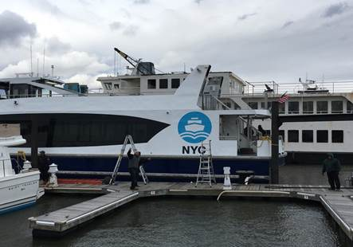

NEW YORK—Mayor Bill de Blasio today welcomed the first three of 20 total NYC Ferry vessels into New York Harbor. The boats departed from Liberty Landing in New Jersey this morning before docking at Pier 1 in Brooklyn Bridge Park.

In keeping with maritime tradition, the docking included the christening of the first NYC Ferry vessel. Named “Lunchbox” by Bay Ridge’s P.S. 170 2nd graders, the first ferry was christened by Deputy Mayor Alicia Glen, who will serve as “godmother” to the ferry boat. The dedication ceremony also included a reading of Sailor’s Paraphrase of the 23rd Psalm, by FDNY Chaplain Ann Kansfield. Additional boats will be christened in the coming weeks.

“All Aboard! As we prepare for launch day on May 1, we celebrate the arrival of NYC Ferry to New York Harbor and what this new citywide ferry service represents: greater opportunity for every New Yorker, from the Rockaways to the Bronx, and at just $2.75 a ride,” said Mayor Bill de Blasio.

“I’m so honored to christen this first ferry. In just two weeks, this service will start transforming the way thousands of New Yorkers travel. The docks are ready. The boats are ready. The riders are ready. NYC Ferry is about to become a reality!” Deputy Alicia Mayor Glen said.

“After months of construction and weeks of travel, the new NYC Ferry boats are officially here in the five boroughs. And in just two weeks’ time, New Yorkers will be able to ride these brand new boats themselves – to work, to school, or to explore all the incredible things our waterfront has to offer,” said New York City Economic Development Corporation President and CEO James Patchett.

In addition to welcoming the new boats, the City announced the construction of new infrastructure at Pier 6 in Brooklyn Bridge Park and Atlantic Basin in Red Hook that will serve New Yorkers when the South Brooklyn route launches in June.

Mayor Bill de Blasio today also released a new 2017 NYC Ferry map, highlighting the routes that will be activated this year, and announced schedules for the Rockaway Route and East River Route, both of which will be operating May 1. The new maps and timetables can be viewed here.

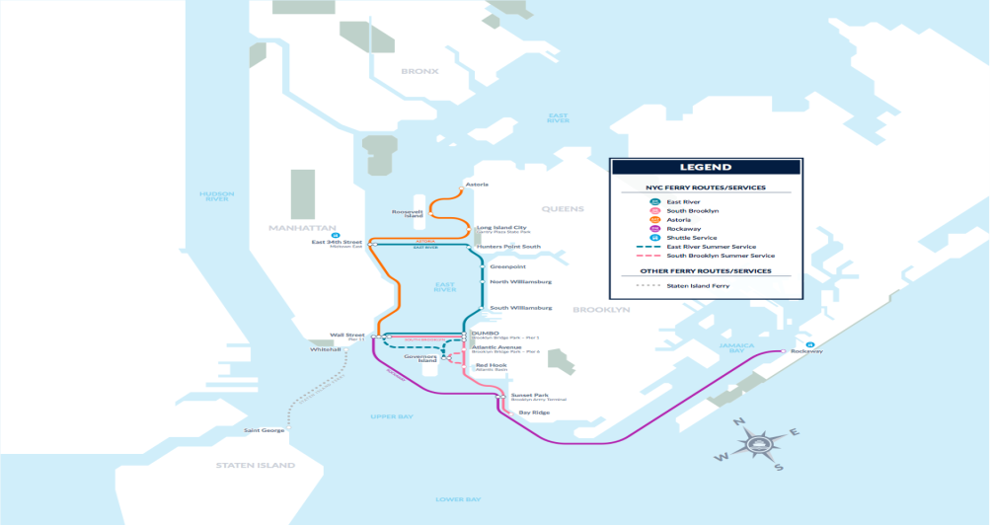
The map and timetable will be displayed at all East River and Rockaway landings by May 1, andat the South Brooklyn and Astoria landings prior to those routes launching in June and August. When the system is fully launched, in 2018, the combined routes will cover more than 60 miles of waterway.

The Rockaway route − which includes a 5:30 a.m. weekday departure added at the request of local elected leaders and community advocates – will operate as follows:

- Ferries will depart the Rockaways every hour on the half-hour on weekdays from 5:30 a.m. to 8:30 p.m. and on weekends from 6:30 a.m. to 9:30 p.m. The total travel time from the Rockaways to Wall Street is about 55 minutes.

- Ferries will depart from the Brooklyn Army Terminal in Sunset Park for Wall Street every hour in each direction, serving those who want access to jobs in Lower Manhattan and visitors to the Rockaways.

- Ferries operating on the Rockaway Route will depart from Wall Street every hour on the half-hour on weekdays from 6:30 a.m. to 8:30 p.m. and on weekends from 7:30 a.m. to 9:30 p.m.

The East River Route, which will have expanded service approximately two hours later than its current schedule, will operate as follows:

- Ferries will depart every 20 minutes throughout the East River route every weekday morning and evening, providing consistent commuter service throughout the year.

- Mid-day service on weekends will operate every 30-minutes throughout the summer and every 45-minutes on weekends.

- From 10 a.m. to 7 p.m. when it is open, the East River route will now stop at Governors Island between Wall Street and DUMBO, allowing for more seats that can serve the island this summer on the East River route. The East River route will stop every 45 minutes in both directions, improved over one stop every 45 minutes as was done in previous seasons.

- Governors Island will be served on weekends during its full open season this year by the East River route, and will also include a stop by the South Brooklyn route on weekends.

NYC Ferry is hiring for various jobs, including captains and deckhands. Jobseekers can apply directly through Hornblower’s website, www.ferry.nyc. NYC Ferry will ultimately provide 200 jobs, all of which will pay the City’s Living Wage or higher and provide comprehensive benefits.
For more information on NYC Ferry and to stay up-to-date on the latest information visit www.ferry.nyc.

More Details on NYC Ferry Service

Routes:

- Rockaway, South Brooklyn and Astoria routes are scheduled to launch in 2017.
- Rockaway route will connect to the Brooklyn Army Terminal and Wall Street.
- Astoria route will connect to Astoria, Roosevelt Island, Long Island City, East 34th Street<x-apple-data-detectors://6> and Wall Street.
- South Brooklyn route will connect Bay Ridge, Brooklyn Army Terminal, Red Hook, Brooklyn Bridge Park’s Pier 1 and Pier 6, and Wall Street, with weekend service to Governors Island.
- Soundview and Lower East Side routes to launch in 2018.
- Routes from Coney Island and Stapleton on Staten Island will be considered in future studies after the 2018 routes launch.
- Combined routes will cover over 60 miles of waterway.

Commuting Times:
- Rockaway to Wall Street (1 stop): Approximately 1 hour
- Astoria to E 34th Street (2 stops): Approximately 22 minutes
- Astoria to Wall Street (3 stops): Approximately 38 minutes
- Soundview to Wall Street (2 stops): Approximately 43 minutes
- Bay Ridge to Wall Street (4 stops): Approximately 48 minutes

Pricing:
- Cost per ride will equal that of a single subway ride.
- Over 4,000 daily East River Ferry customers will see fares reduced from $4 to the cost of a single subway ride.
- Fare will allow for free transfers to any other ferry route within the system, including the East River Ferry.
- Both paper and smartphone ticketing will be available, with payments accepted via cash, credit, or debit card. Discounts will be available for seniors, children and New Yorkers with disabilities.
- Passengers will be allowed to bring bicycles on board for a $1 fee.

The Boats:
- Each boat will be able to carry 150 passengers.
- All boats will be equipped with WiFi.
- Boats will be fully accessible to New Yorkers with disabilities, and will comply with the requirements of both the Americans with Disabilities Act and New York City Local Law 68 of 2005.
- New boats will be equipped with the most modern engine design available to reduce emissions and noise, as well as an efficient hull design that will limit wakes and maximize fuel economy.

City Support:
- The city is investing $55 million in infrastructure upgrades, including building 10 new ferry landings. Barge construction is currently underway at a facility on Staten Island.
- The city is providing $30 million in operating support per year, over a period of six years. Based on a projection of 4.6 million annual trips, the per-trip subsidy for NYC Ferry Service will be $6.60, lower than the nearly $8 per trip subsidy on the Long Island Railroad or the nearly $15 per trip subsidy for express buses. The city is providing $10 million for additional startup costs, such as vessel upgrades and ticketing machines.
- City negotiated an option to acquire ferry vessels, allowing for greater operational flexibility and providing significant savings to taxpayers over the life of the service (roughly up to $5 million per year).
- City will receive a portion of fare-box revenue if ridership exceeds 5.6 million passengers.

###

