
FOR IMMEDIATE RELEASE: June 9, 2025
CONTACT: pressoffice@cityhall.nyc.gov, (212) 788-2958
MAYOR ADAMS, NYCEDC, DOC ANNOUNCE PLAN TO REMOVE DECOMMISSIONED JAIL BARGE FROM HUNTS POINT, UNVEIL AMBITIOUS VISION FOR INNOVATIVE MARINE TERMINAL
City Will Permanently Remove Vernon C. Bain Correctional Center from Hunts Point,
Delivering on Key Recommendation in Mayor Adams’ “Hunts Point Forward” Plan
Adams Administration Reveals Vision for New Hunts Point Marine Terminal on Site to
Connect Cargo to Last-Mile Delivery, Generate $3.9 Billion in Economic Impact,
Create Hundreds of Jobs, Remove 9,000 Truck Trips from City Streets Every Month
Plan Would Establish Economic Mobility Network in Hunts Point to Connect New Yorkers to Jobs, Invest Over $28 Million to Expand Waterfront Access and Improve Greenway
Announcement Part of Adams Administration’s Efforts to Turn New York City’s Waterways into Harbor of the Future, Create Tens of Thousands of Jobs, Support Innovative Industries Across All Five Boroughs
NEW YORK – New York City Mayor Eric Adams, New York City Economic Development Corporation (NYCEDC) President and CEO Andrew Kimball, and New York City Department of Correction (DOC) Commissioner Lynelle Maginley-Liddie today announced that the city will remove the decommissioned Vernon C. Bain Correctional Center (VCBC) barge from Hunts Point and pursue an innovative Hunts Point Marine Terminal on the site to move freight off of ships and onto the last mile in their delivery. After originally decommissioning the VCBC facility in 2023, the Adams administration announced today that NYCEDC will issue a request for proposals (RFP) to remove the former jail barge, freeing up valuable space on the Hunts Point waterfront. In its place, the Adams administration envisions a new Hunts Point Marine Terminal to move cargo from shipping containers onto additional barges and ferries for last-mile deliveries throughout New York City.
The new marine terminal — which is estimated to create 400 construction jobs, 100 permanent jobs, and $3.9 billion in economic impact over the next 30 years — would form a key connection point between ports up and down the East Coast, including the Brooklyn Marine Terminal and other nodes in New York City. By building this new ‘Blue Highways’ facility, the terminal would remove an estimated 9,000 monthly truck trips from city streets and reduce roadway congestion. Additionally, the Adams administration will invest more than $28 million as part of its Fiscal Year 2026 Executive Budget — also known as the “Best Budget Ever” — to extend the existing bike network currently running alongside Food Center Drive to go along Halleck Street and expand access to the waterfront. Today’s announcement continues Mayor Adams’ vision to turn New York City’s waterfront into a Harbor of the Future; establish New York City as the global destination for green technology, innovation, and opportunity; and create approximately 53,000 temporary and permanent jobs and $95 billion in economic impact.
“For hundreds of years, New York City’s waterways have powered our economy and made our city a global destination for commerce, capital, and cargo. With the investments our administration is making every day, we are writing the next chapter in that history and turning our waterfront into a ‘Harbor of the Future.’ From a first-in-the-nation climate research facility on Governors Island to a state-of-the-art life sciences hub at Kips Bay to much more, our ‘Harbor of the Future’ will create tens of thousands of jobs, generate billions in economic impact, and keep our city at the front of emerging industries,” said Mayor Adams. “Today, we are adding yet another stop to that harbor by clearing away the old jail barge in the Bronx and building a new Hunts Point Marine Terminal in its place. We’ll unload cargo from all across the world for delivery throughout New York City, put even more New Yorkers to work in vibrant industries, and continue to show that cities can do bold, ambitious things. But we’re not stopping there. Later this month, our city has a chance to do yet another big thing when leaders vote on the future of the Brooklyn Marine Terminal. We have a once-in-a-generation chance to turn this crumbling facility into a modern maritime port with thousands of new homes, hundreds of thousands of square feet of industrial space, and dozens of acres of green space. In short, we have a chance to say ‘yes’ to a bolder, brighter future for our city.”
“I served the Bronx as borough president and New York City councilmember for nearly 12 years, and I am thrilled by today’s announcement to remove the Vernon Bain Correctional Facility,” said Deputy Mayor for Housing, Economic Development, and Workforce Adolfo Carrión Jr. “But I am even more excited by what’s ahead: meaningful investments in the people of Hunts Point and the transformation of this site into a ‘Blue Highway’ superstation to move more goods by water and reduce truck traffic, congestion and air pollution in the South Bronx.”
“The vision to transform the decommissioned Vernon C. Bain Center into the Hunts Point Marine Terminal will usher in a new era for this site that will result in not only a new ‘Blue Highways’ facility, but bring waterfront access, greenway improvements, and much-needed good-paying jobs for the Hunts Point community,” said NYCEDC President and CEO Kimball. “The Hunts Point Marine Terminal will advance a robust and sustainable food distribution supply chain and deliver on critical commitments, including in our ‘Hunts Point Forward’ plan and as part of our Harbor of the Future. We are grateful to Mayor Adams for his vision and leadership, and look forward to working together with our agency partners, elected officials, and the community to make this vision a reality.”
“As DOC modernizes and develops, we bid farewell to the retired Vernon C. Bain Center,” said DOC Commissioner Maginley-Liddie. “We look forward to a new vision for the community and are proud to do our part to facilitate this transfer. We also thank the many people who bravely served at the facility over the past three decades and who dedicated themselves to keeping our city and the people in our care safe.”
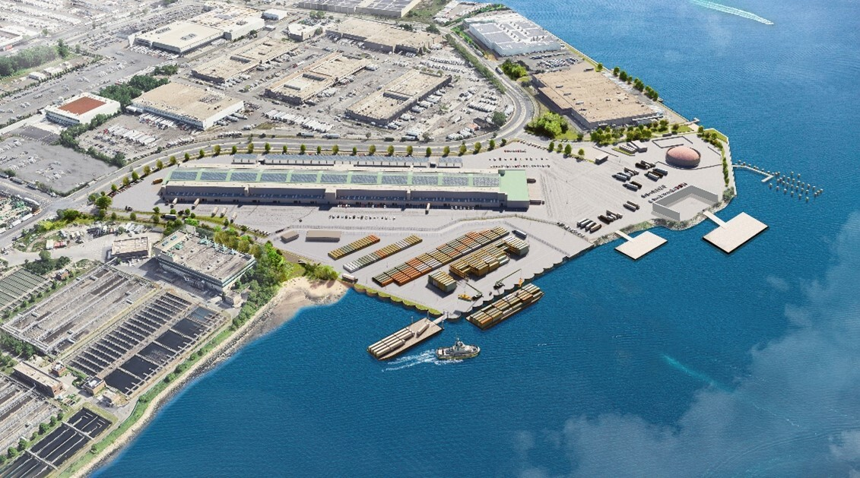
The new, proposed Hunts Point Marine Terminal would move freight off of ships and onto the last stage
in their delivery throughout New York City, creating hundreds of jobs and generating billions
of dollars in economic impact. This image is for illustrative purposes only. Credit: NYCEDC.
The Adams administration originally announced its intention to decommission the VCBC jail barge and begin a community engagement process for the site as part of its ‘Hunts Point Forward’ plan in 2022, a comprehensive plan to create economic opportunity and improve quality of life for New Yorkers in the Hunts Point neighborhood of the South Bronx. The plan is backed by a $40 million commitment from Mayor Adams and outlines a 15-year vision shared by the city and the community with more than 70 short- and long-term recommendations for creating family-sustaining jobs, improving public safety, enhancing community health and access to healthy food, promoting environmental justice, and delivering upgrades to open space, transportation, and other key community infrastructure.
With today’s announcement, the Hunts Point Marine Terminal will continue into a design and planning stage with continued community consultation. Additionally, NYCEDC will lead a comprehensive land remediation effort to address the site’s historical pollution, an essential step toward unlocking its future potential, which is anticipated to be completed in 2027.
The Hunts Point Marine Terminal will also serve as a key node in Mayor Adams’ Blue Highways initiative, a joint project between the New York City Department of Transportation and NYCEDC to promote the use of the city’s waterways for transporting goods in and around the city. The initiative aims to increase the utilization of New York City’s waterways to transport and deliver cargo — reducing emissions, decreasing wear and tear on roadways, alleviating supply chain bottlenecks, and moving goods more quickly from ships to shelves. Progress has been made on this initiative, including by the recent unveiling of the Downtown Skyport, a multi-modal hub for sustainable transportation and last-mile delivery; an investment of $18 million to upgrade port operations at the Brooklyn Marine Terminal; and a $164 million federal grant NYCEDC received to transform the 122-acre Brooklyn Marine Terminal into a modern, 21st-century maritime port and mixed-use community. The competition of each of these sites increases transportation resiliency and helps alleviate critical food security bottlenecks, making New York City better equipped to receive goods during times of emergency or disaster.
The Hunts Point Marine Terminal will build on the recently announced Blue Highways facility in partnership with Con Agg Global, which will be located adjacent to the Fulton Fish Market in the Hunts Point Food Distribution Center and next door to the new Hunts Point Marine Terminal. Con Agg Global’s facility, set to begin operations this year, will initially handle construction materials such as natural sand, gravel, and stone. Eventually, a permanent facility — currently seeking final sourcing and additional approvals — will handle more goods; it is expected to remove approximately 1,000 truck trips per month in the South Bronx. The permanent facility will feature an inland standard barge with a modular pier design to allow for rapid deployment, high capacity, and flexibility to adjust the design and layout based on evolving market demands for freight, including micro freight.
Moreover, NYCEDC has awarded $1.4 million to the Greater Hunts Point Economic Development Corporation (GHPEDC) to lead an Economic Mobility Network in Hunts Point, connecting residents to training and local, good-paying jobs at the Food Distribution Center and innovation industries in the green economy. GHPEDC’s coalition partners will include WorkforceBX, The Point CDC, The Hope Program, Bronx River Alliance, Rocking the Boat, Fulton Fish Market Cooperative, Empire Clean Cities, and the Hunts Point Longwood Community Coalition. The Hunts Point Marine Terminal and the Economic Mobility Network represent the city’s long-term investment to advance equitable economic growth in Hunts Point.
Today’s Hunts Point Marine Terminal announcement builds on the Adams administration’s broader strategy to develop the Harbor of the Future — a reimagined network of innovation and growth across New York City’s waterways. The Harbor of the Future includes emerging innovation centers such as the Hunts Point Produce Market in the Bronx; the newly-announced climate innovation hub “BATWorks” at the Brooklyn Army Terminal in Sunset Park; the country’s largest offshore wind port at the South Brooklyn Marine Terminal; a modern maritime port and vibrant mixed-use community hub at the Brooklyn Marine Terminal in Red Hook; the Science Park and Research Campus in Kips Bay in Manhattan; new sustainable housing and public space on the North Shore of Staten Island; and an anchor research and educational partner with the New York Climate Exchange on Governors Island. Additionally, today’s announcement fulfills a key commitment in Mayor Adams’ “Green Economy Action Plan,” a first-of-its-kind plan that lays out a roadmap to growing the city’s green economy, invests in jobs and sectors that help the city combat climate change, and positions New Yorkers to benefit from the nearly 400,000 projected ‘green-collar’ jobs in New York City by 2040.
“The transformation of the decommissioned Vernon C. Bain Correctional Center into the Hunts Point Marine Terminal is a bold and innovative step forward for the Bronx and New York City. This project not only reimagines our waterfront for productive use, but also directly tackles pollution and congestion. By shifting freight from trucks to marine vessels, we are improving air quality, decreasing traffic on our roads, and enhancing the quality of life for our residents. Equally important, the new terminal will create good-paying union jobs and long-term economic opportunities for Bronx families,” said Bronx Borough President Vanessa L. Gibson. “I want to thank Mayor Adams, NYCEDC, and all the partners involved in this project for investing in sustainable infrastructure and ensuring Hunts Point remains a vital engine for growth in our borough.”
“For almost two decades, first as a member and district manager of Bronx Community Board Two, and now as a councilmember, I have worked tirelessly with the community to erase the stained legacy that the Vernon C. Bain Center has left on the South Bronx,” said New York City Councilmember Rafael Salamanca. “Despite numerous broken promises from past administrations, we never gave up our pursuit of reclaiming our waterfront. Having personally received a commitment from then-mayoral candidate Eric Adams in 2021, I am extremely proud to stand here today with Mayor Adams as we not only announce the next step in removing ‘The Barge’ once and for all, but a future for the South Bronx that will bring green jobs, cleaner air, and a waterfront that is accessible to all in the form of the new, state-of-the-art Hunts Point Marine Terminal. I thank Mayor Adams and his administration for keeping their word in closing the Vernon C. Bain Center, as well as agency and community stakeholders who have made significant contributions in planning for a reimagined South Bronx without the Barge.”
“Permanently closing this jail and opening space for community-building is a major step forward for the South Bronx. A painful part of our history is now behind us, while ahead lies the opportunity to invest in our communities and proceed toward the city’s historic decarceration plan and a more humane justice system,” said Jonathan Monsalve, president and CEO, Osborne Association. “When we remove the symbols of our past failures, we make room for a more just future.”
“The permanent removal of the Vernon C. Bain Correctional Center is a landmark moment for the Bronx and for New York City’s commitment to closing Rikers Island. As a lifelong Bronxite raised in Soundview, I know firsthand the burden this facility has placed on our community. Dismantling the jail barge is not only about reducing jail capacity — it’s about healing a painful legacy and advancing environmental justice for neighborhoods that have long borne the brunt of carceral infrastructure,” said Stanley Richards, president and CEO, The Fortune Society. “It shows what is possible when New York City unites around a shared vision — public safety rooted in prevention, alternatives to incarceration, and robust reentry services. This is how we build safer, healthier, and more just communities for all.”
###

