Mayor Adams Announces New York Embroidery Studio Creating 500 Jobs at Brooklyn Army Terminal
March 18, 2022
Local, Women-Owned Business Will Be Largest New Lease at BAT in Three Years
Company Pivoted From High Fashion to Make Sustainable PPE for Frontline Workers, Now Growing to Help Restore National Stockpile
Announcement Comes During Women’s History Month, Builds on Mayor Adams’ Economic Recovery Blueprint Released Earlier This Month
NEW YORK – New York City Mayor Eric Adams today announced that New York Embroidery Studio (NYES) will be the newest tenant at the Brooklyn Army Terminal (BAT), signing the largest new lease at the terminal in three years and filling one of the largest spaces at BAT. This expansion will create more than 500 on-site jobs, yielding an estimated $73 million in economic output for New York City. The full-service design manufacturer will take over nearly 80,000 square feet to create a state-of-the-art facility, where they will manufacture personal protective equipment (PPE) for frontline health-care workers across the country.
“One week after announcing my administration’s economic recovery plan, I am proud to show New Yorkers that we are getting to work and creating jobs in our city,” said Mayor Adams. “Small and minority- and women-owned businesses must be at the core of an inclusive and equitable economic recovery, and I am proud to honor Women’s History Month by supporting NYES and women entrepreneurs in all five boroughs.”
“The New York Embroidery Studio’s expansion at the Brooklyn Army Terminal will bring 500 jobs to Sunset Park and further advance New York’s economic recovery,” said Deputy Mayor for Economic and Workforce Development Maria Torres-Springer. “As we continue to invest in the city’s garment manufacturing sector, this is a great opportunity to support an innovative, women-led business providing life-saving personal protective equipment to medical professionals across the country. New York Embroidery Studio embodies the spirit of reinvention will bring our economy back from the pandemic.”
“The local production of PPE is essential to our health care workers and our city, so we are always prepared,” said New York City Economic Development Corporation (NYCEDC) President and CEO Andrew Kimball. “We must be forward-thinking as we address our city’s future pandemic preparedness. NYCEDC is proud to support a local, women-led small business, like New York Embroidery Studio, with a new state-of-the-art space in the Brooklyn Army Terminal, to help them meet their PPE quotas and ensure the equipment is made in America. We commend New York Embroidery Studio for answering the call and pivoting from high fashion to sustainable PPE for our frontline workers.”
“New York Embroidery Studio has been manufacturing in the garment center for over 30 years. I am totally committed to growing the apparel industrial base here in NYC,” said Michelle Feinberg, founder and owner, NYES. “Additionally, we want to bring high fashion’s drive for innovation and quality to PPE manufacturing, by developing novel and sustainable products for our clients.”
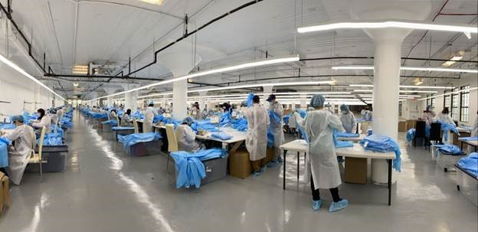
NYES’ production facility at the Brooklyn Army Terminal
Photo Credit: NYES
At the height of the pandemic, NYES pivoted from high fashion to making PPE. Founder Michelle Feinberg and her team prototyped and made more than 590,000 hospital gowns in just nine weeks, while also keeping hundreds of New Yorkers employed when the city’s economy was shut down.
That pivot laid the foundation for the company’s expansion to NYCEDC’s BAT, where they will use state-of-the-art automated cutting and spreading machines and other advanced manufacturing techniques to produce biodegradable and sustainable PPE full-time, as part of an ongoing effort to restore the country’s national stockpile. NYES prioritizes eco-friendly production methods to reduce waste and the city’s carbon footprint. While medical PPE is typically not biodegradable, NYES has developed an innovative biodegradable isolation gown.
In the coming months, NYES will be fitting out the large-scale operation center at BAT, and the company has committed to working with Minority- and Women-Owned Business Enterprises as contractors and subcontractors to build out the space. In addition, NYES will utilize NYCEDC’s HireNYC program, which connects businesses with qualified job seekers in the local community.
Previously, NYCEDC supported NYES with grant funding through the Fashion Manufacturing Initiative from 2014 to 2018, to offset costs associated with purchasing new equipment, upgrading technologies, and making improvements to the company’s Manhattan facility.
Michelle Feinberg founded NYES in 2001, in Manhattan’s Garment Center, offering embellishment and specialized services and skills in fashion manufacturing for the likes of Tory Burch, Thom Browne, Coach, Ralph Lauren, and Alexander Wang, as well as small and emerging New York City-based brands like Kerby Jean-Raymond.
Today’s announcement builds on the mayor’s vision for the future of New York City’s economy outlined in “Rebuild, Renew, Reinvent: A Blueprint for NYC's Economic Recovery.” The blueprint, released this month, contains 70 initiatives designed to capitalize on a once-in-a-generation opportunity to reinvigorate the city’s economy and increase equity and inclusivity. The blueprint specifically aims to accelerate the return to pre-pandemic employment levels, while simultaneously laying the foundation for the city’s economic future — addressing historic injustices and reimagining outdated ways of doing business.
“The road towards a full and just recovery is a long one, but we must learn the hard lessons coming out of this pandemic,” said New York City Councilmember Alexa Avilés. “We cannot continue to rely on unstable global supply chains when our community stands willing and able to produce necessary PPE right here. We welcome New York Embroidery Studio to our district and look forward to working with EDC on adding even more high-quality, good-paying jobs to our working waterfront.”
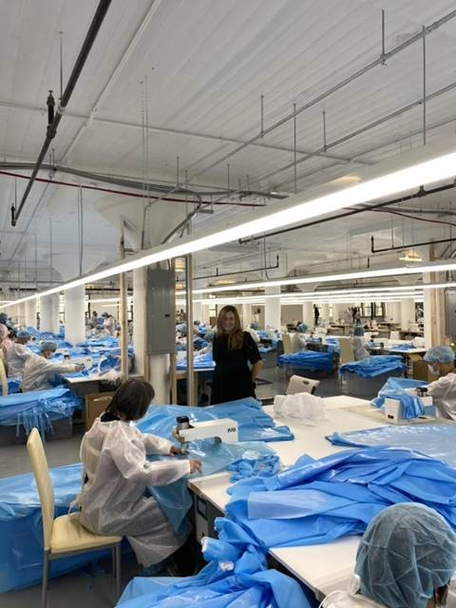
NYES Founder Michelle Feinberg at the Brooklyn Army Terminal facility
Photo Credit: NYES
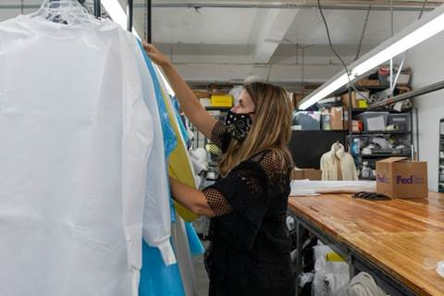
NYES Founder Michelle Feinberg at the company’s Manhattan facility in the Garment Center
Photo Credit: NYCEDC

